|  |  |
| --- | --- |
| **Practicum Case** |  |
| COMP6176 | COMP6232  Human and Computer Interaction |
| **Computer Science** | **E1-COMP6176-WE01** |
| ***Valid on*** *Even Semester Year 2019/2020* | **Revision 00** |

## Learning Outcomes

* Describe the concept of interaction design
* Use guidelines, principles, models, and framework related with interaction design
* Choose the data gathering technique from user to develop successful interaction design
* Design the user requirements with interaction styles
* Evaluate the user interfaces of interactive software

## Topic

* JavaScript Form, Validation and Dialog Box

## Sub Topics

* Submitting Form Data
* Displaying Form Data
* Validation
* Dialog Box

## Soal

*Case*

**Bluejack Candy Store**

**Bluejack Candy Store** manufactures a line of handcrafted quality chocolates and sells over a thousand different types of candies. **Bluejack Candy Store** quickly rose up as top contender in the industry. Mr. Iwatani as the owner of the shop wants to thank their loyal customer by creating a website to help their beloved customer keep up to date with their brand new products. Therefore, you are asked to create a website with your own creativity using **HTML** and **JavaScript** with these following criteria:

* **<form></form>** used to accommodate form components.
* **Form Components**

|  |  |
| --- | --- |
| **Component** | **Tag** |
| Name | <input type=”text”/> |
| Candy Type | <select></select> |
| Quantity | <input type=”text”/> |
| Package | <input type=”radio”/> |
| Address | <textarea></textarea> |
| User Agreement | <input type=”checkbox”/> |
| Submit Button | <input type=”button”/> |
| Reset Button | <input type=”reset”/> |

* You are required to create a **validation** of form components

|  |  |
| --- | --- |
| **Component** | **Validation** |
| Name | Must be minimal 5 character length.  Must be alphabet. |
| Candy Type | Must be chosen. |
| Quantity | Must be number.  Must be between 1 and 12 |
| Package | Must be chosen. |
| Address | Must be minimal 5 words |
| User Agreement | Must be checked. |
| Submit Button | Validate all form components. |
| Reset Button | Clear all form components value. |

* If you click the **reset button**, the website will clear all form components value and gives you a **message dialog box**
* If you click the **submit button** and passed all the validation, the website will show you your order inside a **confirmation dialog box**, and asked you for additional message for the order using **input** **dialog box**

You can see the example below to help you create the order page:

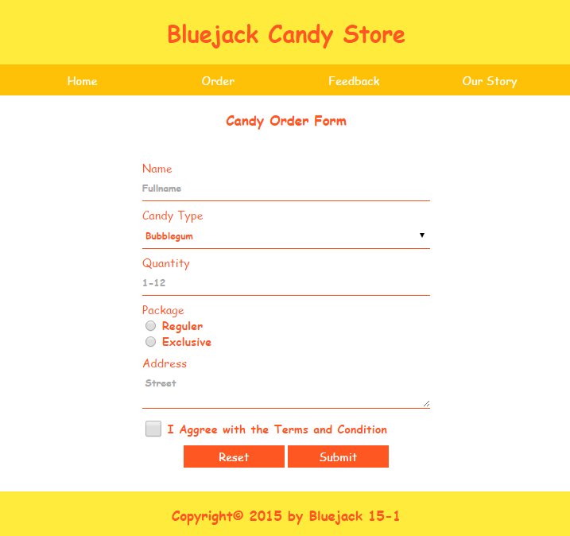

Figure 1. Order Form Page

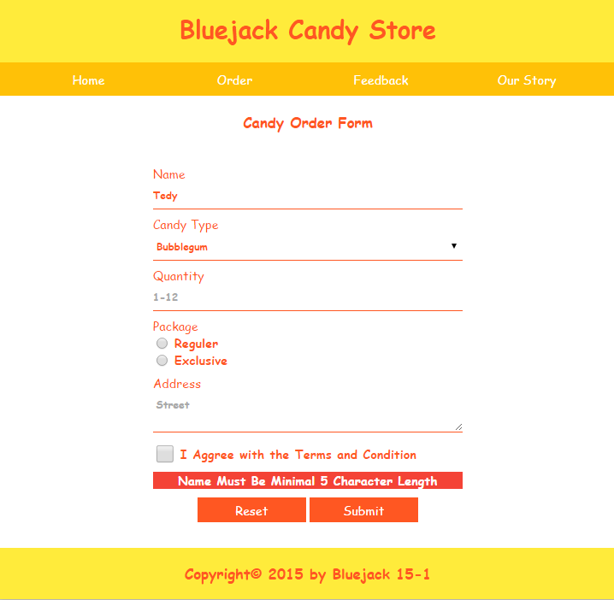

Figure 2. Error message in order form

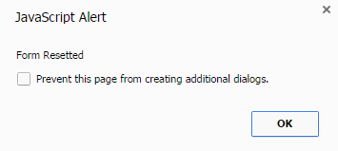

Figure 3. Reset button message

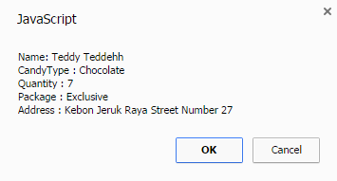

Figure 4. Submit button order confirmation

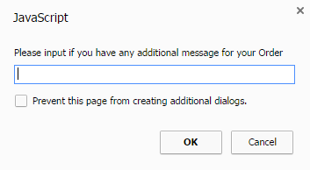

Figure 5. Input dialog box for additional order message

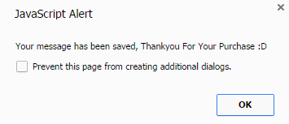

Figure 6. Success message with additional message

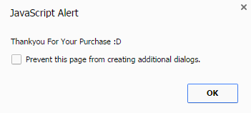

Figure 7. Success message without additional message

**If you have any question, please ask your assistant!**