BVAR Ensemble Forecast Comparison
Primary: garch/markov/student_t/seed 42. Comparison: garch/none/student_t/seed 42.
Field | Primary | Comparison
As-of quarter | 2007Q4 | 2007Q4
Generated at | 2026-07-18T18:25:35Z | 2026-07-18T18:25:34Z
Paths | 10000 | 10000
Horizon | 4 | 4
Vol model | garch | garch
Regime model | markov | none
Anchor regime p_enter | 0.21800670337663774
Shock distribution | student_t | student_t
Seed | 42 | 42
Baseline mode | trailing_trend | trailing_trend
Posterior fingerprint | 2f0ea01e7945a242 | 2f0ea01e7945a242
Handoff fingerprint | 6f2cc04e81580097 | 6f2cc04e81580097

Scenario Probabilities
Scenario | Primary | Comparison | Delta
growth_scare_no_credit | 80.9% | 88.3% | -7.5%
stagflation | 11.7% | 9.2% | +2.6%
credit_led_recession | 3.0% | 0.6% | +2.4%
late_cycle_expansion | 2.7% | 1.5% | +1.2%
inflation_shock | 0.9% | 0.3% | +0.6%
expansion_disinflation | 0.8% | 0.1% | +0.7%

Regime Overlay Comparison
Metric | Primary | Comparison
Regime model | markov | none
Anchor label | calm
Anchor p_enter | 21.8%
Fraction entered stress | 53.5%
Avg quarters in stress | 1.001
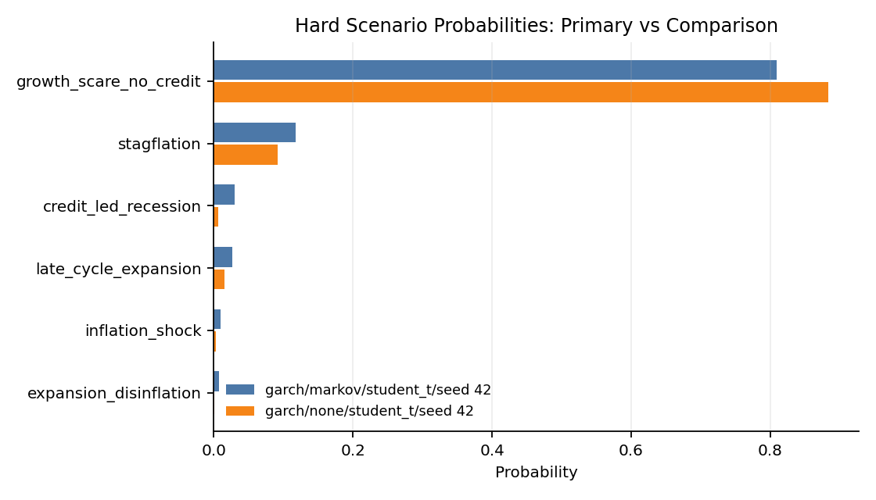

Fan Chart Comparison
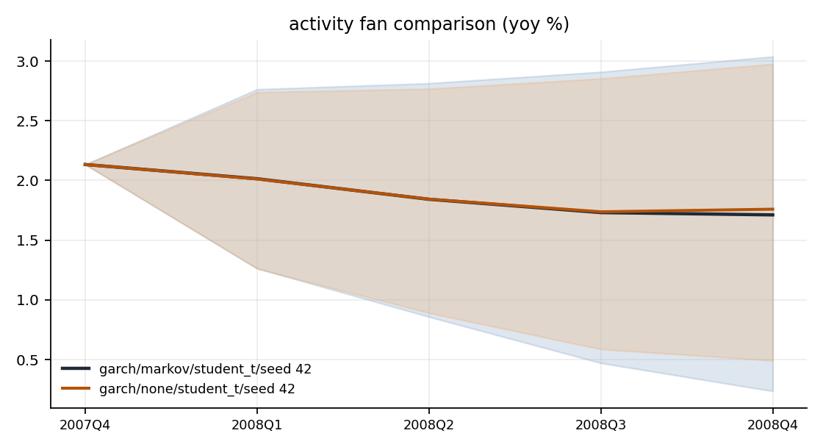
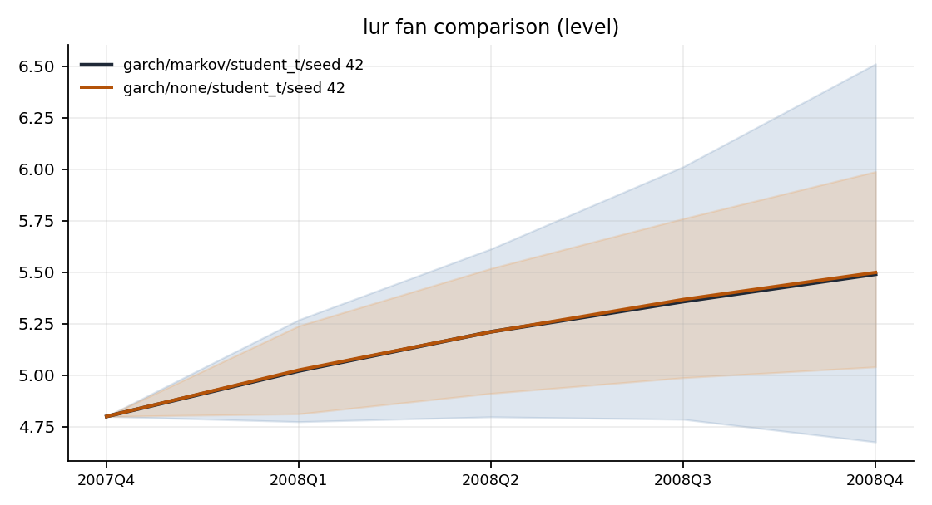
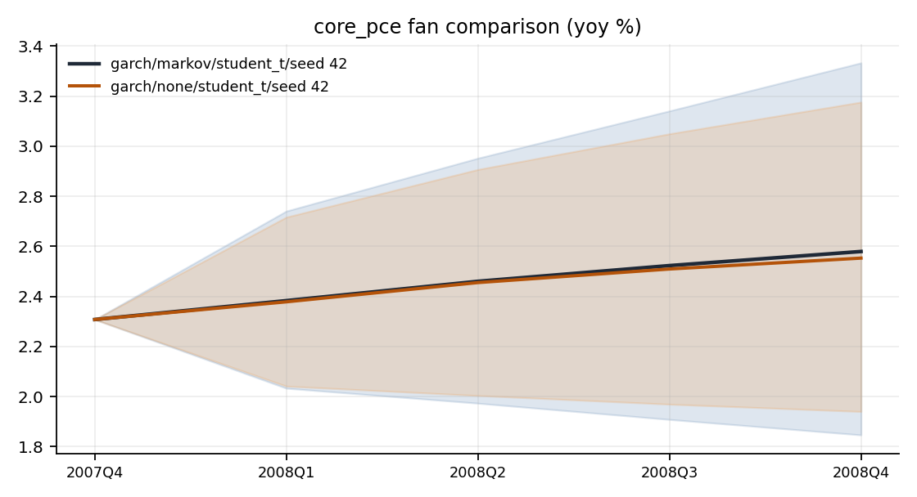
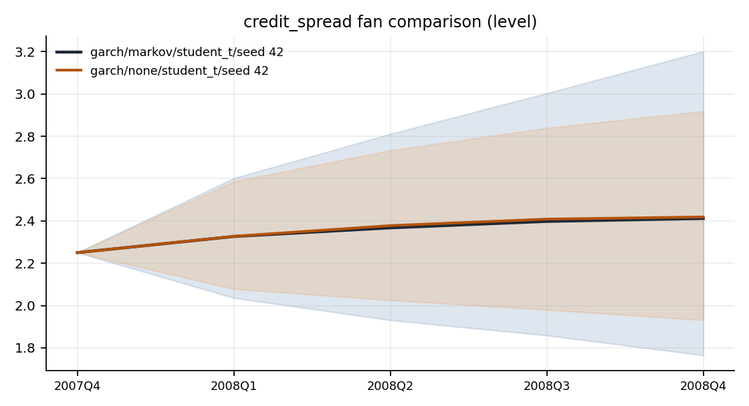
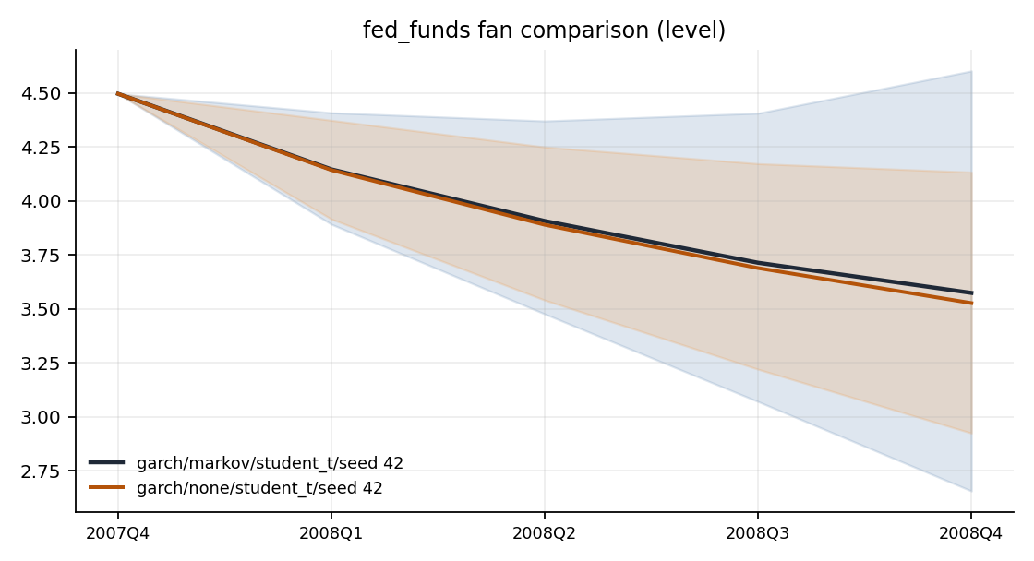
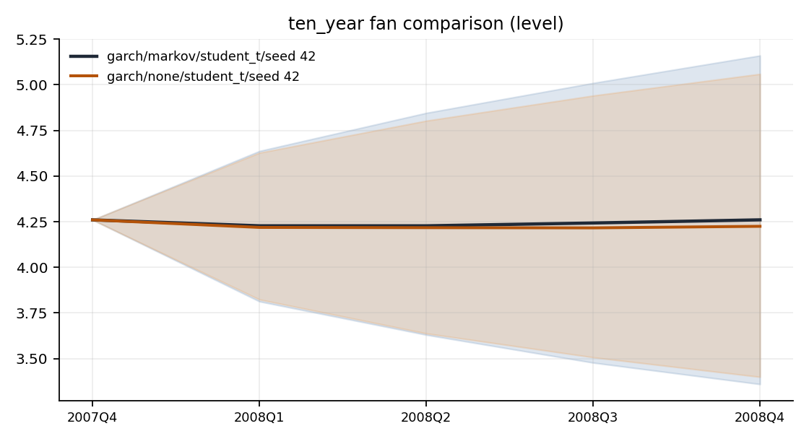
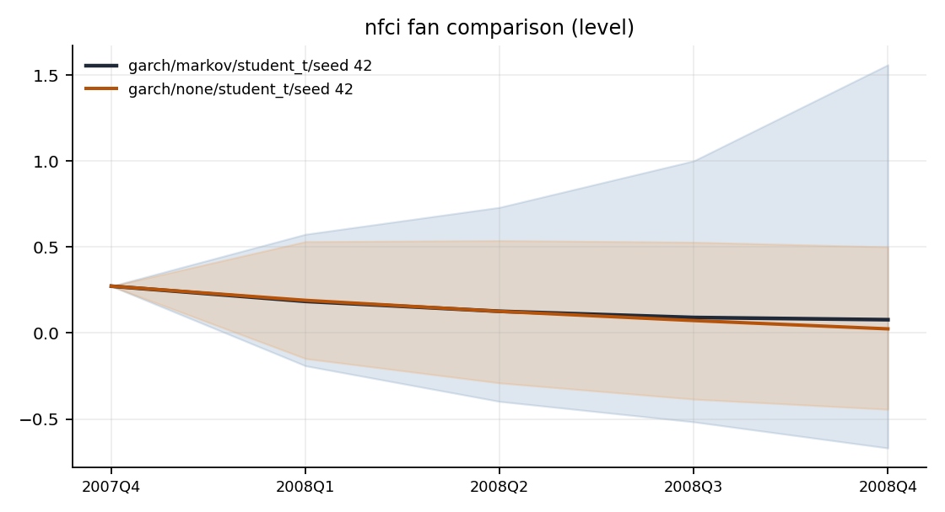

Terminal Distribution Comparison
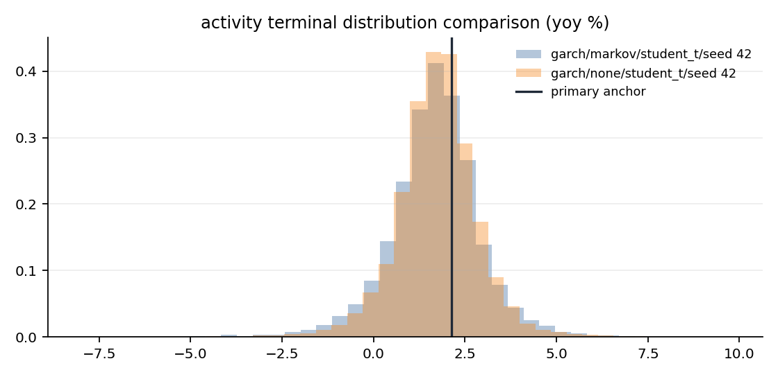
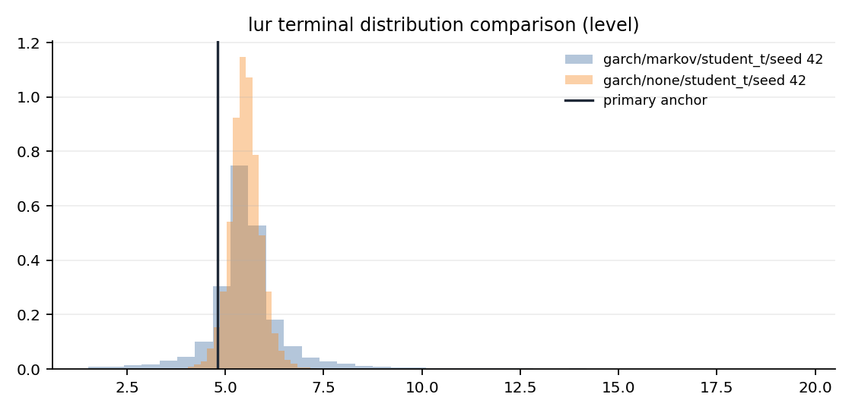
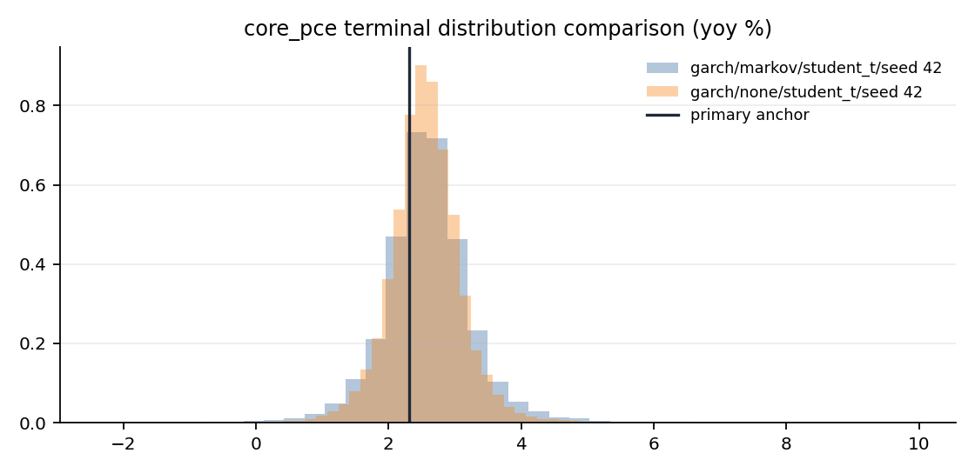
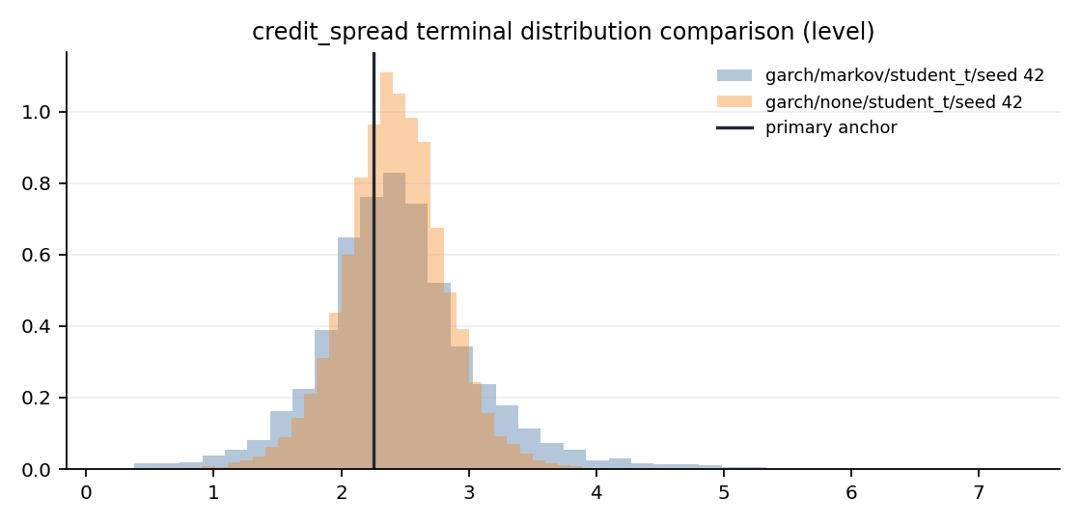

Appendix: Run Configuration
Key | Value
config.estimation_start | 1973Q1
config.garch_dist | student_t
config.garch_max_iter | 500
config.garch_persistence_warn | 0.99
config.garch_t_dof | 6
config.horizon | 4
config.kernel_sigma | 1.0
config.lags | 4
config.lambda1 | 0.2
config.lambda2 | 0.5
config.lambda3 | 1.0
config.lambda4 | 100.0
config.low_margin_threshold | 0.25
config.max_redraws_per_path | 5
config.min_sample_quarters | 120
config.n_paths | 10000
config.nfci_threshold | 0.5
config.regime_min_stress_quarters | 8
config.regime_model | markov
config.regime_proxy_weights | {"credit_spread_change_4q": 1.0, "credit_spread_level": 1.0, "nfci": 1.0}
config.rejection_warn_pct | 5.0
config.report_output_dir | data/agent_system/bvar_cache/reports
config.seed | 42
config.shock_dist | student_t
config.spread_change_threshold | 0.5
config.spread_level_pctile | 80.0
config.t_dof | 6
config.vol_model | garch
posterior.lambda1 | 0.2
posterior.lambda2 | 0.5
posterior.lambda3 | 1.0
posterior.lambda4 | 100.0
classifier.scaling | std
classifier.kernel_sigma | 1.0
classifier.active_variables | ["activity", "lur", "core_pce", "credit_spread", "fed_funds", "ten_year"]
classifier.handoff_file | /Users/terenceobrien/AI_Financial_Operator/data/agent_system/frbus_handoffs/frbus_scenario_paths_2026Q3_20260715T051025Z.json

