BVAR Ensemble Forecast
Field | Value
As-of quarter | 2017Q1
Generated at | 2026-07-27T15:16:44Z
Paths | 10000
Horizon | 4
Shock distribution | student_t
Vol model | garch
Regime model | markov
Anchor regime p_enter | 0.0013227330761268596
Regime artifact | /Users/terenceobrien/AI_Financial_Operator/data/agent_system/bvar_cache/regime_20260721T033955Z.npz
Seed | 42
Baseline mode | trailing_trend
Posterior artifact | /Users/terenceobrien/AI_Financial_Operator/data/agent_system/bvar_cache/posterior_20260716T142426Z.npz
Posterior fingerprint | 2f0ea01e7945a242
Handoff fingerprint | 6f2cc04e81580097
Handoff file | /Users/terenceobrien/AI_Financial_Operator/data/agent_system/frbus_handoffs/frbus_scenario_paths_2026Q3_20260715T051025Z.json
Note: this run used Student-t shocks, so the ensemble intentionally carries fatter simulated tails than the Gaussian setting.

Model Limitations
Credit tail magnitude: conservative
credit_led_recession probability is directionally correct and correctly ordered across anchors (elevated at pre-crisis configurations vs benign calm), but magnitudes are conservative. The crisis-honest regime labeling (~6% stress fraction) limits transition events available to the entry-probability logistic, lowering stress entry rates. Operator judgment should lean against the model on acute credit-stress setups the model may under-weight.

Scenario Probabilities
Scenario | Hard primary | Soft secondary
late_cycle_expansion | 58.7% | 48.4%
expansion_disinflation | 40.2% | 42.5%
growth_scare_no_credit | 0.8% | 3.7%
inflation_shock | 0.3% | 4.7%
stagflation | 0.0% | 0.7%
credit_led_recession | 0.0% | 0.0%
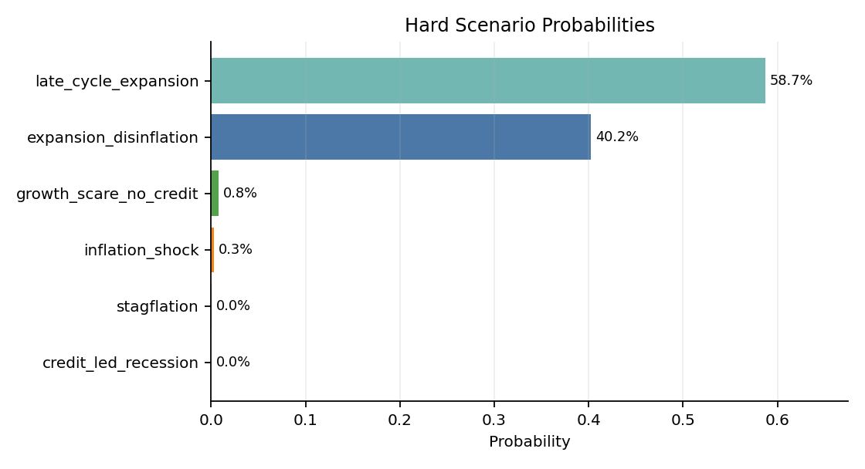
Margin mean: 0.189; p25: 0.077; share low margin: 71.2%.
High share_low_margin means many simulated futures were hard for the classifier to separate cleanly.

Regime Overlay
Metric | Value
Anchor label | calm
Anchor p_enter | 0.1%
Fraction entered stress | 1.7%
Fraction ever stress | 1.7%
Avg quarters in stress | 0.021
Credit spread terminal distribution split by regime path:
Group | Count | p50 | p90 | p99 | Max
ever_stress | 172 | 2.561 | 3.737 | 4.498 | 5.099
stayed_calm | 9828 | 2.213 | 2.724 | 3.238 | 4.288

Fan Charts
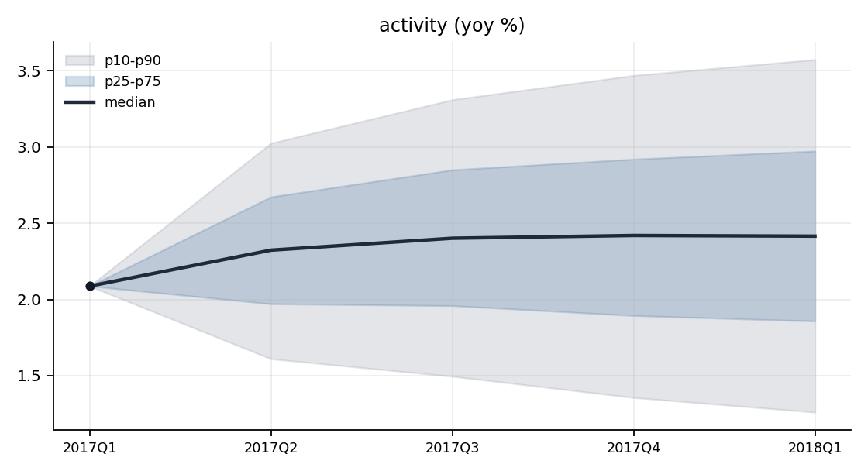
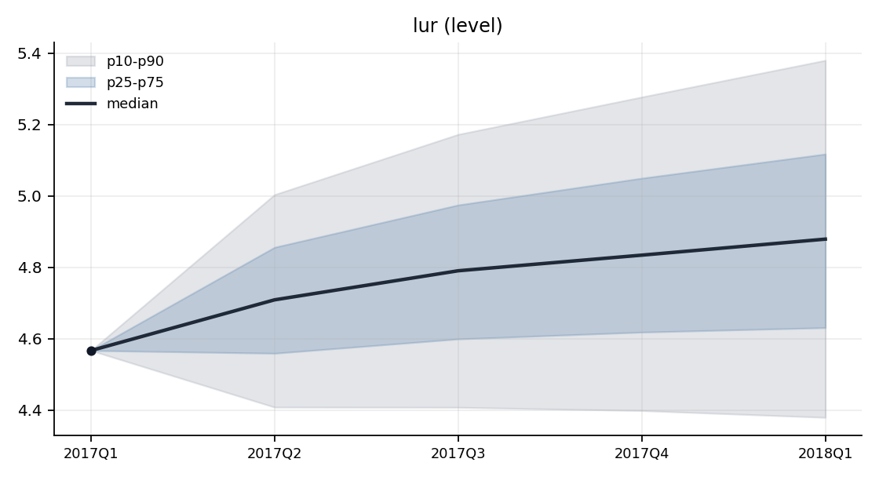
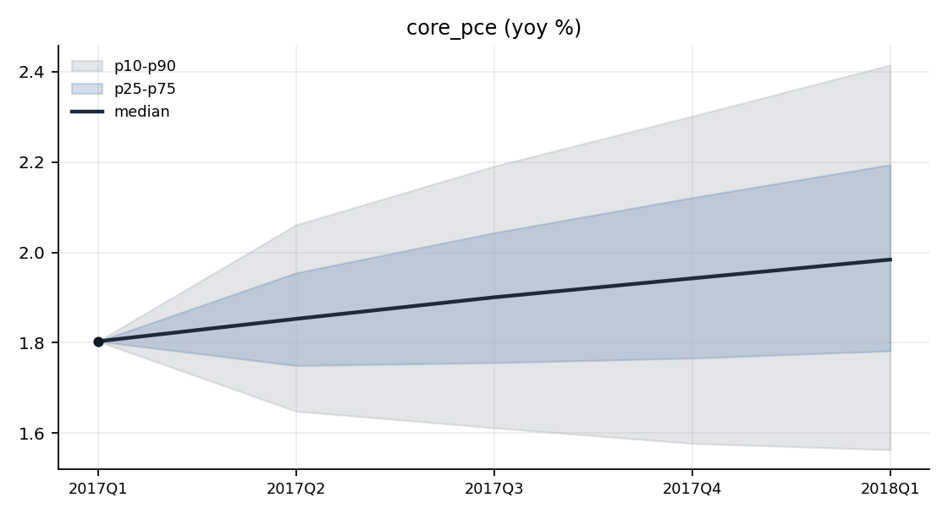
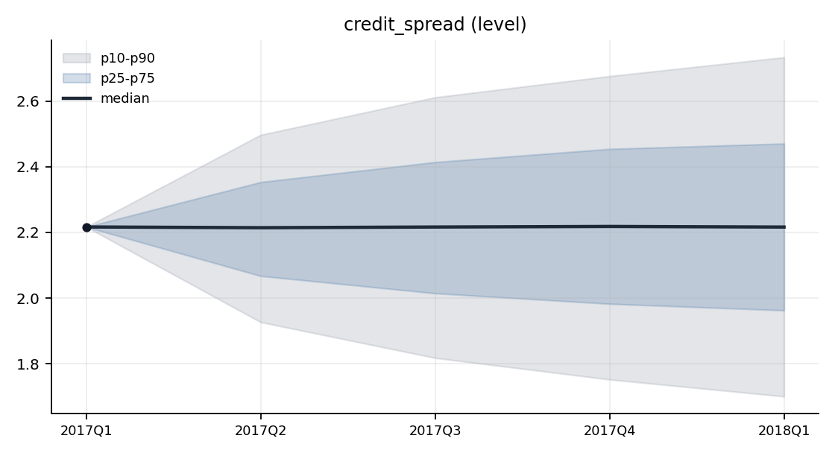
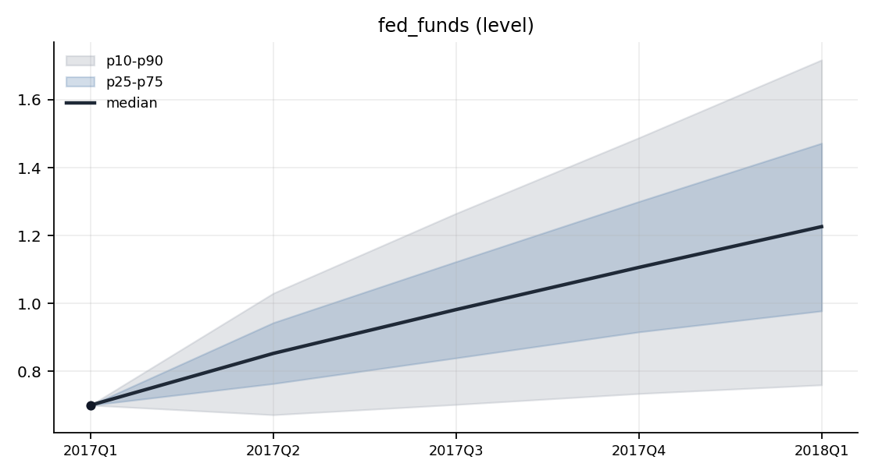
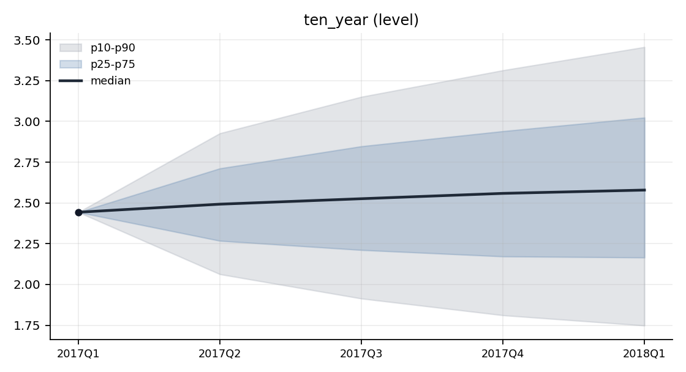
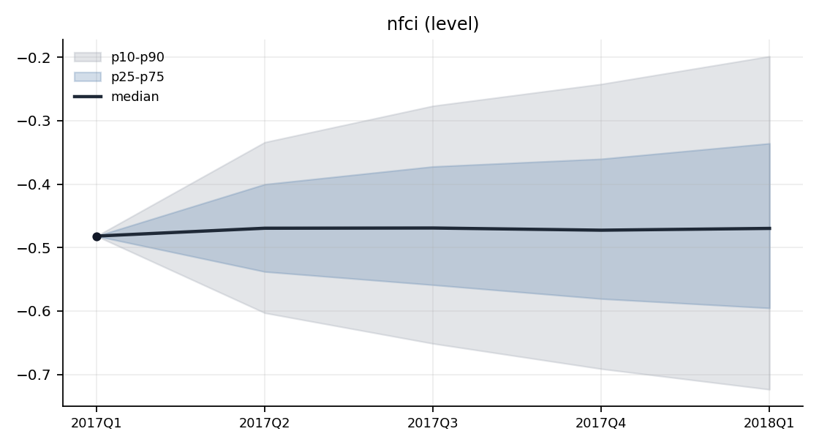

Terminal Distributions
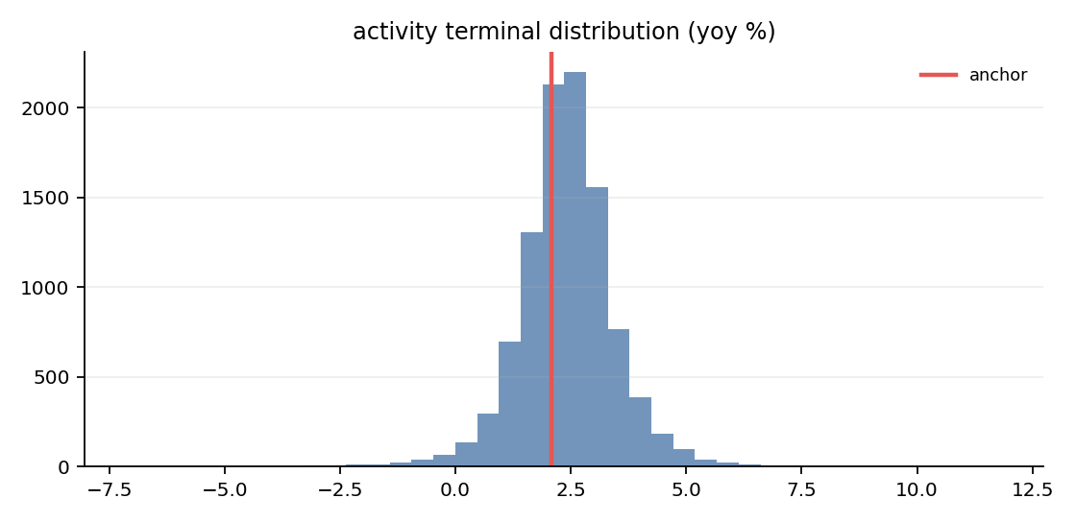
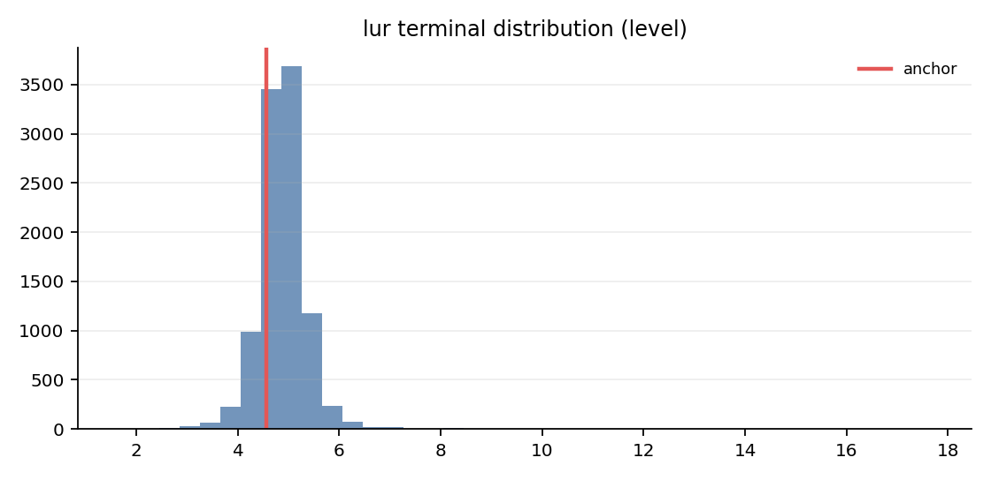
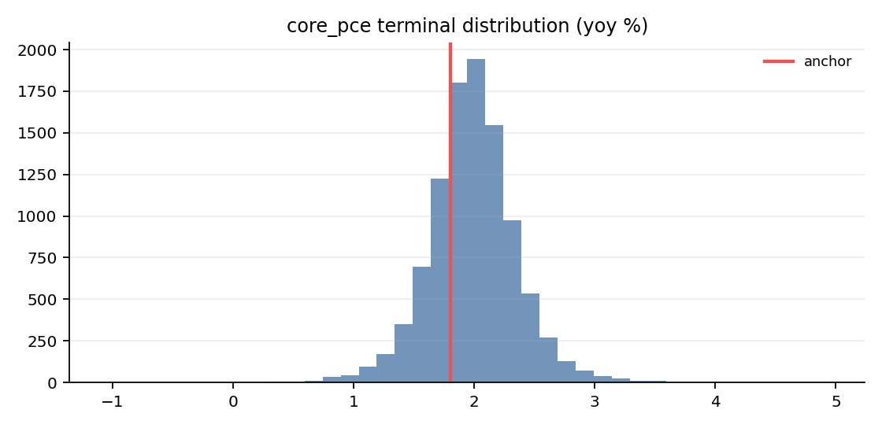
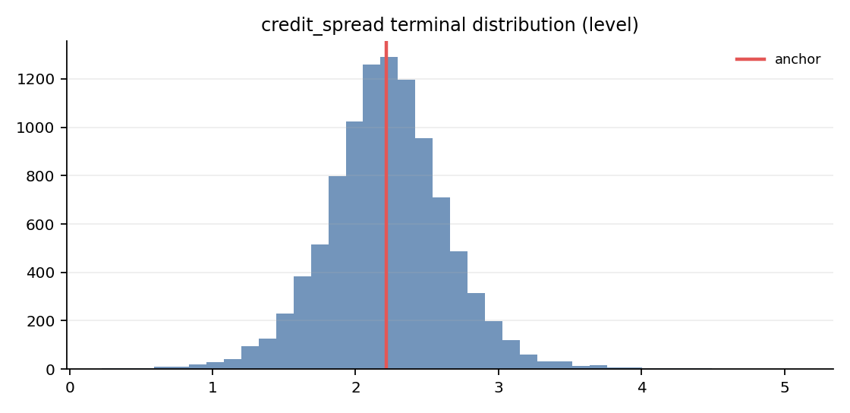

Tail Diagnostics
Ensemble K-quarter changes are compared with historical K-quarter changes; these diagnostics flag unusual tails but do not filter paths.
Variable | Ens p50 | Ens p90 | Ens p99 | Ens max | Hist p50 | Hist p90 | Hist p99 | Hist max
activity | 0.328 | 1.487 | 3.045 | 9.714 | -0.218 | 3.297 | 8.441 | 19.784
core_pce | 0.181 | 0.612 | 1.153 | 3.139 | -0.094 | 0.863 | 4.130 | 4.979
credit_spread | -0.000 | 0.517 | 1.127 | 2.882 | 0.000 | 0.772 | 1.615 | 3.337
fed_funds | 0.526 | 1.017 | 1.614 | 4.994 | -0.003 | 2.137 | 4.927 | 7.740
lur | 0.312 | 0.813 | 1.600 | 13.104 | -0.267 | 1.540 | 3.943 | 9.367
nfci | 0.012 | 0.283 | 0.643 | 3.119 | -0.023 | 0.755 | 2.488 | 2.759
ten_year | 0.136 | 1.013 | 1.901 | 3.816 | -0.083 | 1.334 | 2.862 | 3.893

Validity Summary
Metric | Value
Rejections | 164
Redraws | 164
Clips | 0
Rejection rate | 1.64%
Warning threshold | 5.00%
Per-variable violation counts:
Variable | Violations
activity | 1
credit_spread | 15
fed_funds | 142
lur | 28
nfci | 38
ten_year | 25

Appendix: Run Configuration
Key | Value
config.crisis_correlation_target | 0.8
config.estimation_start | 1973Q1
config.garch_dist | student_t
config.garch_max_iter | 500
config.garch_persistence_warn | 0.99
config.garch_t_dof | 6
config.horizon | 4
config.kernel_sigma | 1.0
config.lags | 4
config.lambda1 | 0.2
config.lambda2 | 0.5
config.lambda3 | 1.0
config.lambda4 | 100.0
config.low_margin_threshold | 0.25
config.max_redraws_per_path | 5
config.min_sample_quarters | 120
config.n_paths | 10000
config.nfci_threshold | 0.5
config.psd_repair_warn_delta | 0.1
config.regime_min_stress_quarters | 8
config.regime_model | markov
config.regime_proxy_weights | {"credit_spread_change_4q": 1.0, "credit_spread_level": 1.0, "nfci": 1.0}
config.rejection_warn_pct | 5.0
config.report_output_dir | data/agent_system/bvar_cache/reports
config.seed | 42
config.shock_dist | student_t
config.spread_change_threshold | 0.5
config.spread_level_pctile | 90.0
config.stress_correlation_impose_weight | 1.0
config.stress_min_conditions | 2
config.t_dof | 6
config.vol_model | garch
posterior.lambda1 | 0.2
posterior.lambda2 | 0.5
posterior.lambda3 | 1.0
posterior.lambda4 | 100.0
classifier.scaling | std
classifier.kernel_sigma | 1.0
classifier.active_variables | ["activity", "lur", "core_pce", "credit_spread", "fed_funds", "ten_year"]
classifier.handoff_file | /Users/terenceobrien/AI_Financial_Operator/data/agent_system/frbus_handoffs/frbus_scenario_paths_2026Q3_20260715T051025Z.json

