BVAR Ensemble Forecast
Field | Value
As-of quarter | 2026Q1
Generated at | 2026-07-15T14:26:16Z
Paths | 10000
Horizon | 4
Shock distribution | student_t
Seed | 42
Baseline mode | t0_change
Posterior artifact | /Users/terenceobrien/AI_Financial_Operator/data/agent_system/bvar_cache/posterior_20260715T052111Z.npz
Posterior fingerprint | bf63ba4f4b07ced0
Handoff fingerprint | 6f2cc04e81580097
Handoff file | /Users/terenceobrien/AI_Financial_Operator/data/agent_system/frbus_handoffs/frbus_scenario_paths_2026Q3_20260715T051025Z.json
Note: this run used Student-t shocks, so the ensemble intentionally carries fatter simulated tails than the Gaussian setting.

Scenario Probabilities
Scenario | Hard primary | Soft secondary
late_cycle_expansion | 35.2% | 29.6%
growth_scare_no_credit | 31.0% | 27.7%
expansion_disinflation | 24.2% | 26.6%
inflation_shock | 5.4% | 9.2%
stagflation | 3.9% | 6.7%
credit_led_recession | 0.3% | 0.3%
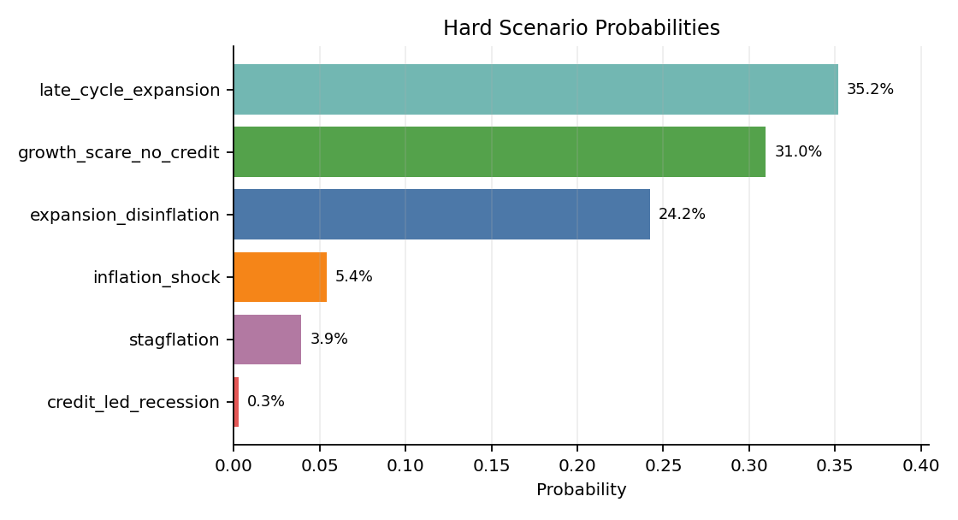
Margin mean: 0.347; p25: 0.139; share low margin: 43.9%.
High share_low_margin means many simulated futures were hard for the classifier to separate cleanly.

Fan Charts
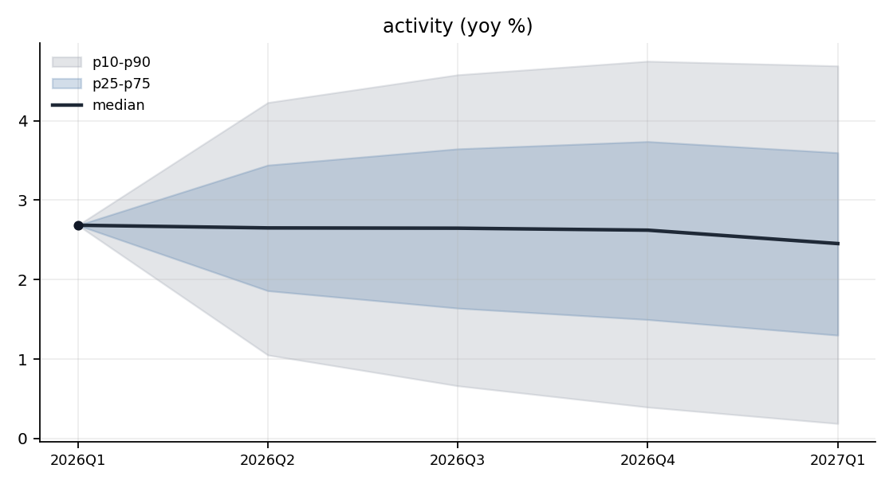
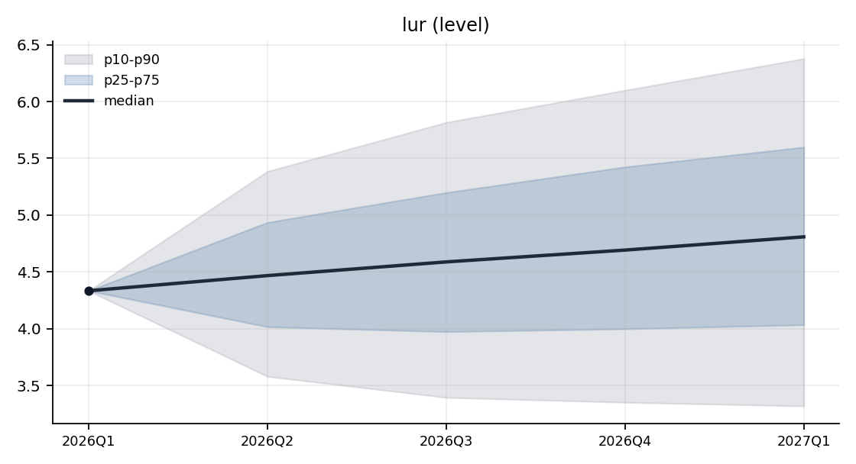
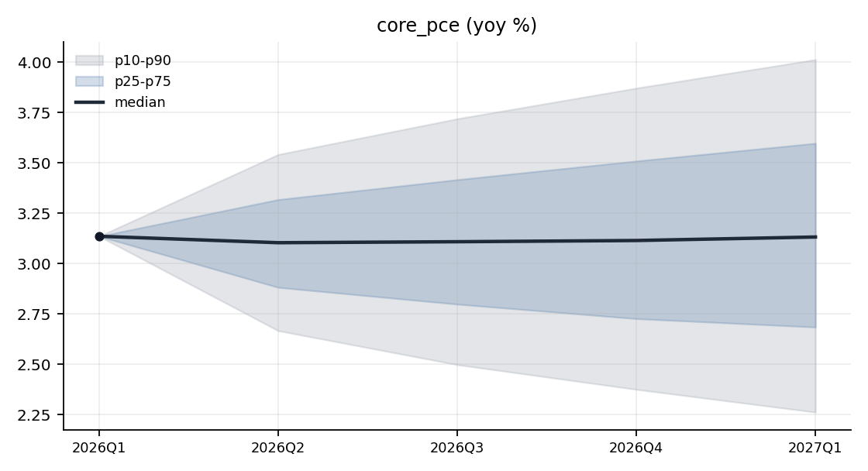
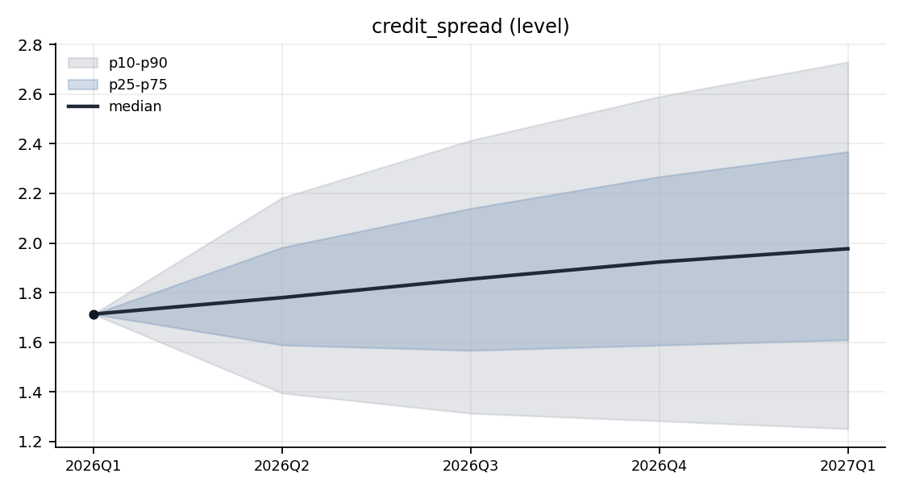
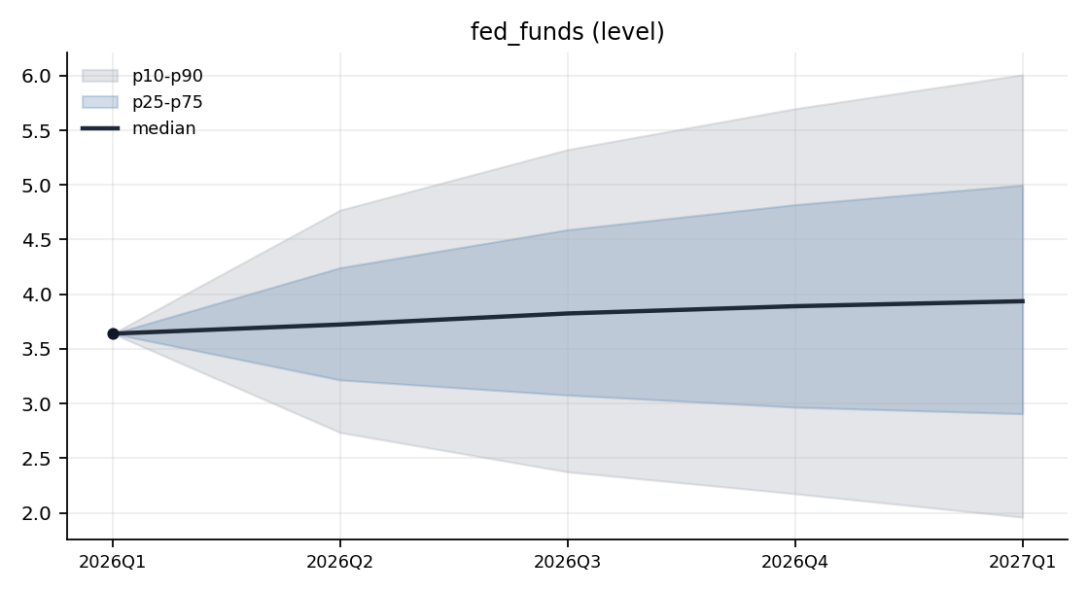
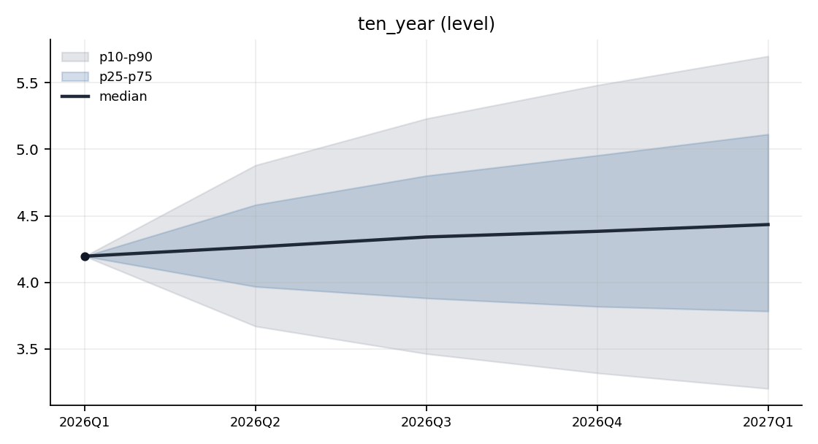
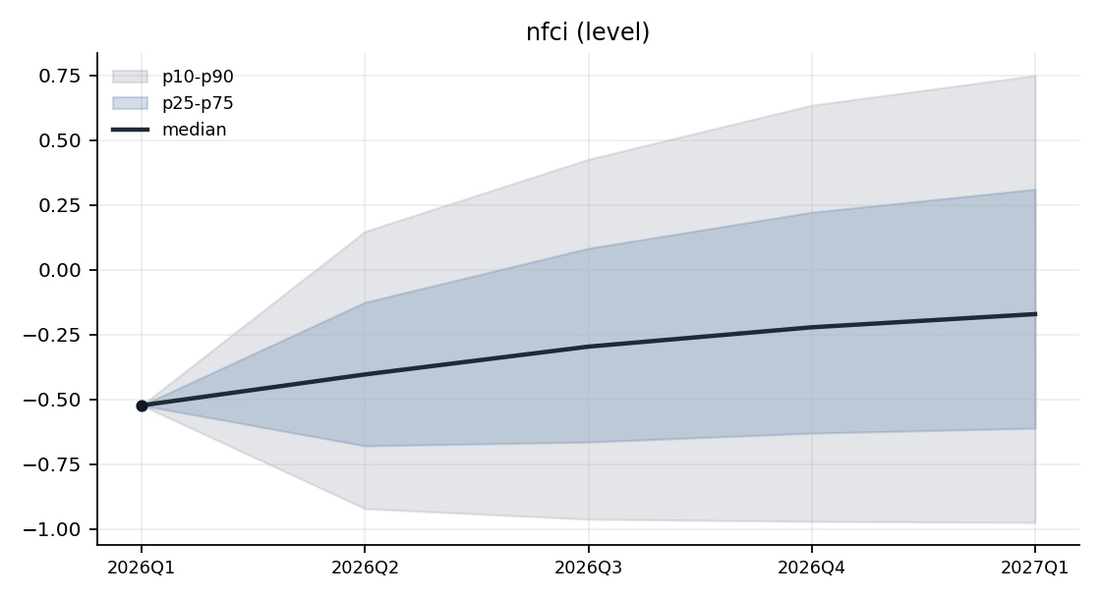

Terminal Distributions
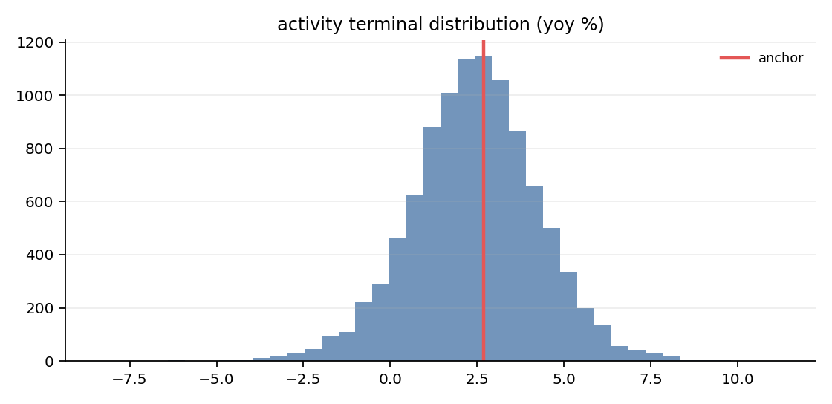
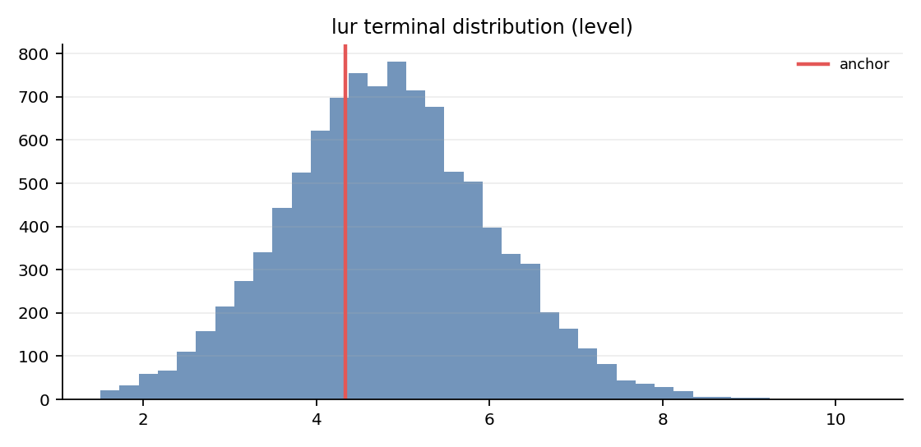
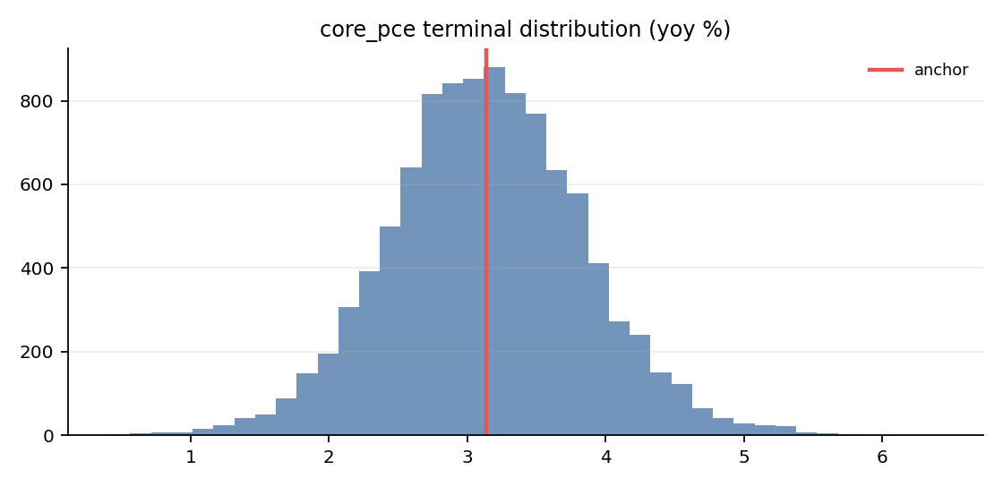
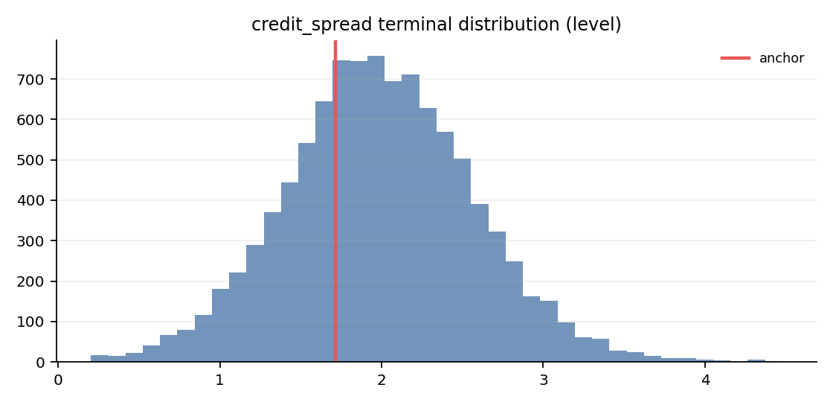

Tail Diagnostics
Ensemble K-quarter changes are compared with historical K-quarter changes; these diagnostics flag unusual tails but do not filter paths.
Variable | Ens p50 | Ens p90 | Ens p99 | Ens max | Hist p50 | Hist p90 | Hist p99 | Hist max
activity | -0.231 | 2.005 | 4.172 | 8.581 | -0.218 | 3.297 | 8.441 | 19.784
core_pce | -0.004 | 0.877 | 1.734 | 3.296 | -0.094 | 0.863 | 4.130 | 4.979
credit_spread | 0.263 | 1.017 | 1.695 | 2.765 | 0.000 | 0.772 | 1.615 | 3.337
fed_funds | 0.297 | 2.368 | 4.199 | 7.479 | -0.003 | 2.137 | 4.927 | 7.740
lur | 0.475 | 2.044 | 3.371 | 6.006 | -0.267 | 1.540 | 3.943 | 9.367
nfci | 0.352 | 1.273 | 2.102 | 4.409 | -0.023 | 0.755 | 2.488 | 2.759
ten_year | 0.238 | 1.503 | 2.574 | 4.610 | -0.083 | 1.334 | 2.862 | 3.893

Validity Summary
Metric | Value
Rejections | 1229
Redraws | 1229
Clips | 0
Rejection rate | 12.29%
Warning threshold | 5.00%
WARNING: BVAR simulation rejection rate exceeds configured threshold; the residual covariance and registry bounds may disagree.
Per-variable violation counts:
Variable | Violations
activity | 2
credit_spread | 108
fed_funds | 235
lur | 135
nfci | 1581
ten_year | 2

Appendix: Run Configuration
Key | Value
config.estimation_start | 1973Q1
config.horizon | 4
config.kernel_sigma | 1.0
config.lags | 4
config.lambda1 | 0.2
config.lambda2 | 0.5
config.lambda3 | 1.0
config.lambda4 | 100.0
config.low_margin_threshold | 0.25
config.max_redraws_per_path | 5
config.min_sample_quarters | 120
config.n_paths | 10000
config.rejection_warn_pct | 5.0
config.report_output_dir | data/agent_system/bvar_cache/reports
config.seed | 42
config.shock_dist | student_t
config.t_dof | 6
posterior.lambda1 | 0.2
posterior.lambda2 | 0.5
posterior.lambda3 | 1.0
posterior.lambda4 | 100.0
classifier.scaling | std
classifier.kernel_sigma | 1.0
classifier.active_variables | ["activity", "lur", "core_pce", "credit_spread", "fed_funds", "ten_year"]
classifier.handoff_file | /Users/terenceobrien/AI_Financial_Operator/data/agent_system/frbus_handoffs/frbus_scenario_paths_2026Q3_20260715T051025Z.json

