BVAR Ensemble Forecast
Field | Value
As-of quarter | 2026Q2
Generated at | 2026-07-31T02:44:37Z
Paths | 10000
Horizon | 4
Shock distribution | student_t
Vol model | garch
Regime model | markov
Anchor regime p_enter | 0.00207450758840086
Regime artifact | /Users/terenceobrien/AI_Financial_Operator/data/agent_system/bvar_cache/regime_20260731T024254Z.npz
Seed | 42
Baseline mode | trailing_trend
Posterior artifact | /Users/terenceobrien/AI_Financial_Operator/data/agent_system/bvar_cache/posterior_20260731T024000Z.npz
Posterior fingerprint | e1effb2b0036dd7e
Handoff fingerprint | 6f2cc04e81580097
Handoff file | /Users/terenceobrien/AI_Financial_Operator/data/agent_system/frbus_handoffs/frbus_scenario_paths_2026Q3_20260715T051025Z.json
Note: this run used Student-t shocks, so the ensemble intentionally carries fatter simulated tails than the Gaussian setting.

Model Limitations
Credit tail magnitude: conservative
credit_led_recession probability is directionally correct and correctly ordered across anchors (elevated at pre-crisis configurations vs benign calm), but magnitudes are conservative. The crisis-honest regime labeling (~6% stress fraction) limits transition events available to the entry-probability logistic, lowering stress entry rates. Operator judgment should lean against the model on acute credit-stress setups the model may under-weight.

Scenario Probabilities
Scenario | Hard primary | Soft secondary
late_cycle_expansion | 80.7% | 53.9%
expansion_disinflation | 12.3% | 23.6%
inflation_shock | 5.7% | 16.2%
growth_scare_no_credit | 1.0% | 3.8%
stagflation | 0.3% | 2.4%
credit_led_recession | 0.0% | 0.0%
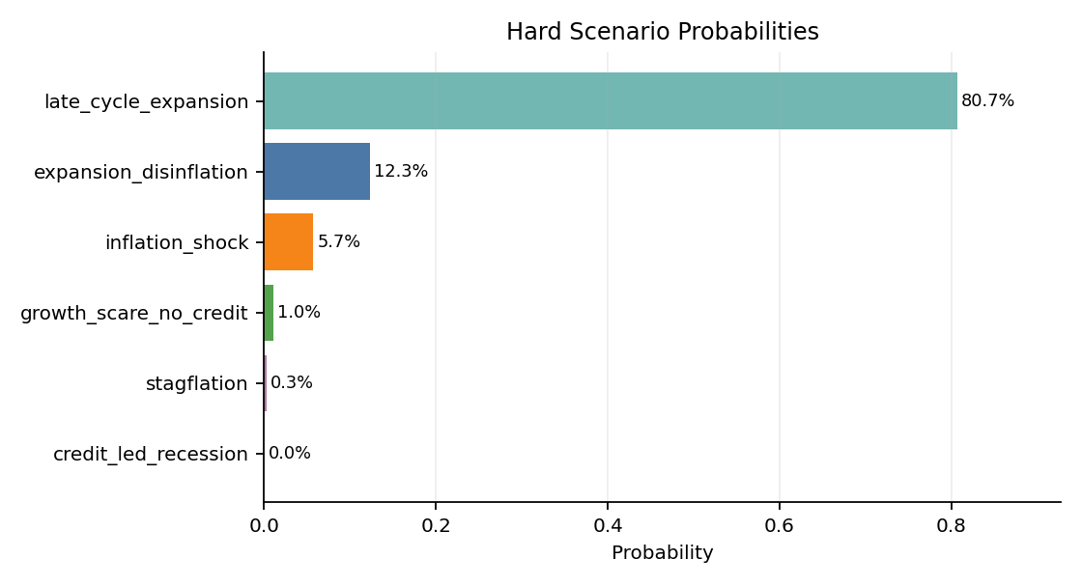
Margin mean: 0.372; p25: 0.201; share low margin: 31.5%.
High share_low_margin means many simulated futures were hard for the classifier to separate cleanly.

Regime Overlay
Metric | Value
Anchor label | calm
Anchor p_enter | 0.2%
Fraction entered stress | 2.2%
Fraction ever stress | 2.2%
Avg quarters in stress | 0.027
Credit spread terminal distribution split by regime path:
Group | Count | p50 | p90 | p99 | Max
ever_stress | 217 | 2.196 | 3.287 | 4.215 | 4.596
stayed_calm | 9783 | 1.882 | 2.358 | 2.843 | 3.790

Fan Charts
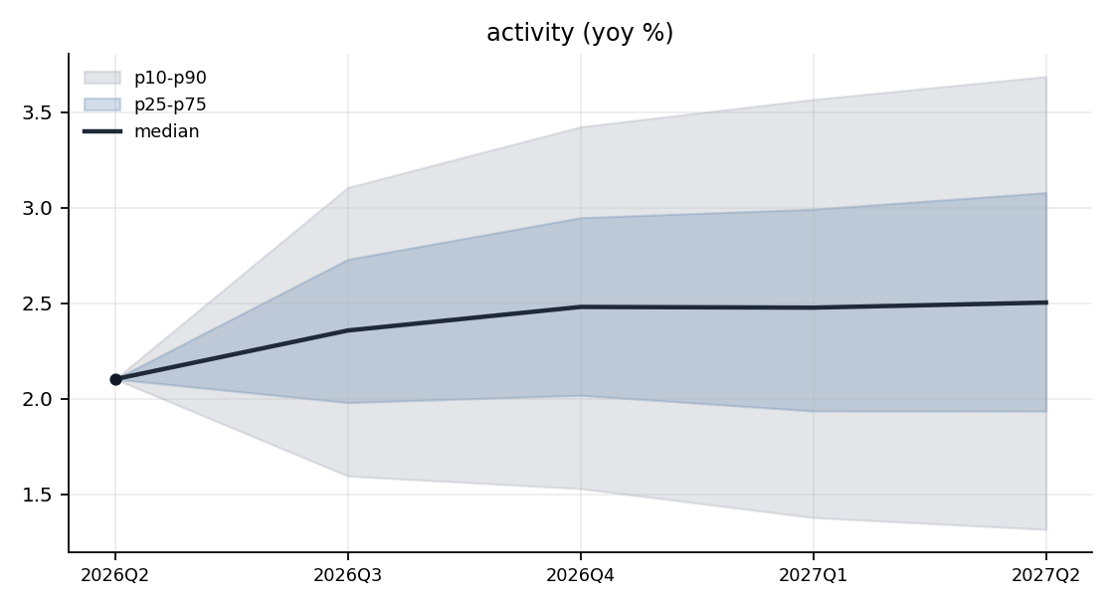
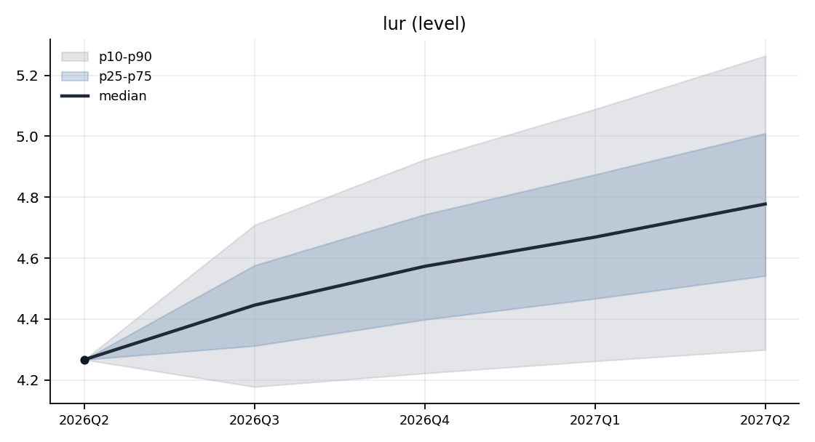
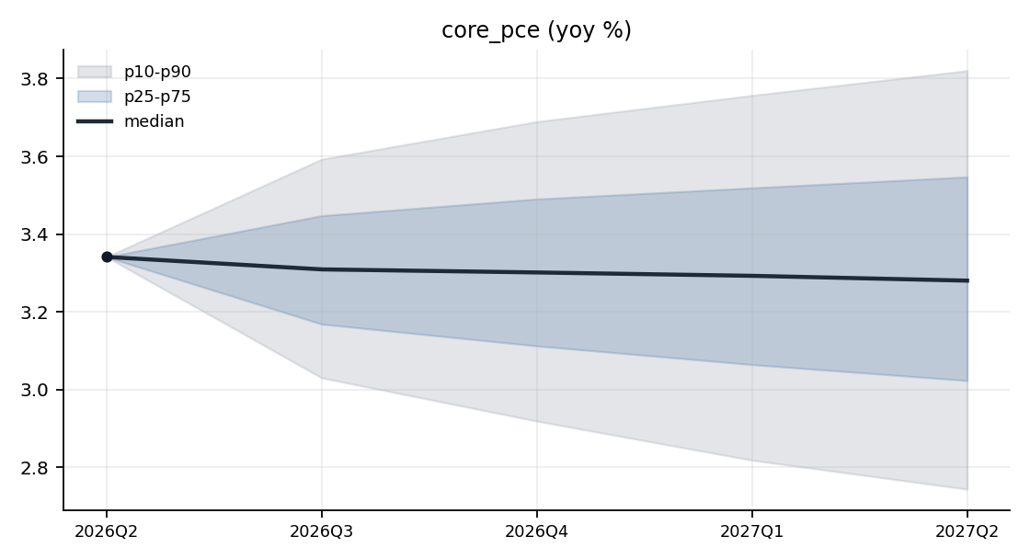
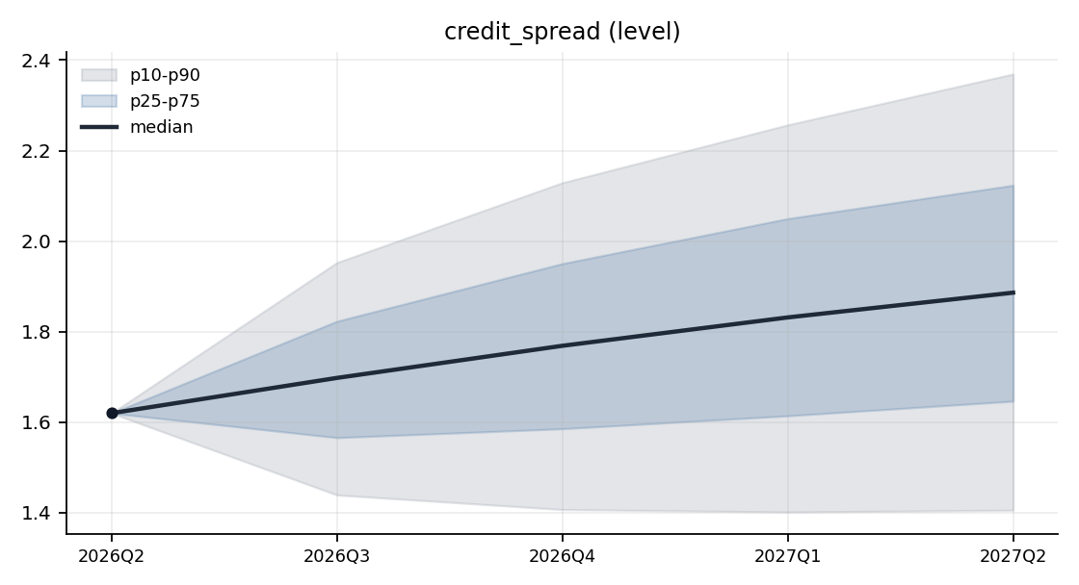
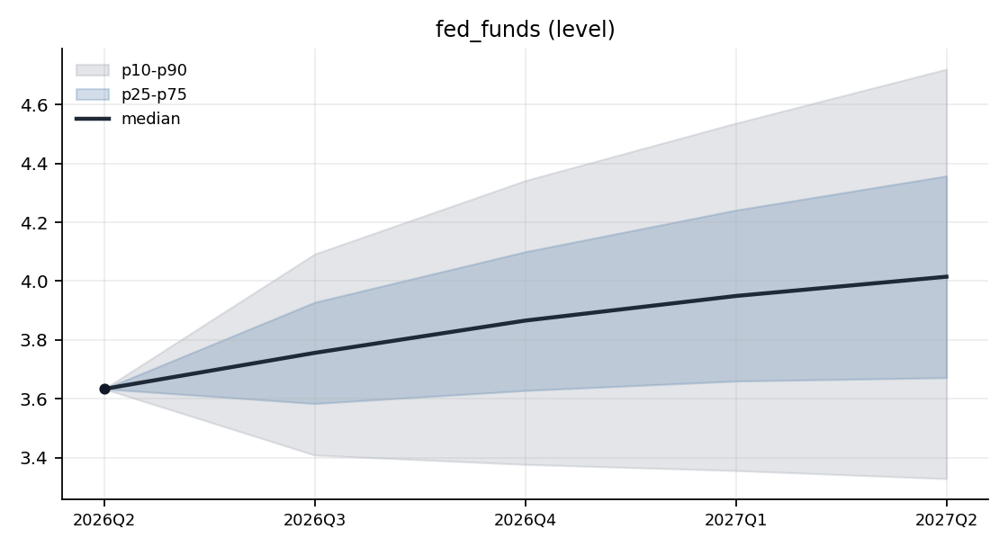
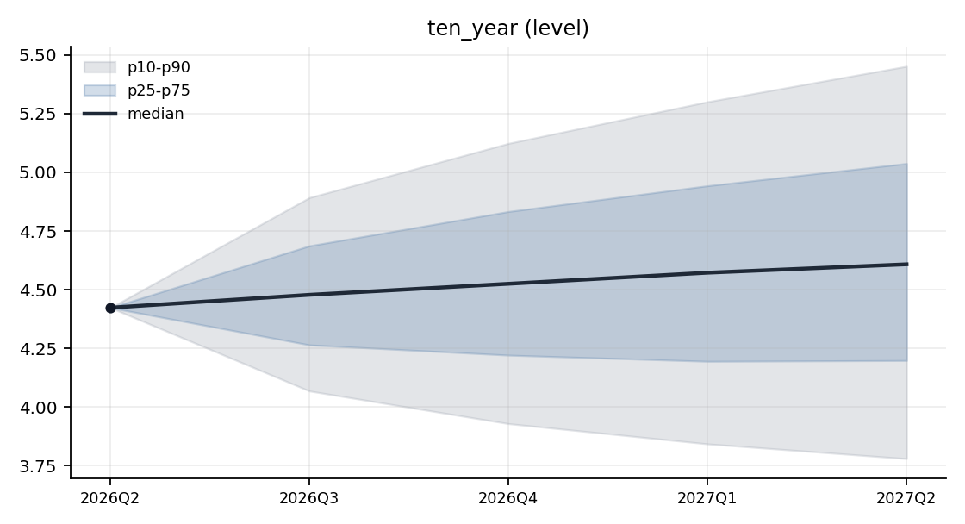
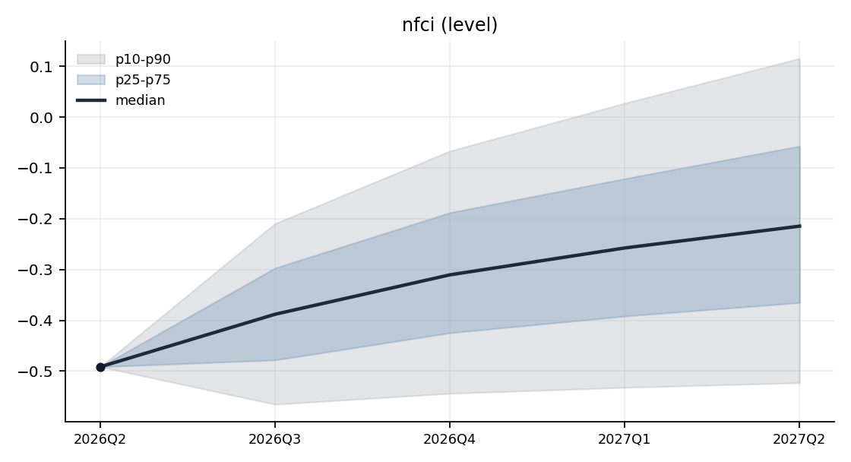

Terminal Distributions
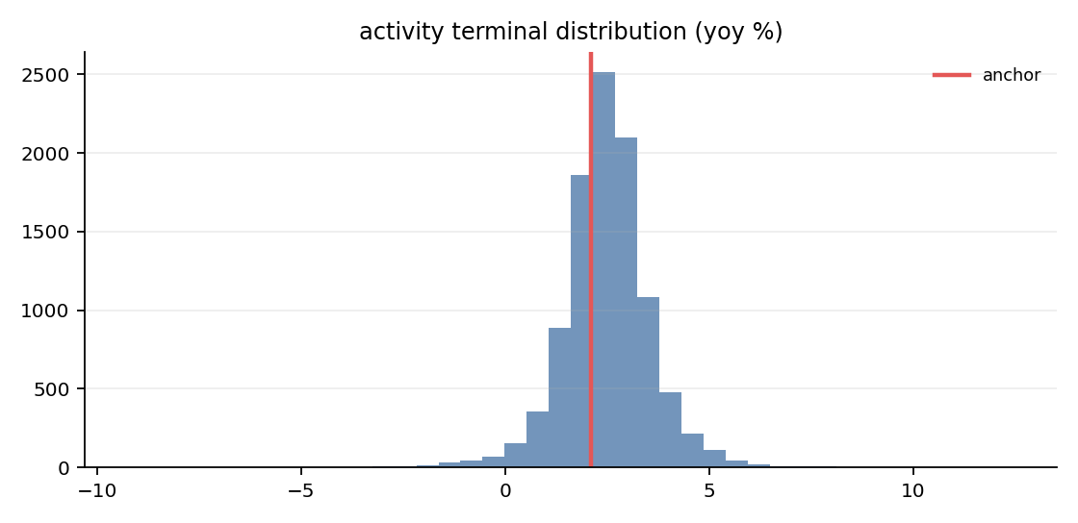
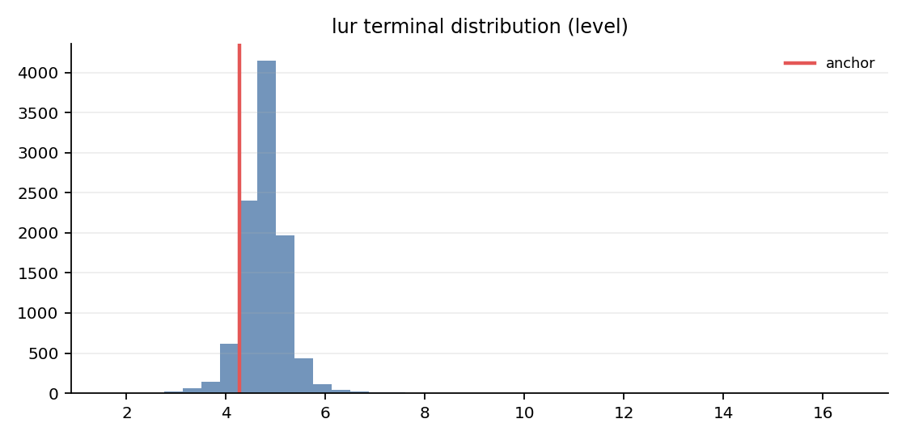
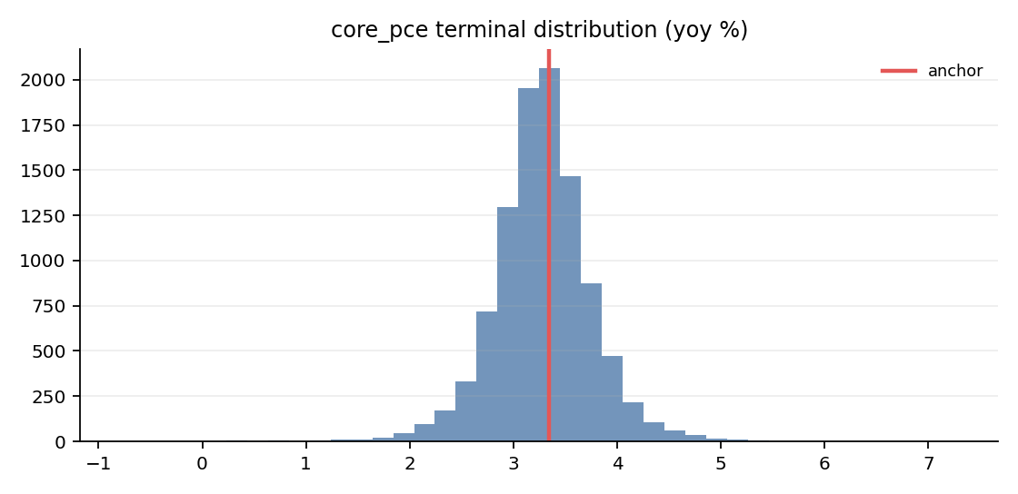
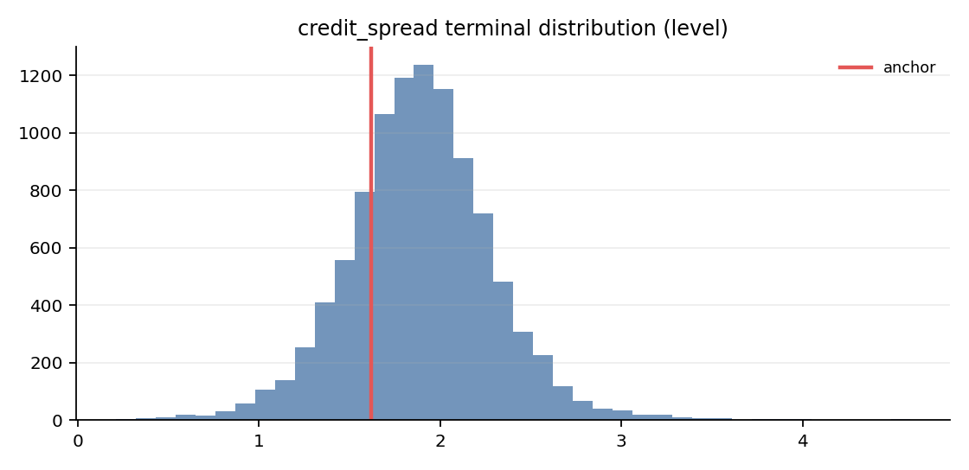

Tail Diagnostics
Ensemble K-quarter changes are compared with historical K-quarter changes; these diagnostics flag unusual tails but do not filter paths.
Variable | Ens p50 | Ens p90 | Ens p99 | Ens max | Hist p50 | Hist p90 | Hist p99 | Hist max
activity | 0.401 | 1.584 | 3.200 | 10.347 | -0.201 | 3.257 | 8.440 | 19.784
core_pce | -0.061 | 0.479 | 1.200 | 3.931 | -0.089 | 0.862 | 4.125 | 4.979
credit_spread | 0.266 | 0.749 | 1.342 | 2.976 | -0.010 | 0.771 | 1.615 | 3.337
fed_funds | 0.382 | 1.088 | 2.096 | 8.325 | -0.007 | 2.132 | 4.921 | 7.740
lur | 0.511 | 0.997 | 1.811 | 12.309 | -0.267 | 1.537 | 3.940 | 9.367
nfci | 0.277 | 0.607 | 1.042 | 4.242 | -0.026 | 0.744 | 2.486 | 2.760
ten_year | 0.185 | 1.029 | 1.891 | 3.729 | -0.072 | 1.334 | 2.860 | 3.893

Validity Summary
Metric | Value
Rejections | 76
Redraws | 76
Clips | 0
Rejection rate | 0.76%
Warning threshold | 5.00%
Per-variable violation counts:
Variable | Violations
activity | 1
credit_spread | 23
fed_funds | 4
lur | 39
nfci | 38

Appendix: Run Configuration
Key | Value
config.crisis_correlation_target | 0.8
config.estimation_start | 1973Q1
config.garch_dist | student_t
config.garch_max_iter | 500
config.garch_persistence_warn | 0.99
config.garch_t_dof | 6
config.horizon | 4
config.kernel_sigma | 1.0
config.lags | 4
config.lambda1 | 0.2
config.lambda2 | 0.5
config.lambda3 | 1.0
config.lambda4 | 100.0
config.low_margin_threshold | 0.25
config.max_redraws_per_path | 5
config.min_sample_quarters | 120
config.n_paths | 10000
config.nfci_threshold | 0.5
config.psd_repair_warn_delta | 0.1
config.regime_min_stress_quarters | 8
config.regime_model | markov
config.regime_proxy_weights | {"credit_spread_change_4q": 1.0, "credit_spread_level": 1.0, "nfci": 1.0}
config.rejection_warn_pct | 5.0
config.report_output_dir | data/agent_system/bvar_cache/reports
config.seed | 42
config.shock_dist | student_t
config.spread_change_threshold | 0.5
config.spread_level_pctile | 90.0
config.stress_correlation_impose_weight | 1.0
config.stress_min_conditions | 2
config.t_dof | 6
config.vol_model | garch
posterior.lambda1 | 0.2
posterior.lambda2 | 0.5
posterior.lambda3 | 1.0
posterior.lambda4 | 100.0
classifier.scaling | std
classifier.kernel_sigma | 1.0
classifier.active_variables | ["activity", "lur", "core_pce", "credit_spread", "fed_funds", "ten_year"]
classifier.handoff_file | /Users/terenceobrien/AI_Financial_Operator/data/agent_system/frbus_handoffs/frbus_scenario_paths_2026Q3_20260715T051025Z.json

