BVAR Ensemble Forecast Comparison
Primary: garch/student_t/seed 42. Comparison: constant/student_t/seed 42.
Field | Primary | Comparison
As-of quarter | 2026Q1 | 2026Q1
Generated at | 2026-07-16T14:25:02Z | 2026-07-16T14:25:13Z
Paths | 10000 | 10000
Horizon | 4 | 4
Vol model | garch | constant
Shock distribution | student_t | student_t
Seed | 42 | 42
Baseline mode | trailing_trend | trailing_trend
Posterior fingerprint | 2f0ea01e7945a242 | 2f0ea01e7945a242
Handoff fingerprint | 6f2cc04e81580097 | 6f2cc04e81580097

Scenario Probabilities
Scenario | Primary | Comparison | Delta
late_cycle_expansion | 72.0% | 52.5% | +19.5%
expansion_disinflation | 12.5% | 14.1% | -1.6%
inflation_shock | 9.9% | 16.4% | -6.4%
growth_scare_no_credit | 5.0% | 12.5% | -7.4%
stagflation | 0.5% | 4.4% | -3.9%
credit_led_recession | 0.0% | 0.1% | -0.1%
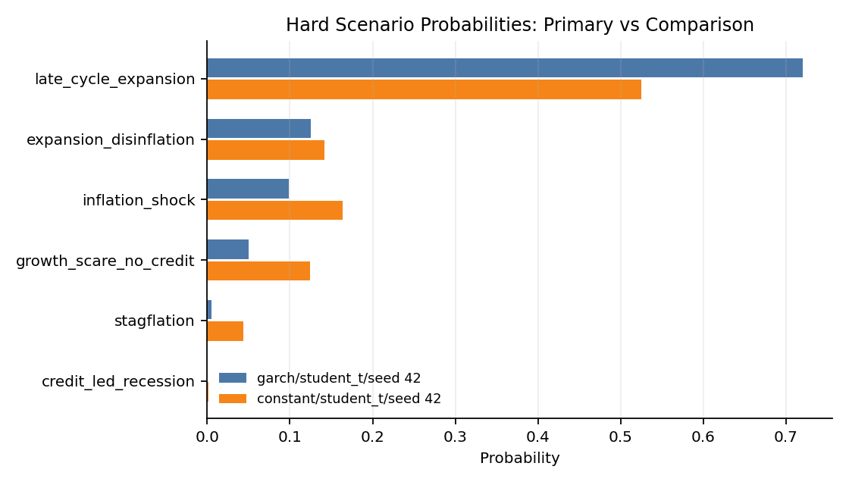

Fan Chart Comparison
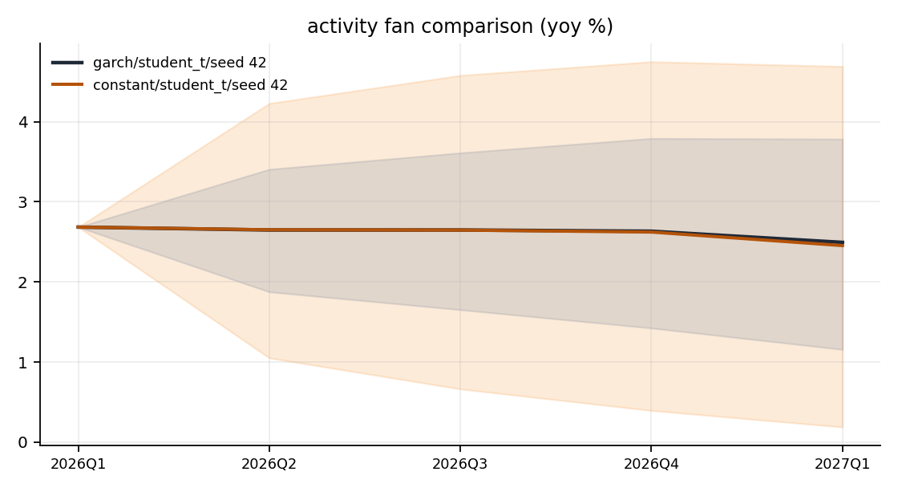
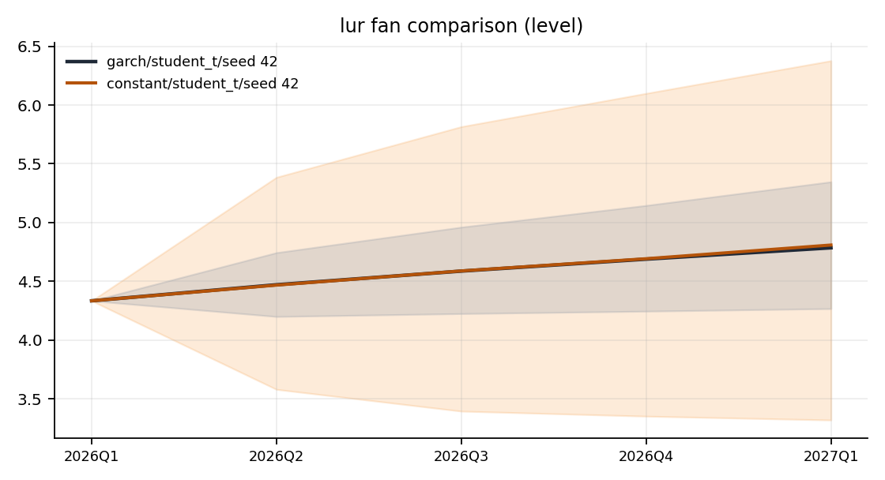
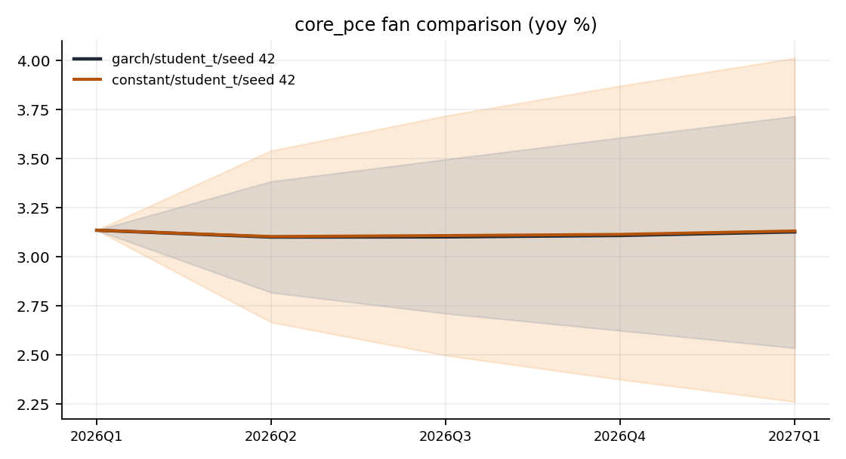
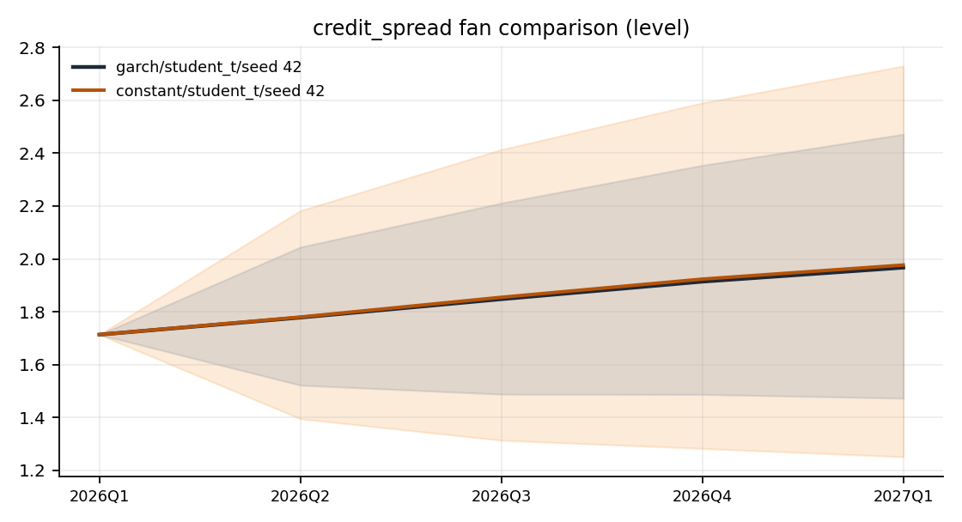
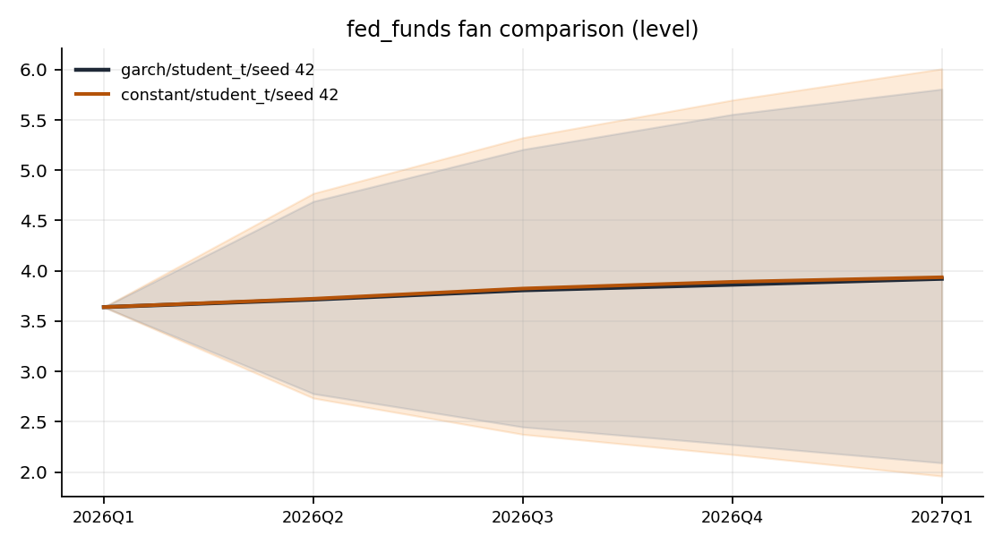
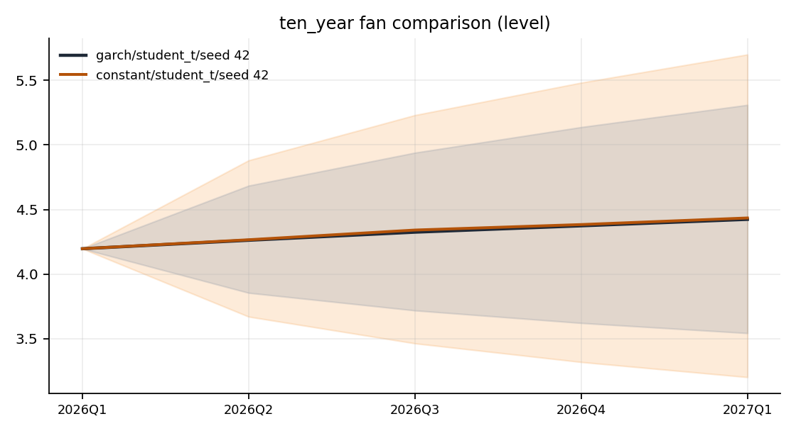
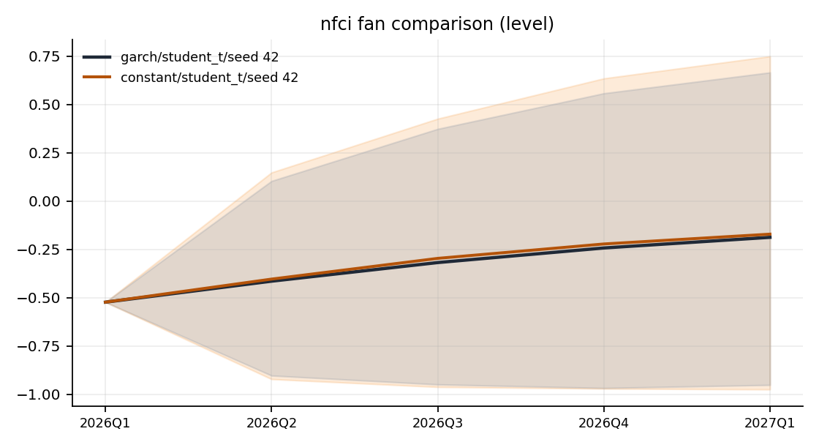

Terminal Distribution Comparison
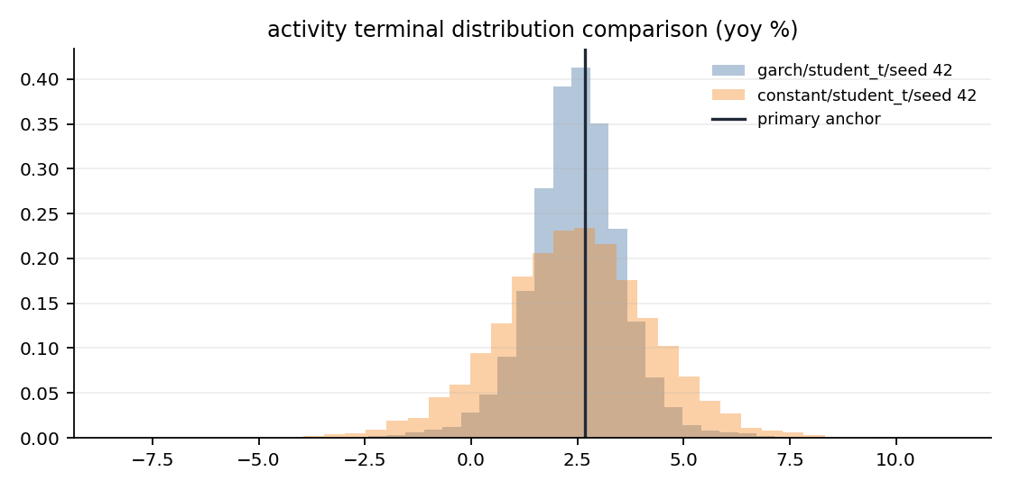
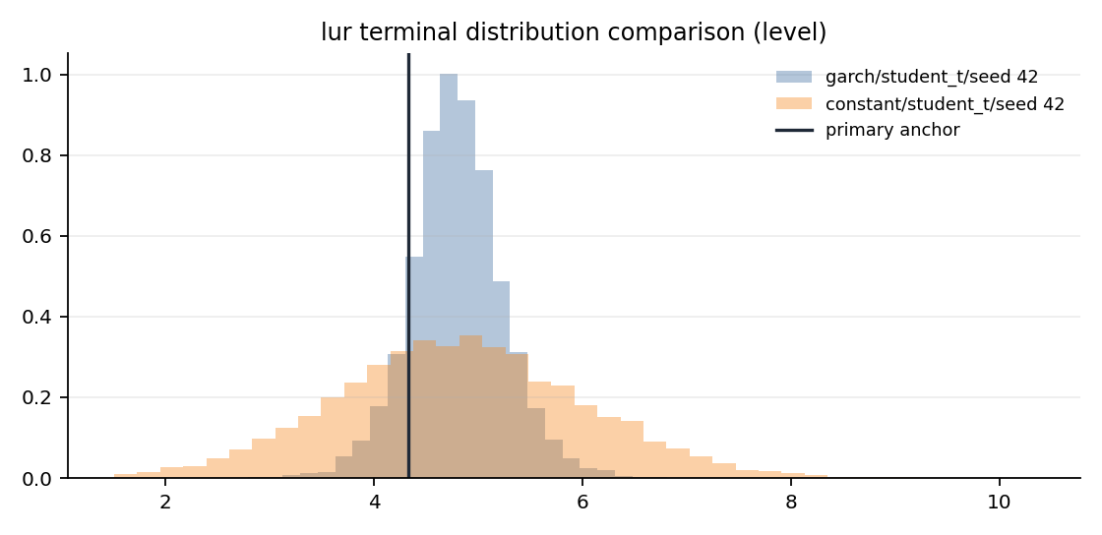
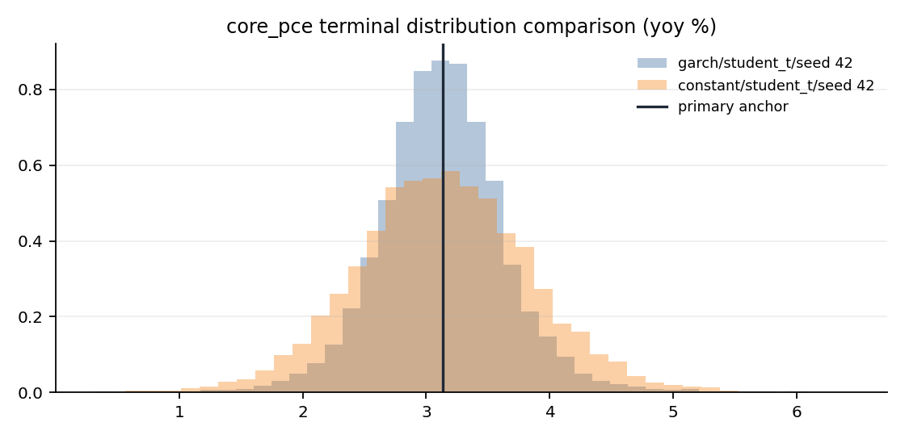
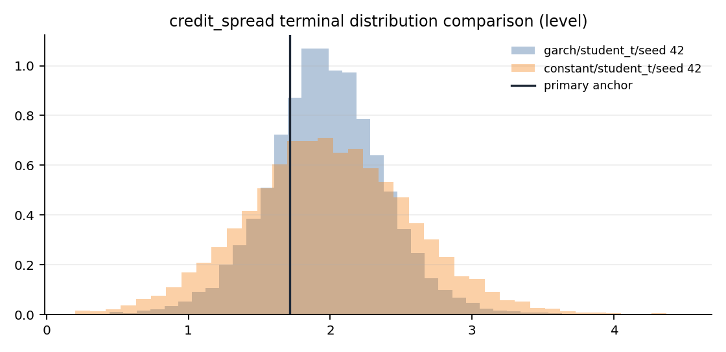

Appendix: Run Configuration
Key | Value
config.estimation_start | 1973Q1
config.garch_dist | student_t
config.garch_max_iter | 500
config.garch_persistence_warn | 0.99
config.garch_t_dof | 6
config.horizon | 4
config.kernel_sigma | 1.0
config.lags | 4
config.lambda1 | 0.2
config.lambda2 | 0.5
config.lambda3 | 1.0
config.lambda4 | 100.0
config.low_margin_threshold | 0.25
config.max_redraws_per_path | 5
config.min_sample_quarters | 120
config.n_paths | 10000
config.rejection_warn_pct | 5.0
config.report_output_dir | data/agent_system/bvar_cache/reports
config.seed | 42
config.shock_dist | student_t
config.t_dof | 6
config.vol_model | garch
posterior.lambda1 | 0.2
posterior.lambda2 | 0.5
posterior.lambda3 | 1.0
posterior.lambda4 | 100.0
classifier.scaling | std
classifier.kernel_sigma | 1.0
classifier.active_variables | ["activity", "lur", "core_pce", "credit_spread", "fed_funds", "ten_year"]
classifier.handoff_file | /Users/terenceobrien/AI_Financial_Operator/data/agent_system/frbus_handoffs/frbus_scenario_paths_2026Q3_20260715T051025Z.json

