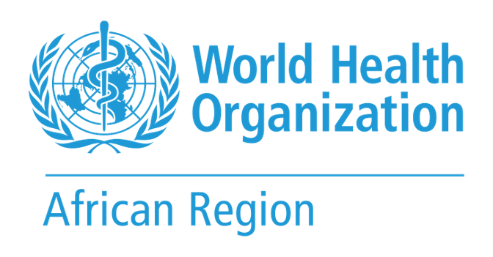  PEN-Plus monthly facility return  NCD and Mental Health, WHO Regional Office for Africa | In partnership with  

One return per country per month, for the month named below and no other. Write 0 where there were none; leave a cell blank only if the figure cannot be produced, since a blank is read as not reported and never as zero. Choose from the drop-down lists rather than typing. Do not add, delete or move rows or columns, because the return is read automatically. Send it to the NCD and Mental Health team, WHO Regional Office for Africa, within two weeks of the end of the month.
Country | Reporting month | Year | Facilities expected to report | Returns received | NPO / WHO Country Office focal point | Date completed
Select | Select | Select

Facility performance this month | One row per PEN-Plus site

Facility ID | Facility name | Return status | Ever enrolled* | Active in care* | Newly enrolled* | Mentorship visit this month? | Quality score % | All critical criteria met? | Readiness band
 |  | Select |  |  |  | Select |  | Select | Select
 |  | Select |  |  |  | Select |  | Select | Select
 |  | Select |  |  |  | Select |  | Select | Select
 |  | Select |  |  |  | Select |  | Select | Select
 |  | Select |  |  |  | Select |  | Select | Select
 |  | Select |  |  |  | Select |  | Select | Select
 |  | Select |  |  |  | Select |  | Select | Select
 |  | Select |  |  |  | Select |  | Select | Select
 |  | Select |  |  |  | Select |  | Select | Select
 |  | Select |  |  |  | Select |  | Select | Select
 |  | Select |  |  |  | Select |  | Select | Select
 |  | Select |  |  |  | Select |  | Select | Select
 |  | Select |  |  |  | Select |  | Select | Select

* Counted across the three priority conditions: type 1 diabetes, sickle cell disease and rheumatic heart disease. Ever enrolled is cumulative since the site started PEN-Plus; active in care and newly enrolled cover this month only. Quality score, critical criteria and readiness band change only when the site is reassessed, so carry forward the last assessment where there was none this month.

