
SAINT LOUIS COLLEGE

Smart Parking and Vehicle Verification System
User Manual: Illustrated Screen Guide

Version 1.0 · September 2026

About this guide
This guide walks through the system screen by screen in 52 annotated pictures. It is organised by who uses each part of the system:
- Getting Started: How to sign in, reset a forgotten password, apply for a vehicle pass, and how security guards sign in at a gate.
- CDSO (Administrator): Every screen available to the CDSO account: the dashboard, registrations, users, devices, suppliers, operations, parking, violations, logs, rules and system settings.
- Security Guard: The gate terminal used by security guards: checking vehicles in and out, recording vehicles with no plate, watching parking and issuing violations.
- Vehicle Owner: The portal a registered vehicle owner sees after signing in.
- Installing the Campus System: Installing the on-campus half of the system with SLC-Smart-Parking-Campus-Setup.exe. Run it on the computer that will serve the gate terminals.
- Running the Campus System: The launcher window that runs the campus server after installation.

How to read the pictures
Each picture has numbered orange boxes. The table under the picture explains each number: what that part of the screen is and what it does. Work through the numbers in order the first time you use a screen.

Notes on the pictures
- The names, plate numbers, email addresses and records shown are sample data for illustration. They are not real students, staff or vehicles.
- Camera pictures are sample illustrations. On a live system these panels show the real camera feed.
- Dates and counts will differ on your system.
- The Activity log in the launcher picture is deliberately blurred.

Contents
About this guide 2
How to read the pictures 2
Notes on the pictures 2
Contents 3
1. Getting Started 5
1.1 Signing in 5
1.2 Two-factor verification 6
1.3 Resetting a forgotten password 7
1.4 Applying for a vehicle pass: privacy consent 8
1.5 Applying for a vehicle pass: the form 9
1.6 Applying for a vehicle pass: student form 10
1.7 Guard sign-in: choosing a gate 11
1.8 Guard sign-in: clocking in 12
2. CDSO (Administrator) 13
2.1 CDSO dashboard and screen layout 13
2.2 Notifications 14
2.3 Vehicle Registration Management 15
2.4 Reviewing an application 16
2.5 Approving or rejecting an application 17
2.6 User Management 18
2.7 Approving detail change requests 19
2.8 Device Management (cameras) 20
2.9 Supplier Management 21
2.10 Operations Center: live monitor 22
2.11 Operations Center: guards 23
2.12 Operations Center: gate records 24
2.13 Parking Space Management 25
2.14 Drawing parking bays 26
2.15 Campus events 27
2.16 Violations 28
2.17 Vehicle Log 29
2.18 Rule Constraints: entry rules 30
2.19 Rule Constraints: registration period 31
2.20 Rule Constraints: access mode 32
2.21 Audit Log 33
2.22 System Settings: accounts & fees 34
2.23 System Settings: gates & scanning 35
2.24 System Settings: parking 36
2.25 System Settings: data & backup 37
2.26 Help & User Manual 38
3. Security Guard 39
3.1 Entry Management (gate terminal) 40
3.2 Checking a plate 41
3.3 Recording a vehicle with no plate 42
3.4 Parking monitor 43
3.5 Issuing a parking violation 44
3.6 Vehicle Log (gate) 45
4. Vehicle Owner 46
4.1 Vehicle owner portal: your pass 47
4.2 Vehicle owner portal: violations & parking 48
4.3 Account security (two-factor) 49
5. Installing the Campus System 50
5.1 Step 1 · License Agreement 50
5.2 Step 2 · Choose the install folder 51
5.3 Step 3 · Select components 52
5.4 Step 4 · Deployment options 53
5.5 Step 5 · Prerequisites check 54
5.6 Step 6 · Start Menu folder 55
5.7 Step 7 · Additional tasks 56
5.8 Step 8 · Ready to install 57
6. Running the Campus System 58
6.1 The campus launcher 59

1. Getting Started
How to sign in, reset a forgotten password, apply for a vehicle pass, and how security guards sign in at a gate.

1.1 Signing in
The login page is the entry point for CDSO staff and registered vehicle owners.
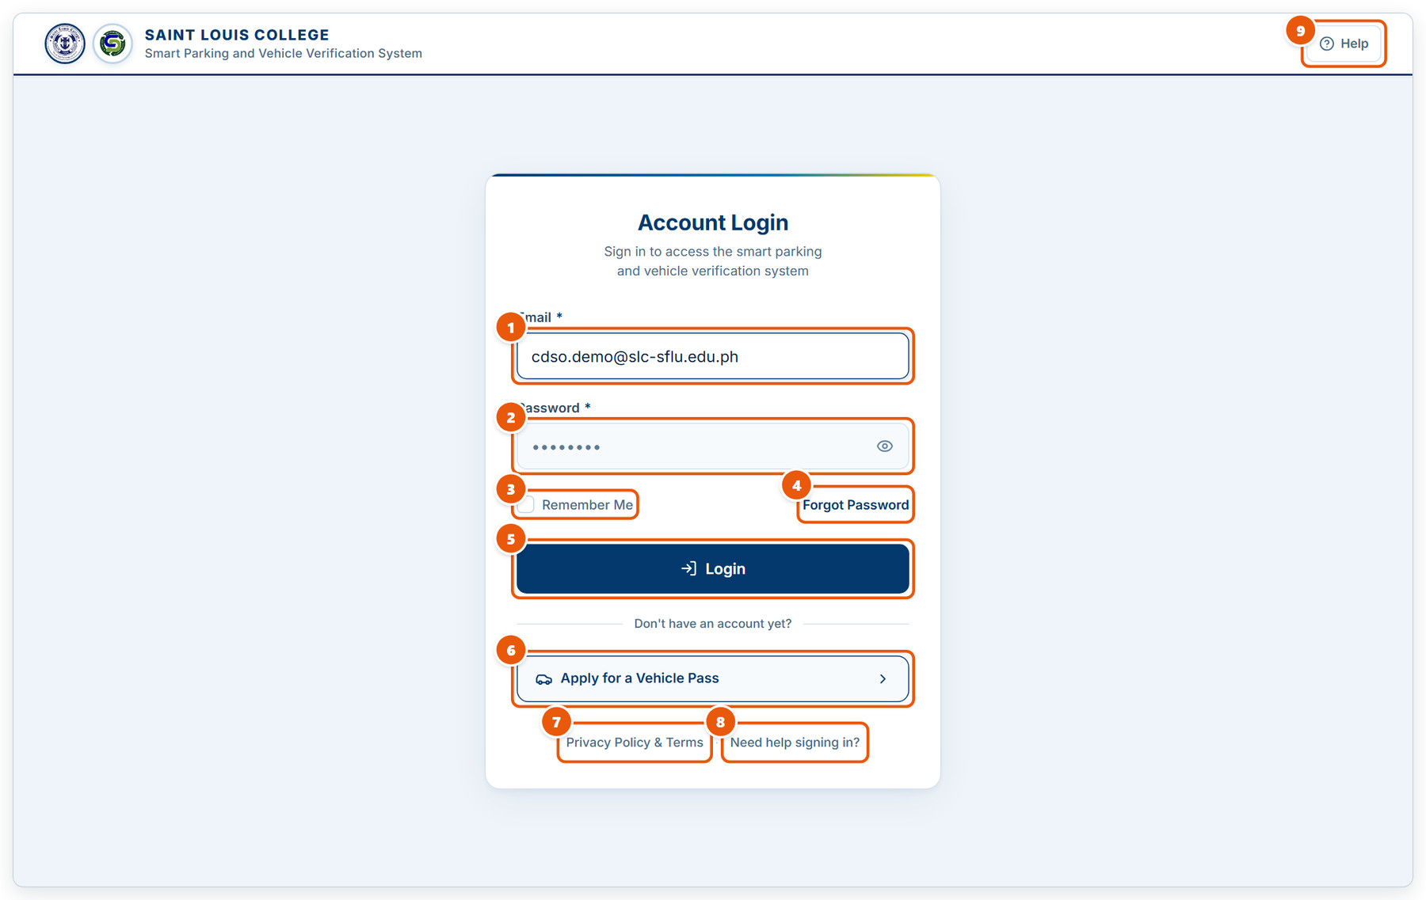
Figure 1.1: Signing in
1 | Email  Type the email address registered to your account. It is not case-sensitive.
2 | Password  Enter your password. The eye icon shows or hides what you typed.
3 | Remember Me  Keeps you signed in on this computer. Leave it unticked on shared computers.
4 | Forgot Password  Sends a password-reset link to your email.
5 | Login  Signs you in. CDSO and vehicle-owner accounts are then asked for a two-factor code.
6 | Apply for a Vehicle Pass  Starts the online vehicle pass application. No account is needed to apply.
7 | Privacy Policy & Terms  Opens the data privacy notice and the vehicle pass terms.
8 | Need help signing in?  Opens the step-by-step guide with pictures, for applicants, guards and CDSO staff.
9 | Help  The same guide, from the top of the page.

1.2 Two-factor verification
After the password, CDSO and vehicle-owner accounts confirm a 6-digit code from an authenticator app.
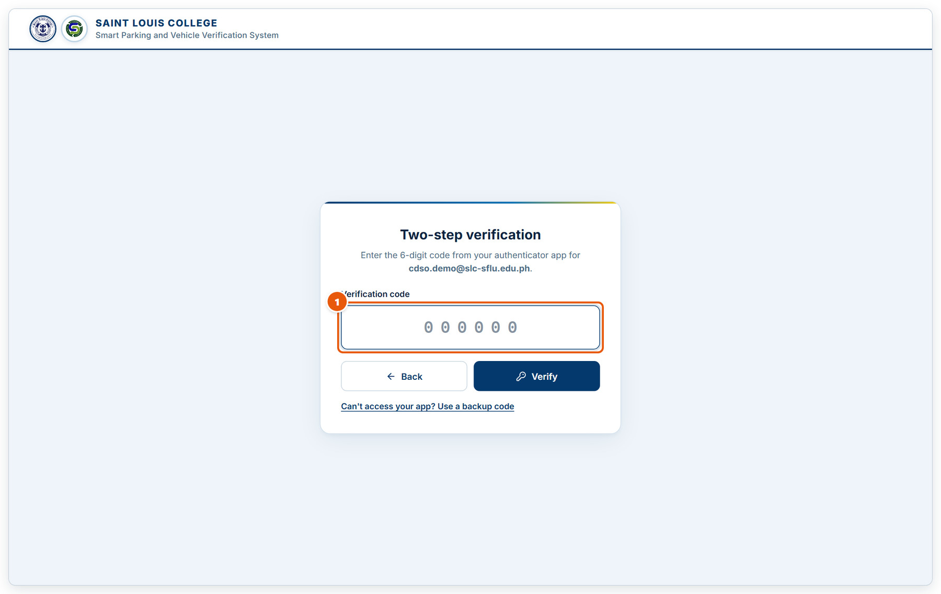
Figure 1.2: Two-factor verification
1 | Verification code  Open your authenticator app (e.g. Google Authenticator) and type the 6-digit code shown for SLC Vehicle Management. It submits by itself on the sixth digit.

1.3 Resetting a forgotten password
Request a reset link when you cannot sign in.
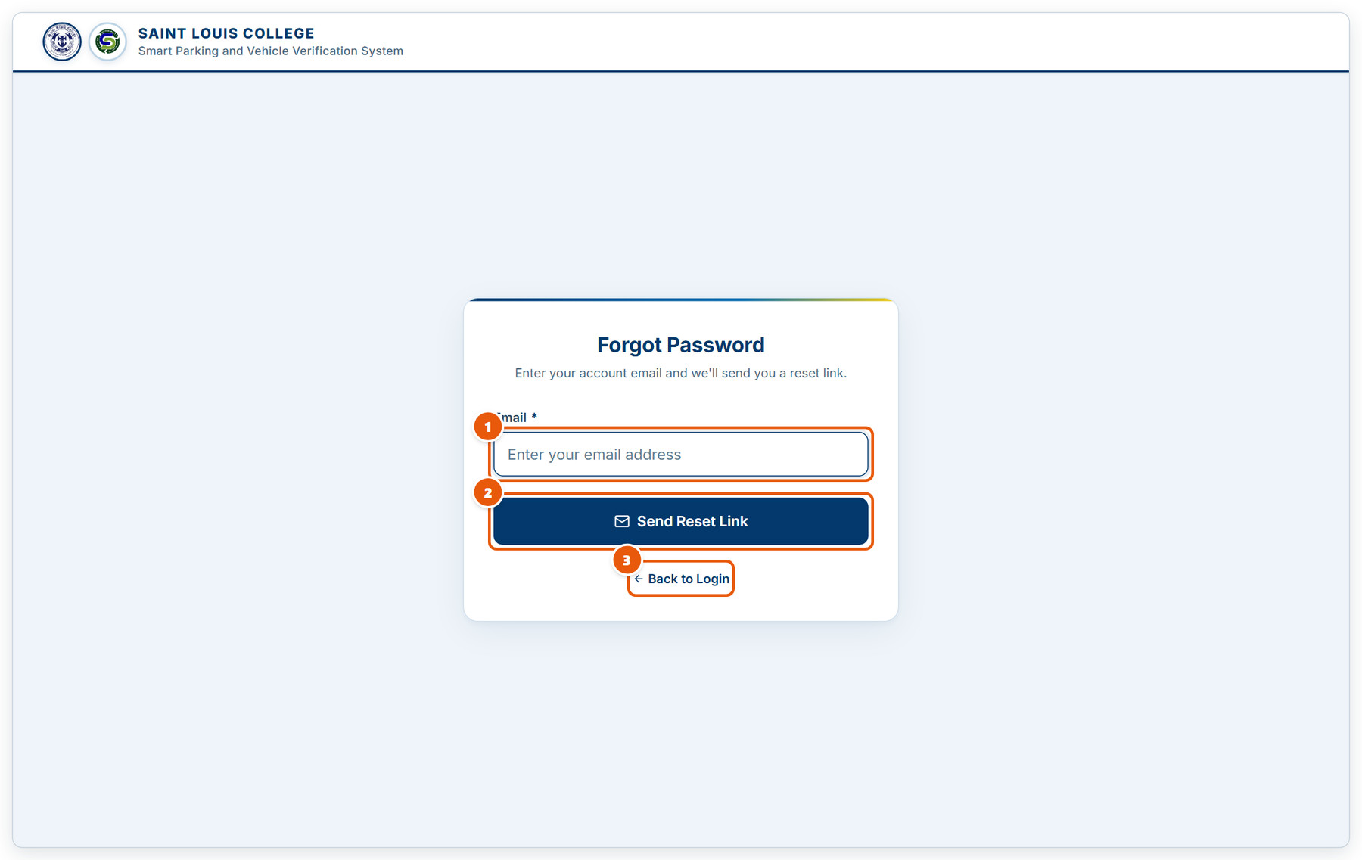
Figure 1.3: Resetting a forgotten password
1 | Email  Enter the email address of your account.
2 | Send Reset Link  Emails you a link to choose a new password. The link expires, so use it soon.
3 | Back to Login  Returns to the login page.

1.4 Applying for a vehicle pass: privacy consent
Every application starts with the Data Privacy Notice (RA 10173).
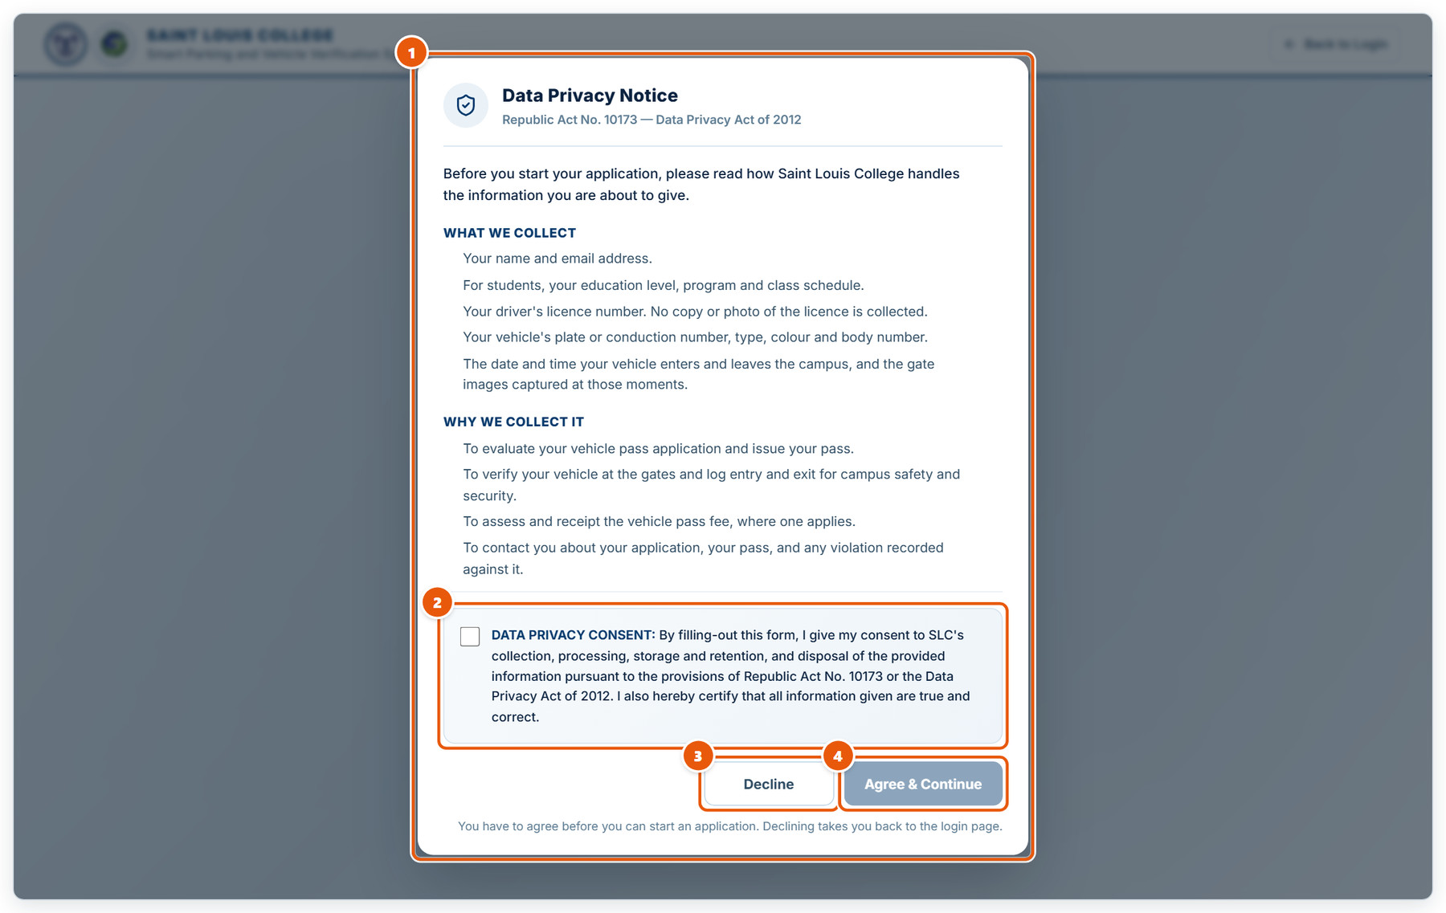
Figure 1.4: Applying for a vehicle pass: privacy consent
1 | What is collected and why  Read what information the college collects and how it is used before applying.
2 | Consent checkbox  Tick to give your consent. Agree & Continue stays disabled until you do.
3 | Decline  Cancels the application and returns to the login page.
4 | Agree & Continue  Opens the application form.

1.5 Applying for a vehicle pass: the form
The public application form, used by students, employees and fetchers.
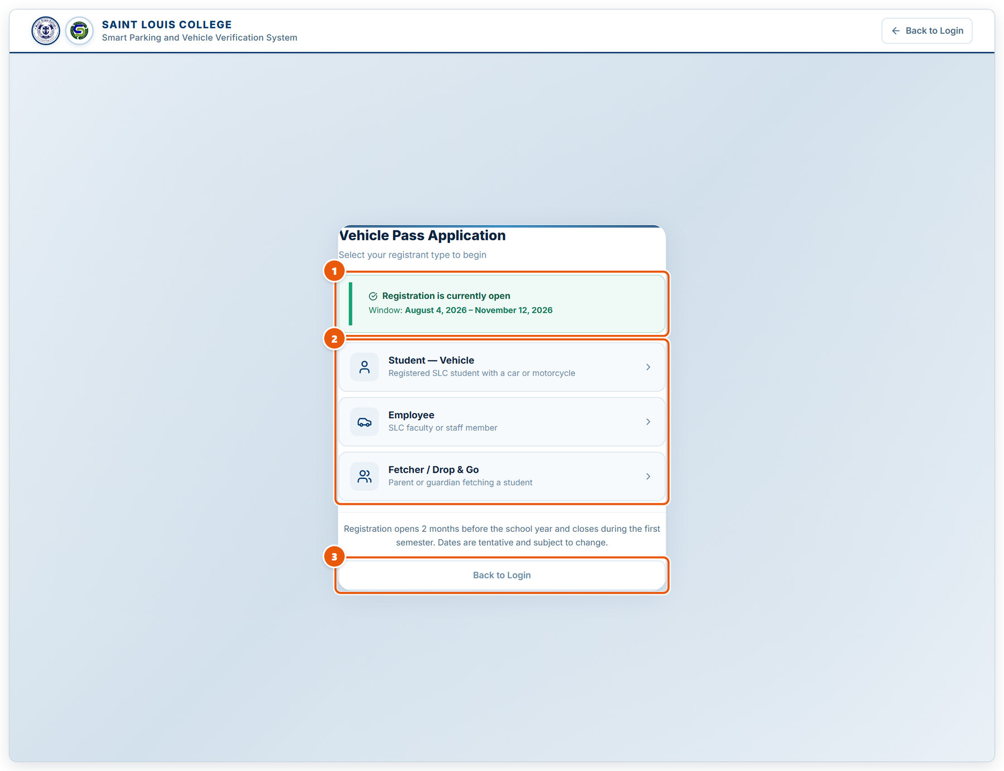
Figure 1.5: Applying for a vehicle pass: the form
1 | Registration window  Shows whether applications are being accepted, and the dates of the current window.
2 | Registrant type  Choose Student — Vehicle, Employee, or Fetcher / Drop & Go. The form that follows asks only for what that type needs.
3 | Back to Login  Leave the application without submitting.

1.6 Applying for a vehicle pass: student form
The details a student applicant fills in.
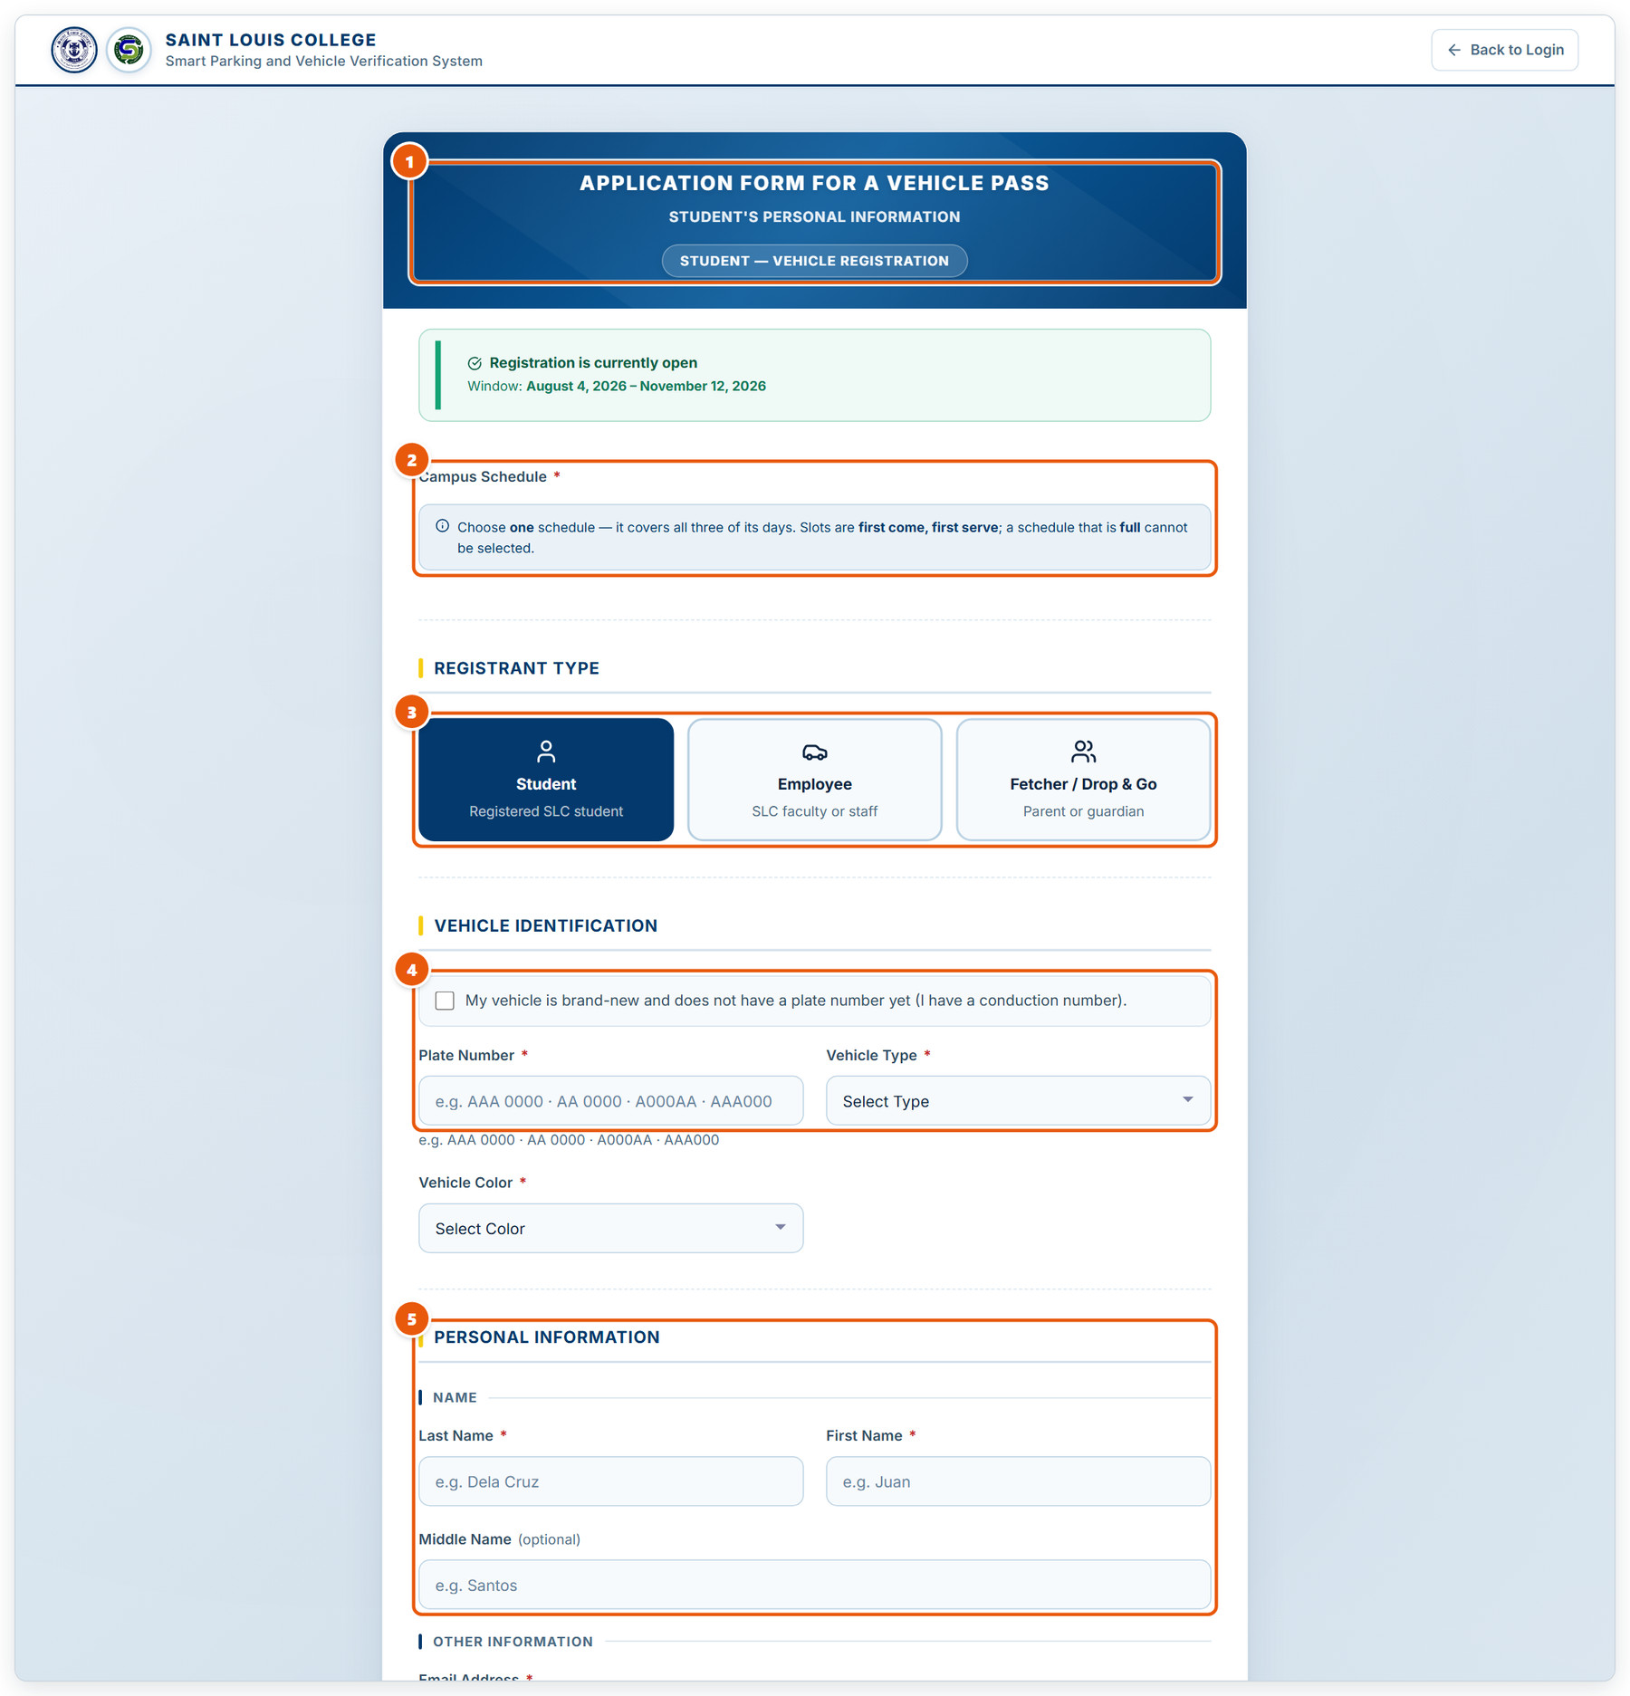
Figure 1.6: Applying for a vehicle pass: student form
1 | Form type  The kind of application you are filling in.
2 | Campus Schedule  Choose one schedule (Mon · Wed · Fri or Tue · Thu · Fri). Slots are first come, first served; a full schedule cannot be selected.
3 | Registrant type  Switch here if you picked the wrong type.
4 | Vehicle identification  Plate number, vehicle type and colour. Tick the box instead if the vehicle is brand-new and only has a conduction number.
5 | Personal information  Your name, then contact details further down. Scroll to the end to attach the required documents and submit.

1.7 Guard sign-in: choosing a gate
Security guards sign in at the gate terminal, not through the main login page.
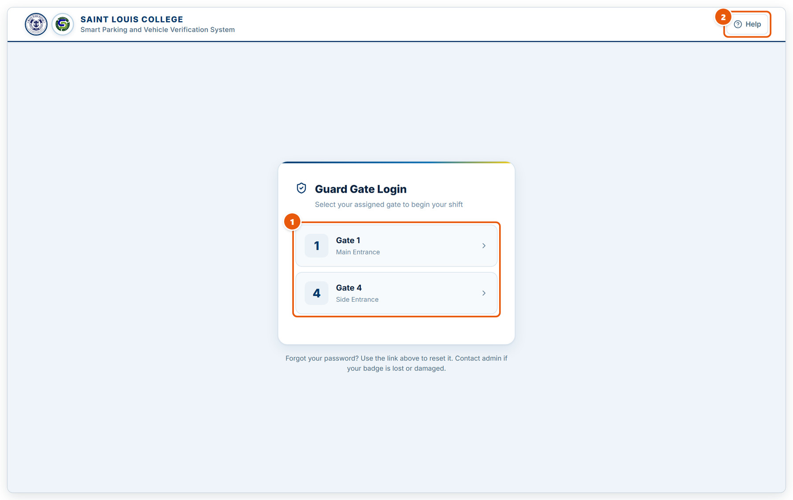
Figure 1.7: Guard sign-in: choosing a gate
1 | Gate list  Pick the gate you are standing at. Your shift and every scan are recorded against this gate.
2 | Help  Opens the guard sign-in guide with pictures.

1.8 Guard sign-in: clocking in
Sign in with your guard account or scan your QR badge to start your shift.
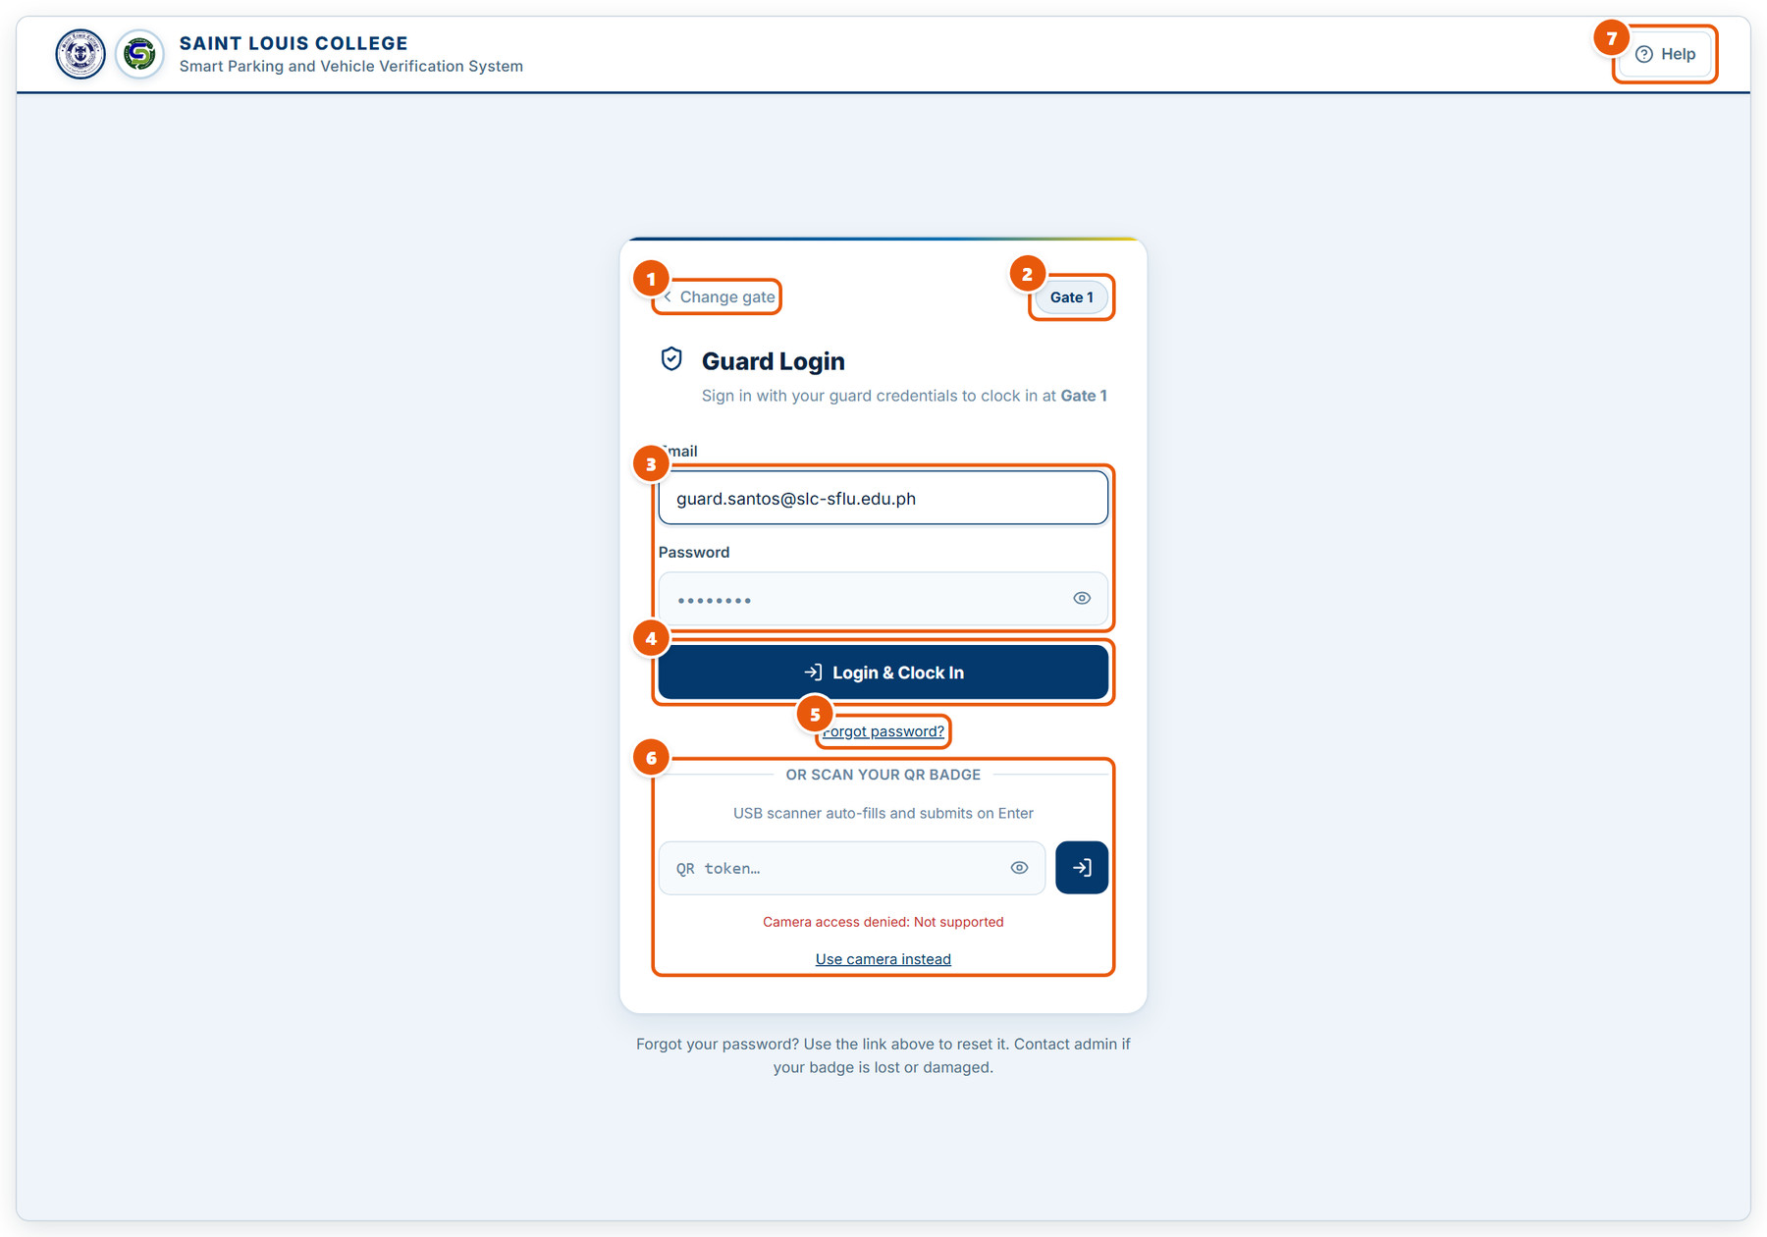
Figure 1.8: Guard sign-in: clocking in
1 | Change gate  Go back if you picked the wrong gate.
2 | Selected gate  The gate you will be clocked in at.
3 | Email and password  Your guard account credentials.
4 | Login & Clock In  Signs you in and starts your shift at this gate. Whoever was on duty here is signed out.
5 | Forgot password?  Sends a reset link to your email.
6 | QR badge  Appears when your account has a badge. Scan it with a USB scanner or the camera instead of typing the password.
7 | Help  Opens the guard sign-in guide with pictures.

2. CDSO (Administrator)
Every screen available to the CDSO account: the dashboard, registrations, users, devices, suppliers, operations, parking, violations, logs, rules and system settings.

2.1 CDSO dashboard and screen layout
Every CDSO screen shares this sidebar. The dashboard summarises the whole system.
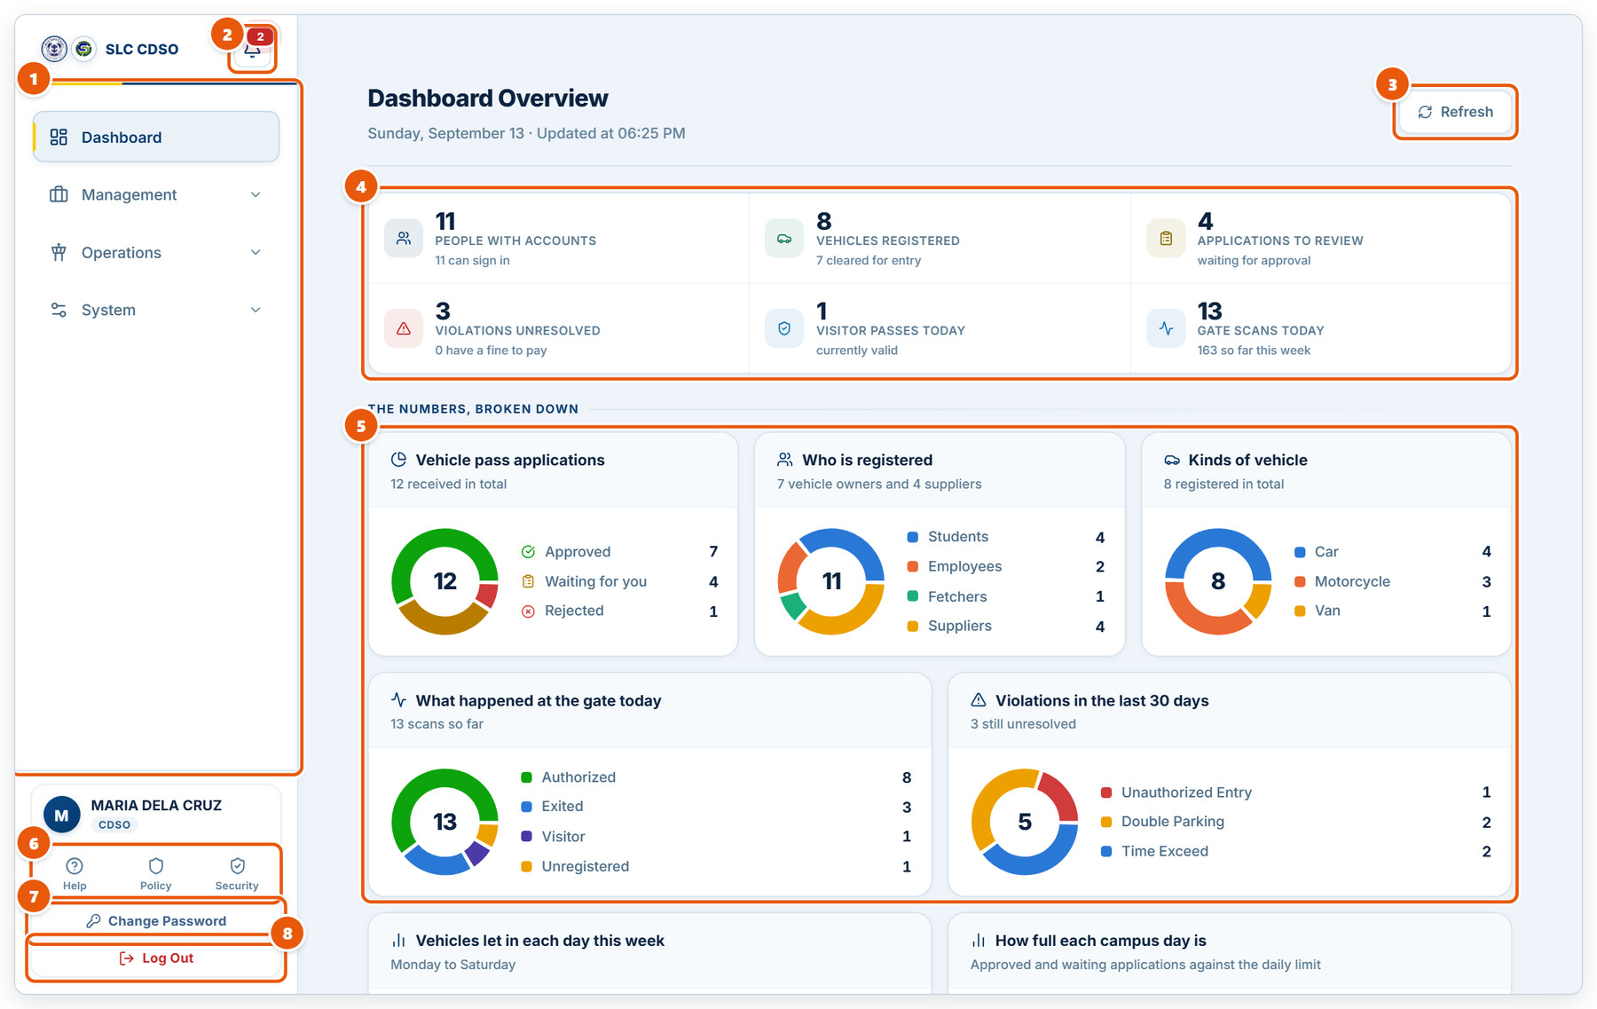
Figure 2.1: CDSO dashboard and screen layout
1 | Main menu  Dashboard, then three groups: Management, Operations and System. Click a group to expand it.
2 | Notifications  The red badge counts unread alerts about registrations and violations. Click to open the list.
3 | Refresh  Reloads every number on the dashboard.
4 | Summary tiles  Accounts, registered vehicles, applications to review, unresolved violations, visitor passes and today’s gate scans.
5 | Breakdown charts  Applications, owner types, vehicle kinds, today’s gate activity and 30-day violations. Scroll down for the weekly charts.
6 | Help, Policy and Security  Help opens the in-app user manual. Security manages your two-factor authentication.
7 | Change Password  Set a new password for your account.
8 | Log Out  Ends your session. Always log out on shared computers.

2.2 Notifications
Alerts raised by new registrations, uploaded receipts and violations.
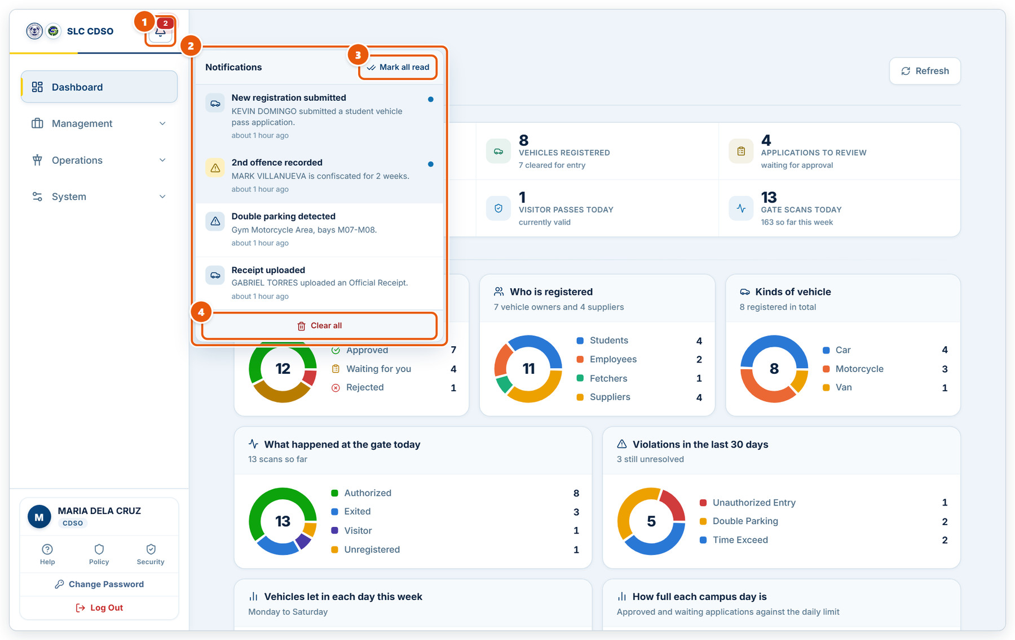
Figure 2.2: Notifications
1 | Bell  The number is how many notifications you have not read yet.
2 | Notification list  Newest first. A blue dot marks an unread item; click one to open the screen it is about.
3 | Mark all read  Clears the unread dots and the badge without deleting anything.
4 | Clear all  Removes every notification from the list.

2.3 Vehicle Registration Management
Management › Vehicle Registration. Review and process vehicle pass applications.
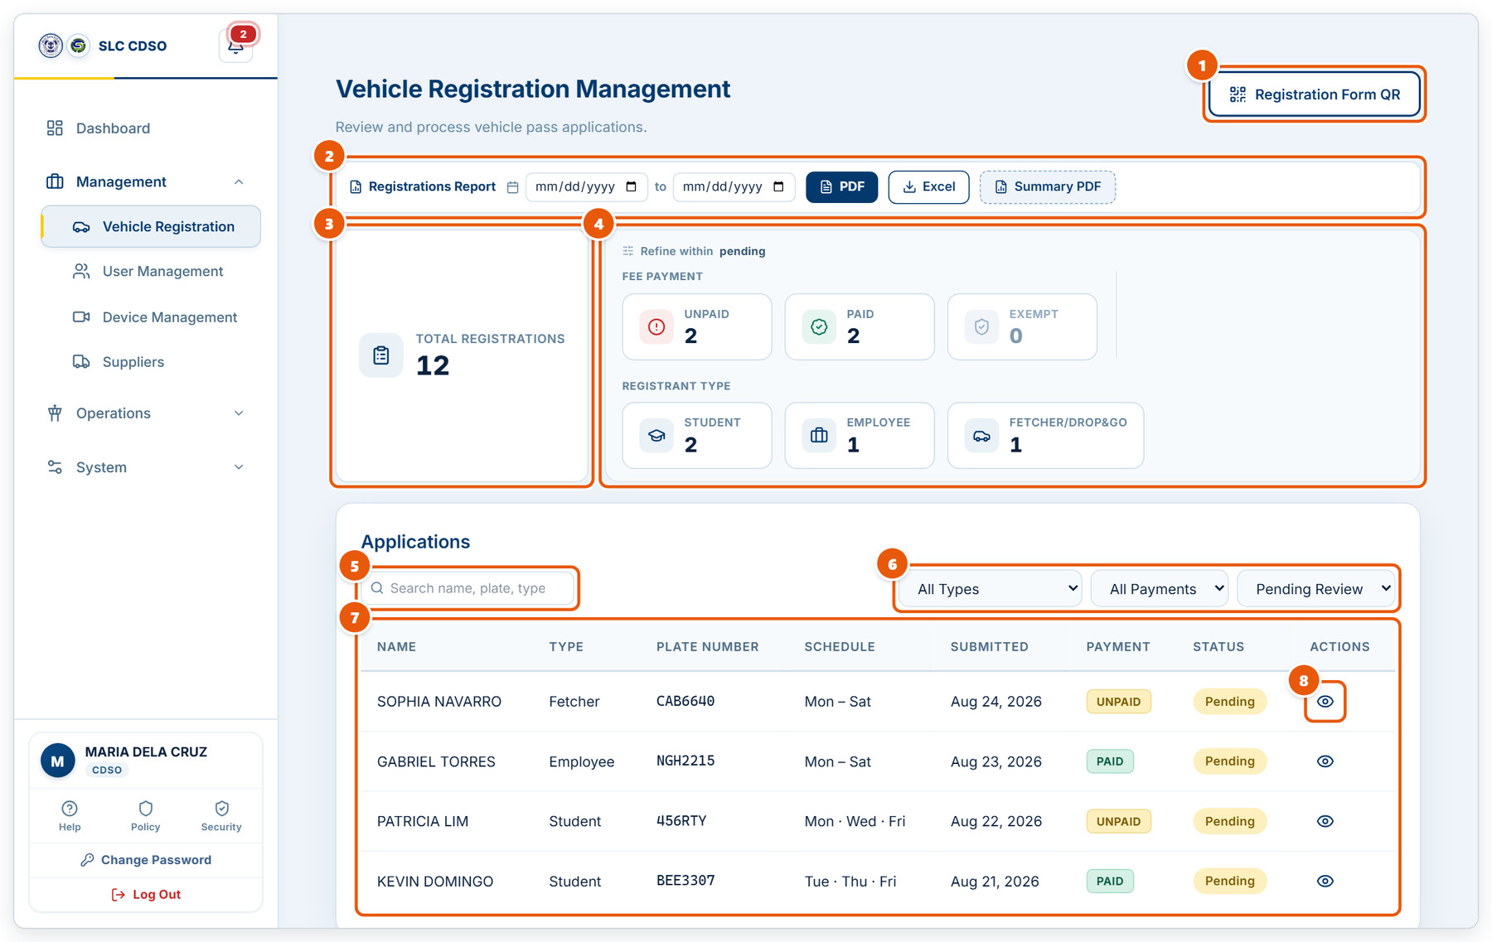
Figure 2.3: Vehicle Registration Management
1 | Registration Form QR  Shows a QR code applicants can scan to open the online application form.
2 | Registrations report  Pick a date range, then download a PDF or Excel report, or a one-page summary PDF.
3 | Total registrations  All applications received.
4 | Quick filters  Click a payment state or registrant type to narrow the list below.
5 | Search  Find an application by name, plate or type.
6 | Type, payment and status filters  Pending Review lists the applications still waiting for your decision.
7 | Applications table  Each row shows the applicant, plate, schedule, payment and status.
8 | View  Opens the application to check documents and approve or reject it.

2.4 Reviewing an application
The application detail window, opened with the View (eye) button.
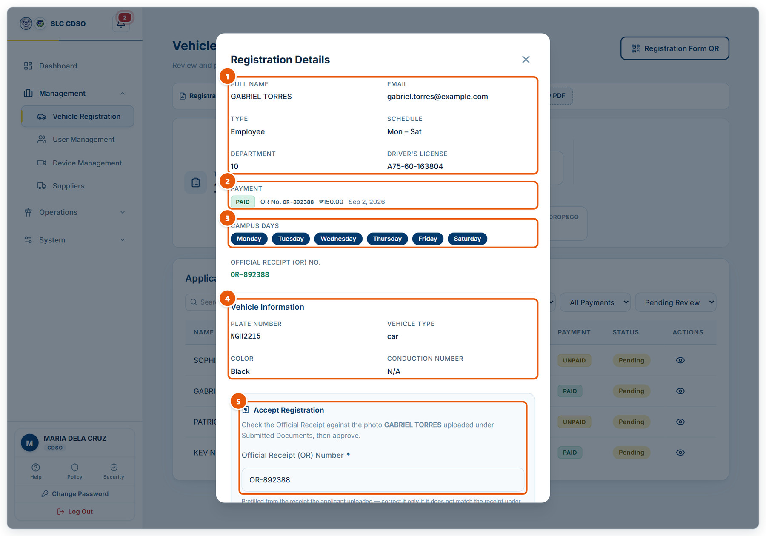
Figure 2.4: Reviewing an application
1 | Applicant details  Name, email, registrant type, schedule, department and driver’s license.
2 | Payment  Whether the fee is paid, the Official Receipt number, amount and date.
3 | Campus days  The days this pass will allow entry.
4 | Vehicle information  Plate, vehicle type, colour and conduction number.
5 | Accept Registration  Check the receipt against the uploaded photo before approving. Scroll down for the documents and the decision buttons.

2.5 Approving or rejecting an application
The bottom of the Registration Details window.
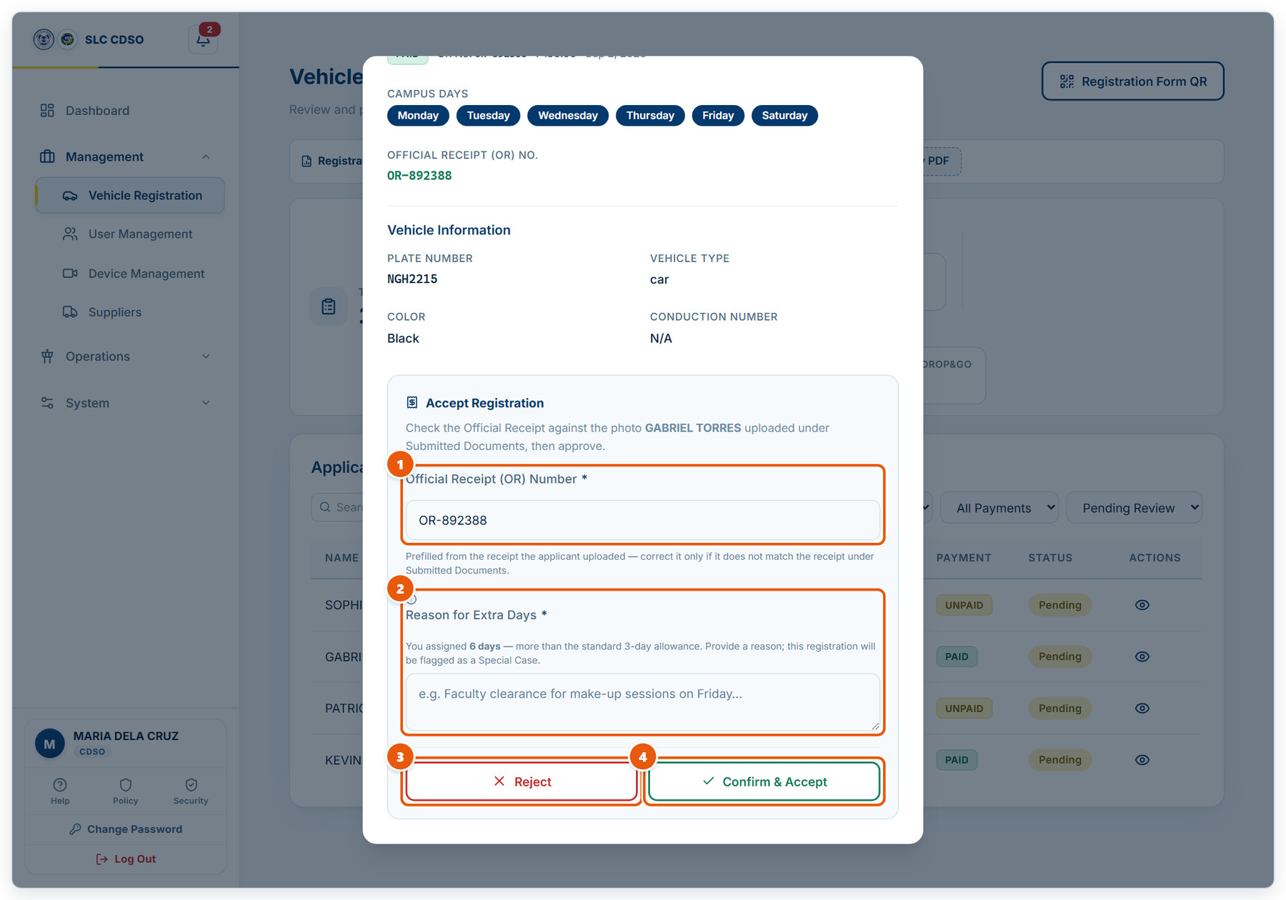
Figure 2.5: Approving or rejecting an application
1 | Official Receipt (OR) Number  Filled in from the receipt the applicant uploaded. Correct it only if it does not match the receipt under Submitted Documents.
2 | Reason for Extra Days  Appears only when the pass allows more than the standard 3 days. Required; the registration is flagged as a Special Case.
3 | Reject  Turns the application down. You will be asked for the reason.
4 | Confirm & Accept  Approves the application: the pass and system ID are issued and the owner’s portal account is created.

2.6 User Management
Management › User Management. Create, edit, disable and delete accounts.
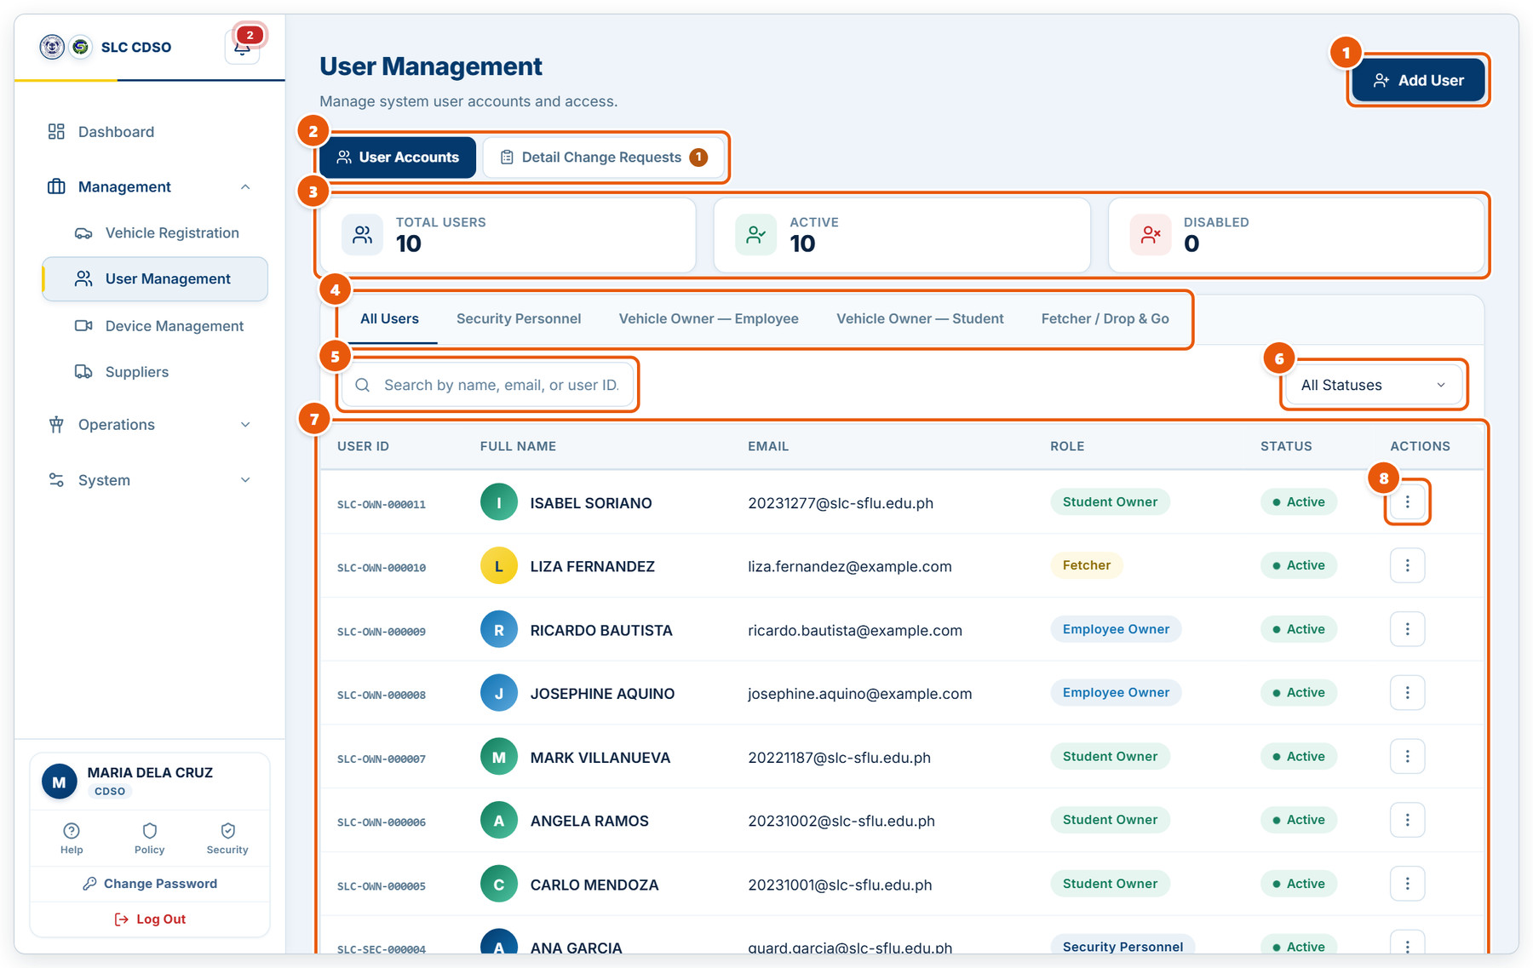
Figure 2.6: User Management
1 | Add User  Create a security guard or vehicle-owner account.
2 | Screen tabs  User Accounts lists everyone. Detail Change Requests holds owners’ requested corrections; the badge counts pending ones.
3 | Account counts  Total, active and disabled accounts.
4 | Role tabs  Show only one kind of account.
5 | Search  Search by name, email or user ID (e.g. SLC-OWN-000005).
6 | Status filter  Show active, disabled or archived accounts.
7 | Accounts table  User ID, name, email, role and status.
8 | Actions menu  Edit, disable/enable, reset two-factor, print a guard QR badge, or delete the account.

2.7 Approving detail change requests
Owners cannot edit an accepted registration directly. Their corrections wait here for approval.
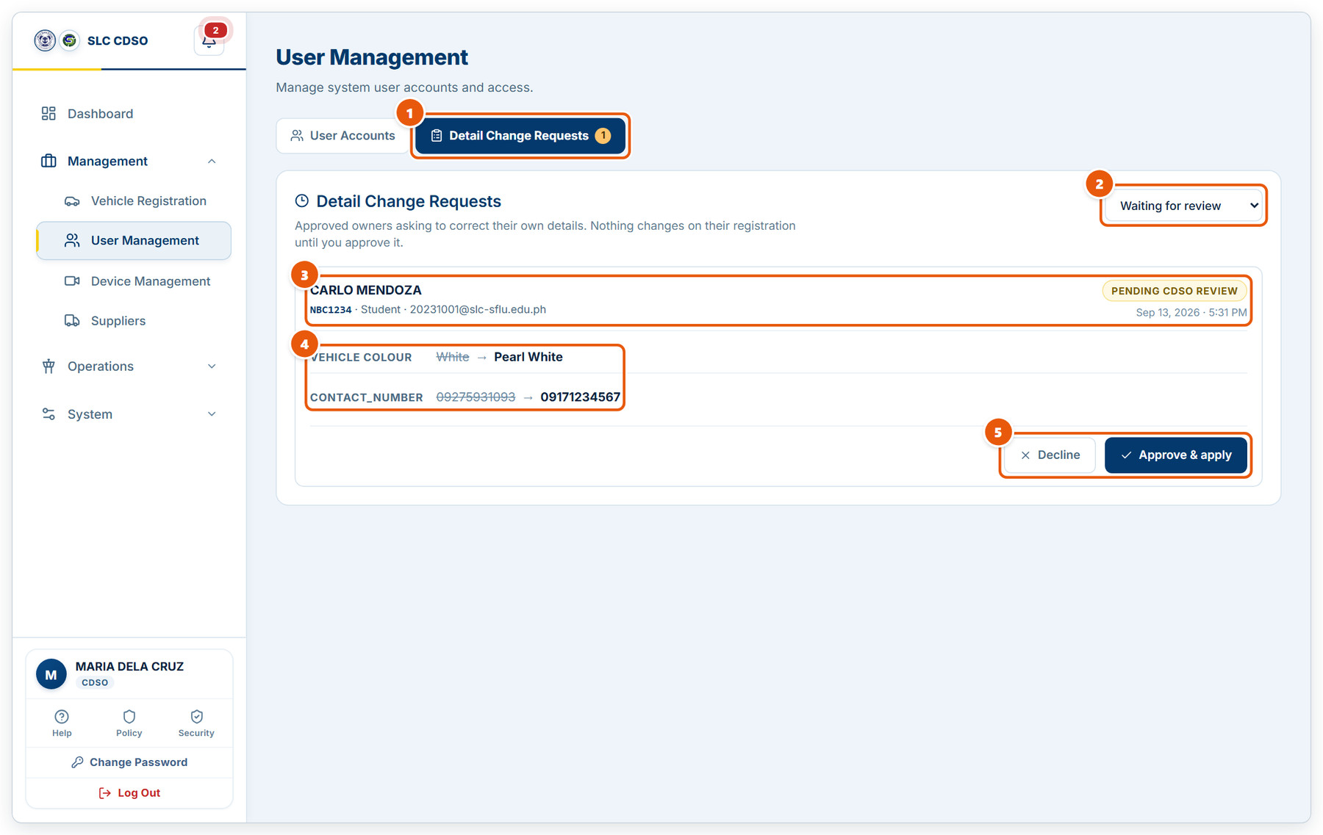
Figure 2.7: Approving detail change requests
1 | Detail Change Requests tab  The badge counts requests waiting for your review.
2 | Status filter  Show requests waiting for review, or ones already decided.
3 | Who is asking  Owner name, plate, registrant type, email, and when the request was filed.
4 | Requested changes  Each field shows the current value struck through and the new value the owner wants.
5 | Decline / Approve & apply  Approve & apply updates the registration. Decline leaves it unchanged. The owner is emailed either way.

2.8 Device Management (cameras)
Management › Device Management. Register the IP cameras used at the gates and parking areas.
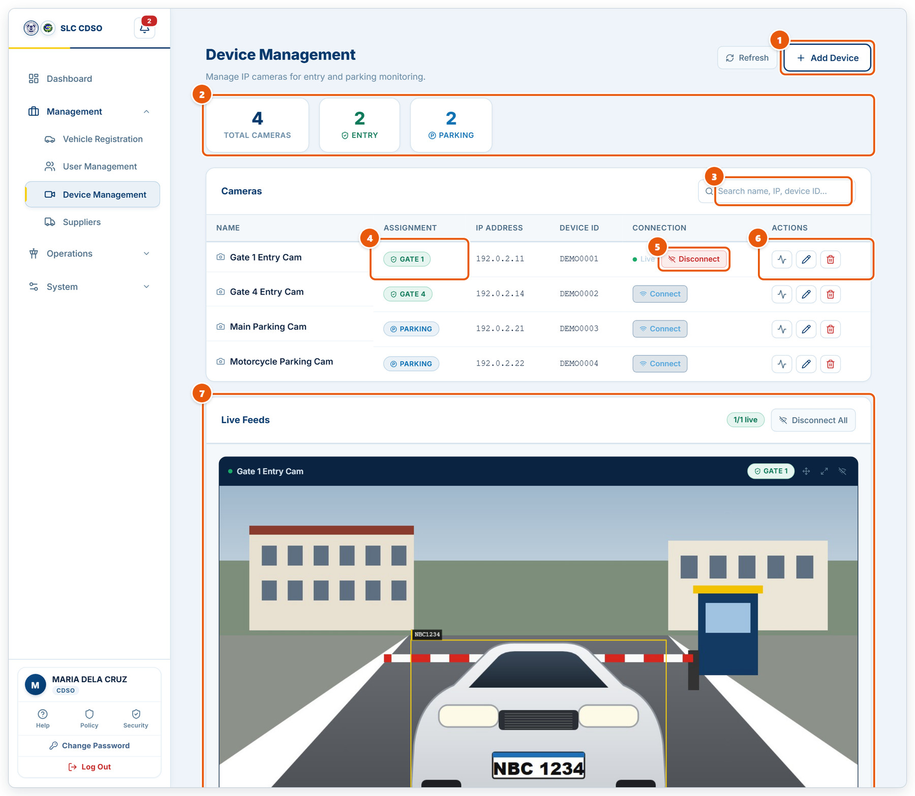
Figure 2.8: Device Management (cameras)
1 | Add Device  Register a new camera: name, IP address, device ID, password and whether it watches a gate or a parking area.
2 | Camera counts  How many cameras are registered, and how many cover entry gates and parking.
3 | Search  Find a camera by name, IP address or device ID.
4 | Assignment  The gate or parking area this camera covers.
5 | Connect / Disconnect  Opens or closes the camera’s live picture in Live Feeds below.
6 | Test, Edit, Delete  Check the camera answers, change its settings, or remove it.
7 | Live Feeds  Live pictures from the cameras you connected. (Sample picture shown.)

2.9 Supplier Management
Management › Suppliers. Supplier vehicles are admitted automatically when their plate is scanned.
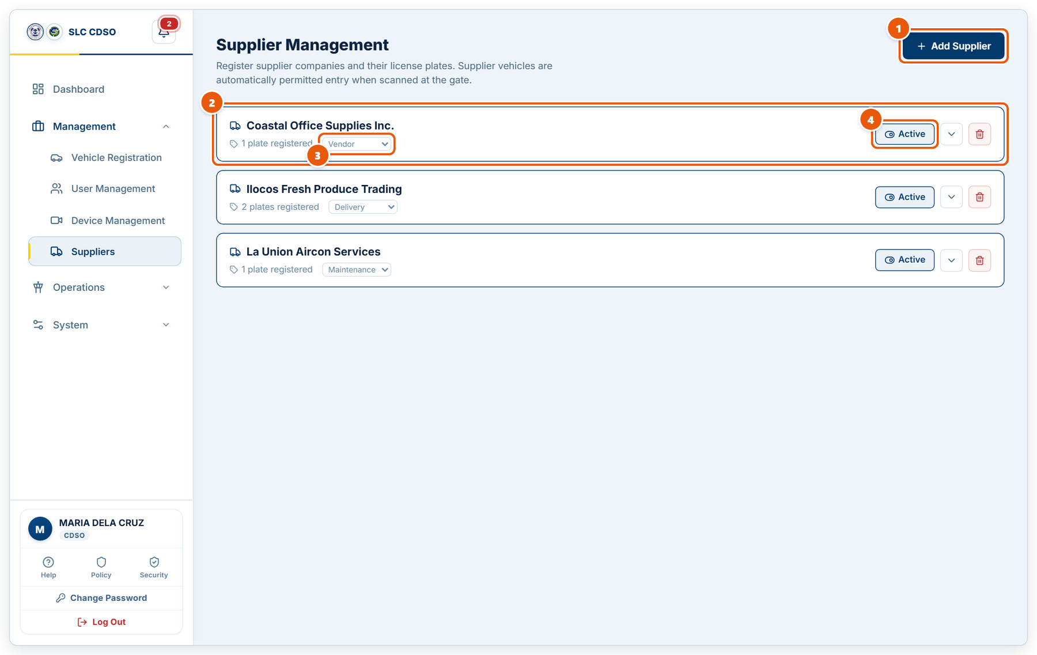
Figure 2.9: Supplier Management
1 | Add Supplier  Register a supplier company and its plates.
2 | Supplier card  Company name and how many plates it has registered.
3 | Category  Delivery, maintenance, vendor, contractor or other.
4 | Active  Click to deactivate a supplier; its vehicles stop being admitted automatically.

2.10 Operations Center: live monitor
Operations › Operations Center. Watch all gates, guards and cameras at once.
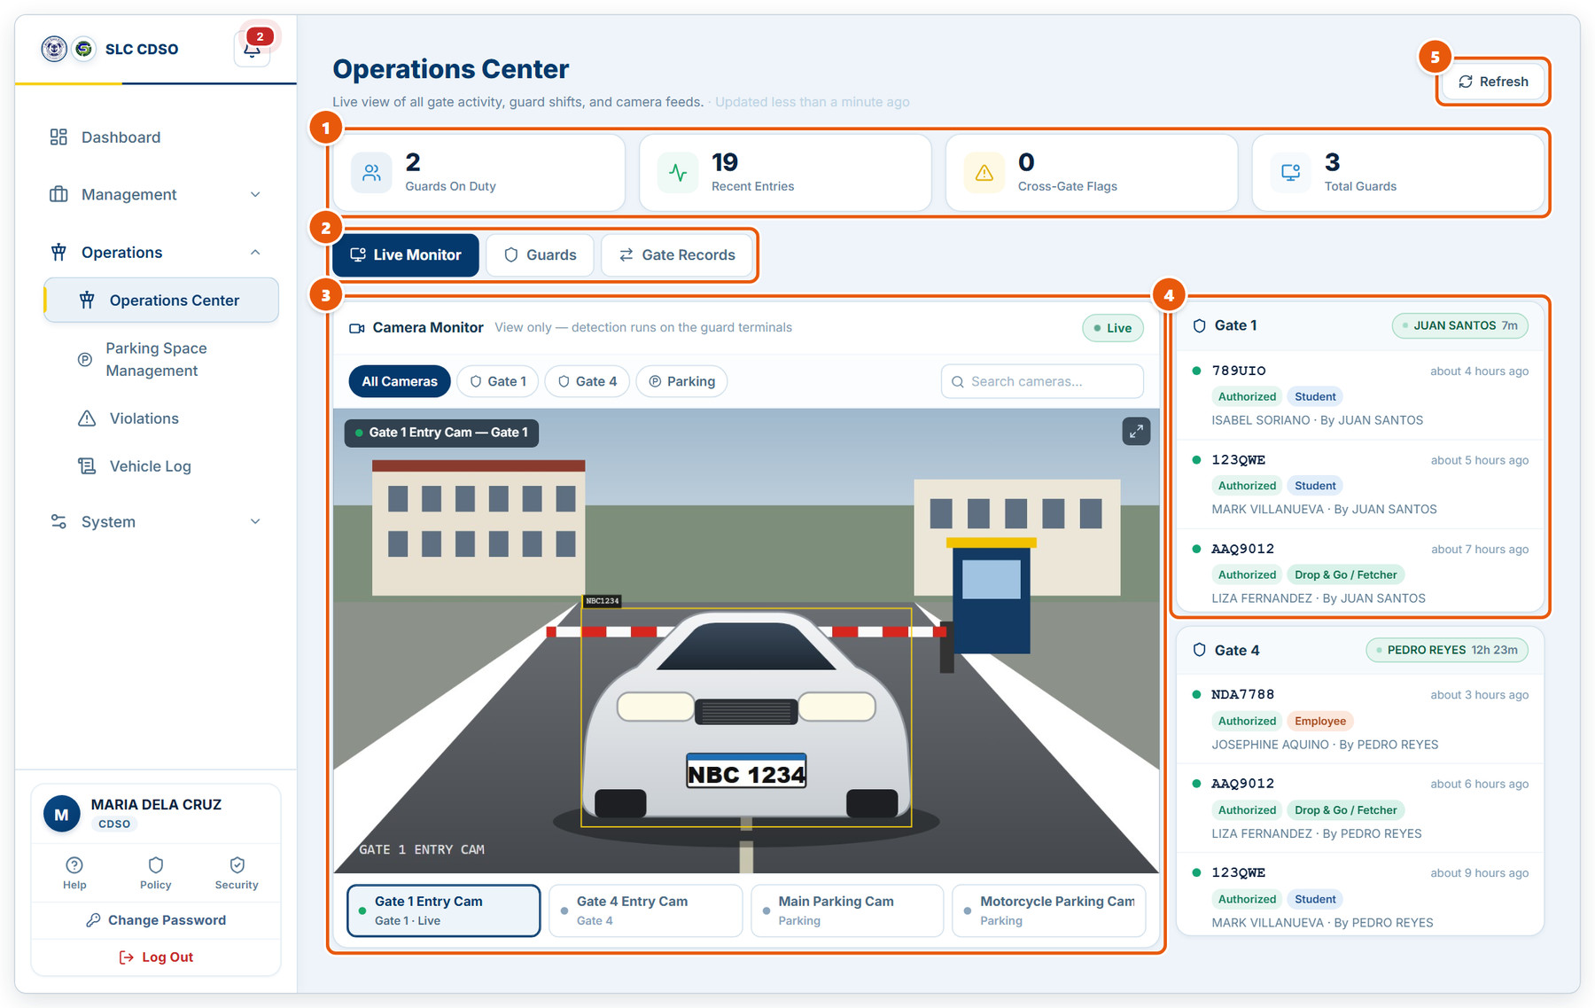
Figure 2.10: Operations Center: live monitor
1 | Live summary  Guards on duty, recent entries, cross-gate flags and total guards.
2 | Screen tabs  Live Monitor (this view), Guards (who is on shift where) and Gate Records (visitors inside, cross-gate discrepancies and confiscated accounts).
3 | Camera Monitor  View-only camera pictures. Plate detection runs on the guard terminals. (Sample picture shown.)
4 | Gate column  Latest scans at each gate. The green chip names the guard on duty and how long they have been on shift.
5 | Refresh  Reloads the screen.

2.11 Operations Center: guards
Guard shifts: who is on duty at which gate.
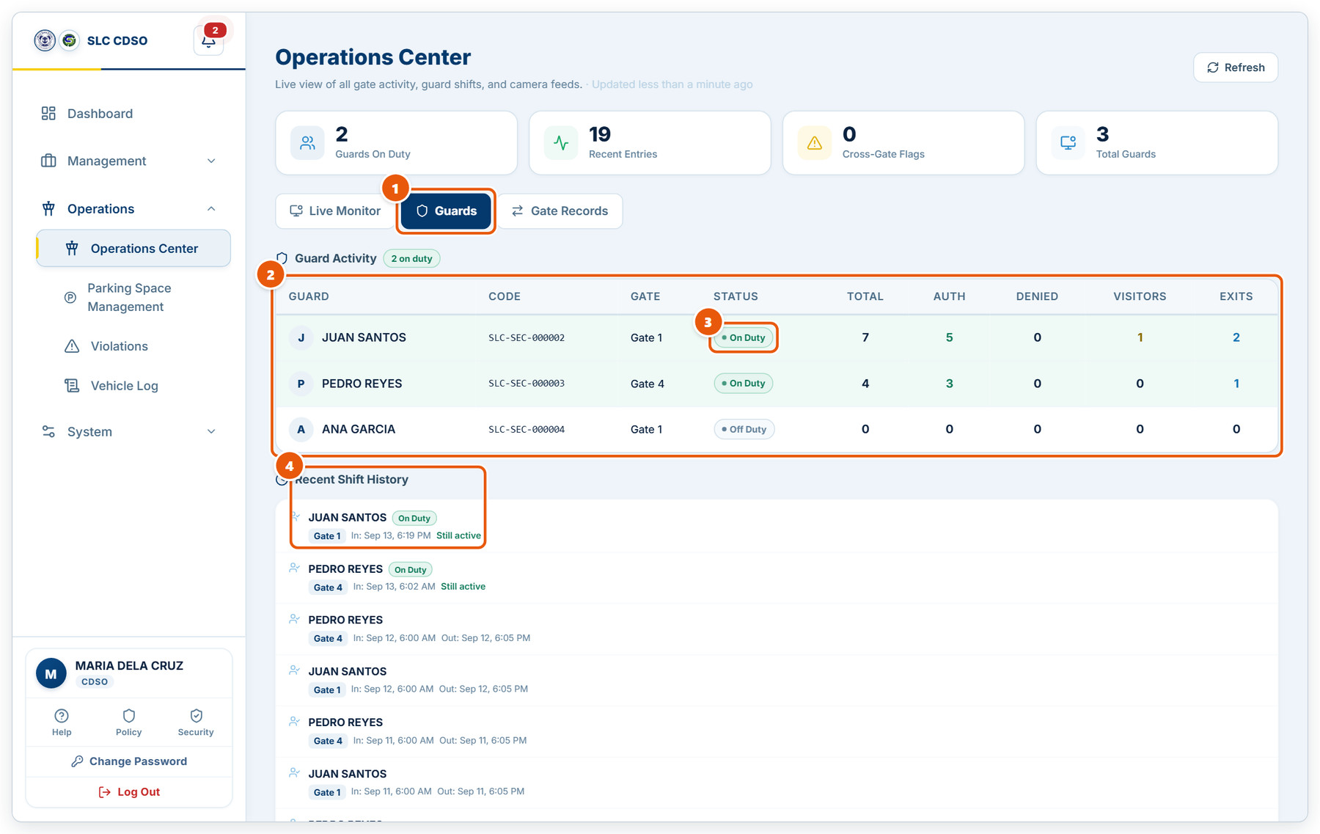
Figure 2.11: Operations Center: guards
1 | Guards tab  Guard activity and shift history.
2 | Guard activity  Each guard’s code, gate, duty status, and today’s totals: scans, authorized, denied, visitors and exits.
3 | Duty status  On Duty while the guard is signed in at a gate; Off Duty otherwise.
4 | Recent shift history  When each shift started and ended. "Still active" means the guard has not signed out yet.

2.12 Operations Center: gate records
Visitors still on campus, cross-gate discrepancies and confiscated accounts.
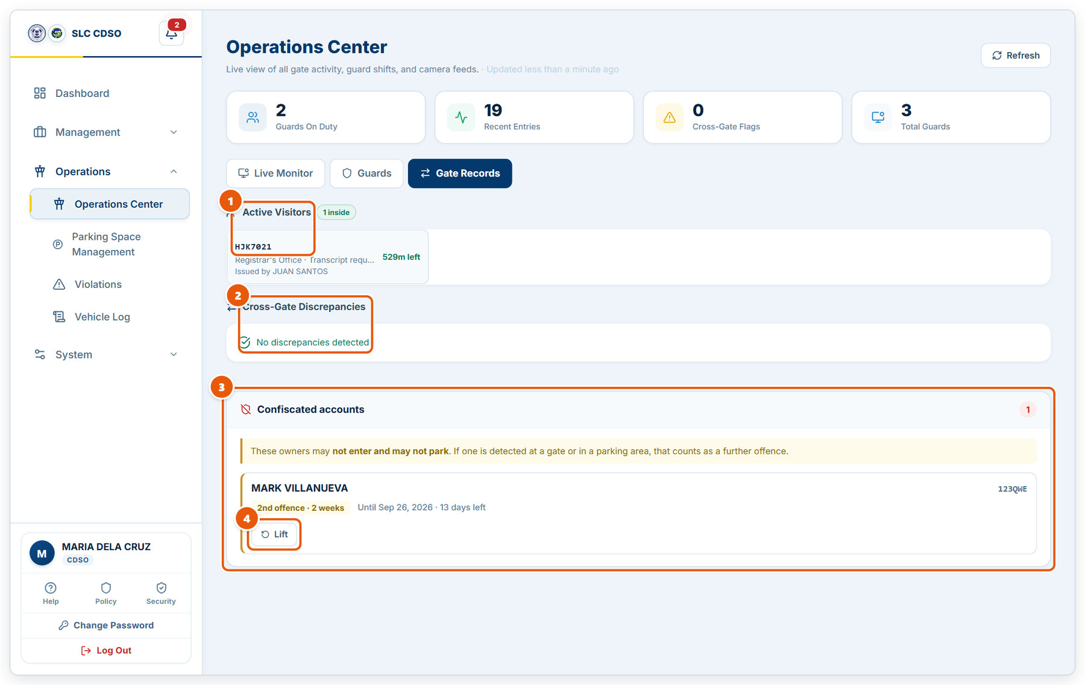
Figure 2.12: Operations Center: gate records
1 | Active Visitors  Visitor passes still inside, with the office visited, who issued the pass, and time left (or how long they have overstayed).
2 | Cross-Gate Discrepancies  Vehicles that entered through one gate and left through another, so both gates’ records can be checked.
3 | Confiscated accounts  Owners serving a violation penalty and when it ends.
4 | Lift  Ends a confiscation early. The violations themselves stay on record.

2.13 Parking Space Management
Operations › Parking Space Management. Bays, zones, live occupancy and events.
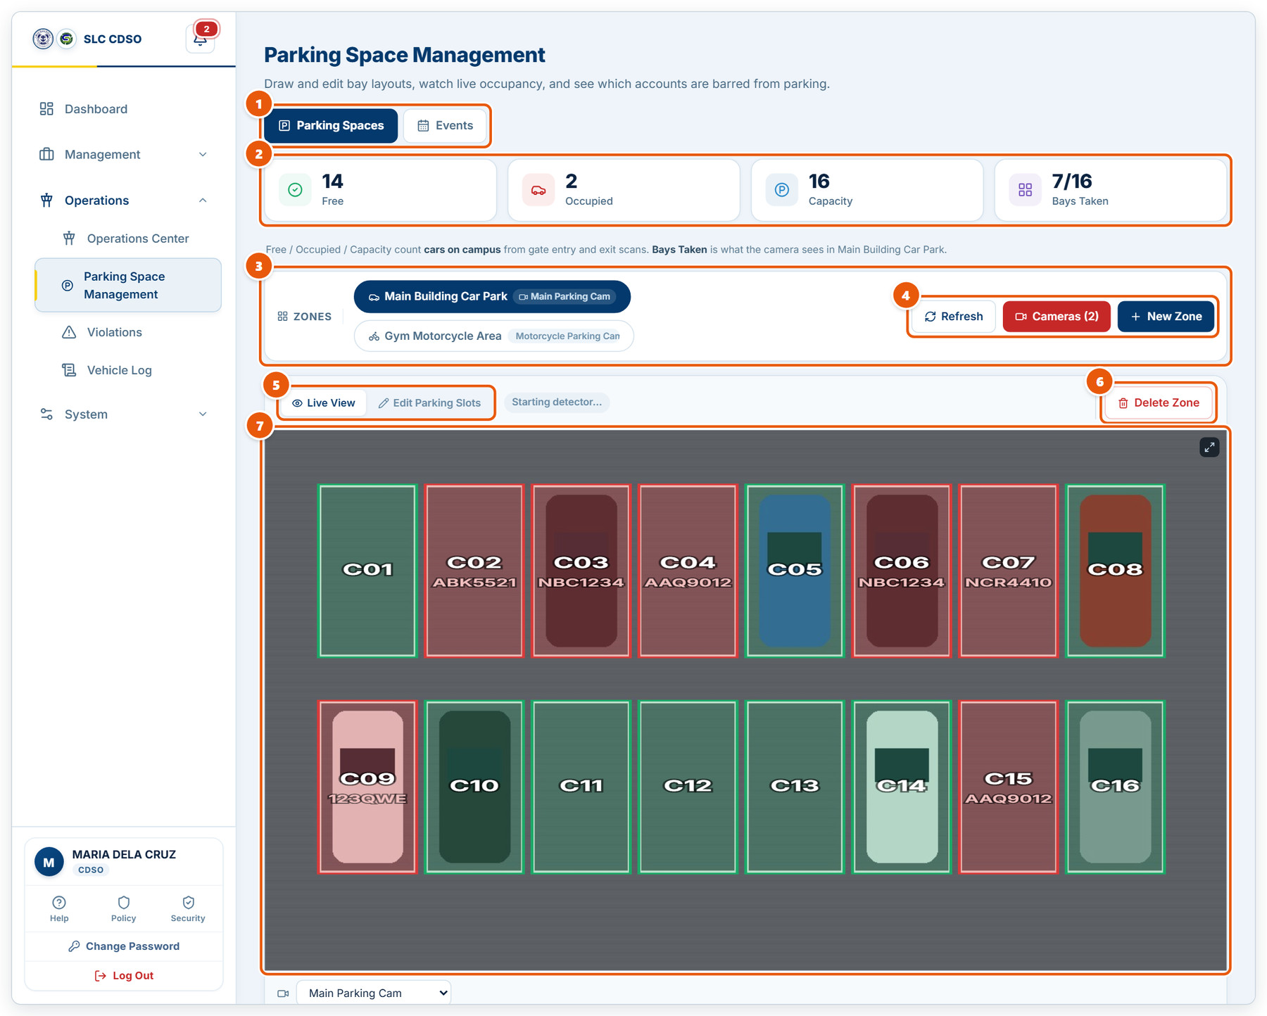
Figure 2.13: Parking Space Management
1 | Screen tabs  Parking Spaces (this view) and Events (campus events that reserve parking).
2 | Occupancy tiles  Free, Occupied and Capacity come from gate scans. Bays Taken is what the camera sees in the selected zone.
3 | Zones  Each parking zone and the camera watching it. Click a zone to select it.
4 | Refresh, Cameras, New Zone  Reload, manage the parking cameras, or draw a new zone.
5 | Live View / Edit Parking Slots  Switch between watching the bays and drawing or adjusting them.
6 | Delete Zone  Removes the selected zone and its bays.
7 | Bay map  Green bays are free, red bays are taken (with the plate when known).

2.14 Drawing parking bays
Edit Parking Slots mode: draw and adjust bays over the camera picture.
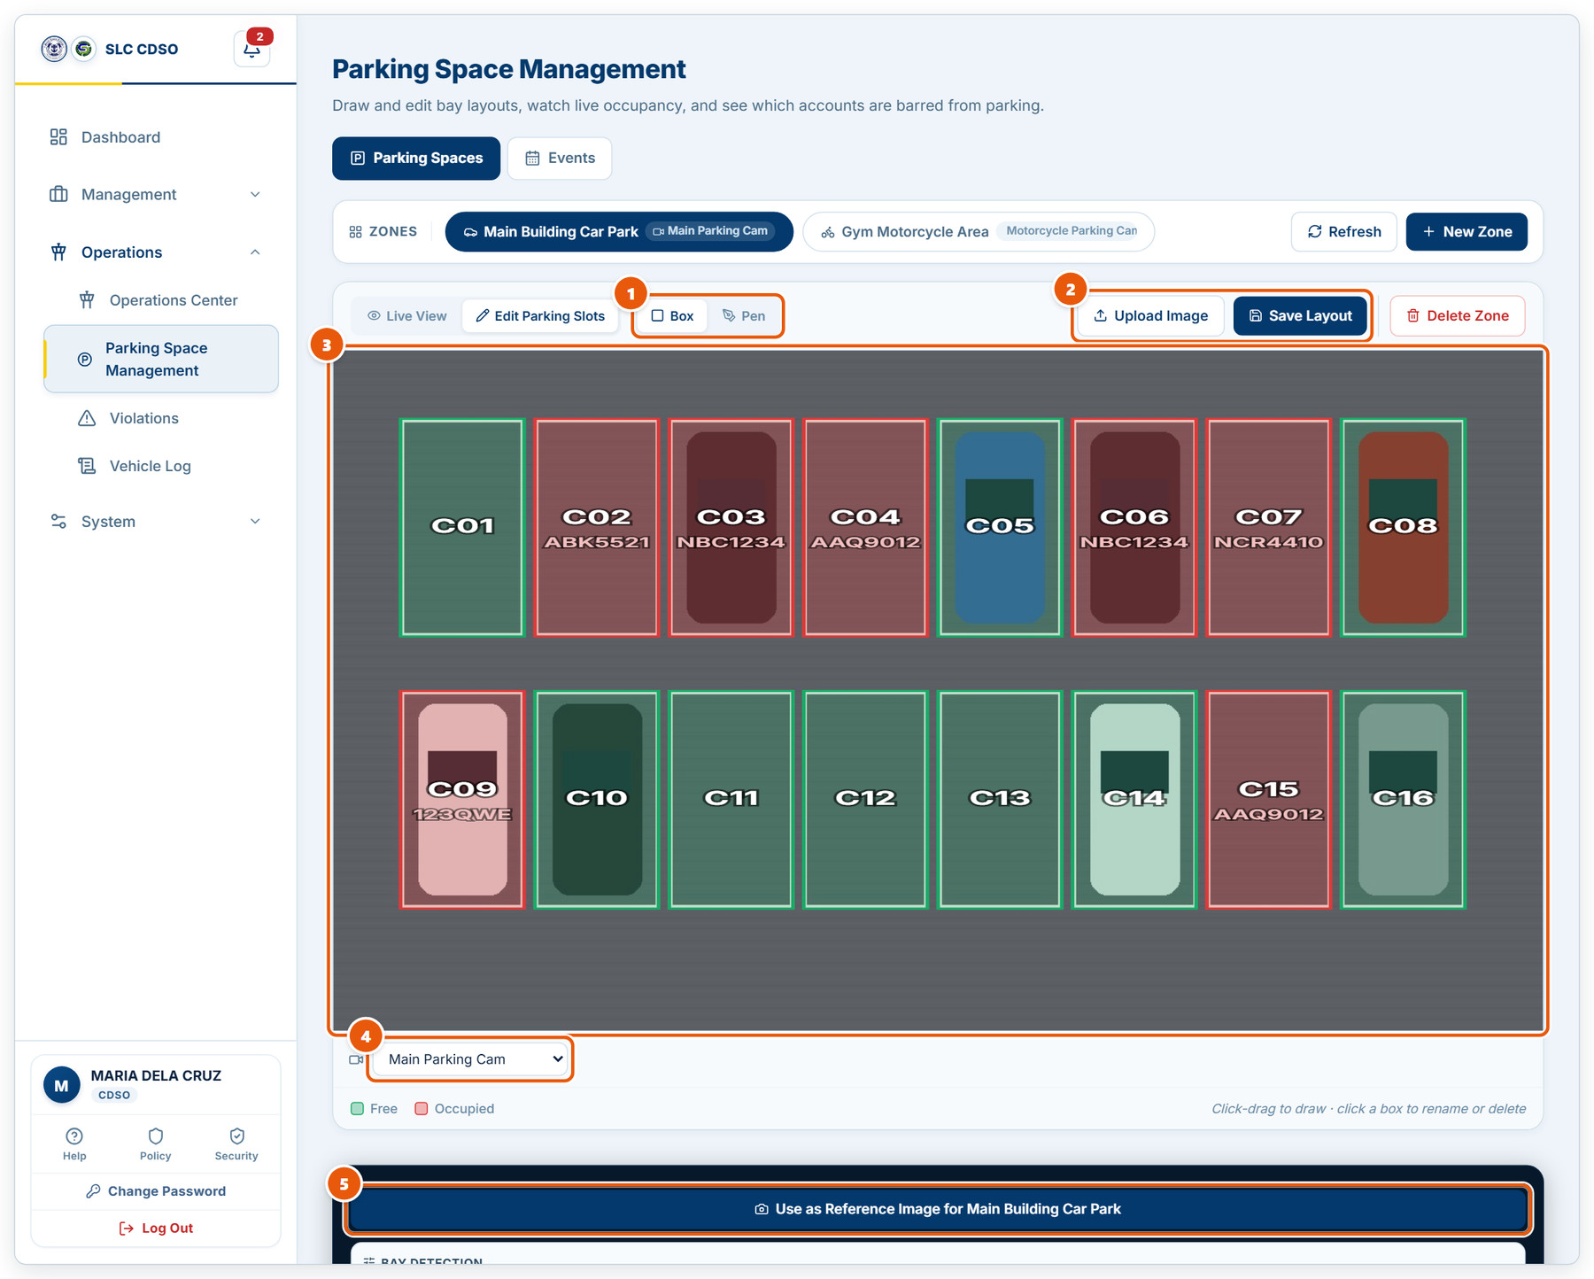
Figure 2.14: Drawing parking bays
1 | Drawing tools  Box draws rectangular bays; Pen draws a free-form outline for angled bays.
2 | Upload Image / Save Layout  Upload a reference picture of the lot, and save the bays when you are done.
3 | Drawing area  Click and drag to draw a bay. Click a bay to rename or delete it.
4 | Camera  The camera whose picture the bays are drawn over.
5 | Use as Reference Image  Takes the current camera picture as this zone’s reference image.

2.15 Campus events
Events reserve part of campus parking and note organizer plates.
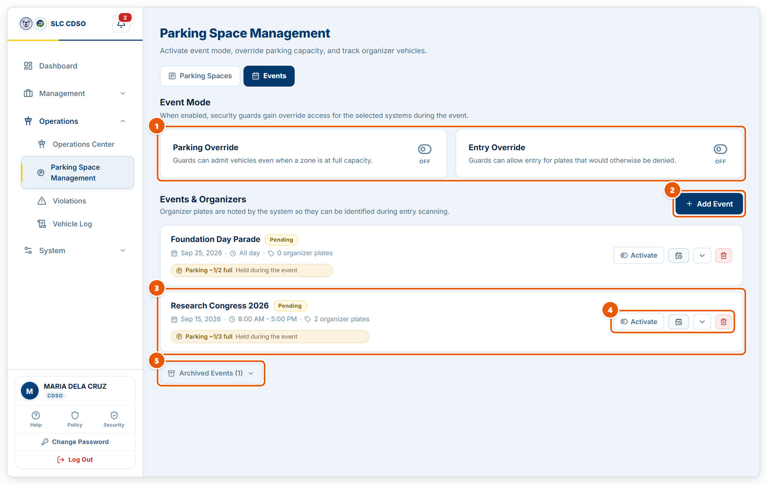
Figure 2.15: Campus events
1 | Event Mode overrides  Parking Override lets guards admit vehicles when a zone is full; Entry Override lets them admit plates that would be denied. Click the switch to turn each on or off.
2 | Add Event  Create an event: name, date, times, how much parking it takes, and organizer plates.
3 | Event card  Date, time, organizer plates, and how much of campus parking the event holds.
4 | Event actions  Activate the event, reschedule it, show its details, or delete it.
5 | Archived Events  Past events, kept for reference.

2.16 Violations
Operations › Violations. The 3-offence penalty ladder and every recorded offence.
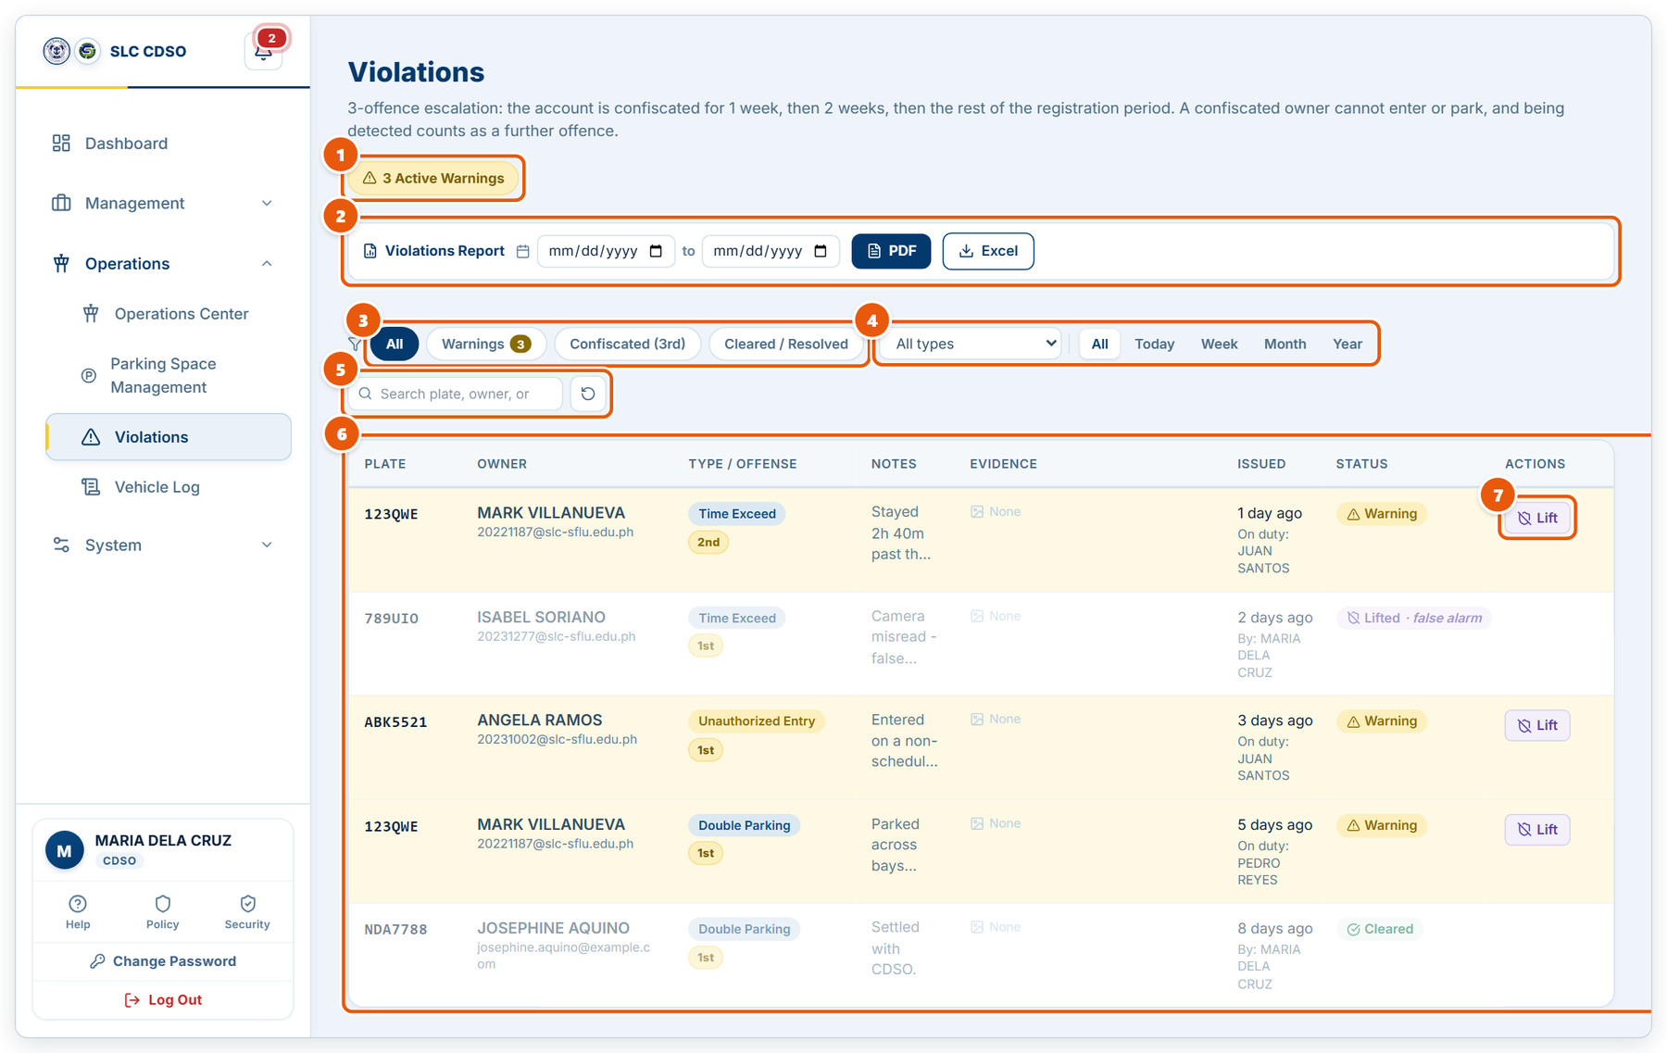
Figure 2.16: Violations
1 | Active warnings  How many violations are still counting against their owners.
2 | Violations report  Pick a date range and download a PDF or Excel report.
3 | Status filter  All, Warnings, Confiscated (3rd offence) or Cleared / Resolved.
4 | Type and period  Filter by violation type, and by Today, Week, Month or Year.
5 | Search  Find by plate, owner or notes. The arrow button resets all filters.
6 | Violations table  Plate, owner, type with offence number (1st, 2nd, 3rd), notes, evidence photo, when it was issued and by whom.
7 | Lift  Voids a violation as a false alarm. It stops counting, and later offences are renumbered.

2.17 Vehicle Log
Operations › Vehicle Log. Every gate scan, entry and exit, across all gates.
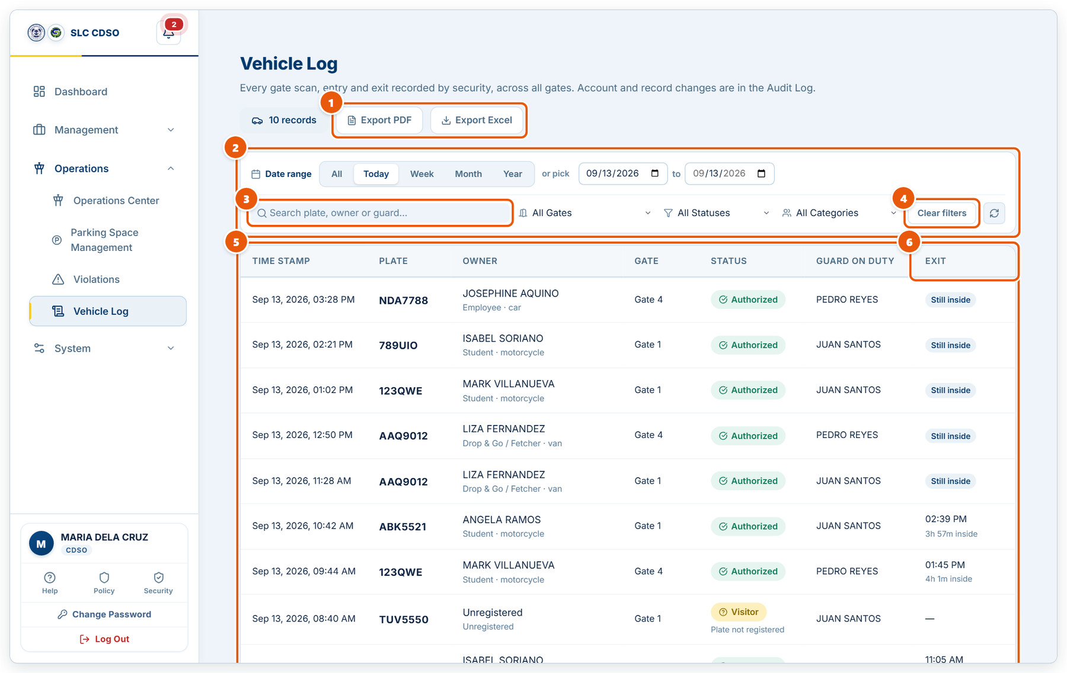
Figure 2.17: Vehicle Log
1 | Record count and exports  Download the filtered log as PDF or Excel.
2 | Date range  Quick ranges, or pick exact start and end dates.
3 | Search  Find a plate, owner or guard.
4 | Gate, status and category filters  Narrow the log; Clear filters resets them.
5 | Log table  Time, plate, owner, gate, decision and the guard on duty.
6 | Exit  When the vehicle left and how long it stayed, or "Still inside".

2.18 Rule Constraints: entry rules
System › Rule Constraints. When each kind of vehicle may enter campus.
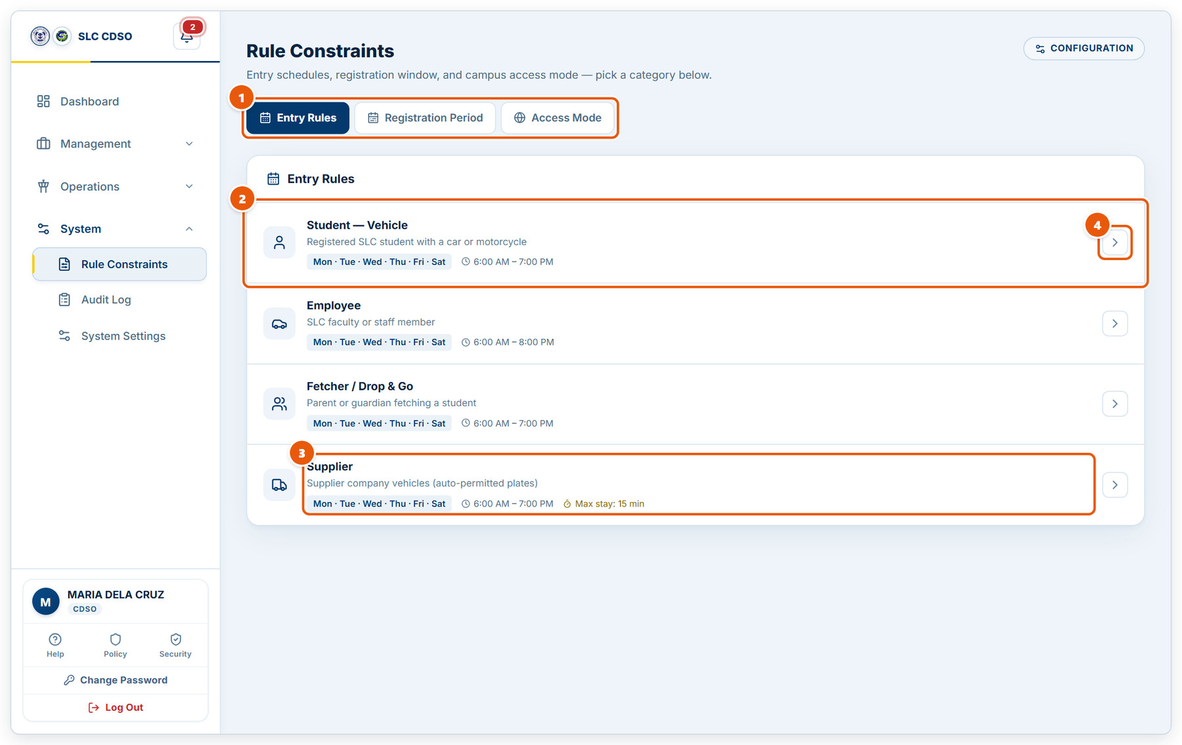
Figure 2.18: Rule Constraints: entry rules
1 | Screen tabs  Entry Rules, Registration Period (when applications are accepted) and Access Mode.
2 | Rule  One rule per registrant type: who it applies to, allowed days and hours.
3 | Days, hours and stay limit  Allowed campus days, the time window, and the maximum stay where one is set.
4 | Edit  Opens the rule to change its days, hours or stay limit.

2.19 Rule Constraints: registration period
Set when the online application form accepts submissions.
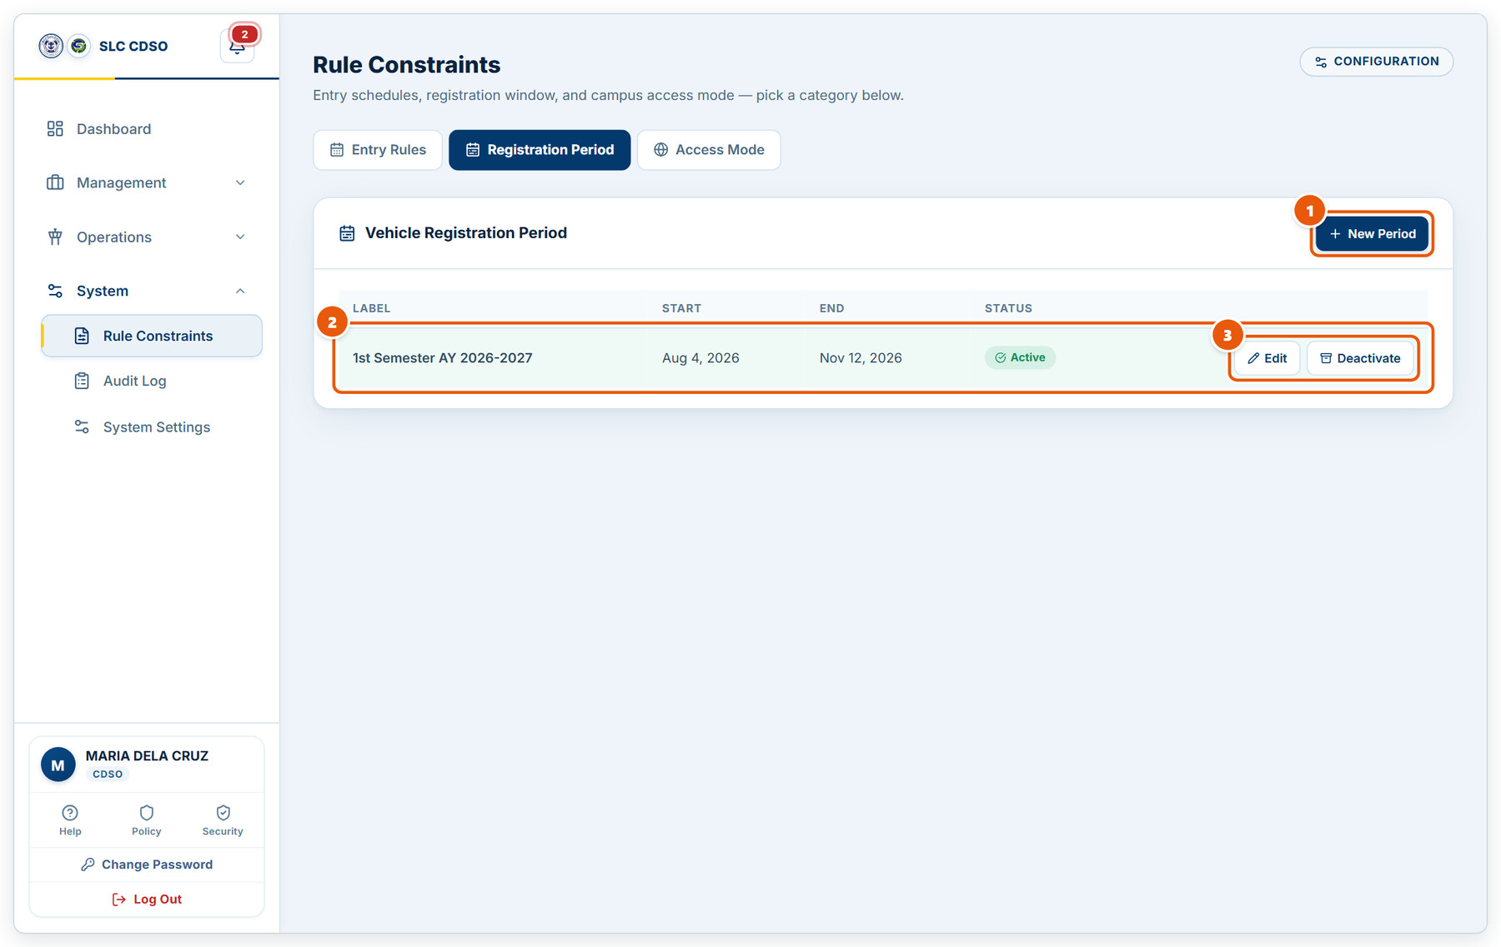
Figure 2.19: Rule Constraints: registration period
1 | New Period  Create a registration window with a label, start date and end date.
2 | Period  Label, start and end dates. Only one period can be Active; the public form accepts applications only while it is open.
3 | Edit / Deactivate  Change the dates, or close the window early.

2.20 Rule Constraints: access mode
Campus-wide overrides such as open campus mode.
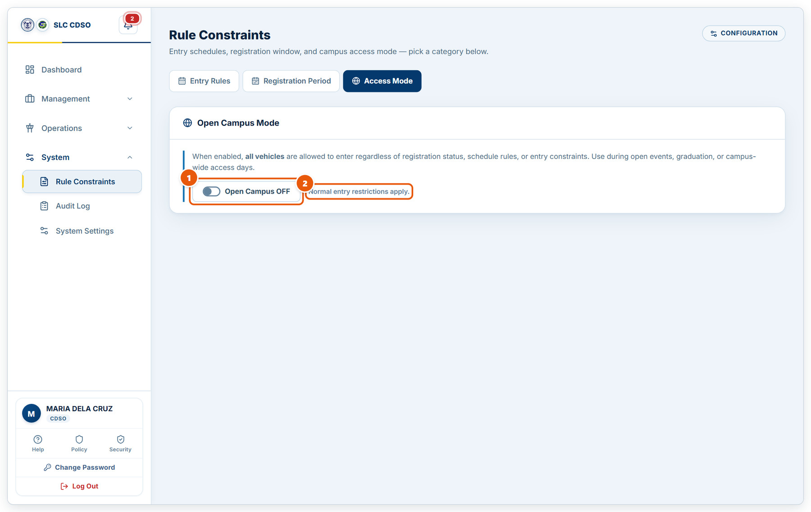
Figure 2.20: Rule Constraints: access mode
1 | Open Campus switch  When ON, every vehicle may enter regardless of registration, schedule or entry rules. Use it for open events or graduation, and switch it OFF afterwards.
2 | Current effect  What the setting means right now.

2.21 Audit Log
System › Audit Log. What staff did to accounts and records.
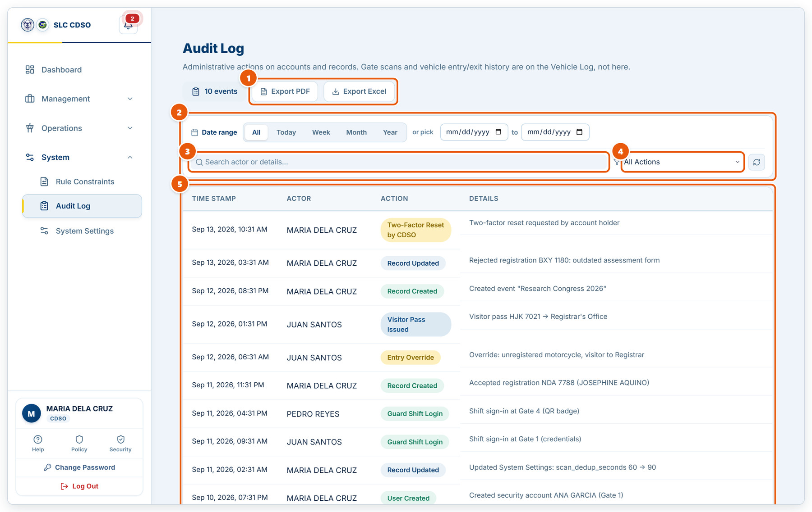
Figure 2.21: Audit Log
1 | Event count and exports  Download the filtered log as PDF or Excel.
2 | Date range  All, Today, Week, Month, Year, or exact dates.
3 | Search  Search by the staff member’s name or the details text.
4 | Action filter  Show one kind of action, e.g. User Created or Entry Override.
5 | Audit table  When, who, what kind of action, and the details.

2.22 System Settings: accounts & fees
System › System Settings. System-wide policies, grouped into four tabs.
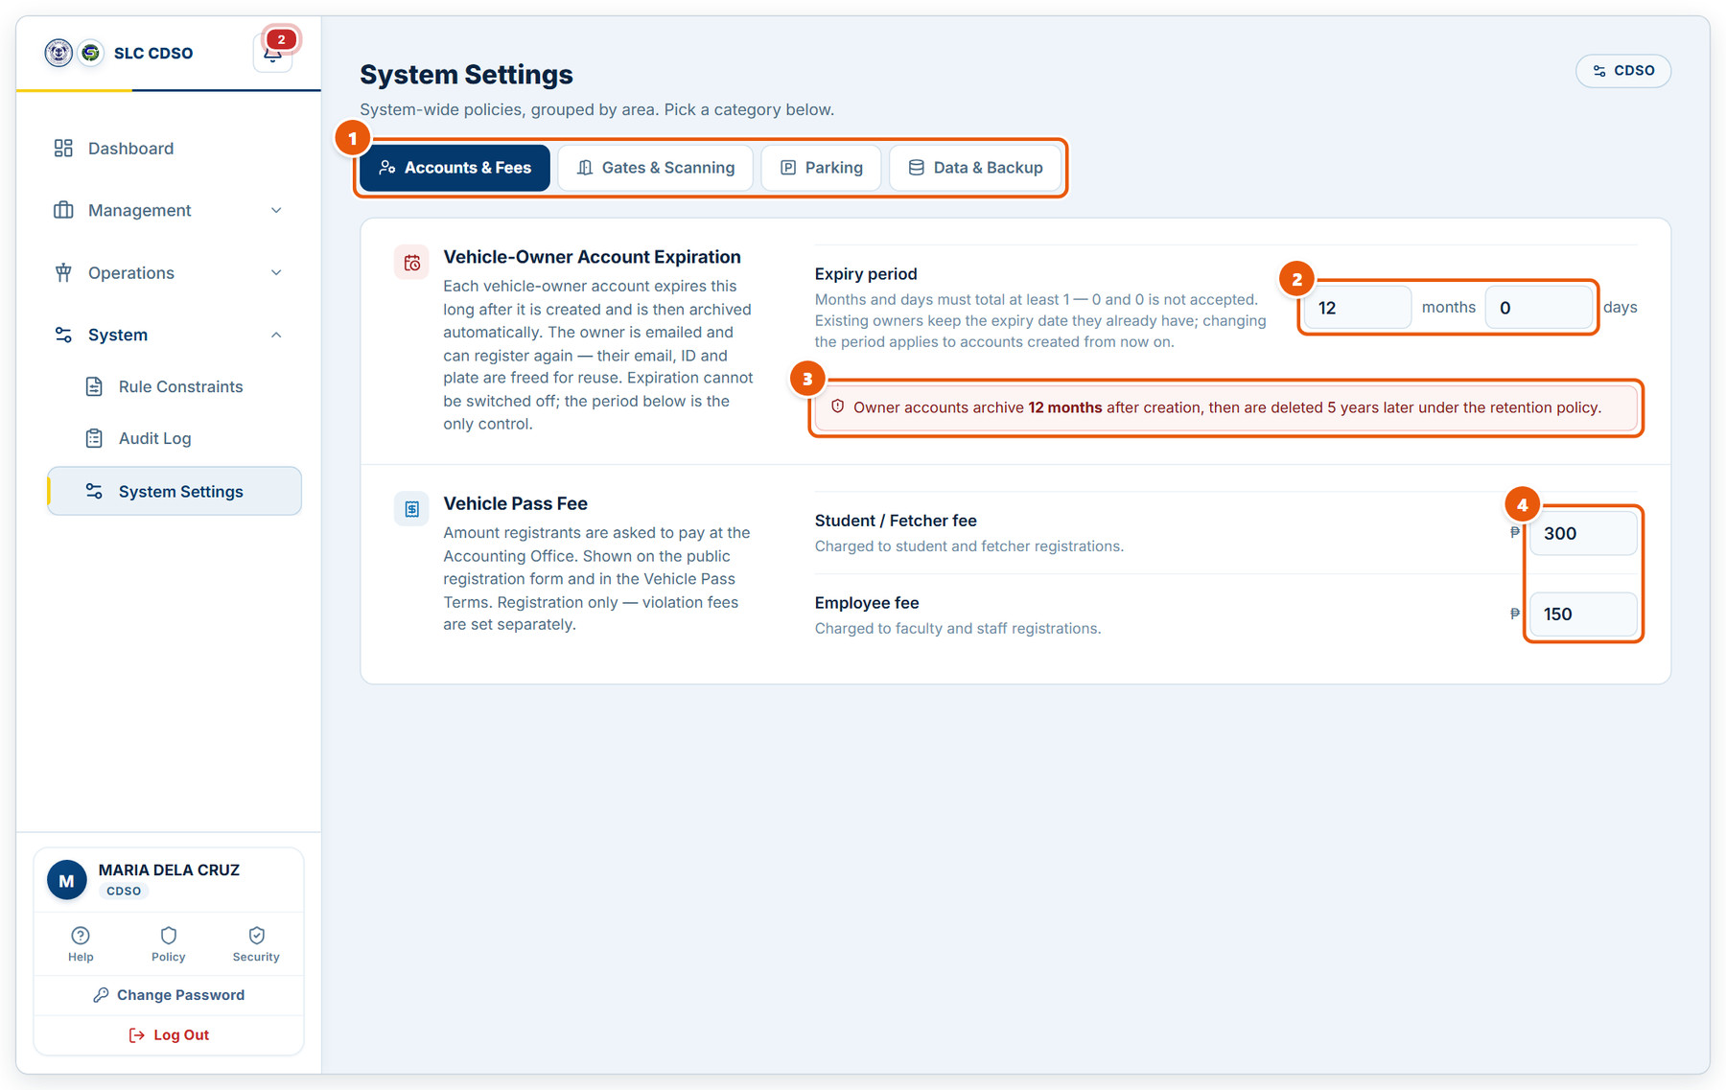
Figure 2.22: System Settings: accounts & fees
1 | Settings tabs  Accounts & Fees, Gates & Scanning, Parking, and Data & Backup.
2 | Account expiry period  How long a vehicle-owner account lasts before it is archived automatically.
3 | Retention notice  What the chosen period means for owners’ records.
4 | Vehicle pass fees  The amounts applicants are asked to pay at the Accounting Office.

2.23 System Settings: gates & scanning
Gates, scan timing and event overrides.
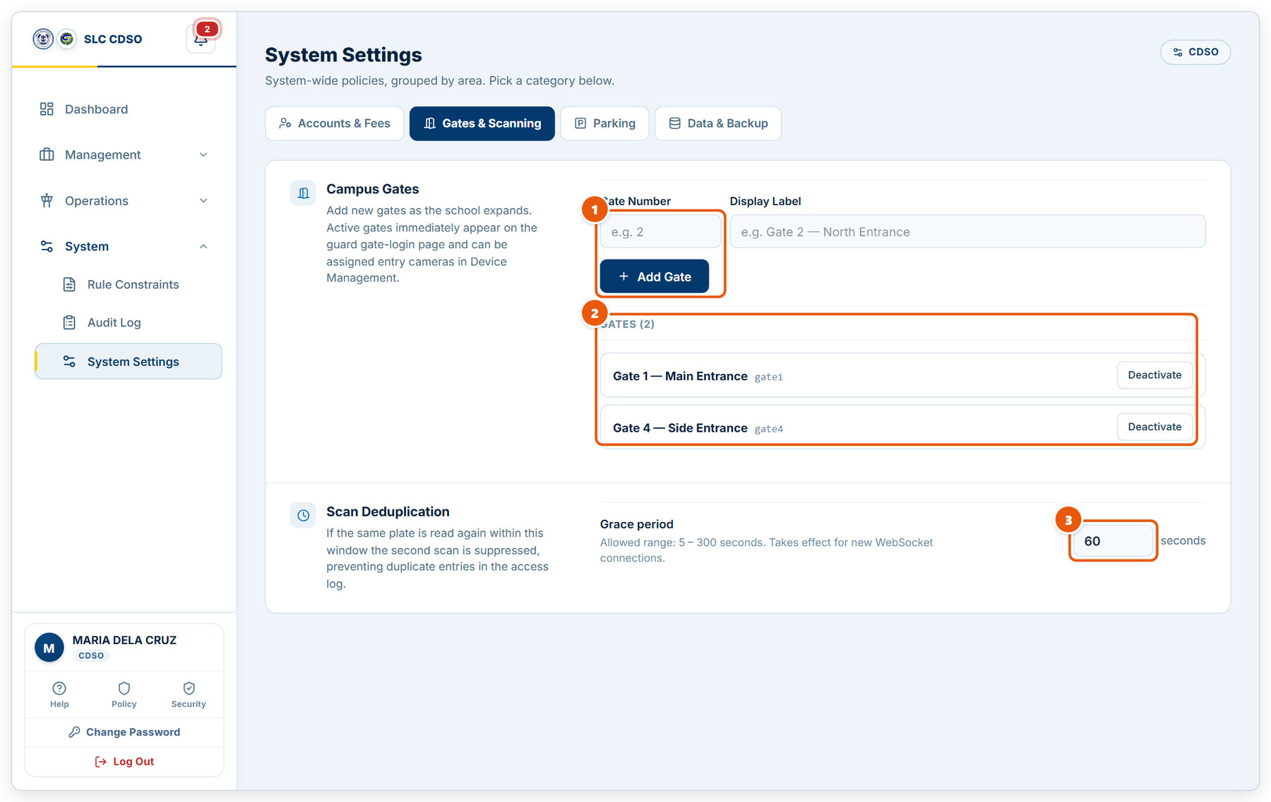
Figure 2.23: System Settings: gates & scanning
1 | Add a gate  Enter the gate number and a display label, then Add Gate. It appears on the guard sign-in page straight away.
2 | Gate list  Every gate. Deactivate removes a gate from the sign-in page without deleting its history.
3 | Scan deduplication  If the same plate is read again within this many seconds, the repeat is ignored so it is not logged twice.

2.24 System Settings: parking
Parking detection thresholds.
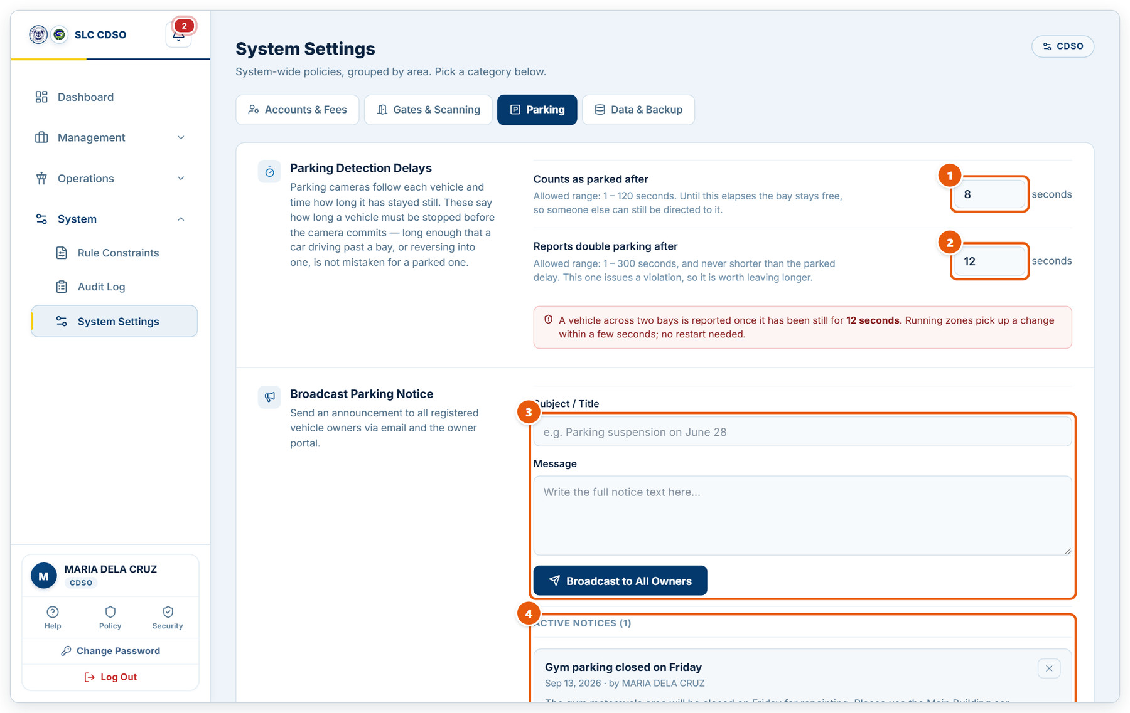
Figure 2.24: System Settings: parking
1 | Counts as parked after  How long a vehicle must stay still before its bay counts as taken.
2 | Reports double parking after  How long a vehicle must sit across two bays before a double-parking violation is issued.
3 | Broadcast Parking Notice  Write a subject and message, then Broadcast to All Owners. It is emailed and shown in every owner’s portal.
4 | Active notices  Notices owners can currently see. The × removes one.

2.25 System Settings: data & backup
Backups, restore and data retention.
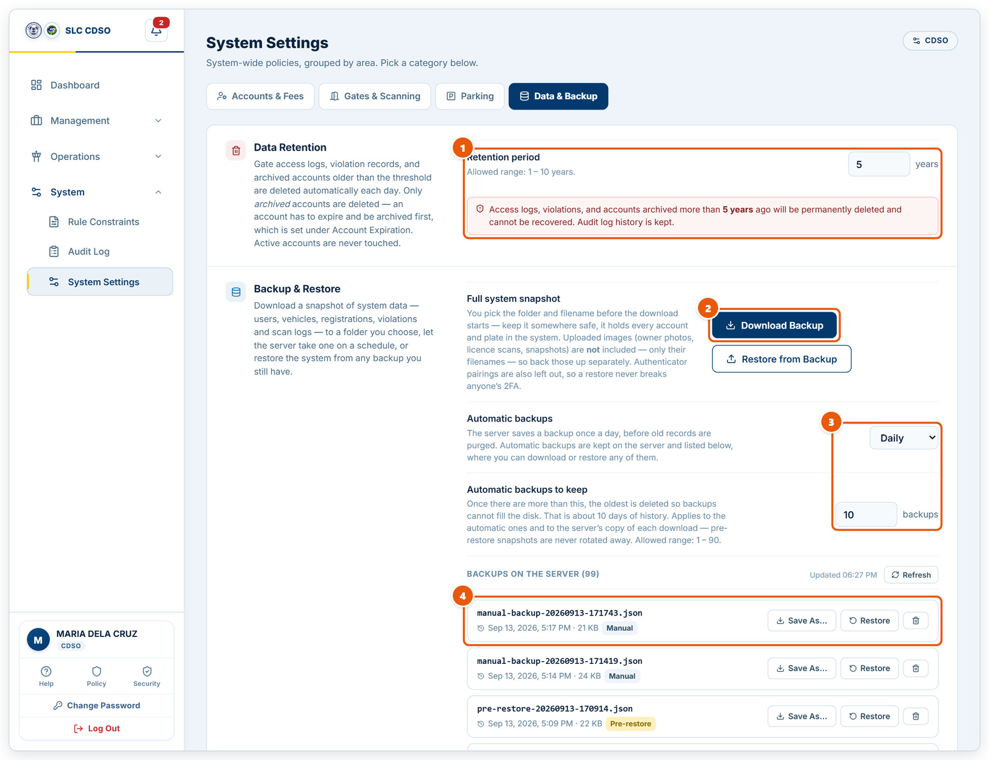
Figure 2.25: System Settings: data & backup
1 | Retention period  Access logs, violations and archived accounts older than this are deleted automatically. The audit log is kept.
2 | Download / Restore  Download a full snapshot of the system data, or restore the system from a backup file.
3 | Automatic backups  How often the server backs itself up, and how many automatic backups to keep.
4 | Backups on the server  Saved backups. Save As downloads a copy, Restore brings the system back to that point, and the bin deletes it.

2.26 Help & User Manual
The built-in guide, available to every role from the sidebar.
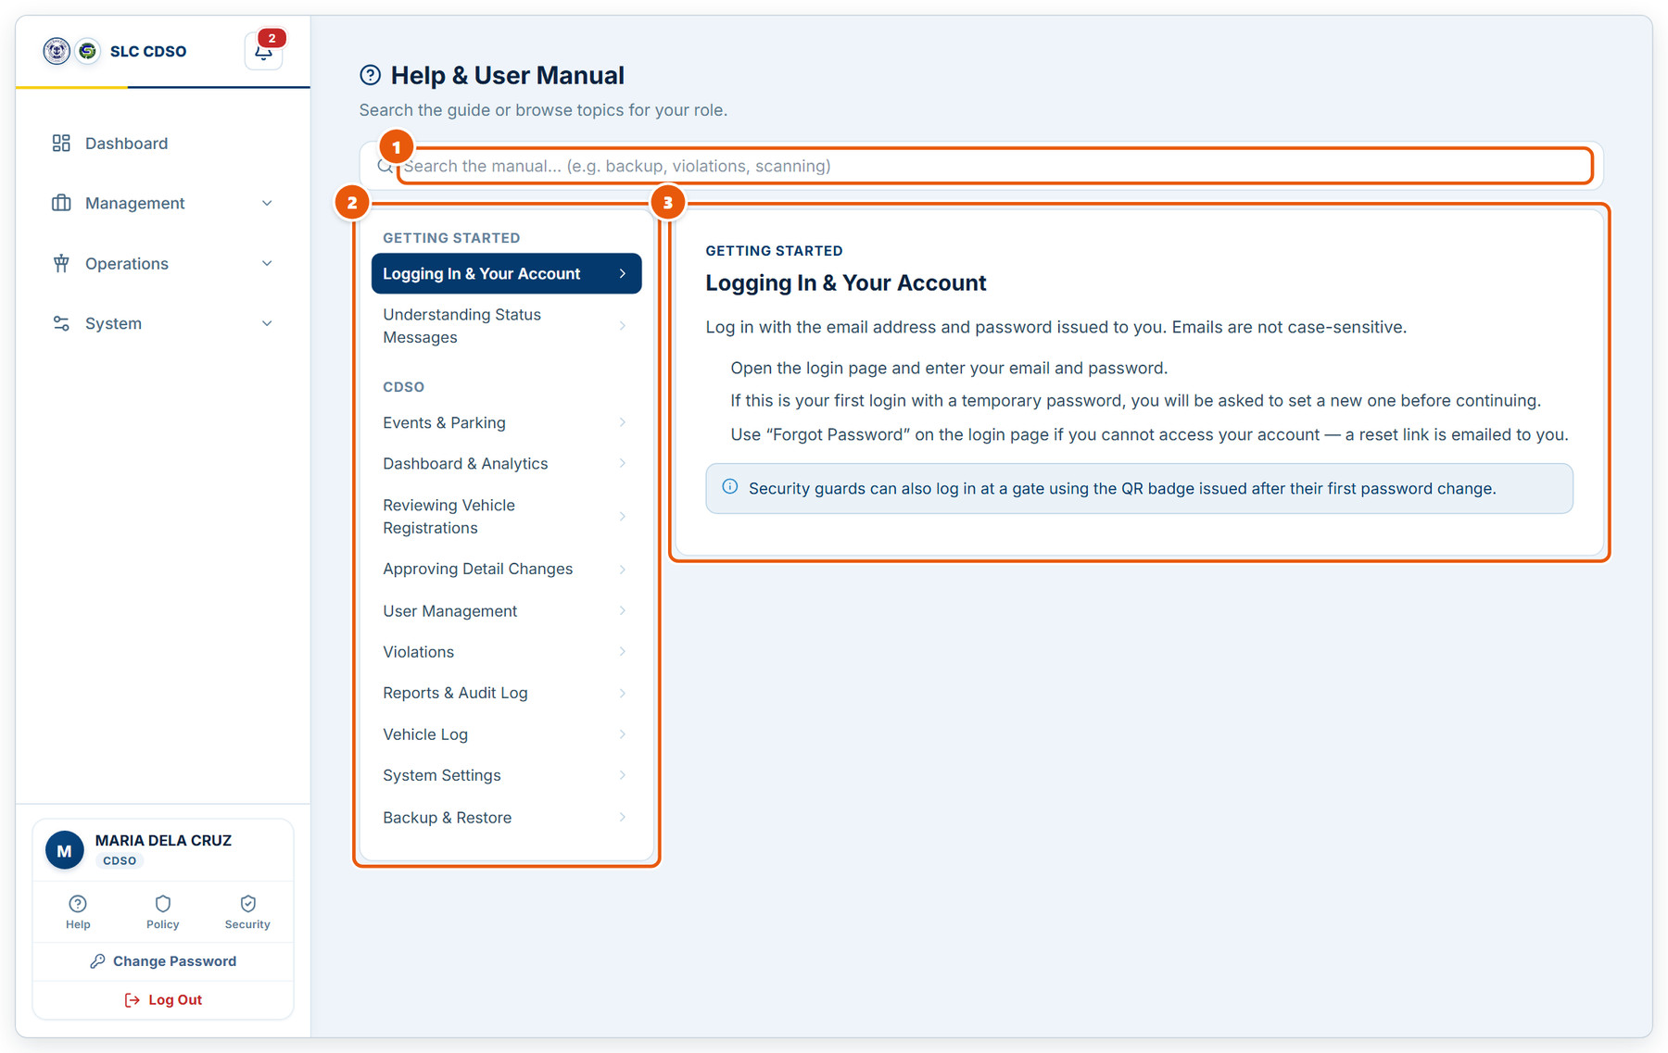
Figure 2.26: Help & User Manual
1 | Search the manual  Type a keyword such as backup, violations or scanning.
2 | Topics  Topics for your role, grouped by area. Click one to read it.
3 | Article  Step-by-step instructions for the selected topic.

3. Security Guard
The gate terminal used by security guards: checking vehicles in and out, recording vehicles with no plate, watching parking and issuing violations.

3.1 Entry Management (gate terminal)
The guard’s main screen at the gate. Plates are read automatically from the entry camera.
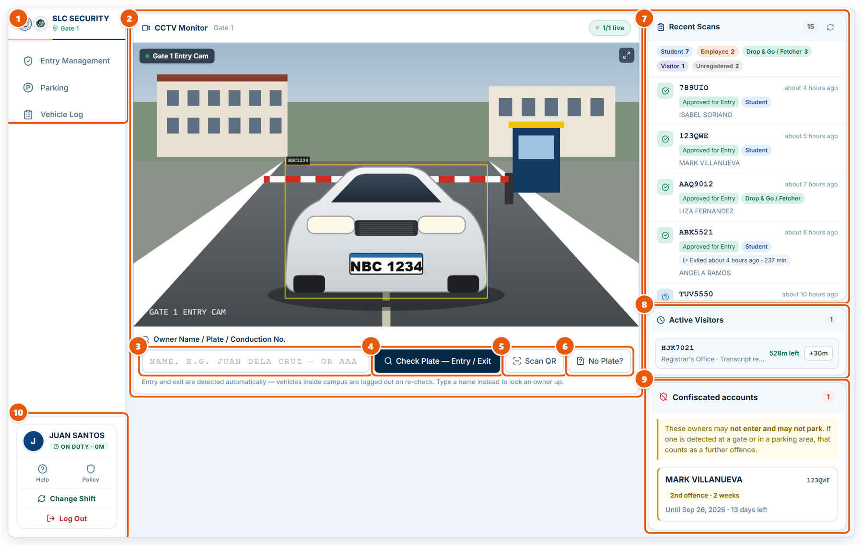
Figure 3.1: Entry Management (gate terminal)
1 | Menu and gate  Entry Management, Parking and Vehicle Log. The green tag shows the gate you are clocked in at.
2 | CCTV Monitor  Live picture from this gate’s entry camera. Detected plates are boxed and checked automatically. (Sample picture shown.)
3 | Owner name / plate search  Type a plate, conduction number or owner name when a plate is not read automatically.
4 | Check Plate — Entry / Exit  Checks the typed plate. A vehicle already inside is logged out; otherwise its entry is checked against its pass and schedule.
5 | Scan QR  Scan the QR code on the owner’s vehicle pass or a visitor slip.
6 | No Plate?  Record a vehicle with no plate or conduction sticker by describing it.
7 | Recent Scans  Latest decisions at this gate. The chips count entries by category.
8 | Active Visitors  Visitor passes still inside, with time left. +30m extends a pass.
9 | Confiscated accounts  Owners serving a violation penalty. They may not enter or park.
10 | Shift controls  On-duty timer, Help, Policy, Change Shift (hand over the gate) and Log Out.

3.2 Checking a plate
The result shown after a plate is checked.
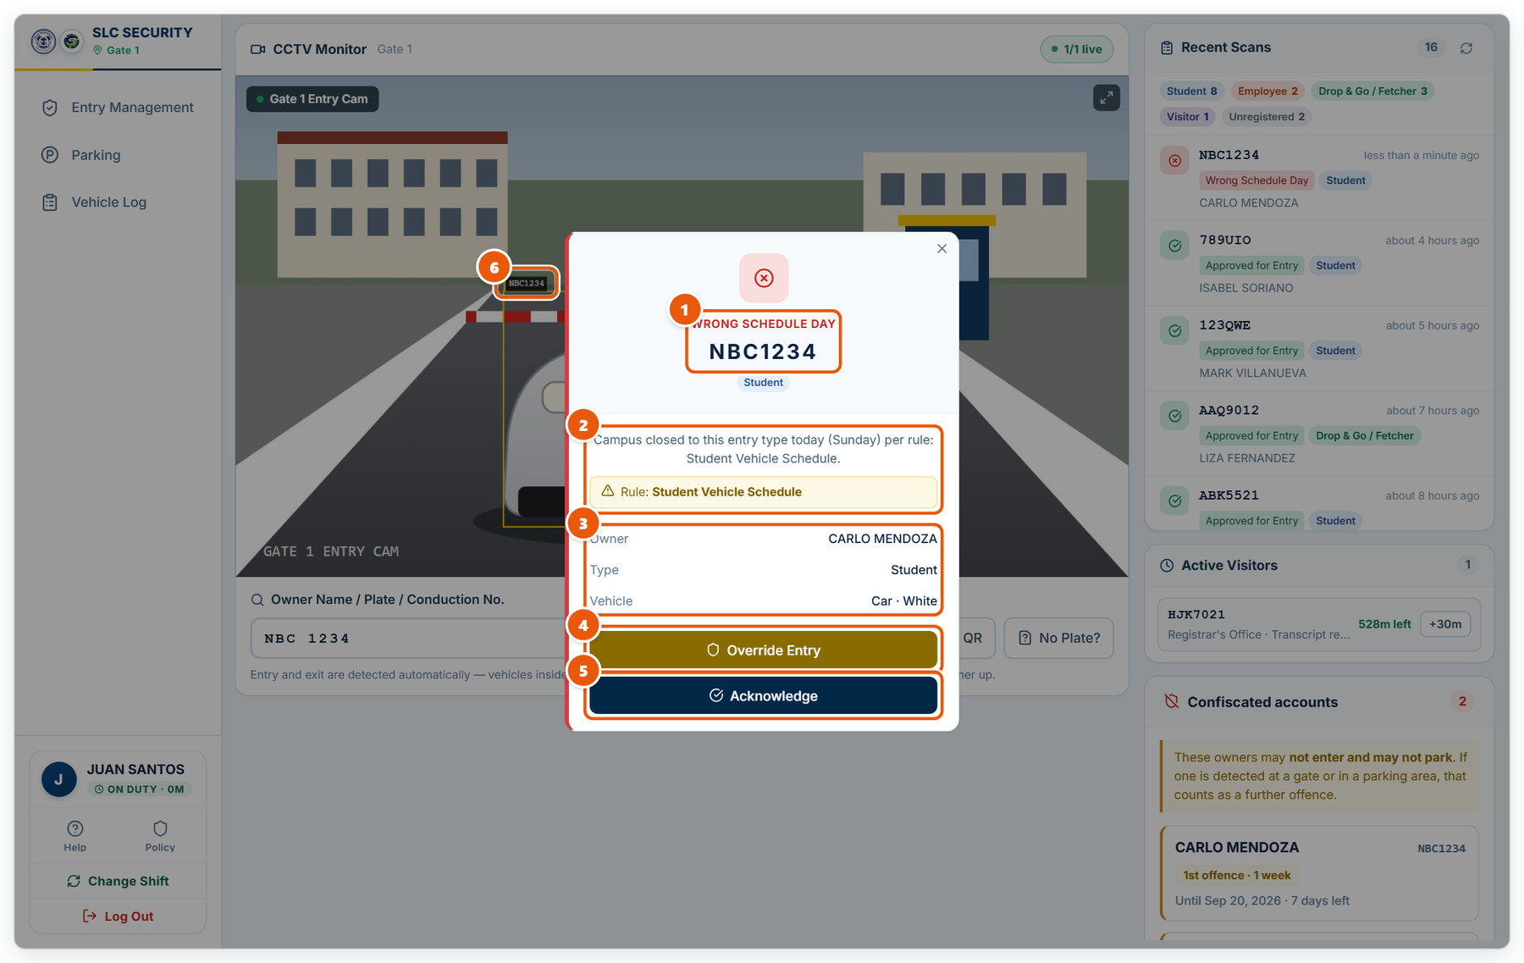
Figure 3.2: Checking a plate
1 | Decision  The result in large type: here WRONG SCHEDULE DAY, with the plate and registrant type. Approved entries show in green.
2 | Reason and rule  Why the vehicle was denied and which entry rule applied.
3 | Owner and vehicle  Check these against the vehicle in front of you.
4 | Override Entry  Let the vehicle in anyway. You must give a reason, and the override is recorded under your name.
5 | Acknowledge  Accept the decision and close the result.
6 | Detected plate  The plate the camera read, boxed on the live picture. (Sample picture shown.)

3.3 Recording a vehicle with no plate
Describe the vehicle when there is no plate the system can read.
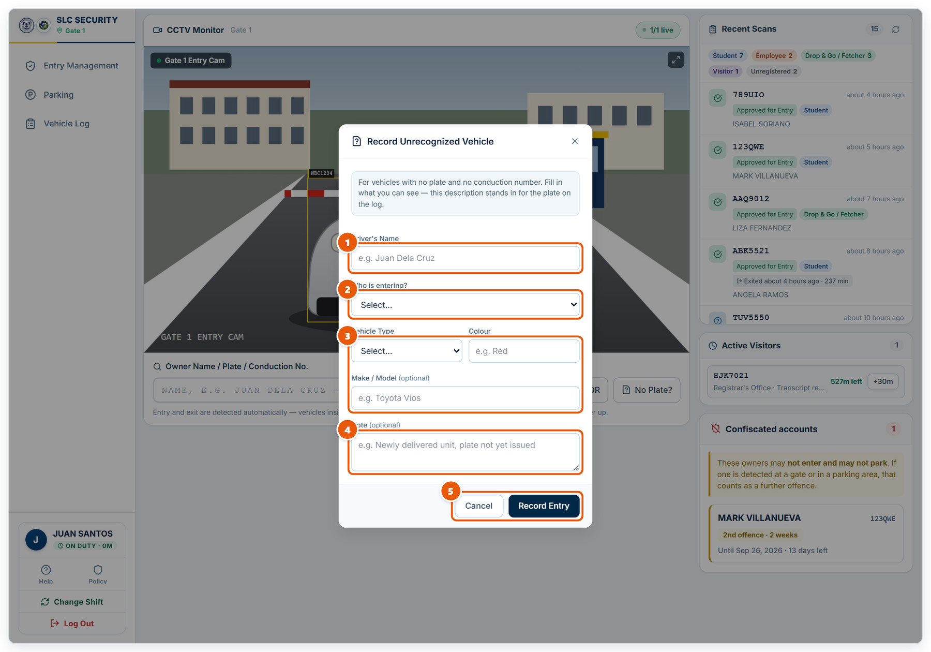
Figure 3.3: Recording a vehicle with no plate
1 | Driver's Name  The name the driver gives you.
2 | Who is entering?  Student, employee, fetcher, visitor or supplier.
3 | Vehicle description  Vehicle type, colour and make/model stand in for the missing plate on the log.
4 | Note  Anything useful, e.g. "newly delivered unit, plate not yet issued".
5 | Record Entry  Saves the entry to the Vehicle Log. Cancel closes without saving.

3.4 Parking monitor
Watch parking zones, see free spaces and act on parking offences.
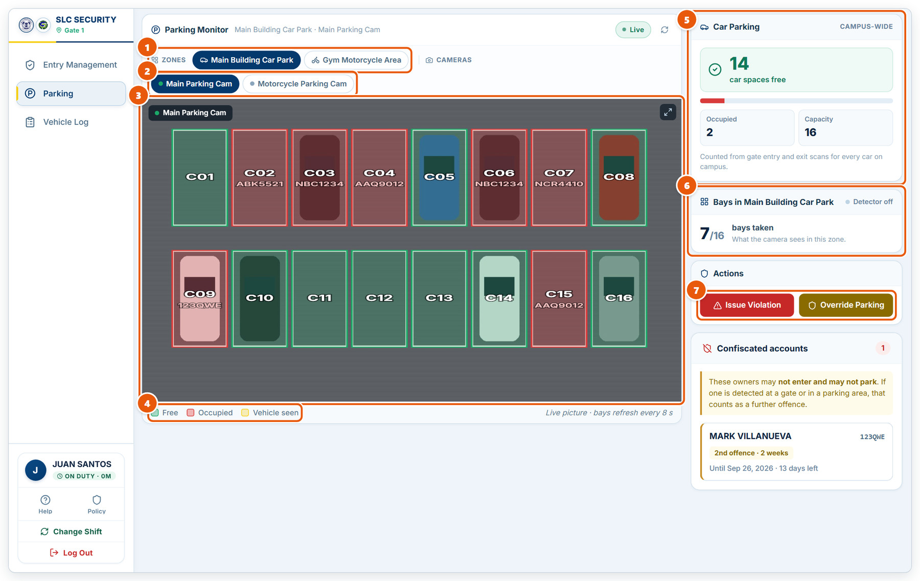
Figure 3.4: Parking monitor
1 | Zones  Pick the parking zone to watch.
2 | Cameras  Switch between the cameras watching parking.
3 | Live picture  The camera view with bay outlines. (Sample picture shown.)
4 | Legend  Free, Occupied, and Vehicle seen (a vehicle the camera is tracking).
5 | Campus-wide spaces  Free spaces for this vehicle type across campus, counted from gate entries and exits.
6 | Bays in this zone  How many bays the camera sees taken.
7 | Issue Violation / Override Parking  Record a parking offence, or let a vehicle park when the area is full (event mode).

3.5 Issuing a parking violation
The violation form opened from the parking monitor.
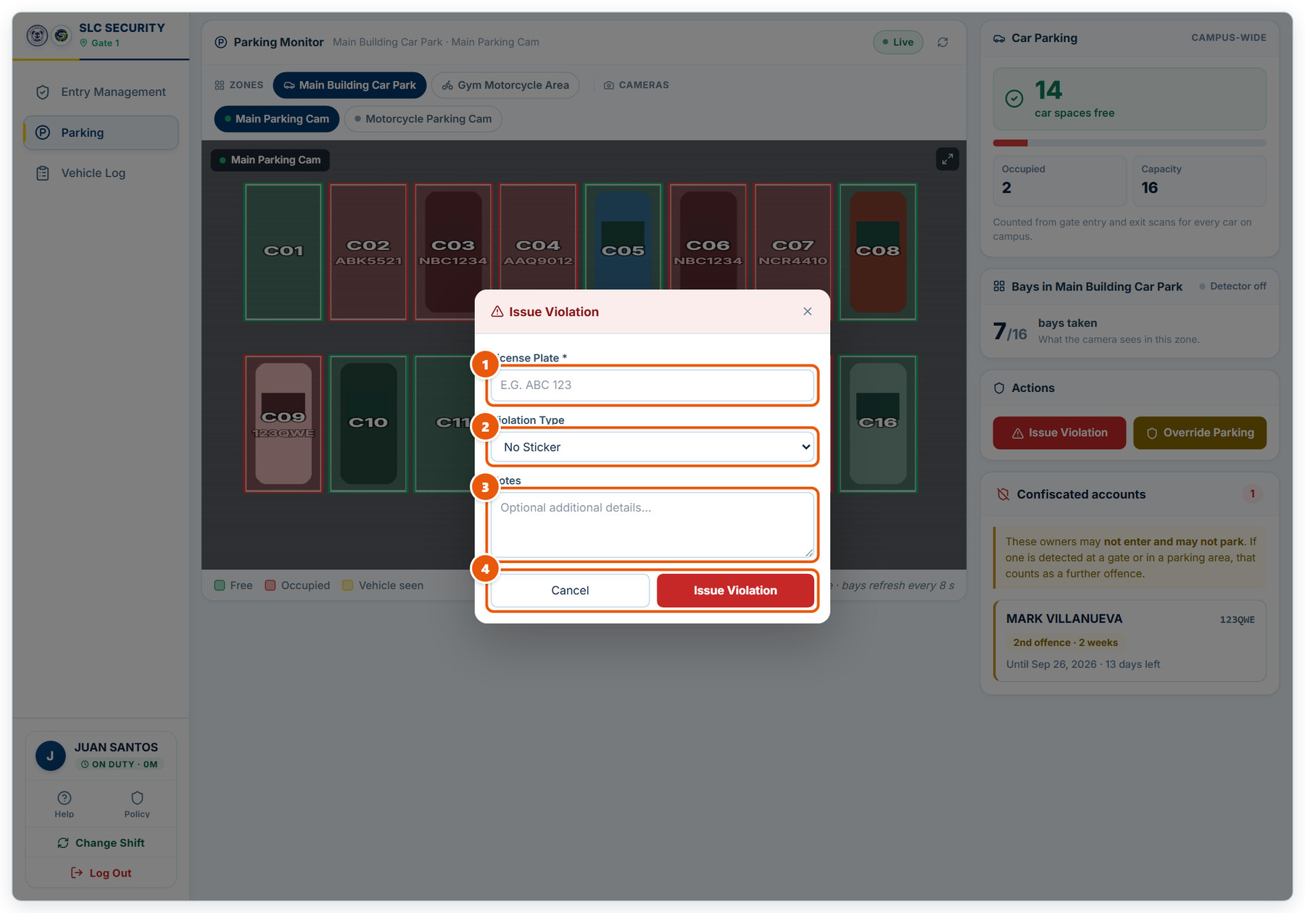
Figure 3.5: Issuing a parking violation
1 | License Plate  The plate of the offending vehicle. Required.
2 | Violation Type  Choose the offence, e.g. No Sticker, Double Parking or Time Exceed.
3 | Notes  Optional details that help the CDSO review it.
4 | Issue Violation  Records the violation against the vehicle’s owner and counts toward the offence ladder. Cancel closes without saving.

3.6 Vehicle Log (gate)
Every scan recorded at your gate.
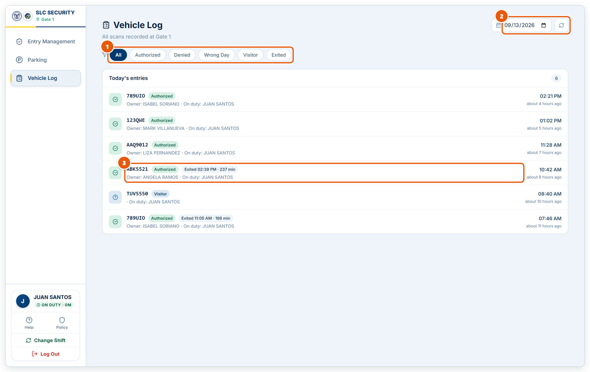
Figure 3.6: Vehicle Log (gate)
1 | Status filter  Show all scans or only one decision: Authorized, Denied, Wrong Day, Visitor or Exited.
2 | Date and refresh  Pick another day, or reload the list.
3 | Scan entry  Plate, decision, owner, guard on duty and time. Exits show when the vehicle left and how long it stayed.

4. Vehicle Owner
The portal a registered vehicle owner sees after signing in.

4.1 Vehicle owner portal: your pass
What a registered owner sees after signing in.
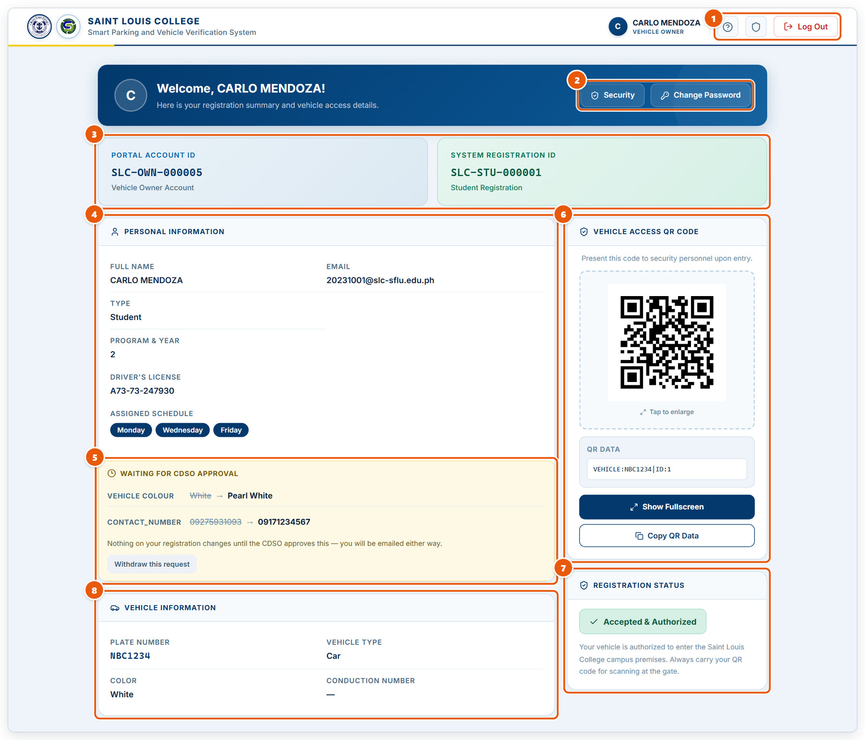
Figure 4.1: Vehicle owner portal: your pass
1 | Help, Policy and Log Out  The in-app guide, the privacy policy, and signing out.
2 | Security and Change Password  Manage two-factor authentication and set a new password.
3 | Account and registration IDs  Your portal account ID and your vehicle pass registration ID.
4 | Personal information  Your details and assigned campus days.
5 | Pending change request  A correction you asked for, waiting for CDSO approval. You can withdraw it.
6 | Vehicle access QR code  Show this at the gate. Tap to enlarge, show it fullscreen, or copy its data.
7 | Registration status  Whether your vehicle is authorized to enter campus.
8 | Vehicle information  Plate, type, colour and conduction number on file.

4.2 Vehicle owner portal: violations & parking
Further down the portal: your violation record, announcements and live parking.
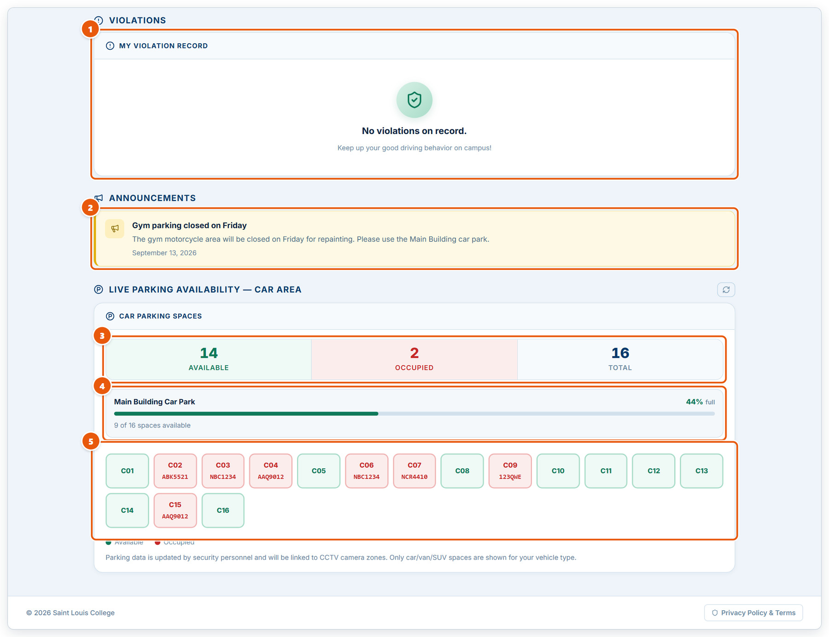
Figure 4.2: Vehicle owner portal: violations & parking
1 | My violation record  Any violations against your account and their status.
2 | Announcements  Parking notices from the CDSO.
3 | Available / occupied / total  Spaces for your vehicle type right now.
4 | Zone fill level  How full each parking zone is.
5 | Bays  Green bays are free; red bays are taken.

4.3 Account security (two-factor)
Manage your authenticator and backup codes.
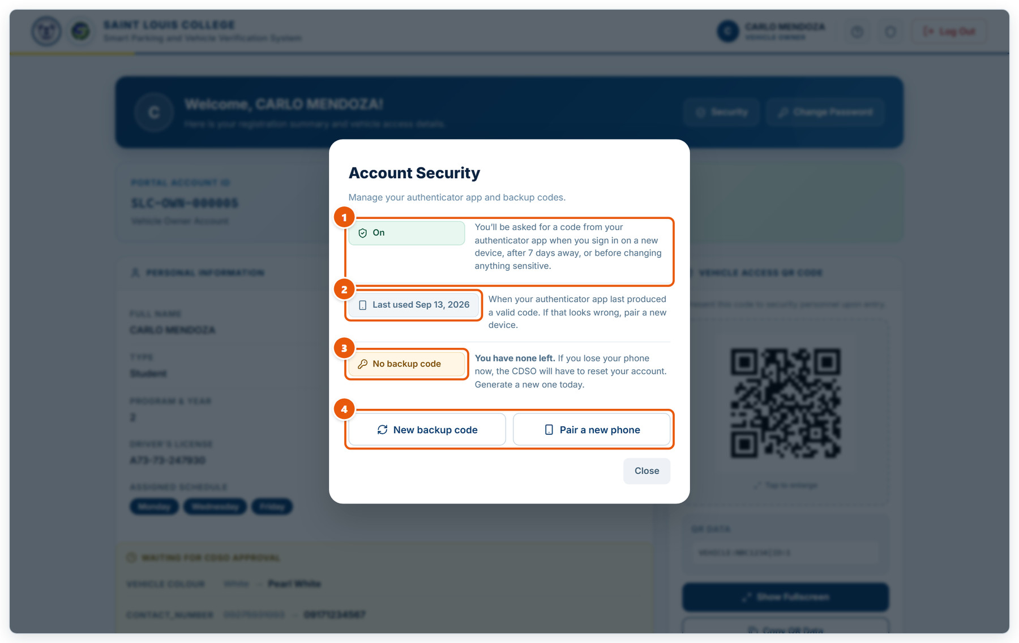
Figure 4.3: Account security (two-factor)
1 | Two-factor status  On means an authenticator code is required when you sign in on a new device, after 7 days away, or before sensitive changes.
2 | Last used  When your authenticator last produced a valid code. If that looks wrong, pair a new phone.
3 | Backup code  A one-time code for signing in if you lose your phone. Generate one and keep it somewhere safe.
4 | New backup code / Pair a new phone  Create a fresh backup code, or move two-factor to a different phone.

5. Installing the Campus System
Installing the on-campus half of the system with SLC-Smart-Parking-Campus-Setup.exe. Run it on the computer that will serve the gate terminals.

5.1 Step 1 · License Agreement
Run SLC-Smart-Parking-Campus-Setup.exe on the campus computer and accept the license to continue.
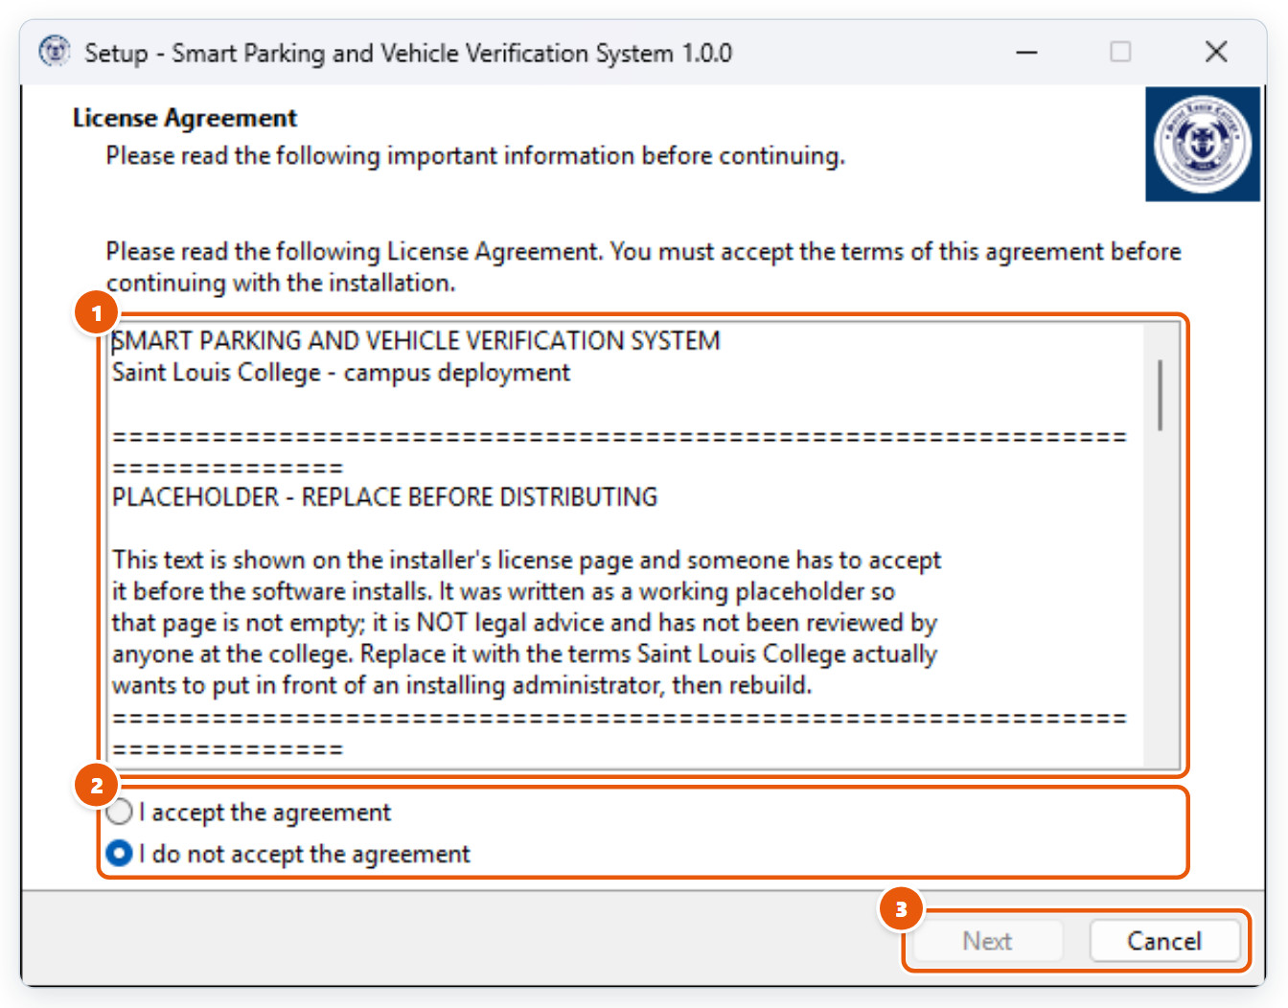
Figure 5.1: Step 1 · License Agreement
1 | License text  Read the terms for installing the system.
2 | Accept  Select "I accept the agreement". Next stays disabled until you do.
3 | Next / Cancel  Next continues. Cancel quits Setup without installing anything.

5.2 Step 2 · Choose the install folder
Keep the default folder unless your IT office says otherwise.
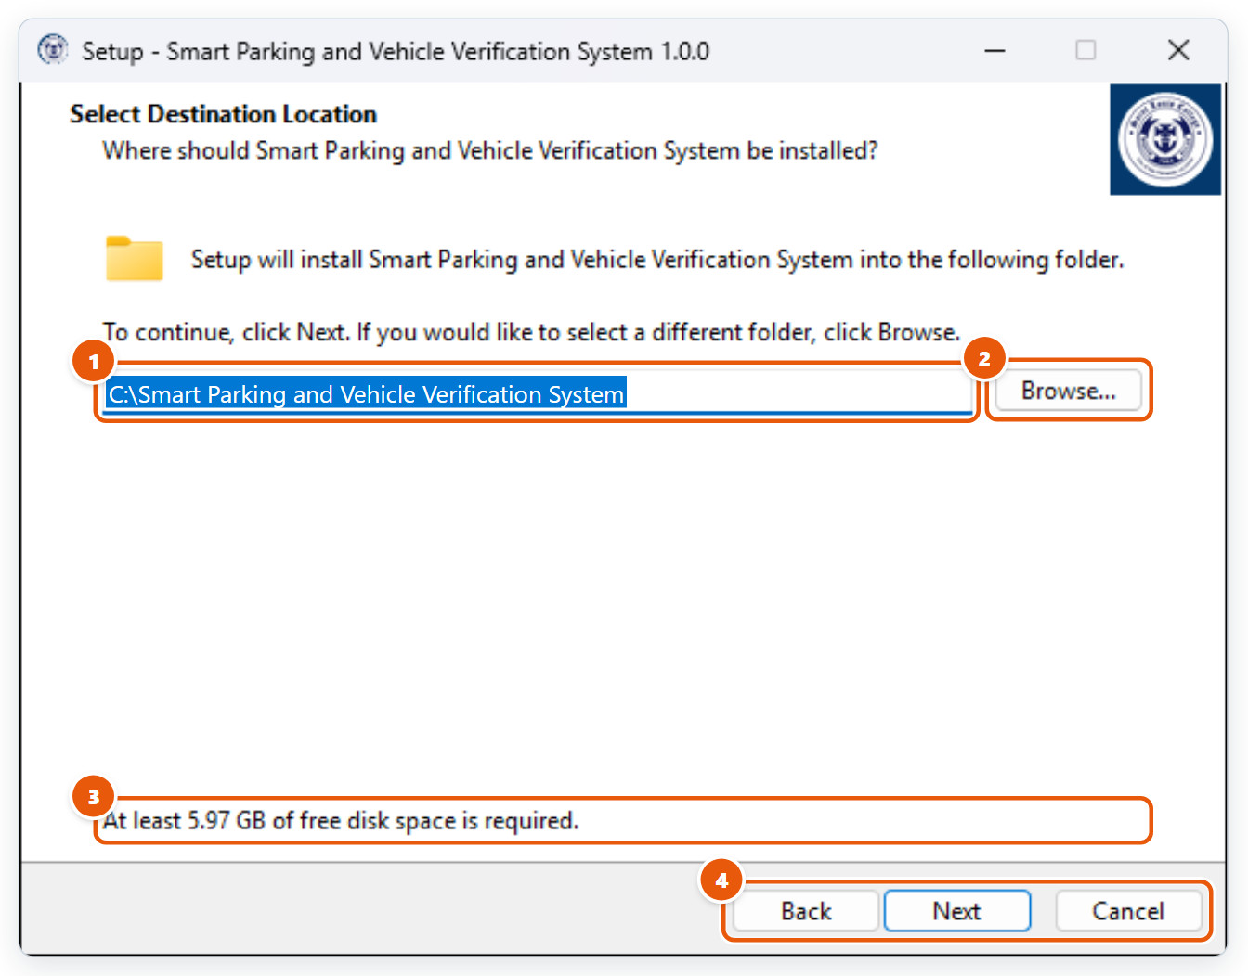
Figure 5.2: Step 2 · Choose the install folder
1 | Install folder  Default: C:\Smart Parking and Vehicle Verification System. Keep the path short: Setup refuses folders longer than 110 characters.
2 | Browse...  Pick a different folder.
3 | Disk space  About 6 GB is needed once the Python environment and application code are downloaded.
4 | Back / Next / Cancel  Next continues, Back returns to the previous page, and Cancel quits Setup without installing anything.

5.3 Step 3 · Select components
Choose what Setup installs. A full installation is right for a new gate computer.
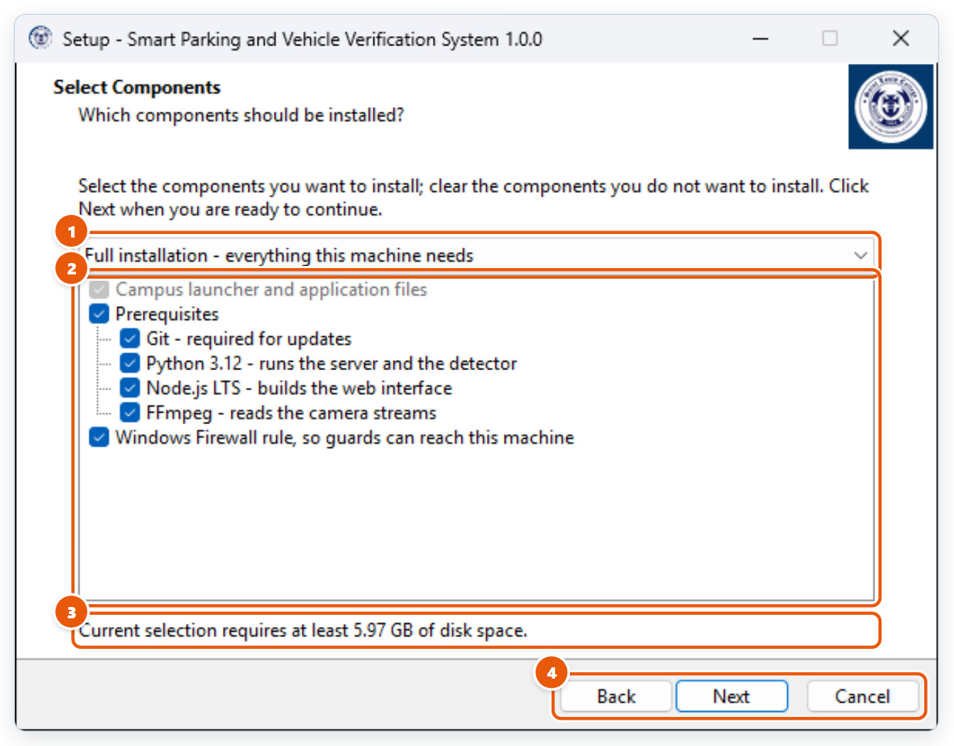
Figure 5.3: Step 3 · Select components
1 | Installation type  Full installation selects everything. Choose Custom installation to pick items yourself.
2 | Component list  The launcher is always installed. Untick Git, Python, Node.js or FFmpeg only if your IT office already manages them. The firewall rule lets guards’ computers reach this machine.
3 | Space required  Disk space the current selection needs.
4 | Back / Next / Cancel  Next continues, Back returns to the previous page, and Cancel quits Setup without installing anything.

5.4 Step 4 · Deployment options
Choose the network port the system is served on.
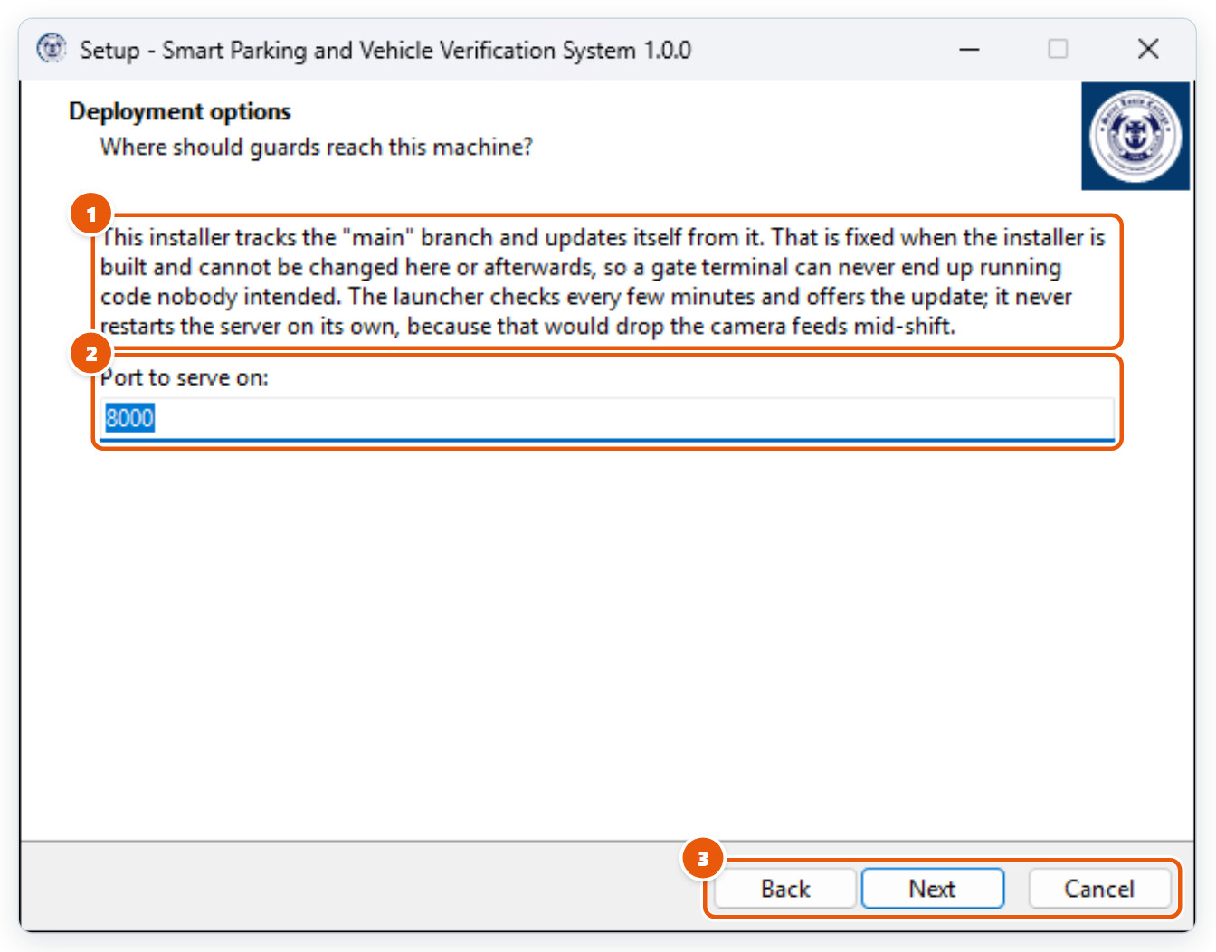
Figure 5.4: Step 4 · Deployment options
1 | Update branch  This computer follows the branch the installer was built for and updates from it. It cannot be changed here.
2 | Port to serve on  Guards open http://<this computer’s address>:<port>. Keep 8000 unless another program already uses it.
3 | Back / Next / Cancel  Next continues, Back returns to the previous page, and Cancel quits Setup without installing anything.

5.5 Step 5 · Prerequisites check
Setup shows what the computer already has before anything is installed.
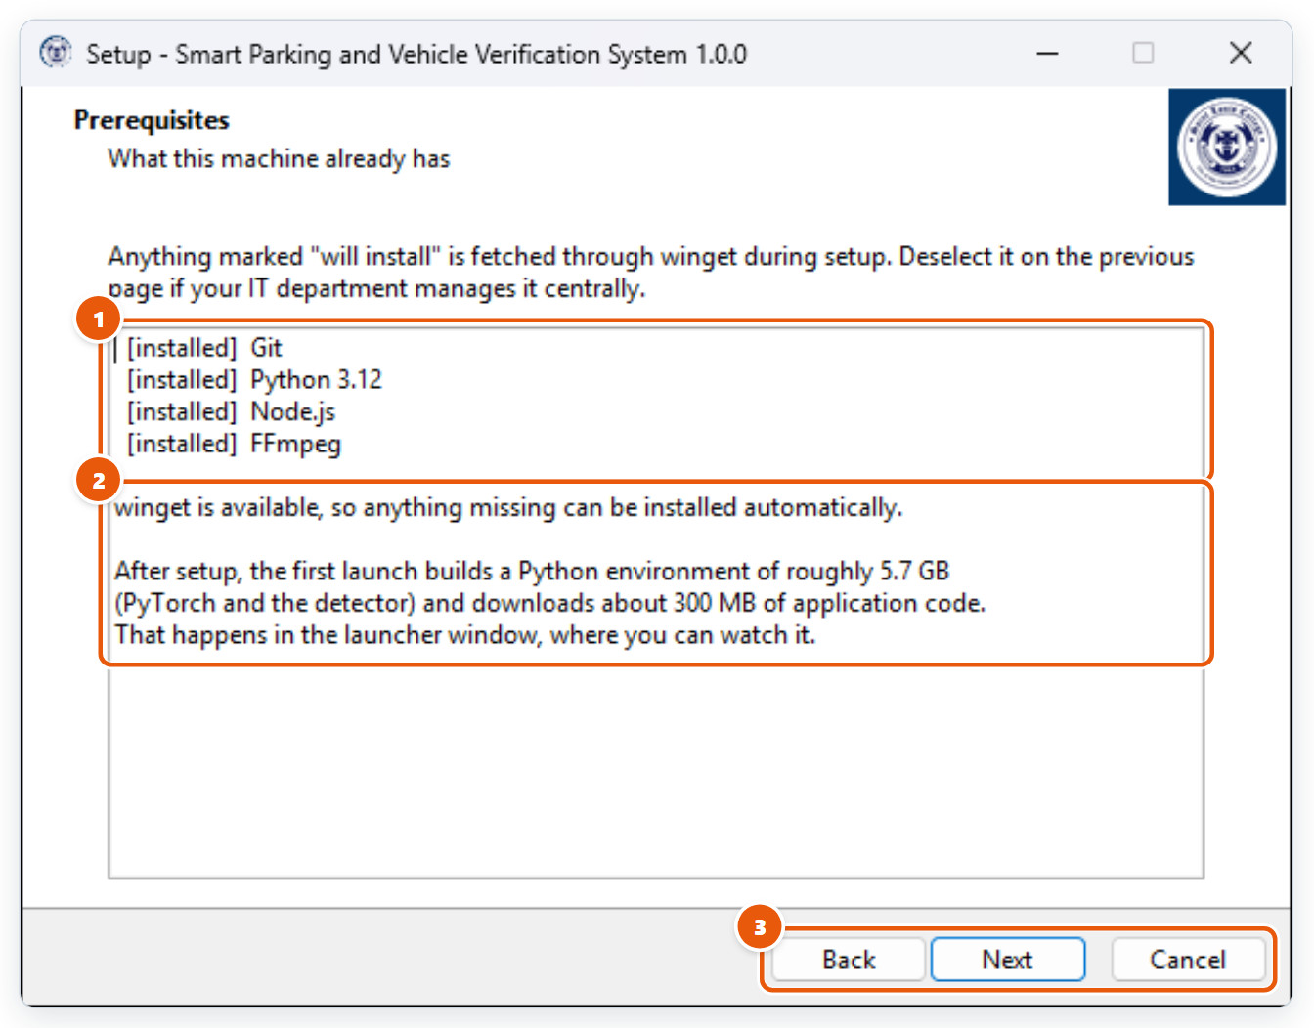
Figure 5.5: Step 5 · Prerequisites check
1 | Detected software  [installed] means it is already present; "will install" means Setup downloads it through winget.
2 | What happens next  On first launch the launcher downloads the application (about 300 MB) and builds a Python environment (about 5.7 GB). This takes a while; keep the computer online.
3 | Back / Next / Cancel  Next continues, Back returns to the previous page, and Cancel quits Setup without installing anything.

5.6 Step 6 · Start Menu folder
Where the launcher, repair and uninstall shortcuts are placed.
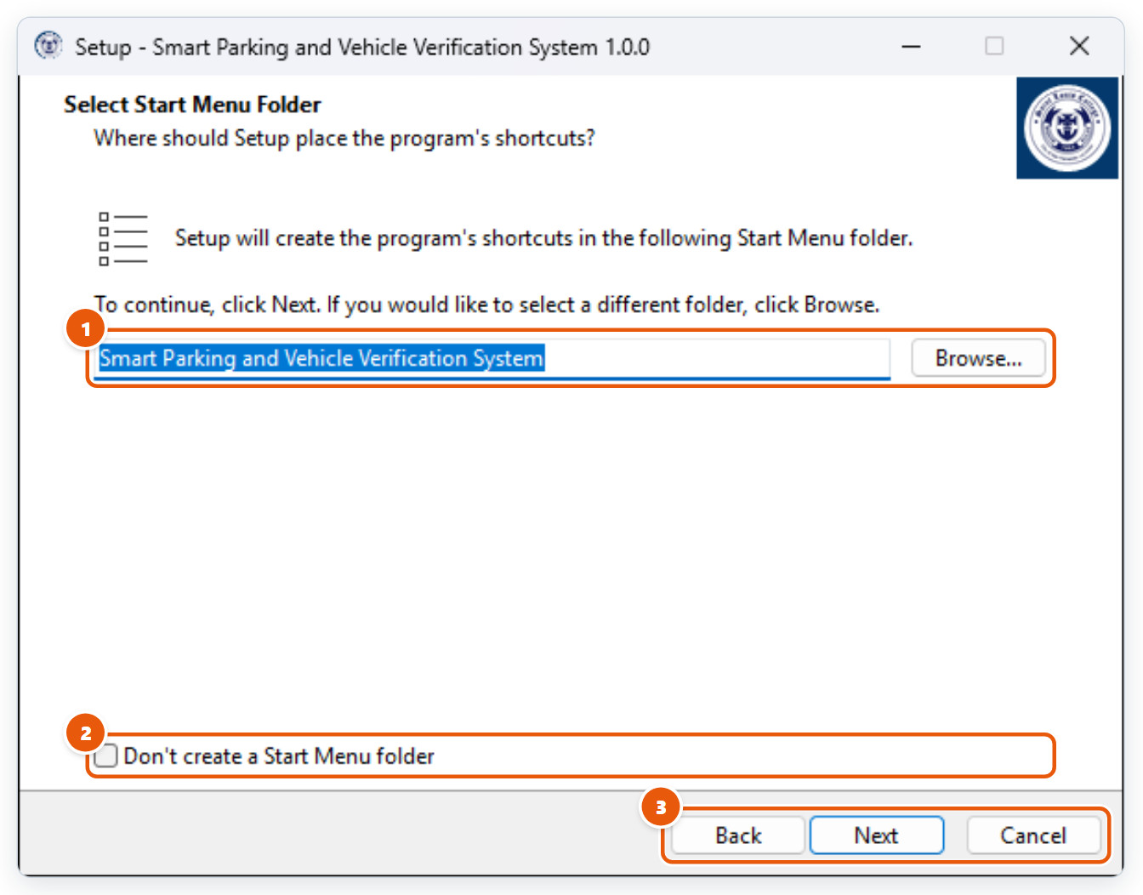
Figure 5.6: Step 6 · Start Menu folder
1 | Folder name  The Start Menu folder for the shortcuts. The default is fine.
2 | No Start Menu folder  Tick to skip creating Start Menu shortcuts.
3 | Back / Next / Cancel  Next continues, Back returns to the previous page, and Cancel quits Setup without installing anything.

5.7 Step 7 · Additional tasks
Optional shortcuts and system changes.
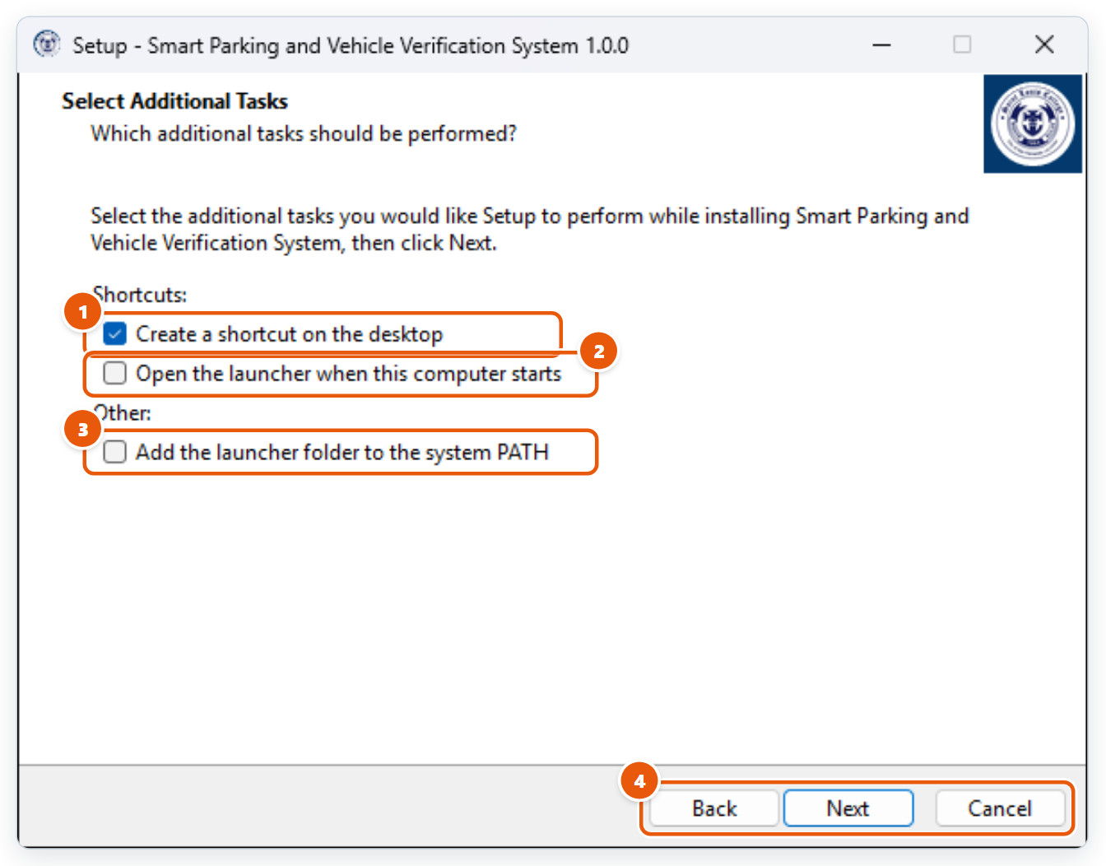
Figure 5.7: Step 7 · Additional tasks
1 | Desktop shortcut  Puts a launcher shortcut on the desktop (recommended).
2 | Open at startup  Opens the launcher automatically when the computer starts. Recommended for a dedicated gate computer.
3 | Add to PATH  For IT staff who run the launcher from a command prompt. Usually not needed.
4 | Back / Next / Cancel  Next continues, Back returns to the previous page, and Cancel quits Setup without installing anything.

5.8 Step 8 · Ready to install
Check the summary, then click Install. The launcher opens when Setup finishes.
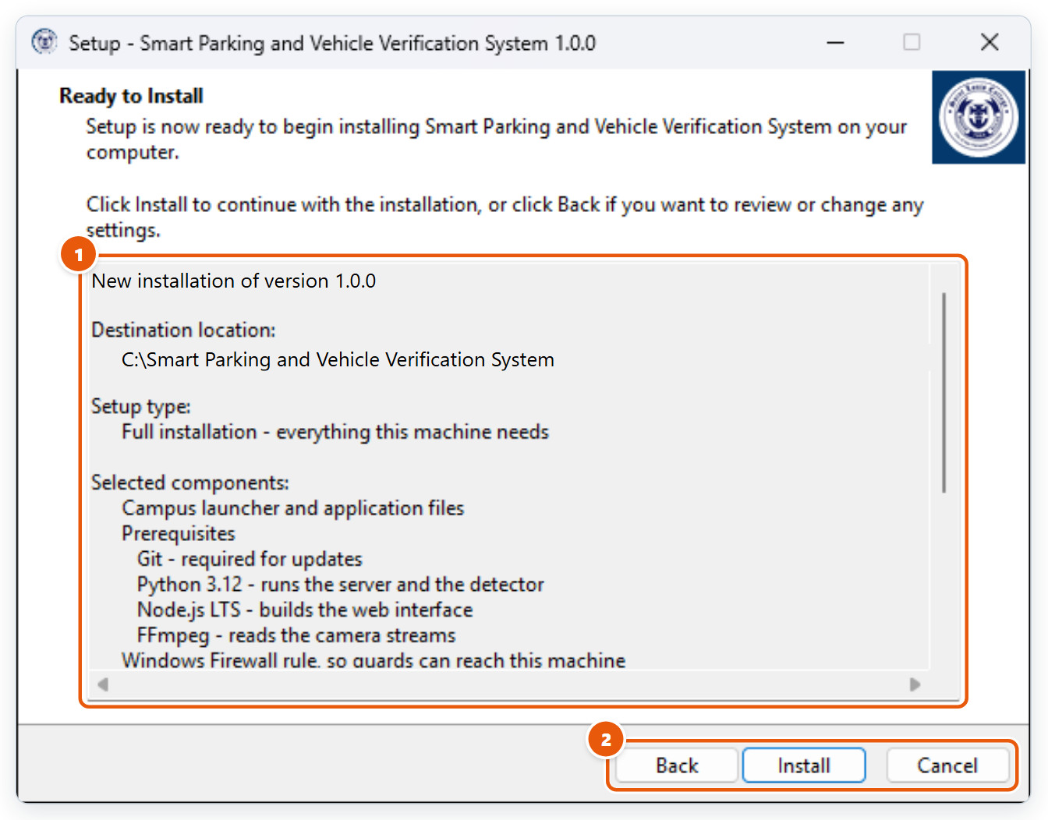
Figure 5.8: Step 8 · Ready to install
1 | Summary  Install type, destination, components and tasks. Click Back to change anything.
2 | Back / Install / Cancel  Install continues, Back returns to the previous page, and Cancel quits Setup without installing anything.

6. Running the Campus System
The launcher window that runs the campus server after installation.

6.1 The campus launcher
Opened from the desktop or Start Menu shortcut. It runs the server that the gate terminals connect to, so leave this window open.
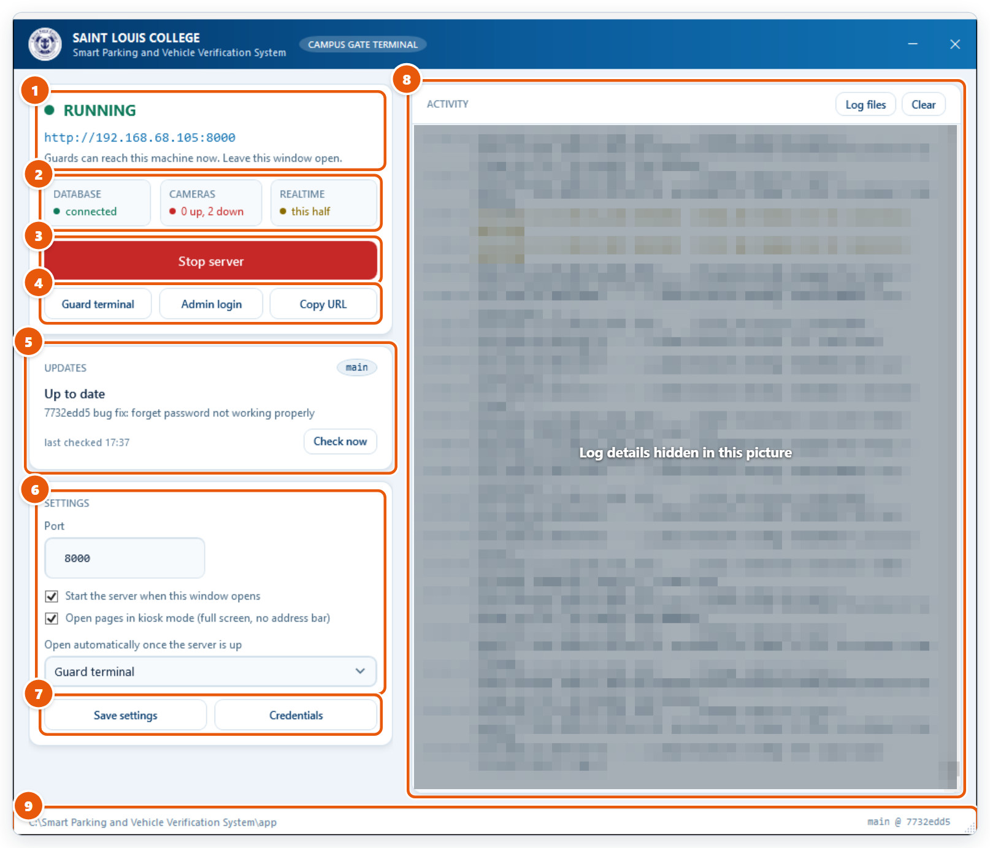
Figure 6.1: The campus launcher
1 | Server status and address  RUNNING or STOPPED, and the address guards and CDSO staff open in their browsers.
2 | Health  Database connection, cameras online, and whether live updates are working.
3 | Start / Stop server  Starts or stops the system. Stopping it disconnects every gate terminal and camera.
4 | Open pages  Guard terminal opens the gate sign-in page, Admin login opens the CDSO login, and Copy URL copies the address.
5 | Updates  Checks for a newer version every few minutes. When one is found, click "Update and restart" at a quiet moment: restarting drops the camera feeds briefly.
6 | Settings  Port, start the server when this window opens, kiosk mode (full screen), and which page opens automatically.
7 | Save settings / Credentials  Save your changes. Credentials holds the shared database URL and secret key; it is only needed once per computer.
8 | Activity  Live messages from the server. Log files opens the saved logs; Clear empties this view. Useful when reporting a problem.
9 | Install location and version  Where the application lives and which version (branch and commit) is running.

