Vadim Reger vreg113

**Report**

Let's start with discussing the red(#A2231D) custom colour I was assigned to. In this assignment we need to use the given colour as the primary colour on the webpage. I realized that the usage of this particular colour for the background is not appropriate as it is highly saturated, and therefore it will distract a user. So that I have decided to use the Photoshop to make some of the pictures I found on the internet coloured in red(#A2231D).

Working on the background image, I was experimenting with combining red colour with other colours. I came up with the idea of using white (#FFFFFF) and a shade of black (#282726) colours to make my overall design look good and have an excellent contrast ratio corresponding to the design principles, as well as to balance colours and make red less aggressive.

While working on the design decisions for the webpage, I thought of Gestalt principles that will need to be conserved. Starting with the Proximity Principle that divides objects into logical groupings. Therefore, registration form (shown below) is clearly divided into three groups by using more spacing between each grouping.

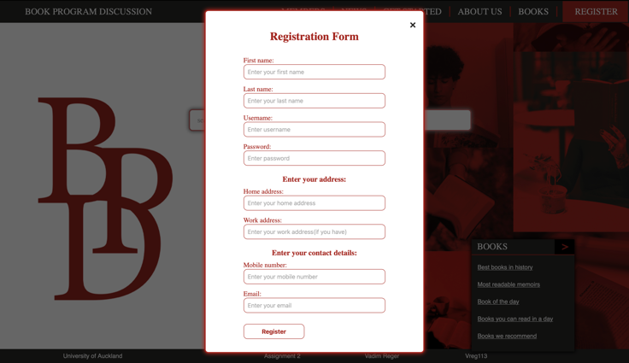

Objects such as two boxes, "GET INVOLVED" and "BOOKS", have similar visual characteristics such as size, shape and colours. Therefore, it is seen as a group of related objects. Moreover, the navigation bar on the top has tabs such as "MEMBERS", "NEWS", "GET STARTED", "ABOUT US", "BOOKS" that are divided by the red vertical line, which makes it look like a group of related objects. Thus, the Gestalt Principle of Perception is also conserved.

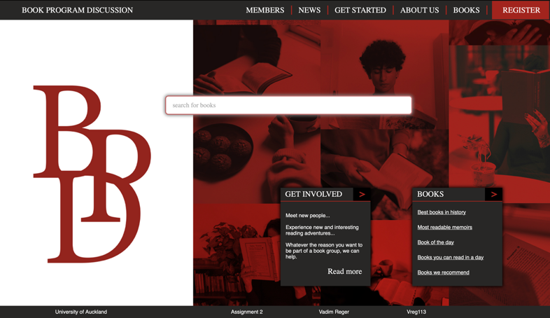

Fate Principle states, "Objects that share a beginning, and the end are seen as related". This principle shown in both the Registration Form and on the main page in the box "BOOKS" with groupings of prompts for the user.

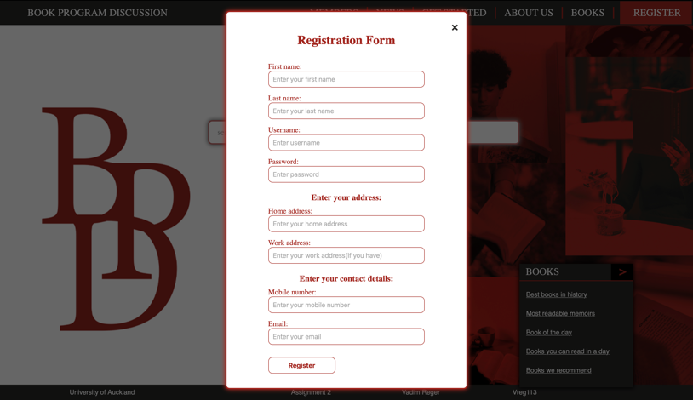

When I was thinking of where to place the logo, I decided to put it in the centre of a white background that takes almost one-third of the webpage; this makes the logo stand up and can be clearly seen. Also, the central position of the "search for books" prompt helps users to find it in the first seconds of their journey.



In designing the webpage, I struggled in achieving symmetrical balance since I wanted the logo to be clearly visible. Therefore, I have decided not to place the red background on entire webpage, but to place the logo on the white background on the left part of the screen. Thus, this design decision led me to make my design asymmetrically balanced.

To emphasize some parts of the webpage, I had to use different techniques to achieve this. First of all, I found colours that have good contrast ratio with my primary red colour, and that these colours look balanced. Doing a little research, I found out that the black colour looks nice with the red webpages, but the contrast ratio with my red colour was 2.79:1, which is terrible; therefore, I decided to use white colour to emphasize some of the objects. Secondly, I wanted the "search for books" prompt and logo to be the main parts on the screen. Thus, I placed it in the middle since central vision is dominant. Also, to make the logo even more emphasized, I have decided to place it apart from all the objects on the screen.

Unity was achieved in the design by creating the colour scheme with compatible colours and making all parts of the design to have some commonality. Such parts are boxes on the bottom of the screen and the navigation bar that shows similar tabs that user can click on.



To meet the principles of accessibility, I first needed to find colours that have a good contrast ratio. Also, I wanted to use red and shade of black colours as my primary colours, but since they have a terrible contrast ratio, I had to work with other colours to emphasize objects. I chose the white colour (#FFFFFF), which has a good contrast ratio with both black colour (#282726) 14.91:1 and my assigned red colour (#A2231D) 7.51:1. In addition, all the tabs on the website can be clicked and found using just the keyboard, so users with mobility impairments can achieve their goals easily. Moreover, the Registration Form has all the labels above the input prompt, so the user can easily understand what needs to be inserted. Last but not least, I have made a title of the webpage that specifies the name of the website so users can easily understand where they are on the web and what approximate content will be on this webpage.



