U.S. Agricultural Commodity Prices Across Business Cycles
A 30-Year Study of Corn, Soybeans, and Wheat | English Essay and 简明中文翻译
Research-based draft | Data: uploaded monthly panel, cycle regressions, rolling-window estimates, shock comparisons, and original figures
Important: This paper reports associations, not proven causal effects. Cycle classification and time-series specification require verification before academic submission.

Part I. English Essay

1. Research Overview
Agricultural prices affect farmers, consumers, and food supply chains. Corn, soybeans, and wheat are major U.S. crops. Their prices can change with energy costs, interest rates, the value of the U.S. dollar, inflation, and unexpected events. This essay studies monthly data from 1995 to 2025 and asks whether these relationships are different across business cycles. The study uses a monthly panel of 1,137 crop-month records, covering three crops and 379 calendar months. The main goal is to compare economic regimes rather than rely only on one average regression for the full period.
The figures from the original research show long-run movements and short-run changes in crop prices. Large price movements around major events make a cycle-based analysis useful, although a chart alone cannot show what caused a change.
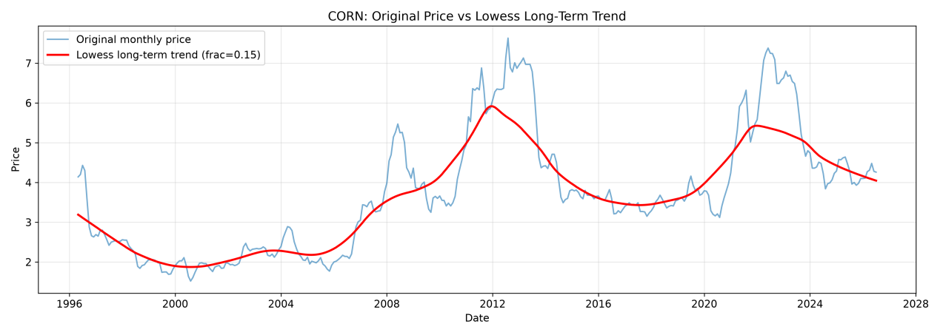
Figure 9. Corn price series and fitted trend
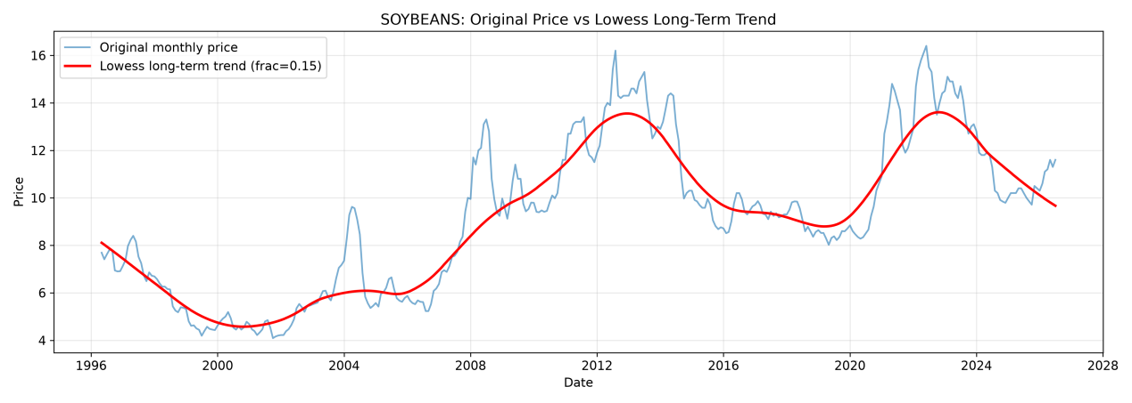
Figure 11. Soybean price series and fitted trend
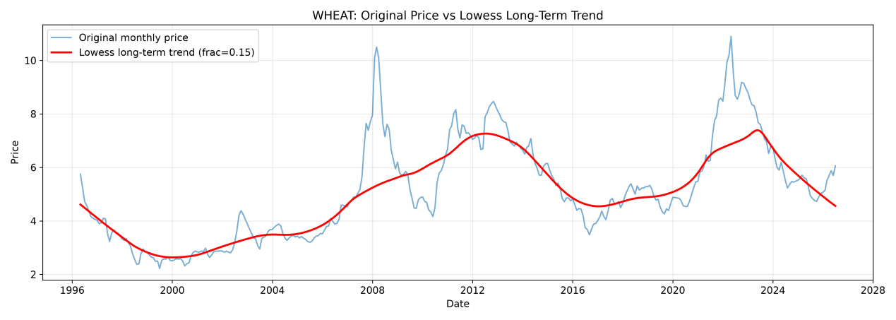
Figure 13. Wheat price series and fitted trend

2. Economic Cycle Framework
The Merrill investment clock separates the economy into four regimes using the direction of growth and inflation. In recovery, growth rises while inflation falls. In overheating, both rise. In stagflation, growth falls while inflation rises. In recession, both fall. The research compares each regime with the full sample. Its working hypotheses are: (H1) macroeconomic coefficients change across regimes; (H2) energy prices and interest rates have different relationships with crop prices; and (H3) the three crops do not respond equally.
The uploaded regression output assigns 242 observations per crop to overheating, 91 to stagflation, 21 to recession, and only 9 to recovery; the full-sample count is 363. These unequal groups matter. In particular, estimates from recovery are too unstable for strong interpretation. The method used to calculate growth and assign months to regimes must also be checked before the cycle labels are treated as final.
Regime | Growth direction | Inflation direction | Observations per crop
Recovery | Up | Down | 9
Overheating | Up | Up | 242
Stagflation | Down | Up | 91
Recession | Down | Down | 21
Full sample | All | All | 363
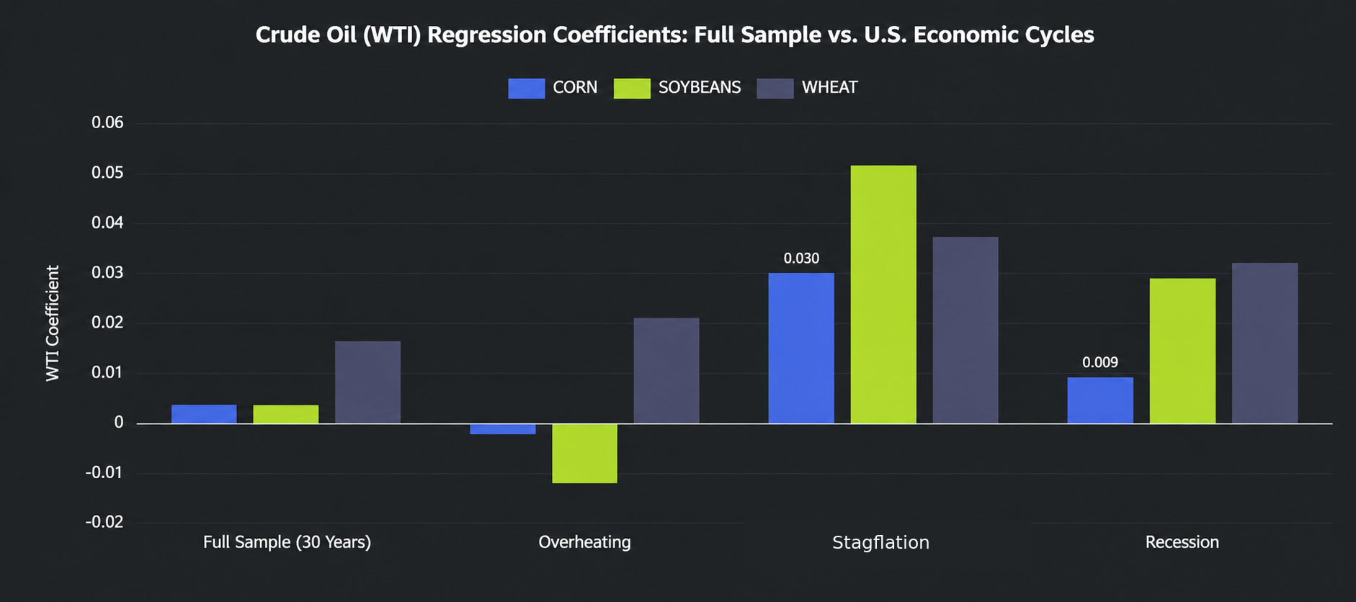
Figure 15. WTI crude-oil regression coefficients: full sample versus selected economic regimes (English labels).

3. Data and Methodology
The data include monthly crop prices, WTI oil prices (WTI_OIL), the federal funds rate (FFR), a U.S. dollar index (USD_INDEX), and the consumer price index (CPI). The models also include event indicators for the Renewable Fuel Standard (RFS), the 2012 drought, the U.S.–China trade war, COVID-19, and the Russia–Ukraine war. Two interaction terms, WTI_DROUGHT and FFR_SEASON, examine whether selected relationships change under special conditions.
The original study estimates separate OLS models for each crop and economic regime and reports Newey–West heteroskedasticity and autocorrelation consistent (HAC) standard errors. The results also include R², Durbin–Watson statistics, autocorrelation plots, rolling-window estimates, and before/after shock comparisons. The coefficient sizes depend on the variables’ units, so a large number does not automatically mean a larger economic effect. These models describe conditional relationships; they do not by themselves identify causal impacts.

4. Missing Data Analysis and Treatment

4.1 Missingness Patterns and Distribution
The panel contains 1,137 crop–month observations (379 each for corn, soybeans, and wheat). Agricultural prices and the five event indicators have no missing values. Among the macroeconomic variables, WTI crude oil prices and the federal funds rate each have 36 missing entries (3.2%), CPI has 39 (3.4%), and the US Dollar Index has 1,017 (89.4%). Only 40 observations per crop are complete across all regression variables; 339 per crop (89.4%) have at least one missing explanatory variable. Figures 2–4 show a 30-row diagnostic excerpt, in which USD_INDEX is missing in 5 rows; Figure 5 presents the missingness pattern for the full 1,137-row panel. The excerpt is not representative of the overall missingness rate.
Figure 3. Histogram of variable completeness in the diagnostic excerpt (30 observations).
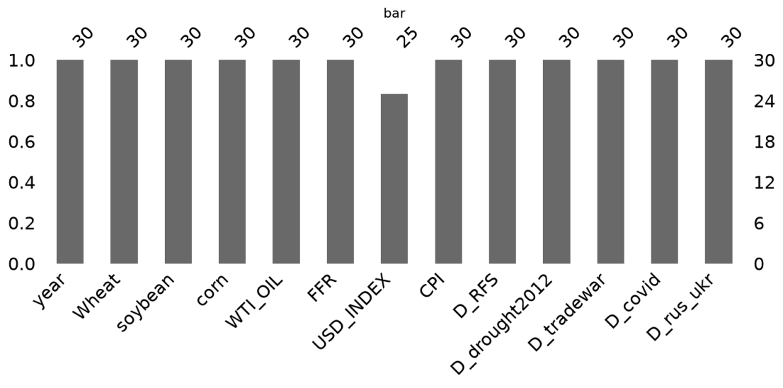
Figure 5. Missing-value heatmap of the full 1,137-row crop–month panel.
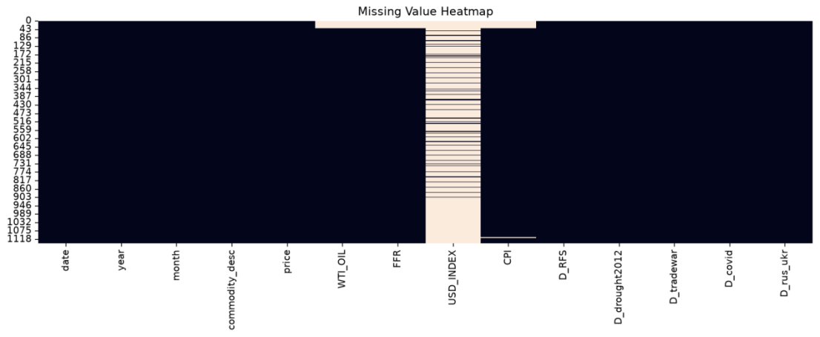

4.2 Price Distributions and Sigma Intervals
Figures 6–8 compare the full 379-price distribution (blue) with the 40 complete-case prices (green). The red vertical line is the full-sample mean, while the orange and green lines mark ±1 and ±2 sample standard deviations (σ). To locate the 339 incomplete explanatory-variable records precisely, prices in those records were classified using each crop’s full-sample mean and sample standard deviation. The four mutually exclusive categories are |price − mean| ≤ 1σ, 1σ < |price − mean| ≤ 2σ, 2σ < |price − mean| ≤ 3σ, and >3σ. These are price positions associated with missing macroeconomic data, not missing price observations.
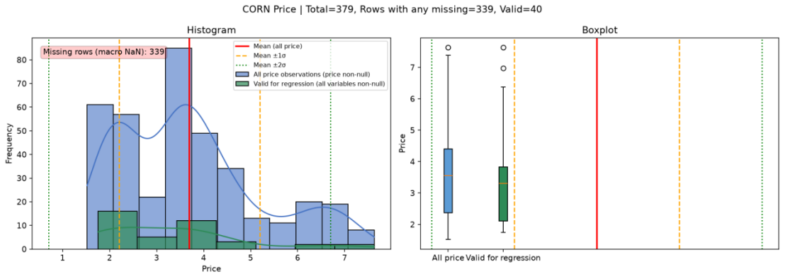
Figure 6. Corn price distribution and boxplots (all observed versus complete-case rows).
Corn (mean 3.697; σ 1.498): Of the 339 rows with at least one missing explanatory variable, 214 (63.1%) have prices within ±1σ, 105 (31.0%) lie between 1σ and 2σ, and 20 (5.9%) lie between 2σ and 3σ; none exceed 3σ. Thus 319 (94.1%) fall within ±2σ. The all-price boxplot has a high-price tail, but missing explanatory variables are not restricted to that tail.
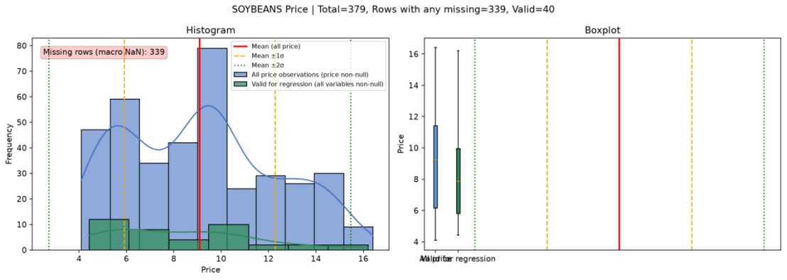
Figure 7. Soybean price distribution and boxplots (all observed versus complete-case rows).
Soybeans (mean 9.087; σ 3.186): Among the 339 incomplete rows, 194 (57.2%) fall within ±1σ, 141 (41.6%) between 1σ and 2σ, and 4 (1.2%) between 2σ and 3σ; none exceed 3σ. Therefore, 335 (98.8%) lie within ±2σ. The incomplete records span both central and less typical price levels, rather than being confined to extremes.
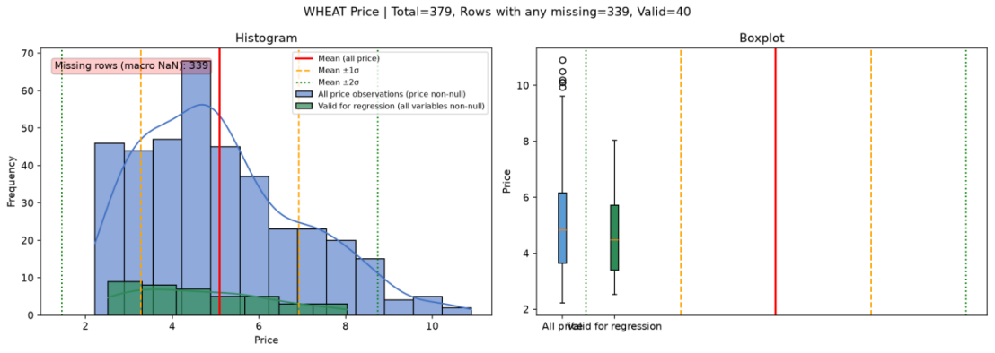
Figure 8. Wheat price distribution and boxplots (all observed versus complete-case rows).
Wheat (mean 5.091; σ 1.823): Among the 339 incomplete rows, 225 (66.4%) lie within ±1σ, 100 (29.5%) between 1σ and 2σ, 13 (3.8%) between 2σ and 3σ, and 1 (0.3%) beyond 3σ. In total, 325 (95.9%) lie within ±2σ. The boxplot also shows high-price outliers, one of which corresponds to a record with missing explanatory-variable information beyond 3σ.
Across the three crops, the largest number of incomplete records occurs within ±1σ, and 94.1%–98.8% occur within ±2σ. This reflects the location of prices associated with incomplete macroeconomic observations; it does not establish a missing-at-random mechanism. Deleting incomplete rows would discard 339 of 379 monthly observations for each crop, including many observations at ordinary price levels.

4.3 Iterative Imputation of Missing Explanatory Variables
Missing macroeconomic values were estimated using iterative imputation based on Bayesian ridge regression. For each incomplete explanatory variable, available values of the other explanatory variables informed its predicted values, which were updated iteratively. Bayesian ridge regularization helps stabilize predictions in the presence of correlated macroeconomic indicators. Agricultural prices were retained as observed rather than imputed.
The resulting completed explanatory-variable dataset was used in the subsequent commodity-price regressions. The substantial reconstruction of USD_INDEX (89.4% of crop–month entries) remains an important limitation: its estimated association with crop prices depends heavily on imputed information and should be interpreted cautiously.

5. Regression Results and Cross-Cycle Comparison

5.1 Recovery: Small-Sample Positive Rate and Inflation Associations
The recovery regime includes only nine observations per crop, so its statistically significant associations should be interpreted cautiously. The following discussion summarizes direction and significance rather than individual coefficients.
WTI oil is significantly and positively associated with corn and soybeans, but not wheat. FFR and CPI are significantly positive for all three crops, in contrast to their generally negative relationships in the other regimes. The US Dollar Index is significantly negative for all three crops. The RFS indicator and the FFR–season interaction are also significantly positive, while the drought indicator and the oil–drought interaction are significantly negative. The trade-war, COVID-19, and Russia–Ukraine indicators cannot be separately identified in this small subsample. Large estimated effects should not be interpreted as stable or causal.

5.2 Overheating: Negative Dollar and Rate Effects with Positive Event Indicators
Overheating has 242 observations per crop and shows a clear negative dollar-price association. The following discussion summarizes direction and statistical significance.
The US Dollar Index is significantly negative for corn, soybeans, and wheat. FFR is negative for all three crops, significantly so for corn and soybeans; WTI oil is insignificant across crops. CPI has a weak negative association only for wheat. RFS, the 2012 drought, COVID-19, and Russia–Ukraine indicators are significantly positive for all three crops. The trade-war indicator is positive and significant for corn and wheat, but not soybeans. The oil–drought interaction is significantly negative for all crops, while the FFR–season interaction is negative but insignificant.

5.3 Stagflation: Consistent Positive Oil Associations
Stagflation has 91 observations per crop and displays the most consistent positive oil-price relationship. The following discussion summarizes direction and statistical significance.
WTI oil is significantly positive for all three crops, whereas FFR and CPI are significantly negative for all three. The US Dollar Index is insignificant across crops. The RFS, drought, COVID-19, and Russia–Ukraine indicators are significantly positive for all three crops. The trade-war indicator is positive and significant for corn and wheat but not soybeans. Unlike overheating, the oil–drought interaction is significantly positive for every crop. The FFR–season interaction is negative for all crops, but significant only for wheat.

5.4 Recession: Heterogeneous Rates and COVID-19 Responses
Recession includes only 21 observations per crop, limiting the stability of its estimates. The following discussion summarizes direction and statistical significance.
WTI oil is positive but insignificant for all three crops. FFR is negative across crops but significantly negative only for soybeans, where the estimated association is comparatively large. The US Dollar Index is insignificant for all three; CPI is significantly negative for corn and wheat, but not soybeans. The RFS and Russia–Ukraine indicators are significantly positive for all three crops. The COVID-19 indicator is significantly negative for soybeans and weakly positive for wheat, but insignificant for corn. The drought and trade-war indicators and the oil–drought interaction are not identified in this subsample. The FFR–season interaction is significantly positive only for soybeans.

5.5 Shared Regression Patterns and Cross-Cycle Differences
The RFS indicator is positive and statistically significant for corn, soybeans, and wheat in all four cycle-specific regressions, making it the clearest common positive association in the reported estimates. No explanatory variable is consistently significant and negative for all three commodities across all four regimes, and no variable is uniformly insignificant across every crop and regime. The Russia–Ukraine indicator is significantly positive in the overheating, stagflation, and recession samples where it is estimable, but the recovery sample does not provide comparable event variation. Federal funds rate coefficients are negative for all three crops in overheating, stagflation, and recession, although statistical significance differs; the recovery estimates instead have positive signs and are based on only nine observations per crop.
The main differences across regimes concern the macroeconomic variables and interactions. WTI oil is significantly positive for all three commodities in stagflation, but does not show the same consistent significant association in overheating or recession. The US Dollar Index is significantly negative for all three crops in overheating and recovery, but not uniformly significant in stagflation or recession. The oil–drought interaction reverses its reported direction between overheating and stagflation, while CPI, the drought, trade-war and COVID-19 indicators, and the rate–season interaction vary by commodity or regime. These are within-model associations; changes in significance or sign do not, by themselves, constitute formal tests of differences between cycle coefficients. Event indicators with no within-regime variation should not be interpreted as evidence of zero effects.
The two interaction terms require conditional rather than standalone interpretation. WTI_DROUGHT is the product of WTI oil prices and the 2012 drought indicator: its coefficient measures how the marginal oil–price association differs during the drought relative to non-drought months, holding the other regressors constant. It is significantly negative for all three crops during overheating but significantly positive during stagflation. Thus the oil–price association appears to change with both drought exposure and the macroeconomic regime; the interaction coefficient is not itself the total effect of drought. In recovery, the negative estimates are unstable because of the very small sample; in recession the term is not separately identified. FFR_SEASON measures how the federal-funds-rate association changes with the seasonal indicator used in the model. Its positive recovery estimates should not be interpreted as robust evidence given only nine observations. During recession the interaction is significantly positive for soybeans, whereas in stagflation it is significantly negative for wheat; most other cycle–crop estimates are not significant. The marginal interest-rate association therefore depends on the main FFR coefficient plus the relevant interaction contribution, rather than on either coefficient in isolation.
Crop | Full-sample FFR | Stagflation WTI | Full-sample R² | Full-sample DW
CORN | -0.1434*** | 0.0301*** | 0.792 | 0.229
SOYBEANS | -0.3605*** | 0.0516*** | 0.838 | 0.231
WHEAT | -0.1233** | 0.0373*** | 0.822 | 0.313
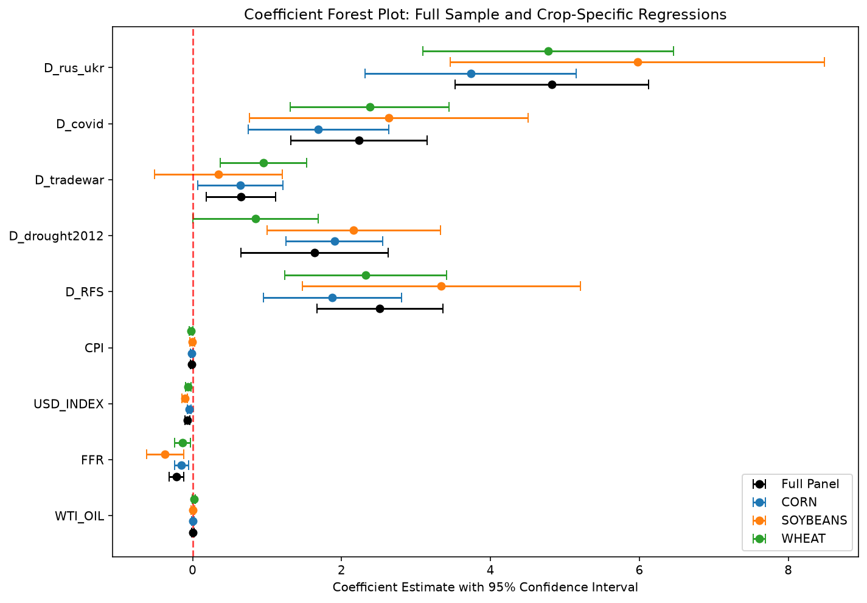
Figure 8. Original coefficient forest plot across crops and regimes
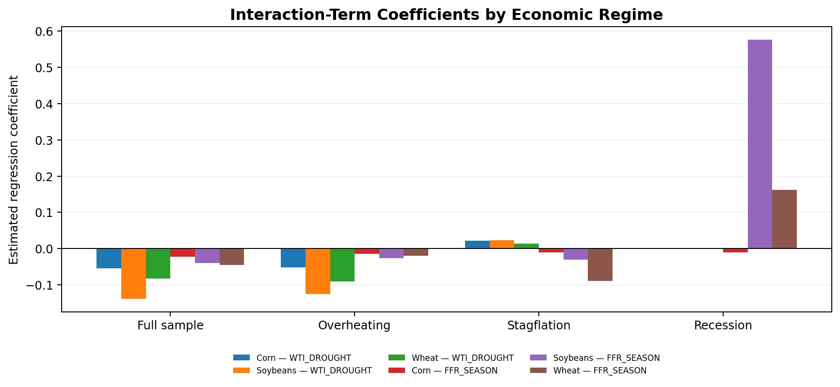
Figure 16. Interaction-term coefficients across economic regimes (WTI_DROUGHT and FFR_SEASON; English labels).
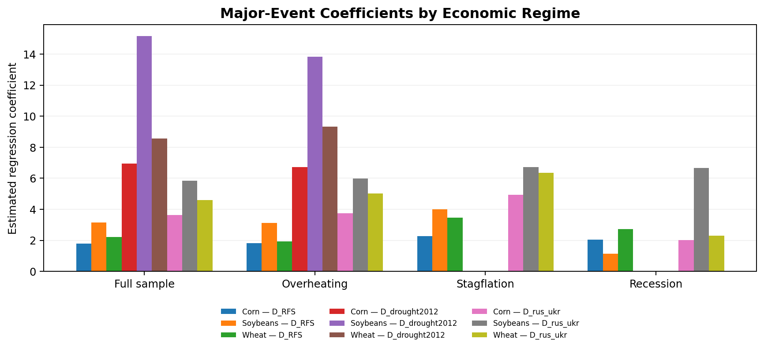
Figure 17. Major-event indicator coefficients across economic regimes (RFS, drought, and Russia–Ukraine conflict; English labels).

6. Model Diagnostics

6.1 White-Noise and Residual Independence Tests
The Durbin–Watson statistics for the full-sample corn, soybean, and wheat regressions are 0.229, 0.231, and 0.313, respectively, indicating strong positive first-order residual dependence. The Ljung–Box white-noise tests are used to assess whether residual autocorrelations are jointly zero over the tested lags. The reported residual diagnostics raise concerns about the white-noise assumption, rather than establishing independent errors. Newey–West HAC standard errors with 12 monthly lags were applied to regression inference; this adjustment does not remove serial correlation from the residuals.

6.2 Autocorrelation Function (ACF) Analysis
The residual ACF plots for corn, soybeans, and wheat display serial dependence, consistent with the low full-sample Durbin–Watson values. Persistent autocorrelation suggests that current price movements may not be fully captured by contemporaneous macroeconomic regressors and event indicators. These diagnostics qualify the statistical interpretation of the OLS models, particularly for the small recovery and recession subsamples.
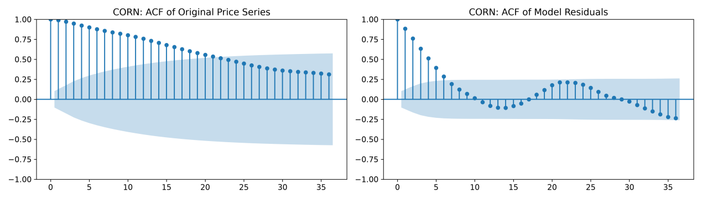
Figure 10. Corn autocorrelation diagnostics
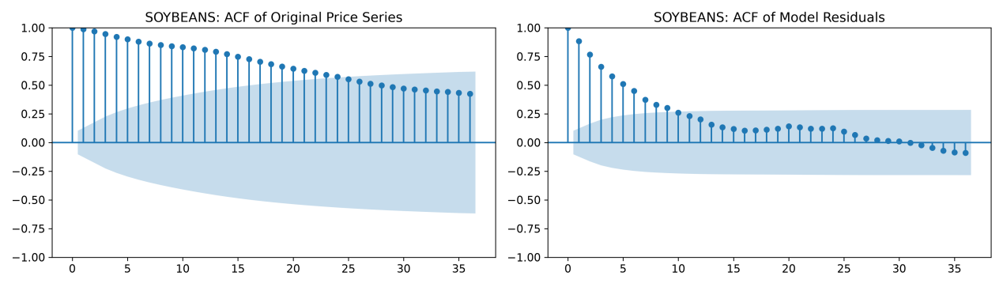
Figure 12. Soybean autocorrelation diagnostics
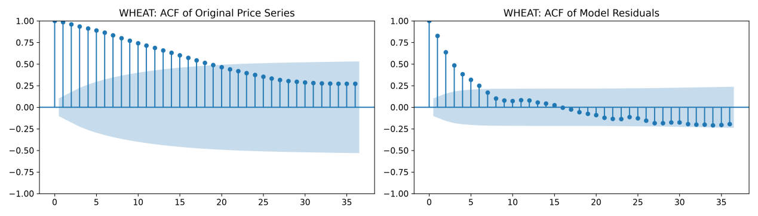
Figure 14. Wheat autocorrelation diagnostics

7. Robustness and Event Analysis

7.1 Rolling-Window Sensitivity: 48-, 60-, and 72-Month Specifications
Figures 18–20 trace the WTI_DROUGHT interaction coefficient using rolling regressions estimated over 48, 60, and 72 months. The three lines often move in similar directions, especially during the central episode surrounding the 2012 drought, but their amplitudes and turning points differ. Thus, the plots suggest some qualitative agreement across window lengths while rejecting the stronger proposition that the coefficient is constant over time. A rolling interaction coefficient is a conditional change in the oil-price slope during drought months, not the total drought effect or the baseline oil-price coefficient. The nearly flat sections outside the main drought episode should not automatically be read as evidence of a true zero effect: limited within-window variation in the drought dummy or the interaction may make the coefficient weakly identified or effectively unestimable.
For corn (Figure 18), the 48-, 60-, and 72-month curves move below zero during much of the central drought-related interval and show short-lived positive spikes near its boundaries. The changing signs and sharp excursions suggest that the estimated interaction is sensitive to the precise months included in each regression. The shared negative portion is more informative than the isolated peaks, but the figure does not provide confidence bands or a formal equality test across windows.
For soybeans (Figure 19), the negative central segment is generally more pronounced, and the coefficients display especially large positive excursions around the onset of the active interaction period. This combination is consistent with stronger local parameter instability rather than a stable, uniformly negative or positive oil–drought relationship. For wheat (Figure 20), the three curves again share a broad negative interval, while large swings near the ends of the active period indicate sensitivity to window boundaries. Across crops, the recurring negative central segment offers limited directional reassurance, but the spikes, sign reversals, and dependence on window length weaken claims of quantitative robustness.
The rolling-window estimates should therefore be treated as a sensitivity diagnostic, not independent confirmation of the cycle-specific OLS findings. In particular, differences between the negative overheating interaction and positive stagflation interaction cannot be formally established from the rolling lines alone; regime-specific confidence intervals or interaction tests are needed.

7.2 Event-Based Sensitivity: Before-and-After Coefficient Comparisons
Figure 24 displays the Renewable Fuel Standard (RFS) split as an example of the event-study sensitivity plots. For all three crops, the estimated D_RFS coefficient is far larger in the after-shock specification than in the before-shock specification: approximately 0.20 versus 11.95 for corn, 0.24 versus 10.44 for soybeans, and 0.25 versus 14.81 for wheat. The after-shock bars dominate the chart, especially for wheat. This is evidence of substantial specification and sample sensitivity, not a defensible estimate of the causal effect of the RFS policy. In a sample split, an event dummy may have little or no variation on one side of the cutoff; coefficients on such indicators can be unidentified, unstable, or difficult to compare.
The underlying before/after sensitivity table also covers the 2012 drought, the U.S.–China trade war, COVID-19, and the Russia–Ukraine war. The coefficient changes are heterogeneous. Around the drought split, the estimated D_drought2012 coefficients increase from roughly 0.57 to 1.34 for corn, 1.38 to 3.00 for soybeans, and 0.53 to 1.65 for wheat; however, the event indicator and WTI_DROUGHT interaction are not necessarily comparable when the shock is absent from one subsample. Around the trade-war split, the soybean WTI_OIL coefficient moves from approximately +0.032 to −0.016, while the wheat coefficient increases from +0.011 to +0.043. These shifts suggest that the oil–crop association depends on sample composition and period.
Around the COVID-19 split, the soybean WTI_OIL estimate changes from about +0.031 to −0.037, whereas the wheat estimate rises from +0.011 to +0.062. Around the Russia–Ukraine split, the corresponding oil coefficients increase for all three crops: corn from approximately 0.000 to +0.036, soybeans from +0.019 to +0.052, and wheat from +0.012 to +0.103. These are descriptive comparisons of fitted coefficients, not estimates of the isolated impact of COVID-19 or the war. The before/after periods also differ in inflation, monetary policy, energy-market conditions, and the number of observations.

7.3 Interpretation, Identification, and Limits of the Sensitivity Evidence
Taken together, the rolling and event-split analyses show that the estimated macroeconomic relationships are not invariant to the time period or window definition. The partial alignment of 48-, 60-, and 72-month paths supports a recurring local pattern in WTI_DROUGHT, but the sharp coefficient excursions and large event-split changes caution against treating any single numerical estimate as a structural constant. The event plots also show why visually large coefficients do not automatically imply economically large or statistically significant effects: the scale of a dummy coefficient, sample composition, multicollinearity, and within-sample variation all matter.
A stronger robustness exercise would report standard errors or 95% confidence intervals for each window and event split, flag nonidentified regressors explicitly rather than plotting zeros, use matched-length pre/post periods where feasible, and test differences in coefficients in a pooled model with event interactions. It would also compare the current imputed-dollar-index specification against models excluding USD_INDEX or using only genuinely observed index data, and estimate dynamic alternatives with lagged prices or lagged macroeconomic regressors. These checks are especially important because 89.4% of USD_INDEX entries were imputed and the full-sample Durbin–Watson statistics (0.229, 0.231, and 0.313) indicate substantial positive residual autocorrelation. HAC standard errors help with inference under dependence but do not correct an omitted dynamic structure. The present evidence is therefore best described as exploratory sensitivity analysis, not causal event identification.
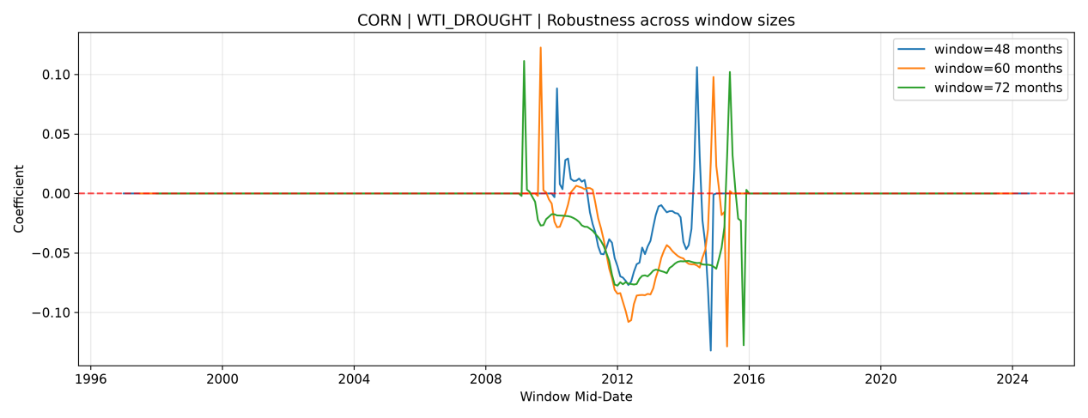
Figure 18. Corn WTI_DROUGHT rolling estimates
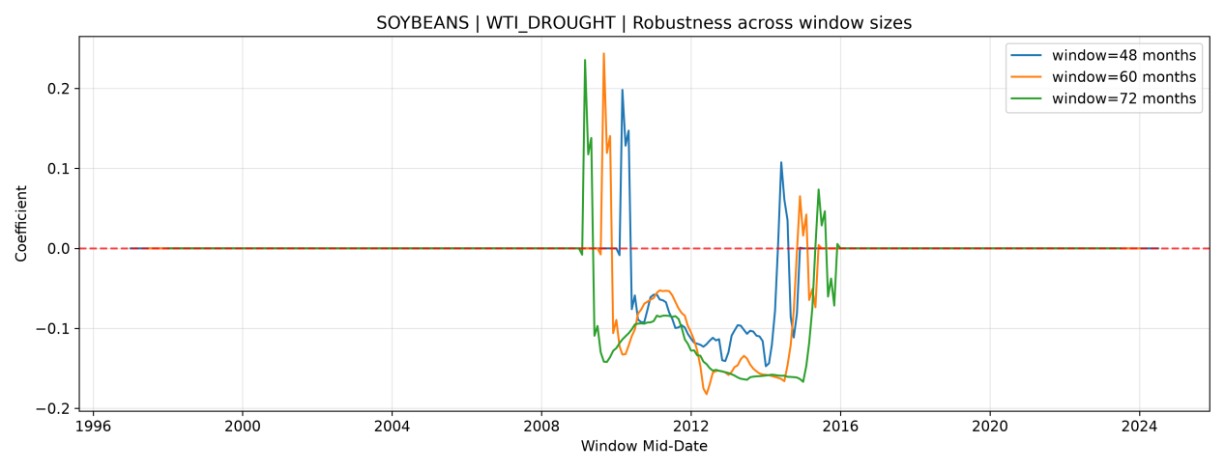
Figure 19. Soybean WTI_DROUGHT rolling estimates
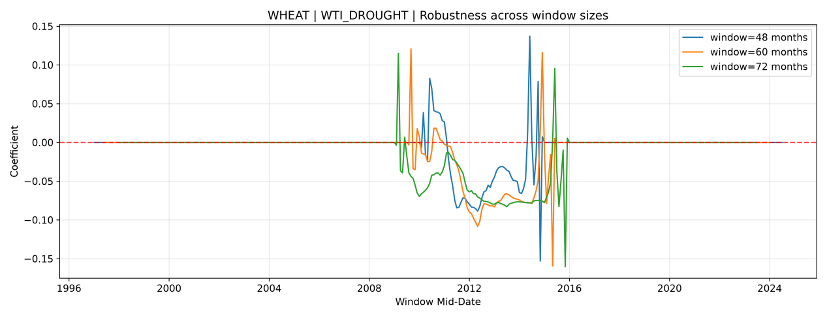
Figure 20. Wheat WTI_DROUGHT rolling estimates
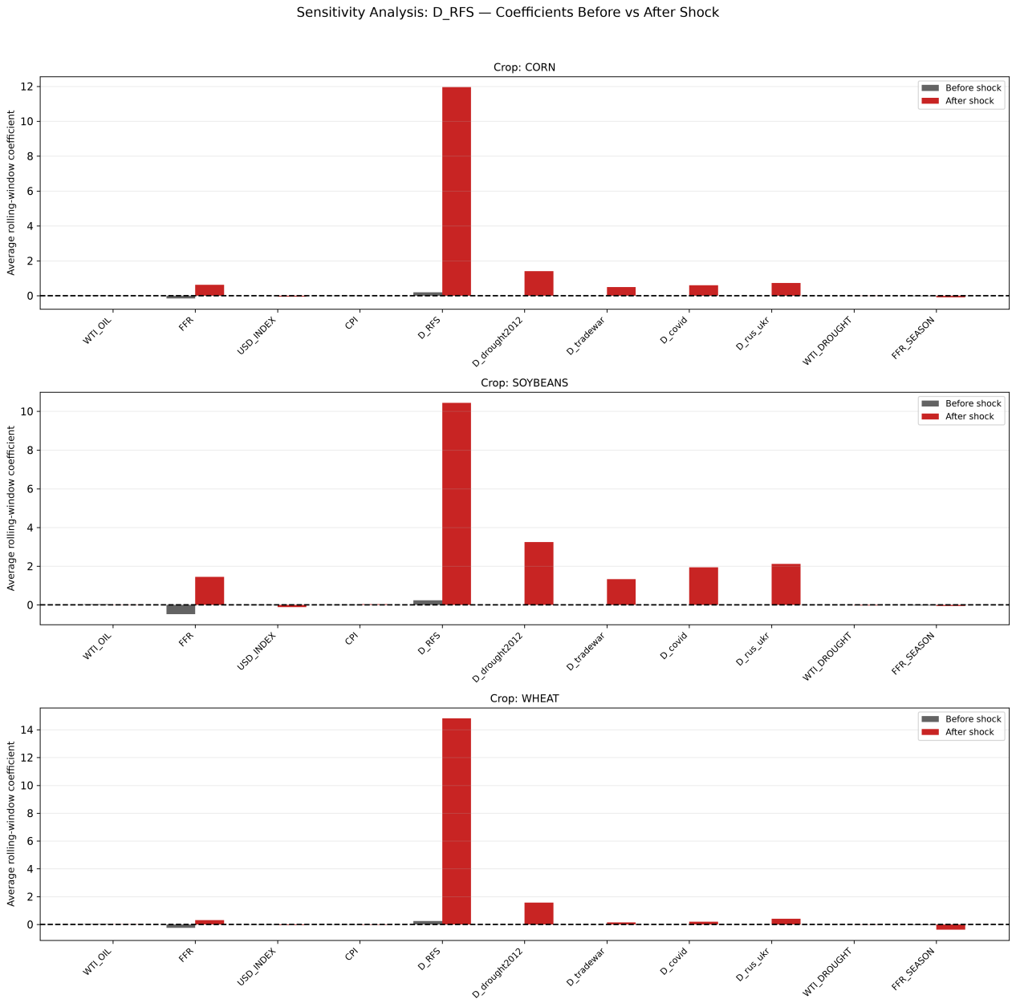
Figure 24. Original event-study coefficient comparison

8. Conclusions and Limitations
This research finds that relationships between macroeconomic indicators and U.S. crop prices differ across economic cycles. The clearest reported pattern is a positive oil-price coefficient for all three crops during stagflation. Interest rates and the U.S. dollar also show negative associations in several specifications. The results support a regime-sensitive approach to agricultural price analysis rather than assuming one fixed relationship for every period.
The conclusions remain provisional. Recovery has only nine observations per crop, and recession has 21. Serial correlation is strong in important models, and some event and interaction coefficients may be poorly identified. The cycle classification and growth-rate calculations need to be verified.
Future work should test lagged-price or dynamic models, compare alternative cycle definitions, report confidence intervals, and check whether the results remain stable after these changes. Another possible improvement is to introduce a Jump Diffusion model in future research. The current OLS models examine how macroeconomic factors and major events are associated with agricultural commodity prices, but they may not fully capture sudden and large price changes. Events such as extreme droughts, the COVID-19 pandemic, and the Russia–Ukraine war may create unexpected shocks in agricultural markets. A Jump Diffusion model could separate normal price fluctuations from occasional large price jumps. This approach may help explain how corn, soybean, and wheat prices respond to sudden market disruptions. Future studies could compare Jump Diffusion models with the current regression models to examine whether including price jumps improves model fit and forecasting performance. However, estimating such models would require additional testing and careful consideration of the available monthly data.
Source note: All numerical results and figures come from the user-provided datasets and original research images. No outside references were added; formal submission should include the original data-source citations and econometric references.

Part II. 简明中文翻译

1. 研究概览
农产品价格影响农民收入、消费者和食品供应链。本文研究1995—2025年美国玉米、大豆和小麦的月度价格，重点分析油价、利率、美元指数、通货膨胀和重大事件与粮价的关系。研究使用1,137条“作物—月份”记录，目的是比较不同经济周期，而不只看全样本的平均结果。价格图可以展示变化，但不能单凭图表判断因果关系。

2. 经济周期框架
美林时钟根据经济增长和通胀的变化方向，把经济分为复苏、过热、滞胀和衰退四个阶段。本文假设：宏观变量的回归系数会随周期变化；油价和利率的关系在各周期不同；三种农产品的反应也不同。每种作物在过热期有242个样本，滞胀期91个，衰退期21个，复苏期只有9个。复苏期样本太少，结论不可靠。正式使用周期分类前，还要核对增长率计算和月份划分。

3. 数据与方法
研究变量包括农产品价格、WTI油价、联邦基金利率、美元指数和CPI，还加入RFS政策、2012年干旱、贸易战、新冠疫情和俄乌冲突等事件变量。研究分别对不同作物和周期进行OLS回归，并使用Newey–West HAC稳健标准误。还通过R²、Durbin–Watson、自相关图、滚动回归和事件前后比较来检查结果。回归关系不等于因果关系。

4. 缺失值分析与处理

4.1 缺失值分布与特征
本研究共有1,137条作物—月份记录，玉米、大豆和小麦各379条。农产品价格及五个事件虚拟变量均无缺失。宏观变量中，WTI原油价格和联邦基金利率各缺失36条（3.2%），CPI缺失39条（3.4%），美元指数缺失1,017条（89.4%）。每种农产品仅有40条记录的全部回归变量完整，另339条（89.4%）至少有一个解释变量缺失。图2—4为30行局部样本，其中美元指数缺失5行；图5展示全部1,137行的缺失结构。局部样本的完整率不代表全样本。

4.2 价格分布、箱线图与西格玛区间
图6—8中，蓝色表示每种作物379条全部价格记录，绿色表示40条解释变量完整记录。红色竖线为全部价格的均值，橙色及绿色虚线分别为均值±1σ和±2σ。以各作物379条价格的样本均值和样本标准差为基准，将339条解释变量不完整记录对应的价格划分为四个互不重叠的区间：±1σ以内、1σ至2σ、2σ至3σ、以及3σ以外。统计的是宏观变量缺失记录所在的价格区间，并非价格本身缺失。
玉米：均值为3.697，σ为1.498。在339条解释变量不完整记录中，214条（63.1%）位于±1σ以内，105条（31.0%）位于1σ—2σ，20条（5.9%）位于2σ—3σ，没有超过3σ的记录；319条（94.1%）位于±2σ以内。大豆：均值为9.087，σ为3.186；相应区间分别有194条（57.2%）、141条（41.6%）、4条（1.2%）和0条，±2σ以内共335条（98.8%）。
小麦：均值为5.091，σ为1.823；339条不完整记录中，225条（66.4%）位于±1σ以内，100条（29.5%）位于1σ—2σ，13条（3.8%）位于2σ—3σ，1条（0.3%）超过3σ；±2σ以内共325条（95.9%）。总体而言，三种农产品的缺失解释变量记录大多对应于常见价格区间，并非仅发生在价格异常时期。这一分布不能证明缺失机制是随机的；如果直接删除不完整记录，每种作物将损失339个月的价格与宏观变量配对信息。

4.3 缺失值迭代插补
本研究采用基于贝叶斯岭回归的迭代插补方法估计宏观解释变量的缺失值。每个不完整变量的缺失观测由其他可用解释变量预测，并经过多轮迭代更新。贝叶斯岭回归的正则化有助于在宏观变量相关时提高预测稳定性；农产品价格始终保留原始观测值，不进行填补。
插补后的解释变量用于后续农产品价格回归。美元指数有89.4%的作物—月份记录依赖估计值，仍是研究的重要局限，因此与美元指数相关的回归系数需要谨慎解释。

5. 回归结果与跨周期比较

5.1 复苏期：利率和通胀系数转正
复苏期每种作物仅有9条观测值，因此即使部分变量达到统计显著，也应谨慎解释其稳定性。以下仅概括系数方向与显著性。
WTI油价与玉米、大豆价格显著正相关，与小麦价格的关系不显著。FFR与CPI对三种作物均显著正相关，与其他周期通常呈现的负向关系不同；美元指数对三种作物均显著负相关。RFS政策变量和利率—季节交互项均显著为正，干旱变量与油价—干旱交互项均显著为负。贸易战、新冠疫情及俄乌战争变量在该小样本中缺乏有效识别。由于样本极少，不宜将较大的估计效应解释为稳定或因果关系。

5.2 过热期：美元指数显著负相关
过热期每种作物有242条观测值，美元指数的负向关系最为一致。以下仅概括系数方向与显著性。
美元指数对三种作物均显著负相关。FFR对三种作物均为负，其中玉米和大豆显著；WTI油价对三种作物均不显著。CPI仅对小麦表现为较弱的显著负相关。RFS、2012年干旱、新冠疫情和俄乌战争变量对三种作物均显著为正。贸易战变量对玉米和小麦显著为正，对大豆不显著。油价—干旱交互项对三种作物均显著为负，利率—季节交互项虽为负但均不显著。

5.3 滞胀期：油价正相关最一致
滞胀期每种作物有91条观测值，WTI油价的显著正相关最为一致。以下仅概括系数方向与显著性。
WTI油价对三种作物均显著正相关，FFR和CPI则均显著负相关。美元指数对三种作物均不显著。RFS、干旱、新冠疫情及俄乌战争变量均显著为正。贸易战变量对玉米和小麦显著为正，对大豆不显著。与过热期相反，油价—干旱交互项对三种作物均显著为正；利率—季节交互项对三种作物均为负，但仅小麦显著。

5.4 衰退期：利率与疫情反应分化
衰退期每种作物仅有21条观测值，估计稳定性受到样本规模限制。以下仅概括系数方向与显著性。
WTI油价对三种作物均为正但不显著。FFR对三种作物均为负，但仅大豆显著，且其负向关联相对较强。美元指数对三种作物均不显著；CPI对玉米和小麦显著为负，对大豆不显著。RFS和俄乌战争变量对三种作物均显著为正。新冠疫情变量对大豆显著为负、对小麦弱显著为正，对玉米不显著。干旱、贸易战变量和油价—干旱交互项在本周期缺乏有效识别。利率—季节交互项仅对大豆显著为正。

5.5 四周期共同回归特征与差异综合比较
RFS政策虚拟变量在复苏、过热、滞胀和衰退四个周期中，对玉米、大豆和小麦均呈统计显著的正向关联，是结果中最一致的共同特征。没有解释变量在四个周期中对三种作物始终显著为负，也没有变量在所有作物和周期中一律不显著。俄乌战争指标在能够估计的过热、滞胀和衰退期均显著为正，但复苏期缺少相应事件变化，不能据此比较。FFR在过热、滞胀和衰退期对三种作物均为负向系数，但显著性不一致；复苏期系数转正，且每种作物仅有9个观测值。
周期差异主要体现在WTI油价、美元指数、油价—干旱交互项及部分事件变量。WTI油价在滞胀期对三种作物均显著为正，但在过热和衰退期没有同样一致的显著性；美元指数在过热和复苏期均显著为负，在滞胀和衰退期则并非普遍显著。油价—干旱交互项在过热和滞胀期的方向不同；CPI、干旱、贸易战、新冠疫情及利率—季节交互项也随周期或作物而变化。上述比较反映各模型内部的条件相关关系，不能仅凭系数符号或显著性差异断言周期之间的系数差异已通过统计检验。
两个交互项应按条件效应解释，而不能把交互项系数直接当作独立事件效应。WTI_DROUGHT为WTI油价与2012年干旱虚拟变量的乘积，其系数表示在控制其他变量后，干旱期间油价与粮价的边际关联相较非干旱期间如何变化。该交互项在过热期对三种作物均显著为负，在滞胀期均显著为正，说明油价关联可能随干旱状态及宏观周期共同变化；它并不等于干旱事件的总影响。复苏期的负向估计受极小样本限制，衰退期则无法单独识别该交互项。FFR_SEASON表示联邦基金利率与模型季节指标的交互作用，反映利率关联随季节状态变化的幅度。复苏期虽呈显著正向，但每种作物仅有9条观测，不宜作稳健结论；衰退期大豆为显著正向，滞胀期小麦为显著负向，其他多数作物—周期组合不显著。因此解释利率的边际效应时，应将FFR主效应与对应交互项共同考虑。

6. 模型诊断

6.1 白噪声与残差独立性检验
玉米、大豆和小麦全样本回归的Durbin–Watson统计量分别为0.229、0.231和0.313，提示残差存在较强的正向一阶自相关。Ljung–Box白噪声检验用于检验多个滞后阶数的残差自相关是否联合为零；现有诊断结果提示残差难以满足白噪声假设。回归使用12个月滞后的Newey–West HAC稳健标准误进行统计推断，但该方法不会消除残差的序列相关。

6.2 自相关函数（ACF）分析
玉米、大豆和小麦的残差ACF图显示不同程度的时间依赖，与全样本较低的DW统计量相一致。这说明仅使用同期宏观变量和事件指标，可能不足以捕捉价格变化中的动态结构。考虑到复苏和衰退期样本量较少，这些诊断结果也要求对各周期的显著性结论保持谨慎。

7. 稳健性和事件分析
7.1 滚动窗口敏感性分析：图18—20采用48、60和72个月窗口估计WTI_DROUGHT交互项。三种作物的曲线在2012年干旱相关时段附近均出现较长的负值区间，但在时段边界又有明显的正向尖峰和符号变化。玉米的负值区间较清楚，大豆的负向幅度及边界波动较大，小麦也表现出类似的不稳定性。不同窗口的部分同步变化支持局部方向上的一致性，却不能证明系数在整个样本期稳定。窗口内干旱变量缺乏变化时，接近零的估计值也不能直接解释为真实影响为零。
7.2 重大事件前后比较：图24以RFS为例，玉米、大豆和小麦的D_RFS系数在事件前约为0.20、0.24和0.25，事件后分别约为11.95、10.44和14.81。后期系数显著放大说明估计对样本切分十分敏感，但不能解释为RFS的因果效应，因为事件虚拟变量在切分样本中可能缺乏足够变化。2012年干旱切分后，三种作物的干旱指标系数也较前期上升；贸易战切分前后，大豆WTI系数约从+0.032转为−0.016，而小麦从+0.011升至+0.043。
在疫情前后比较中，大豆WTI系数约从+0.031变为−0.037，小麦从+0.011上升到+0.062。俄乌冲突前后，WTI系数在玉米、大豆和小麦中分别约由0.000、+0.019、+0.012变为+0.036、+0.052、+0.103。这些变化说明回归关联具有时间敏感性，但不同阶段同时存在通胀、利率、供需等其他变化，不能把差异全部归因于单一事件。
7.3 解释与局限：滚动估计中三种窗口的局部一致性提供有限的方向性支持，但边界尖峰、符号变化和事件前后系数大幅改变，说明数值结论缺乏充分稳定性。交互项反映干旱期间油价边际关联的变化，而非干旱的总影响。后续应报告置信区间、标记无法识别的系数而非当作零、检验事件前后系数差异，并比较不含高度插补美元指数的模型和包含滞后项的动态模型。美元指数89.4%的缺失插补以及残差强自相关，进一步限制了稳健性与因果解释。

8. 结论与局限
总体而言，美国三种主要农产品价格与宏观变量的关系会随着经济周期变化。滞胀期油价与粮价的正相关是最一致的发现。利率和美元指数在一些模型中呈负相关。不过，复苏期和衰退期样本量较小，残差存在自相关，部分事件和交互项估计可能不稳定。下一步应核实周期分类，加入滞后变量，尝试动态模型，并检查置信区间和其他稳健性结果。

Appendix. Additional Original Figures / 原始补充图片
The following figures are reproduced from the uploaded “NA images.docx” to preserve the author’s original visual outputs. They are supporting exhibits; not every figure is directly discussed in the main text. / 以下为上传文档中的其他原始图表，用作补充材料。
Figure 2. Additional original analysis figure / 原始分析补充图
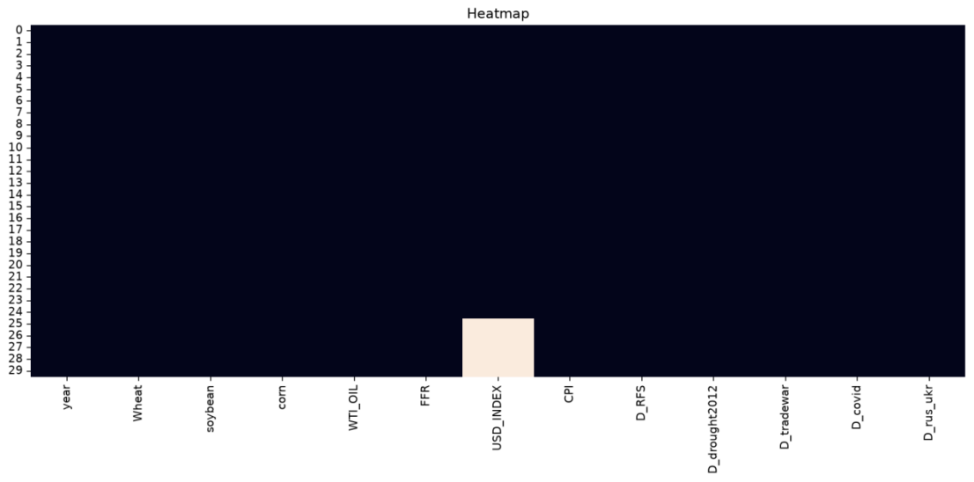
Figure 3. Additional original analysis figure / 原始分析补充图
Figure 4. Additional original analysis figure / 原始分析补充图
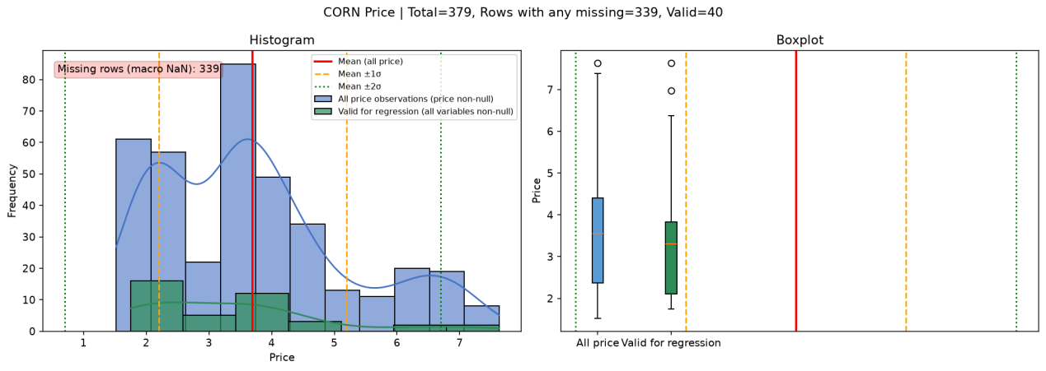
Figure 5. Additional original analysis figure / 原始分析补充图
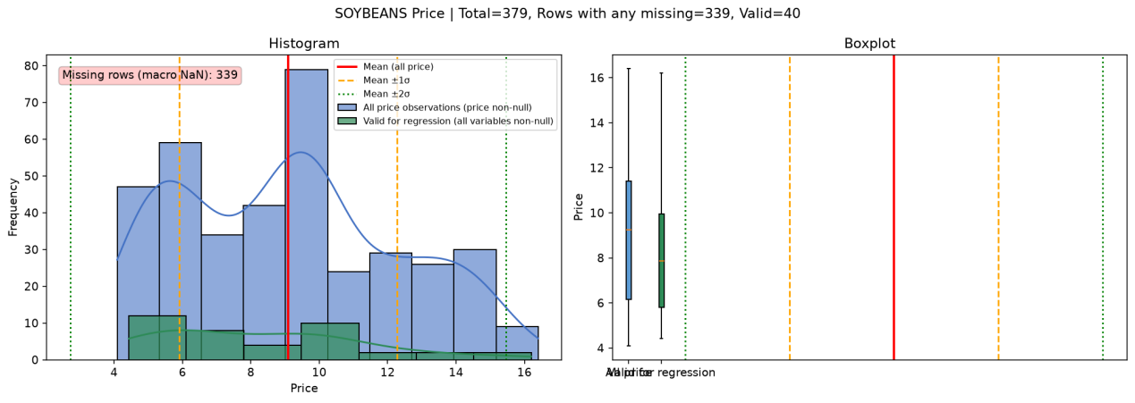
Figure 6. Additional original analysis figure / 原始分析补充图
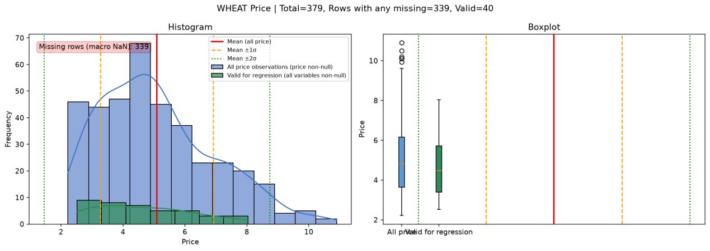
Figure 7. Additional original analysis figure / 原始分析补充图
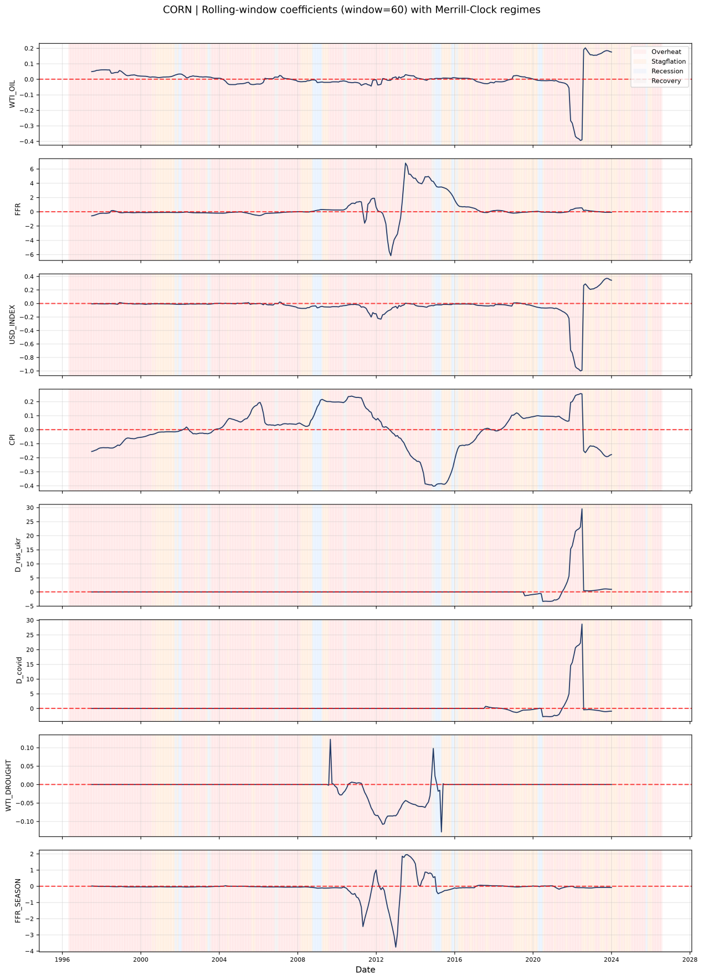
Figure 21. Additional original analysis figure / 原始分析补充图
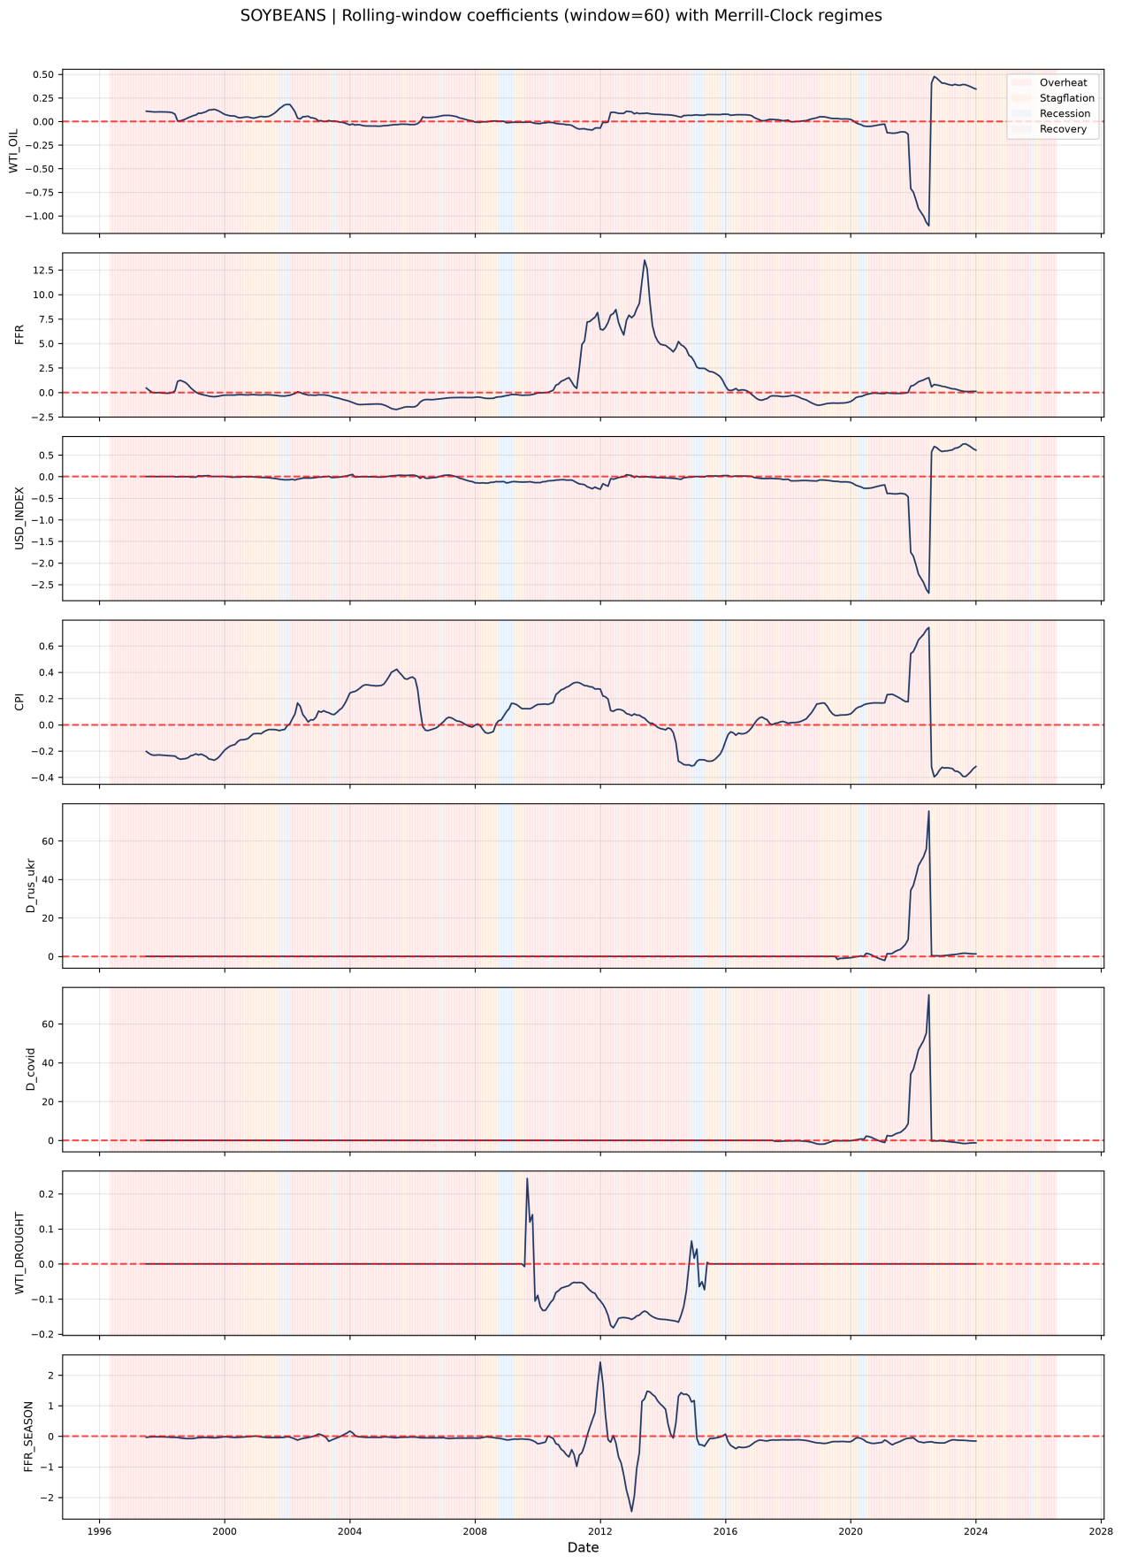
Figure 22. Additional original analysis figure / 原始分析补充图
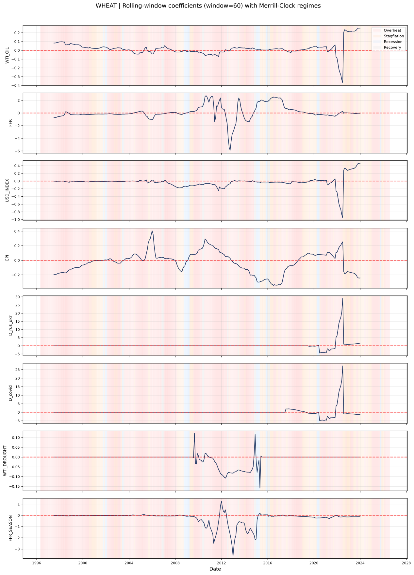
Figure 23. Additional original analysis figure / 原始分析补充图
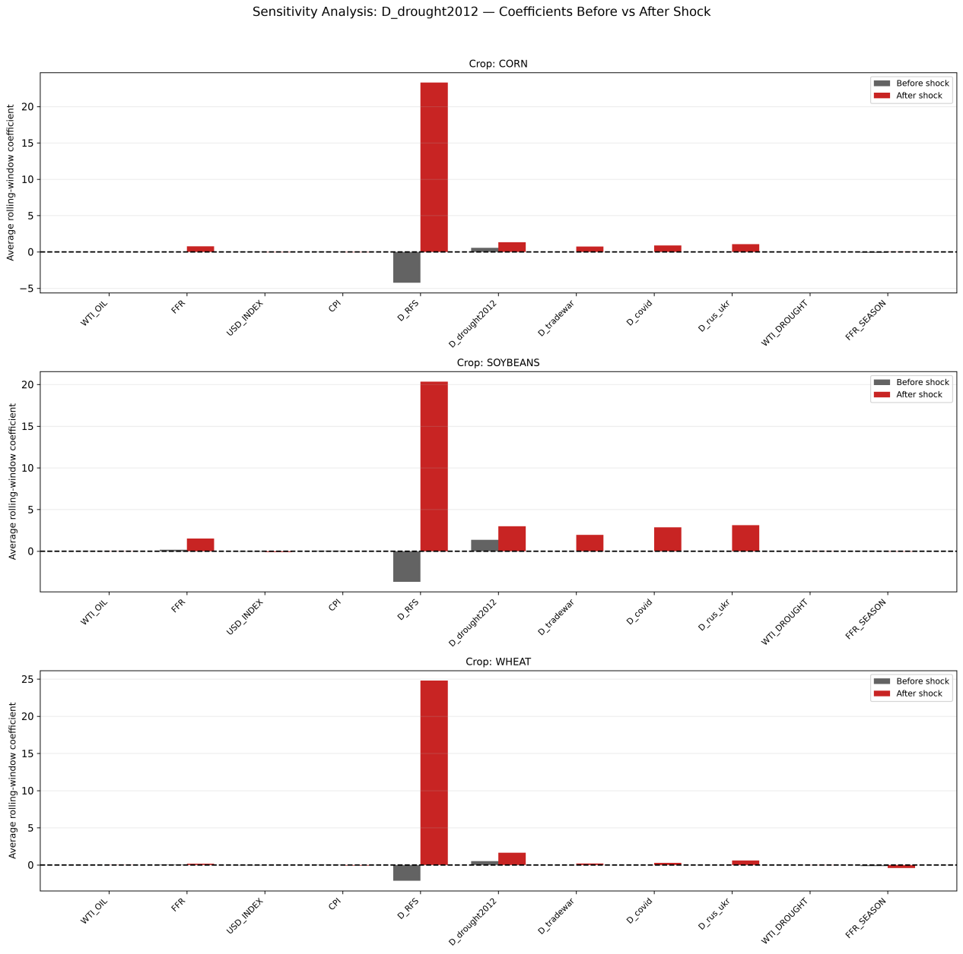
Figure 25. Additional original analysis figure / 原始分析补充图
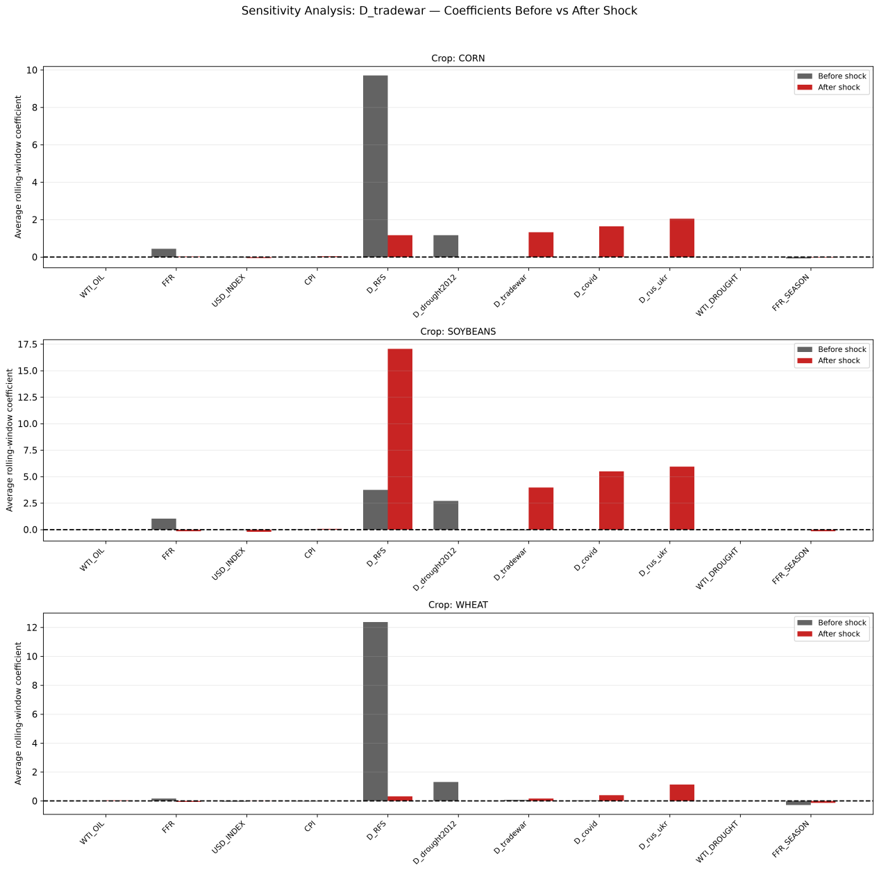
Figure 26. Additional original analysis figure / 原始分析补充图
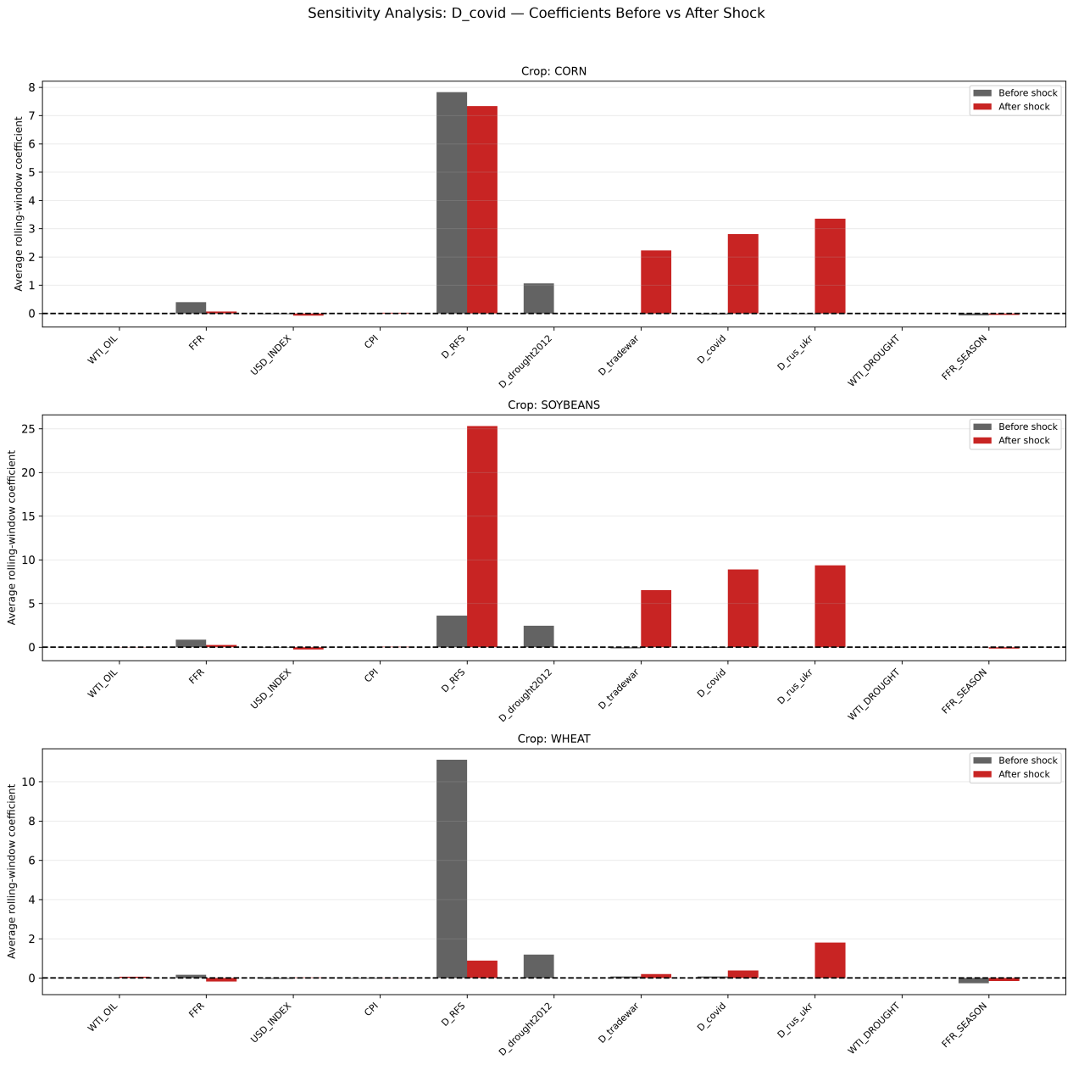
Figure 27. Additional original analysis figure / 原始分析补充图
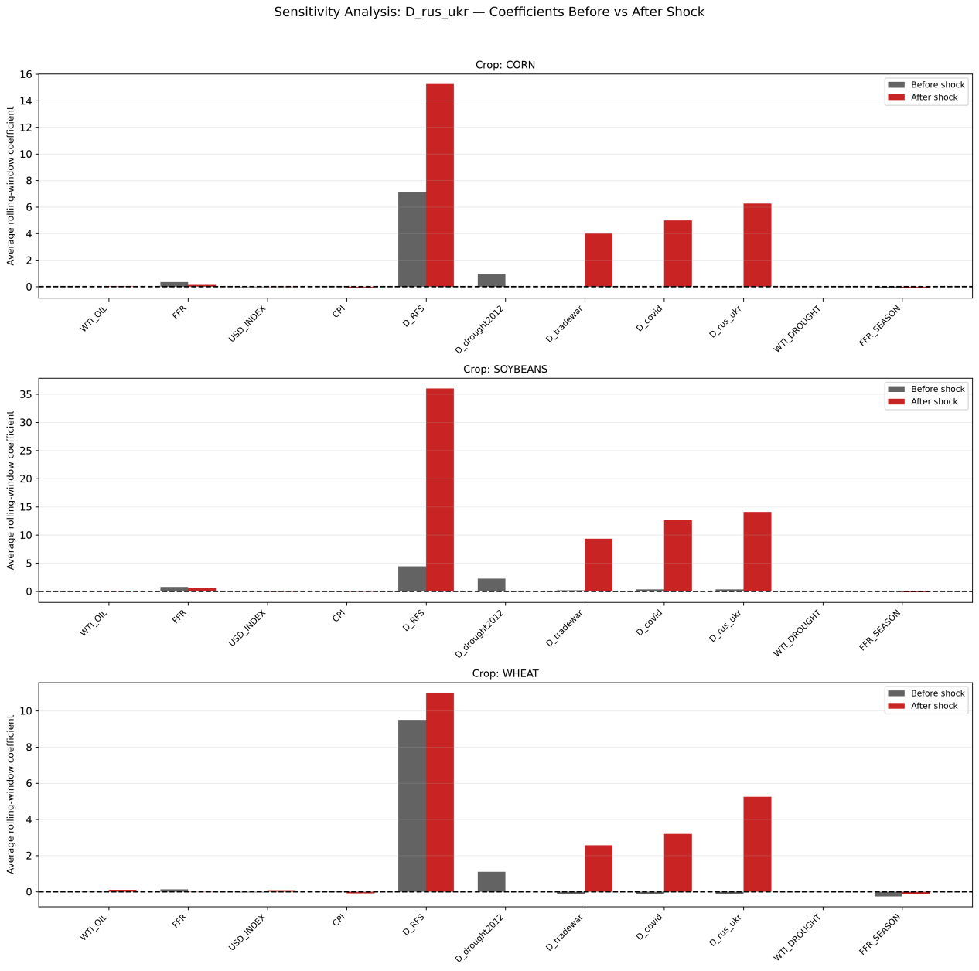
Figure 28. Additional original analysis figure / 原始分析补充图

