I used wxPython. To install, I used this command:

pip install -U wxPython

to run it, I just had the tunnel in the background and used Windows Powershell.

Experience:

This project gave me lots of practice using python and PSQL. I think some of my queries are different from ones we discussed in class, but I do think they are correct, which is good.

Using wxPython limited the aesthetic capabilities of the UI. And that is especially true because of my lack of abilities with wxPython. But building the GUI was kind of fun, so maybe I can work towards a better understanding of wxPython and make something that looks mildly modern.

Originally, I thought for 2 (Browse questions with at least some filtering if not full search.) that you meant filtering as in only show the question, or creation date, or select all. So I started with that, but switched it eventually. My filtering is kind of minimal, and if I had more time that is something I probably would’ve done more of.

**Examples of your program running demonstrating each of the features listed above (screen shots or saved webpages for example).**

Ask a question:

This first has the user enter a question, then their id.

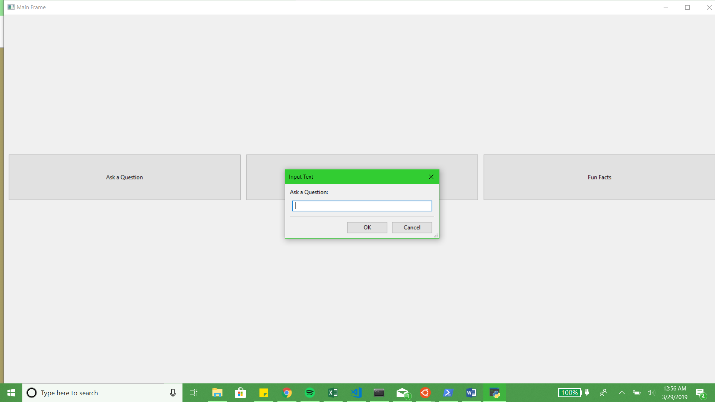

Browse questions with at least some filtering if not full search.:

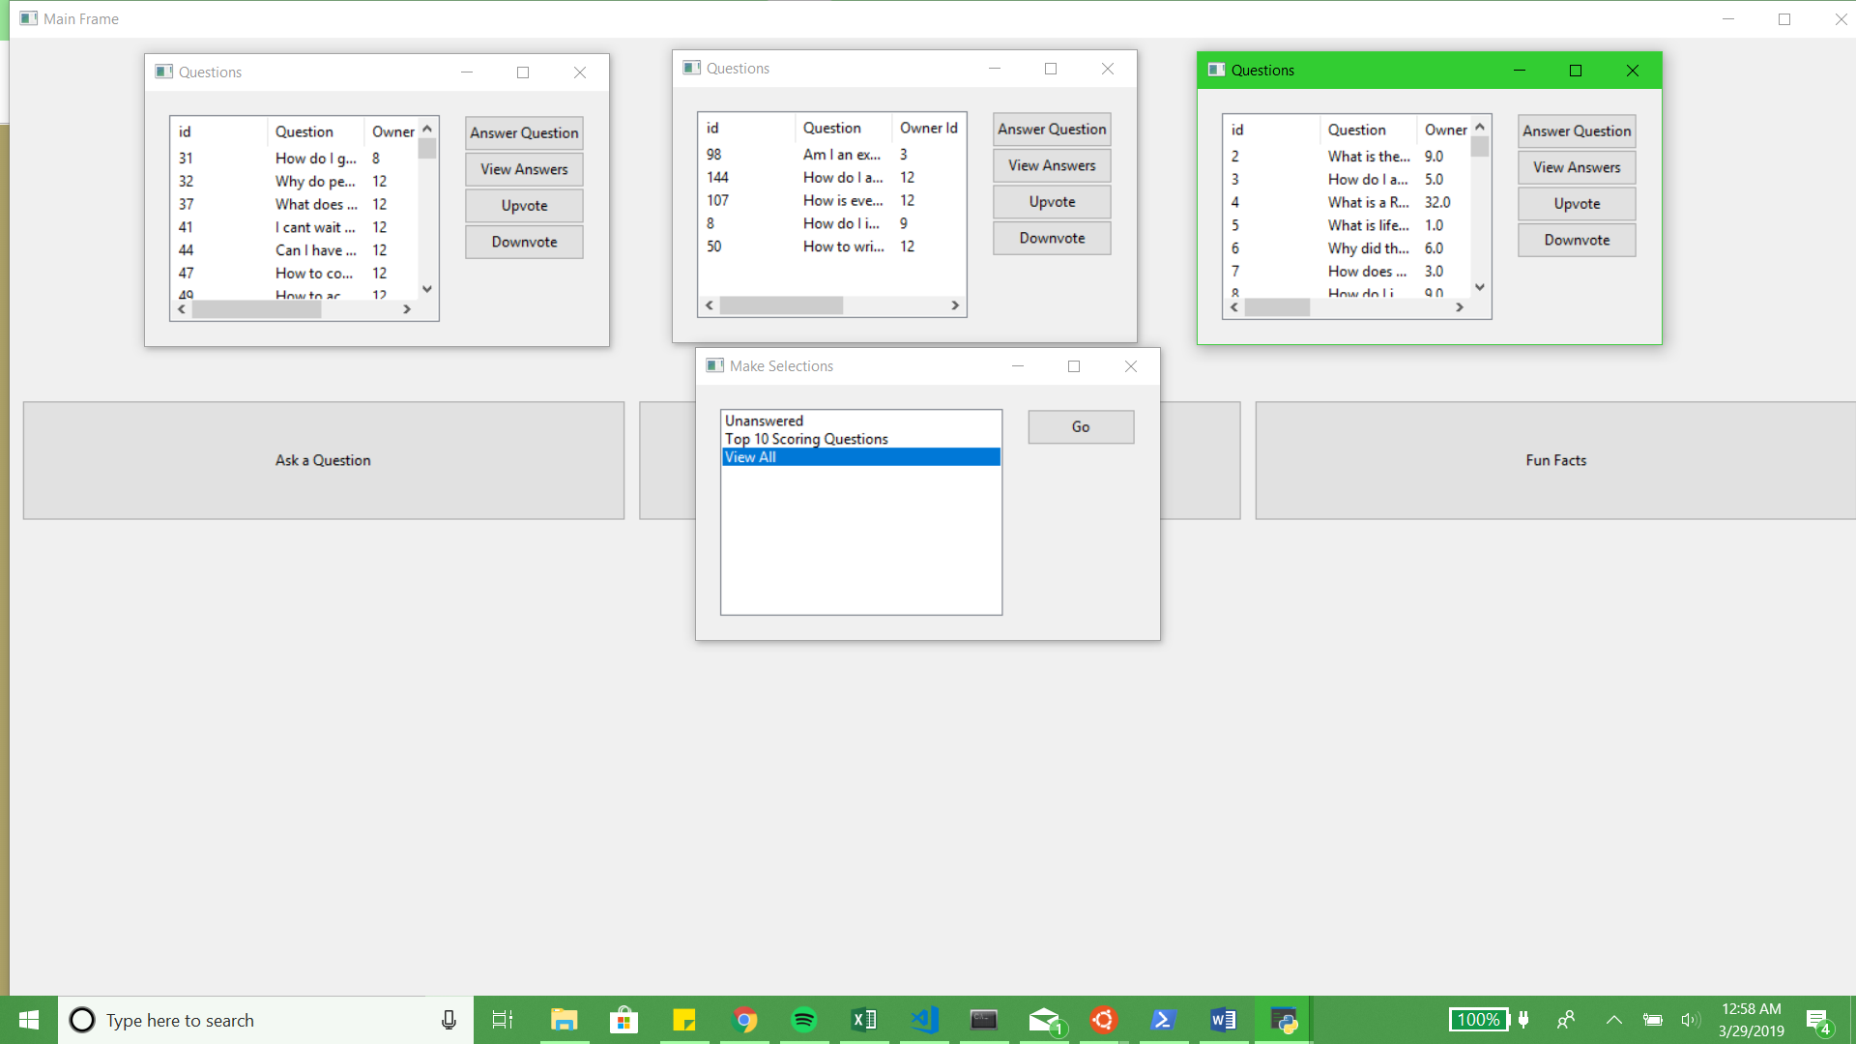

Answer a question.:

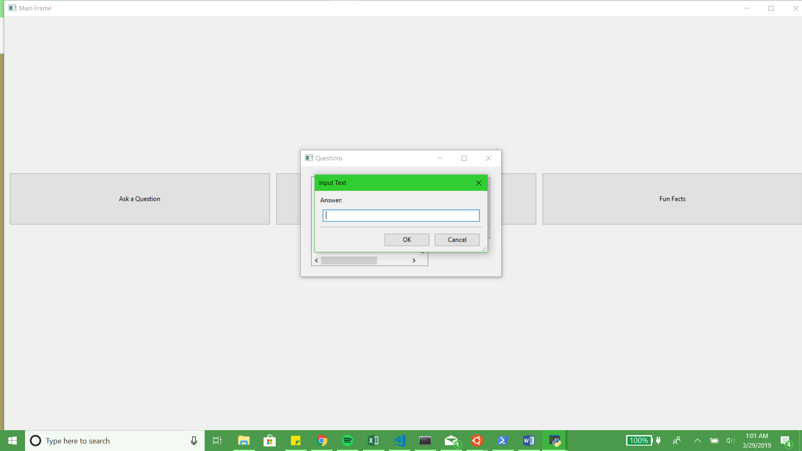

View some basic aggregate information:

