Testing and Analysis File
Initial EDA: Summary
- All 21 variables are floats.
- The description of each feature is included in the README file (i.e. the question asked and the possible response codes)
- The dataset has been cleaned
- There are no null values
- BMI has outliers.
Data Analysis
The following table describes the original BMI measure, while the histogram below offers a visual representation of the original data.
BMI is more typically between 18 and 50 (e.g. https://www.cdc.gov/healthyweight/assessing/bmi/adult_bmi/index.html (cdc.gov in Bing)
Therefore, in this dataset, there are some extreme outliers at both the lower and upper ends.
Feature | Count | mean | std | min | 25% | 50% | 75% | max
BMI | 253680 | 28 | 6.61 | 12 | 24 | 27 | 31 | 98

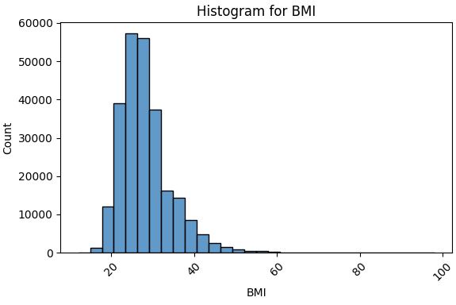
Windsorisation
Windsorisation is a practical way to limit the influence of extreme values without discarding data entirely. Instead of removing outliers, they are capped at the chosen percentile thresholds. This preserves sample size and distributional shape while preventing extreme values from dominating your visualisations or summary statistics.
In this dataset, Windorisation for BMI was set to 1% (BMI = 18) and 99% (BMI = 50). The revised BMI distribution is summarised in the following histogram.
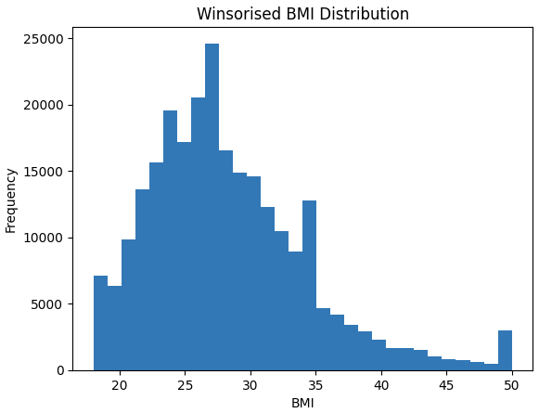
Spearman Correlation
Description of Spearman Correlation
Spearman correlation is a rank-based measure of association that captures how well the relationship between two variables can be described by a monotonic trend (as one variable increases, the other always tends to decrease) rather than a straight line. It’s especially useful when your data are non-normal, skewed, ordinal, or contain outliers, which is why it works so well in health and behavioural datasets like the one you’re analysing.
Analysis Undertaken
A Spearman correlation was selected as the distributions for the features are typically skewed (i.e. not normally distributed).
Two separate correlations were run:
- An initial correlation of all features vs all features, to get an idea of the interplay between the features
- A second correlation to focus on Diabetes_012 as the target versus all of the other features.
Findings
The results from the second correlation are shown below and illustrate the importance of GenHlth, HighBP and BMI_winsorised in predicting Diabetes.
Feature: importance in predicting Diabetes
- Diabetes_012 1.000000
- GenHlth 0.297138
- HighBP 0.271668
- BMI_winsorised 0.235914 (similar to original BMI)
- DiffWalk 0.223567
- HighChol 0.210668
- Age 0.186357
- HeartDiseaseorAttack 0.178564
- PhysHlth 0.161718
- Stroke 0.105887
- CholCheck 0.068018
- Smoker 0.063040
- MentHlth 0.044921
- NoDocbcCost 0.037379
- Sex 0.030143
- AnyHealthcare 0.014530
- Fruits -0.042268
- HvyAlcoholConsump -0.057244
- Veggies -0.059353
- PhysActivity -0.121988
- Education -0.126862
- Income -0.172611
Chi-square
Description of Chi_square
Chi-square is a statistical test that measures whether two categorical variables are associated. It compares the observed counts in a contingency table with the expected counts you would get if there were no relationship between the variables.
Analysis Undertaken
Chi-square tests were undertaken for the 14 binary variables, with Diabetes_012 as the target variable.
Findings
- The strongest predictors of diabetes are having high blood pressure, difficulty walking and high cholesterol.
- Moderator predictors are the presence of heart disease, physical inactivity and stroke.
- Weak predictors are: diet (fruit/vegetables), alcohol consumption, sex and healthcare availability.
Modelling
Logistic Regression
Description of Logistic Regression
Logistic regression is a statistical classification method used to model the probability of a binary outcome (such as yes/no or disease/no disease) based on one or more predictor variables. It uses a logistic function to map predicted values to probabilities between 0 and 1.
Analysis Undertaken
Initially, a logistic regression was undertaken with the target maintaining the 3 outcome codes:
- No diabetes
- Prediates
- Diabetes
The accuracy was 69%.
Definitions of:
- precision = Of all the cases the model said were diabetes, how many were truly diabetes (i.e. few false positives)
- recall = Of all the people who actually have diabetes, how many did the model correctly identify? (i.e. few false negatives)
- f1_score: = How well does the model perform when we care about both catching true cases and avoiding false alarms?
- support = How many real examples of this class were in the data?
Results Summary:
- Despite moderate accuracy (69%), logistic regression performs poorly on minority classes, especially prediabetes, indicating a limited ability to separate the three diabetes states.
- Individuals who are younger, leaner, healthier, and socioeconomically advantaged are much more likely to be classified as having no diabetes.
Class distribution:
Diabetes_012
- 0: 213703
- 2: 35346
- 1: 4631
Accuracy: 0.6901
Confusion Matrix

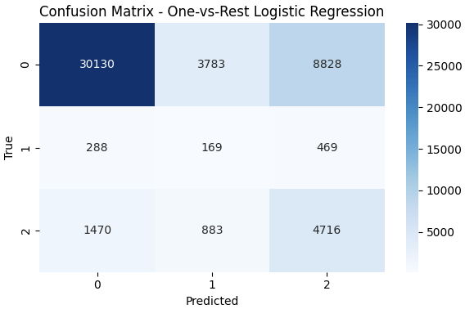
Top positive/negative coefficients per class
No diabetes: top positive features:
HvyAlcoholConsump | 0.145355
Income | 0.133858
PhysHlth | 0.055354
Education | 0.042370
Fruits | 0.024307
PhysActivity | 0.016320
MentHlth | 0.015768
Veggies | 0.011974

GenHlth | -0.586325
BMI_winsorised | -0.503940
Age | -0.467266
HighBP | -0.333542
HighChol | -0.293158
CholCheck | -0.228686
Sex | -0.128226
HeartDiseaseorAttack | -0.066704

Prediabetes: top positive features:
Age | 0.390335
BMI_winsorised | 0.310915
GenHlth | 0.264090
HighChol | 0.242938
CholCheck | 0.124227
HighBP | 0.122307
NoDocbcCost | 0.099967
MentHlth | 0.066339

Prediabetes: top negative features:

Income | -0.128164
Education | -0.060001
DiffWalk | -0.054067
PhysHlth | -0.049724
HeartDiseaseorAttack - | 0.043618
Stroke | -0.040096
AnyHealthcare | -0.019065
HvyAlcoholConsump | -0.018618

Diabetes: top positive features:
GenHlth | 0.617056
BMI_winsorised | 0.505217
Age | 0.463535
HighBP | 0.357944
HighChol | 0.285405
CholCheck | 0.246751
Sex | 0.142219

Diabetes: top negative features:

HvyAlcoholConsump | -0.166793
Income | -0.124718
PhysHlth | -0.057332
Education | -0.036977
MentHlth | -0.030262
Fruits | -0.025697
PhysActivity | -0.016740
Veggies | -0.011804

Redo Logistic Regression with binary variable: Diabetes vs Prediabetes/Diabetes
Results Summary: The logistic regression model shows weak overall performance, with good precision for non-diabetic cases but poor ability to correctly identify diabetics. Its accuracy (0.59) and ROC AUC (0.62) indicate only limited discriminatory power, largely due to the strong class imbalance in the dataset.
Diabetes_012
0 35346
1 4631
Accuracy: 0.5932
ROC AUC: 0.6241
Top positive coefficients (Prediabetes):
NoDocbcCost 0.096627
HvyAlcoholConsump 0.095689
MentHlth 0.090416
PhysActivity 0.020658
PhysHlth 0.012075
Fruits 0.011002
Income -0.001100
Smoker -0.013267
Veggies -0.022703
AnyHealthcare -0.023970

Top negative coefficients (Prediabetes):
HighChol -0.032735
Education -0.037476
Age -0.048128
DiffWalk -0.056069
Sex -0.077414
Stroke -0.080416
HeartDiseaseorAttack -0.114240
BMI_winsorised -0.130547
HighBP -0.166303
GenHlth -0.283423
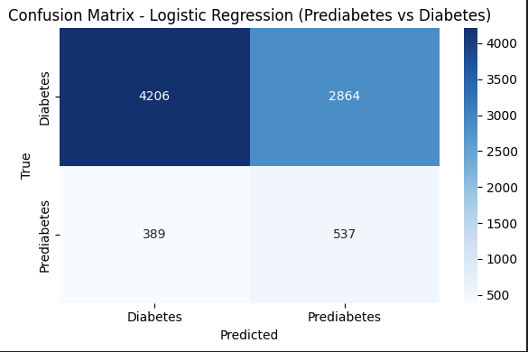
Random Forest
A random forest is an ensemble machine-learning method that builds many decision trees and combines their predictions to produce a more stable, accurate result. Each tree sees a slightly different sample of the data and a random subset of features, which reduces overfitting and captures complex, non-linear relationships. Because of this structure, random forests tend to perform well on noisy, imbalanced, or high-dimensional datasets like health surveys.
Analysis Undertaken
An initial Random Forst was undertaken with 2 classes:
- No diabetes
- Prediabetes/Diabetes
Results
The model has an accuracy of 84%.
Top 15 feature importances:
- BMI_winsorised 0.176090
- Age 0.136864
- Income 0.098828
- PhysHlth 0.078618
- GenHlth 0.071413
- Education 0.068487
- MentHlth 0.065723
- Smoker 0.035564
- Fruits 0.035047
- HighBP 0.034379
- Sex 0.033271
- Veggies 0.027300
- PhysActivity 0.027211
- HighChol 0.026885
- DiffWalk 0.018963
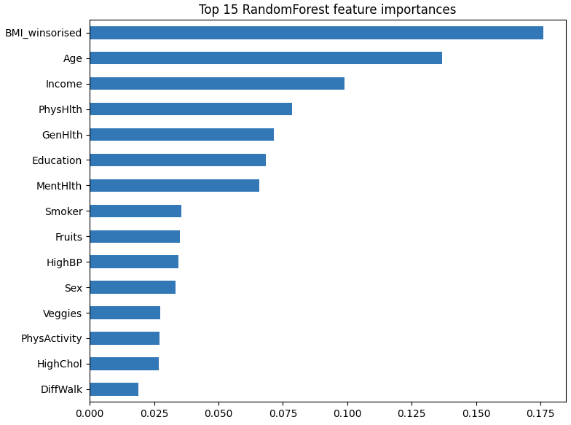

To help improve this model 2 further actions were undertaken:
- SMOTE analysis
- Class based weights learned from the initial model
SMOTE
Definition of SMOTE
SMOTE is a resampling technique used to fix class imbalance by creating synthetic minority-class examples rather than simply duplicating existing ones. It works by selecting a minority sample, finding its nearest neighbours, and generating new points along the line between them, which helps the model learn a fuller decision boundary instead of being overwhelmed by the majority class.
Results
SMOTE did not improve the model.
Class-Based Weights
Accuracy: 74%
Top 15 feature importances:
- GenHlth 0.214270
- HighBP 0.178877
- BMI_winsorised 0.149961
- Age 0.111840
- HighChol 0.085582
- Income 0.044127
- DiffWalk 0.042807
- PhysHlth 0.040593
- HeartDiseaseorAttack 0.022892
- Education 0.020479
- MentHlth 0.018176
- Sex 0.012761
- PhysActivity 0.011353
- Smoker 0.010054
- Fruits 0.009378

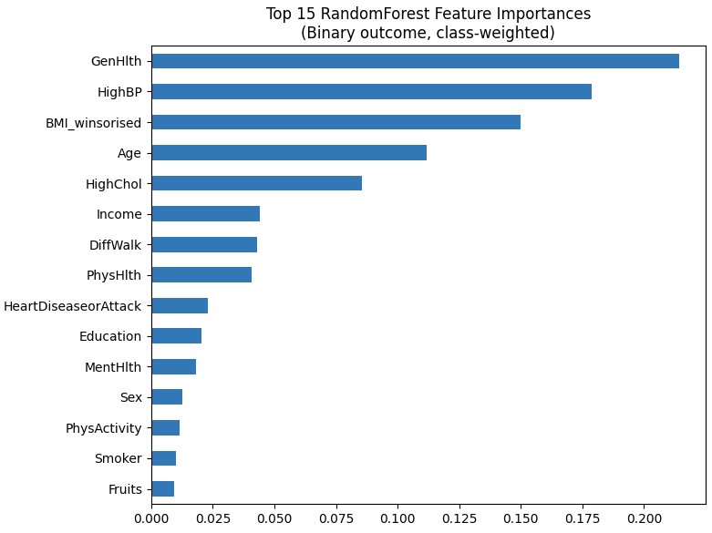
These top 15 features were then grouped into 1 of 5 groups:
Clinical / Physiological:
- GenHlth
- HighBP
- BMI_winsorised
- HighChol
- HeartDiseaseorAttack
Demographic:
- Age
- Sex
Functional Health:
- DiffWalk,
- PhysHlth,
- MentHlth,
Socioeconomic:
- Income,
- Education

Lifestyle:
- Smoker,
- Fruits,
- PhysActivity,

Groups:
- Clinical/Physiological: 41%
- Functional health: 19.2%
- Demographic: 17.8%
- Socioeconomic: 14.7%
- Lifestyle: 7.3%

Hyperparamter Tuning fo Random Forest

