CIFAR 10 CNN Comparison Report
CAP4453 Assignment 2 | Implementation

Implementation

Dataset and preprocessing
The images use CIFAR-10 which contains 32 x 32 color images in 10 classes. The training data is divided into training and validation subsets using a seeded 80/20 split. Both models use the same split and a batch size of 64.

Model architectures
The two-layer convolutional neural network has two 3 x 3 convolutional layers with 16 and 32 output channels.
The three-layer convolutional neural network has three 3 x 3 convolutional layers with 16, 32, and 64 output channels.

Training configuration/Hyperparameter table
Setting | Value
Optimizer | Adam
Learning rate | 5 × 10⁻⁴
Weight decay | 5 × 10⁻⁴
Learning rate schedule | StepLR; step size 20, gamma 0.1
Epochs | 30
Batch size | 64
Batch normalization | Disabled in both comparison runs
Batch size | 64
Epochs | 30
LR scheduler | StepLR, step size 20, gamma 0.1
Train/validation split | 80/20, seeded
Training augmentation | Random crop (padding 4), random horizontal flip
Normalization | CIFAR-10 channel means and standard deviations
Batch normalization | Disabled for both models

Hyperparameter / setting | Value
Dataset | CIFAR-10
Optimizer | Adam
Learning rate | 5 × 10⁻⁴
Weight decay | 5 × 10⁻⁴

Both models are trained for 30 epochs using Adam with a learning rate of 5 × 10⁻⁴ and weight decay of 5 × 10⁻⁴.

Curves
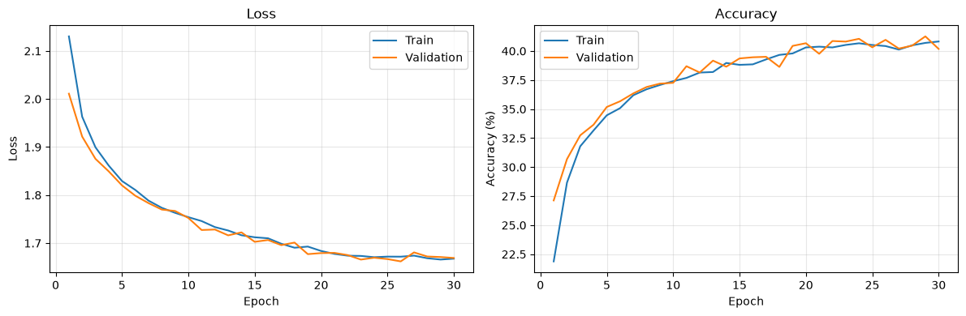
Two-layer CNN epoch loss and accuracy results

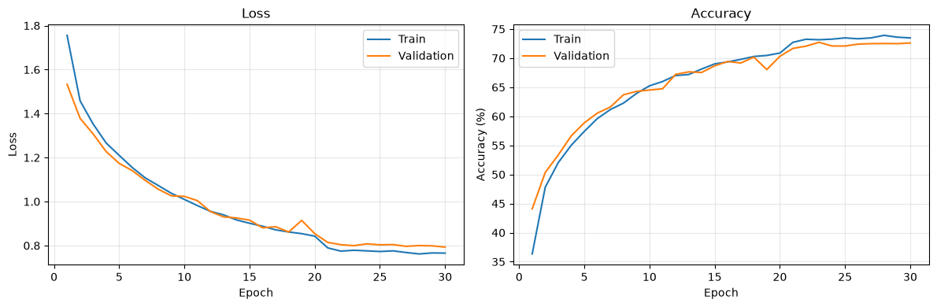
Three-layer CNN epoch loss and accuracy results

Failure cases
The misclassified examples show that both models can struggle when two CIFAR-10 classes share similar visual features. Background clutter and variation in lighting, color, and viewpoint can also make the object less distinct.
The three-layer model’s errors should be compared with the two-layer model’s errors to see whether the deeper architecture resolves any of these confusions or makes different ones. These limitations help to address potential limitations on the accuracy scores.

Validation accuracy
Validation accuracy measures performance on held-out images during training. Three layer reached 72.72% at epoch 23, while two layer peaked at 41.26% at epoch 29, suggesting the deeper model learned more useful CIFAR-10 features.

