Evidence-Based Quality Assessment of the NovaCart Application: A Risk-Oriented Testing Study

Abstract
This article presents an evidence-based quality assessment of NovaCart, an existing commerce application with a FastAPI backend, PostgreSQL persistence, and a React frontend. The study evaluates the project’s current quality state using preserved repository artifacts rather than a fresh execution run. The testing strategy followed a risk-based approach, prioritizing authentication, shopping cart behavior, checkout and order creation, admin product management, and persistence-critical flows. The evidence shows strong breadth of automation across high-risk functions, with overall high-risk coverage of 92% (23/25 functions automated), fast execution (1.955 s for the preserved full suite), and stable rerun behavior in the saved artifacts (0% flaky rate). At the same time, regression trustworthiness remained limited because the baseline included 20 failed tests, unresolved failures in critical flows, and gaps in direct automation for coupon removal and explicit migration validation. The study concludes that the QA effort established a strong technical foundation, but the suite still requires cleanup and a full rerun before it can serve as a reliable release gate.
Keywords: software testing, risk-based testing, QA automation, Playwright, API testing, regression analysis, evidence-based assessment

1. Introduction
Testing existing web applications requires both technical coverage and strategic prioritization. In practice, teams rarely have enough time to test every feature with equal depth, which is why risk-based testing remains a practical decision framework. Foidl and Felderer argue that risk-based testing is most effective when risk assessment drives where testing effort is concentrated, especially under time and resource pressure (Foidl and Felderer, 2018). That perspective is directly relevant to NovaCart, where authentication, order processing, and data persistence have greater business impact than utility endpoints.
NovaCart is a demo e-commerce platform, but it still includes the kinds of workflows that are typical sources of production defects: user registration and login, cart mutation, coupon and shipping logic, checkout, order retrieval, admin product management, and persistence-backed transaction handling. Because those workflows are interconnected, a defect in one area can propagate into multiple user journeys. The objective of this article is therefore not simply to list test cases, but to explain how the existing QA implementation performed against the application’s highest-risk behaviors.
The article also aligns its interpretation with recent literature on automated testing. For example, Poth, Rrjolli, and Arcuri show that industrial REST API testing benefits from explicit tool adoption criteria and measurable evidence, rather than tool choice by preference alone (Poth et al., 2025). Similarly, Taromirad and Runeson highlight that assertion quality is central to useful automated testing because assertions determine whether a test meaningfully detects incorrect behavior (Taromirad and Runeson, 2025). These ideas frame the present study: NovaCart’s suite is judged not only by how much it covers, but by how trustworthy its results are.

2. Background and Related Work
Risk-based testing is widely used when a system contains more possible test targets than a team can deeply verify within one iteration. In such settings, the purpose of testing is not to spread effort evenly, but to maximize the value of each test cycle by focusing on the areas where failure would hurt most. Foidl and Felderer describe this integration of quality models and risk prioritization as a way of making software testing more strategically aligned with business consequences (Foidl and Felderer, 2018).
This study also draws on the broader argument that test automation must be evaluated as an engineering system rather than as a binary success. A suite may run quickly, cover many features, and still fail to act as a release gate if its assertions are weak, its fixtures are unstable, or its failures are difficult to interpret. The literature on assertion design is especially relevant here because poor assertions can create false confidence just as unstable harness design can create false alarms (Taromirad and Runeson, 2025).
There is also a useful connection to model-based and systematic testing research. Gurbuz and Tekinerdogan show that structured test design improves traceability and makes safety or quality claims easier to justify across complex systems (Gurbuz and Tekinerdogan, 2018). Although NovaCart is not a safety-critical application, the same logic applies: a documented chain from risk assessment to automated evidence gives stronger support for conclusions than a collection of isolated test scripts.
Within that context, NovaCart is a good case study because it includes both customer-facing and administrative behavior, transactional state changes, and persistence-sensitive operations. Those characteristics allow the article to examine not only whether the project added tests, but whether the chosen test design produced useful quality knowledge.

3. System Under Test
NovaCart consists of a layered FastAPI backend, PostgreSQL database, Alembic migrations, and a React frontend served by the same application. The backend supports customer and admin capabilities, including:
- user registration and login
- product catalog browsing and product detail retrieval
- cart operations, coupon handling, and shipping selection
- checkout and order creation
- order history and order-status updates
- admin product CRUD and dashboard metrics
From a QA perspective, this architecture makes the application suitable for multi-level testing. API-level tests can validate business rules directly, while browser-based tests can verify whether the frontend still supports core user journeys. The preserved project evidence reflects exactly that split: Playwright API suites under tests/ validate backend workflows, and Playwright browser smoke tests under postman/ validate end-to-end UI behavior.

4. Research Questions
The article is organized around four research questions derived from the project goals and available evidence:
RQ1. How much of NovaCart’s highest-risk behavior is represented in the preserved automation suite?
RQ2. Which modules produced the strongest concentration of discovered defects or quality risk?
RQ3. Is the automation suite efficient and stable enough to support CI-based regression use?
RQ4. Do the measured results support release-gate confidence for the current application state?
These questions are intentionally practical. Rather than asking whether the suite is theoretically complete, they ask whether the existing evidence supports dependable engineering decisions.

5. Methodology

3.1 Study Design
This study is based on preserved repository evidence only. No new tests were rerun for this article. All quantitative claims come from saved markdown evidence tables, Playwright JSON reports, logs, and the project’s existing QA documentation.
The main evidence sources were:
- docs/task5-midterm-report.md
- docs/task3-metrics-analysis.md
- docs/test-strategy.md
- evidence/AUTOMATION_COVERAGE_TABLE.md
- evidence/DEFECTS_RISK_COMPARISON_TABLE.md
- evidence/EXECUTION_TIME_TABLE.md
- evidence/QUALITY_GATE_TABLE.md
This design choice matters because it prevents overstating progress. Some additional scenarios were implemented later in the project, but unless those improvements were reflected in preserved execution artifacts, they are treated here as structural improvements rather than measured results.

5.2 Evidence Processing
The evidence was synthesized in three steps. First, the saved project documentation was used to identify the intended testing priorities, quality gates, and scope boundaries. Second, evidence tables and Playwright artifacts were used to extract measured values for coverage, defects, runtime, and suite outcomes. Third, those measurements were compared against the project’s own release criteria to determine whether the implemented test program behaved like a trustworthy release-control mechanism.
This process is important because it distinguishes between the presence of automation and the value of automation. A repository may contain many tests, but the evidence-based question is whether those tests produce stable and decision-relevant feedback.

5.3 Test Strategy
The NovaCart QA strategy prioritized modules according to business impact and failure probability. The highest-priority areas were authentication, shopping cart behavior, checkout and order creation, admin product management, and database migration or persistence handling. This is consistent with risk-oriented testing literature, which treats probability and impact as the central dimensions for deciding test depth and order of execution (Foidl and Felderer, 2018).
Automation was implemented at three levels:
- API integration testing with Playwright under tests/
- Browser smoke and UI validation with Playwright under postman/
- Supporting CI orchestration through github-actions-ci.yml
This tool consolidation is methodologically useful because it reduces framework sprawl while still covering both service and interface layers. That choice is broadly aligned with evidence that technology selection for automated API testing is more effective when it balances maintainability, reporting, and execution practicality (Poth et al., 2025).

5.4 Metrics
The article reports four categories of evidence:
- coverage of high-risk functions
- defect concentration by module
- execution efficiency
- quality gate conformance
These metrics are interpreted conservatively. A failed automated test is treated as discovered quality risk, but not automatically as a confirmed product defect, because the repository evidence also records automation issues such as setup instability and Playwright fixture misuse.

5.5 Scope Boundaries
The article excludes claims about:
- load, stress, or performance testing
- penetration testing or deep security assessment
- comprehensive accessibility certification
- cross-browser compatibility beyond the saved smoke evidence
- post-expansion results that were not rerun and preserved
That limitation is deliberate. The purpose of the article is to make defensible claims from actual evidence, not to imply quality characteristics that were never measured.

6. Results

4.1 Testing Workflow Illustration
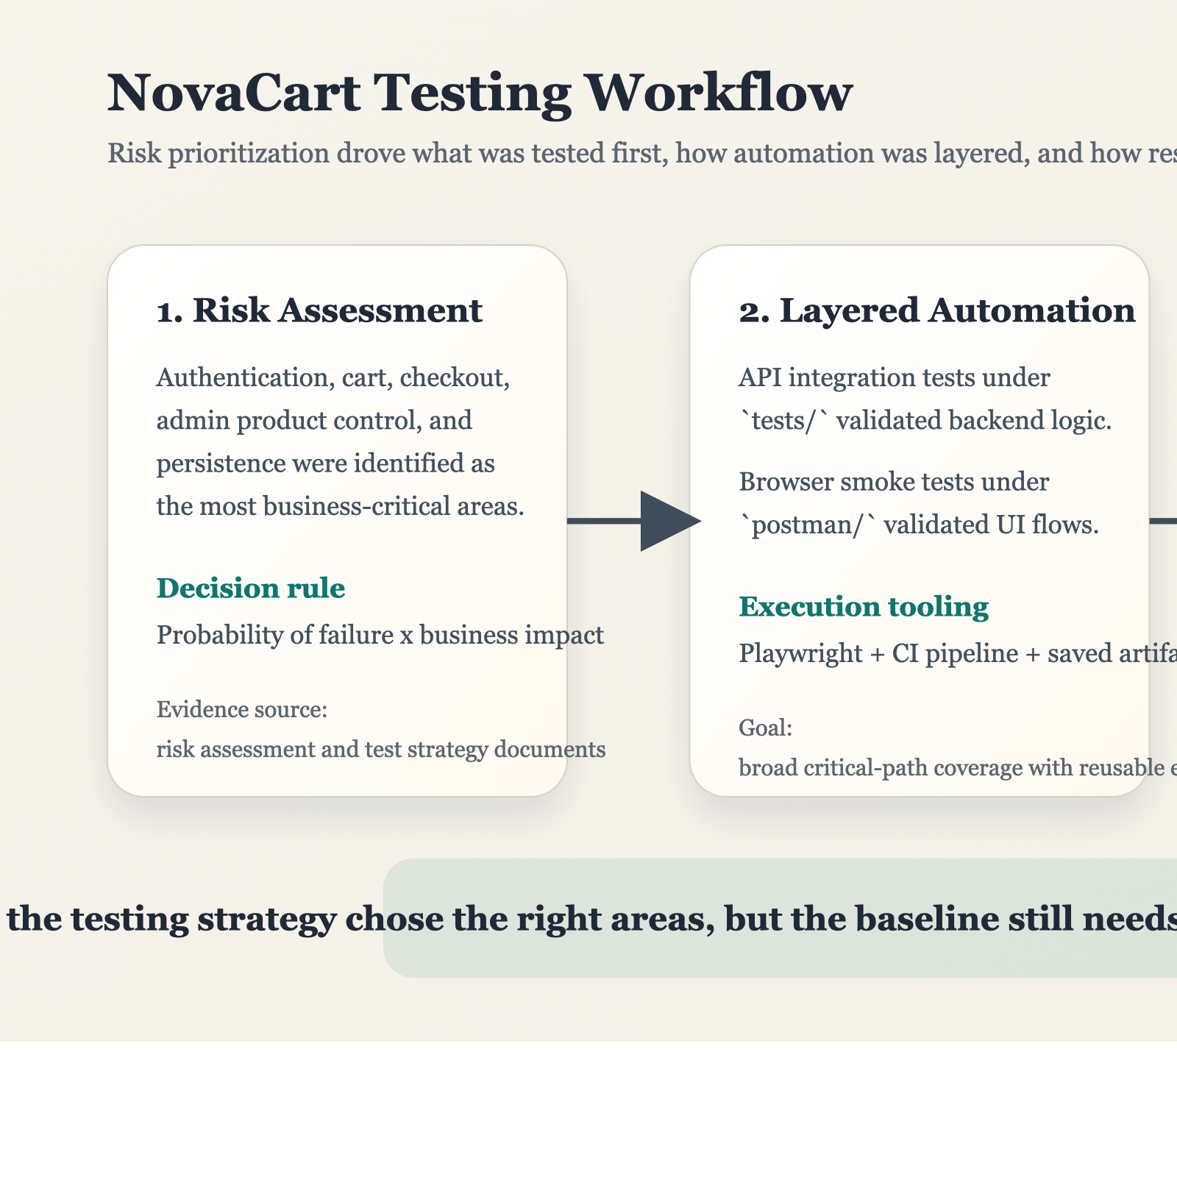
NovaCart testing workflow
Figure 1 summarizes how risk identification shaped the preserved testing effort. The workflow moved from risk assessment into layered automation and finally into evidence-based interpretation.

6.2 Coverage Results
The preserved evidence shows strong automation breadth across the highest-risk workflows. Overall coverage across high-risk functions reached 92% (23/25). Authentication, checkout and order creation, and admin product management each reached 100% in the measured baseline. Shopping cart coverage was 86%, while database migration and persistence reached 80%.
Two important gaps remained in the measured baseline:
- direct automation for coupon removal
- direct scripted validation of migration success
These gaps are not minor because both behaviors touch state consistency. Coupon removal affects pricing correctness, and migration validation affects deployment confidence and persistence integrity.
Table 1 summarizes the measured high-risk coverage profile.
High-risk module | Measured coverage | Interpretation
Authentication | 100% | Strong direct automation coverage of access-control behavior.
Shopping Cart | 86% | Broad cart-state coverage, with coupon removal missing in the preserved baseline.
Checkout and Order Creation | 100% | Core transactional flow represented in automation.
Admin Product Management | 100% | CRUD paths fully present in the baseline model.
Database Migration and Persistence | 80% | Transaction behavior covered, but migration validation remained operational rather than test-script based.
The coverage result answers RQ1 positively in a narrow sense: the suite covers most high-risk business behavior. However, the missing two functions matter because both are state-sensitive and closely tied to user trust and release confidence.

6.3 Defect Findings
Defect concentration strongly matched the initial risk model. Authentication produced the highest preserved defect count with 6 failures, exceeding the expected range for that module. Shopping cart produced 3 defects, checkout and order creation produced 2, admin product management produced 1, and database migration and persistence produced 1.
One notable exception was the Admin Dashboard, a medium-risk area that produced 2 defects and exceeded its expected defect range. This result suggests that medium-risk areas should not be ignored once high-risk coverage is established, especially when those areas aggregate system state and summary data.
The defect distribution also helps answer RQ2. The strongest concentration of discovered quality risk appeared exactly where the system was most business sensitive: authentication, cart-state changes, and order-related logic. This supports the project’s initial prioritization logic rather than contradicting it.
Table 2 summarizes the preserved defect picture by key module.
Module | Risk level | Defects found | Interpretation
Authentication | High | 6 | Highest defect concentration and above expected range.
Shopping Cart | High | 3 | Significant state-related failures, some coupled to setup instability.
Checkout and Order Creation | High | 2 | Important transactional issues surfaced in the main purchase path.
Admin Product Management | High | 1 | Lower count, but still relevant because of catalog integrity implications.
Admin Dashboard | Medium | 2 | Unexpected medium-risk outlier affecting metrics accuracy.
Database Migration and Persistence | High | 1 | Persistence-related behavior remains risk-sensitive even with lower defect volume.

6.4 Execution Efficiency and Stability
The preserved full API suite completed in 1.955 s, and the slowest module was System/Admin at 1.195 s. From a CI perspective, execution time was therefore not the limiting factor. In fact, the evidence suggests that NovaCart already achieved the speed needed for frequent regression use.
Stability findings were more nuanced. The saved artifacts reported 0 flaky tests, but that does not imply high confidence. Instead, the suite’s weakness came from deterministic failures and harness issues. The full preserved baseline recorded:
- 37 passed
- 20 failed
- 54 skipped
- 0 flaky
This pattern indicates that the suite was broad enough to find problems, but not yet clean enough to function as a dependable release gate.
That result provides a mixed answer to RQ3. On efficiency, the suite performed very well. On stability and actionable signal, it performed less well because deterministic failures and setup problems reduced trust in the regression outcome.

6.5 Quality Gate Assessment
The project defined explicit quality gates for coverage, critical defects, runtime, regression success, and lint or static-analysis evidence. When the preserved measurements are compared against those gates, the outcome is mixed:
- coverage passed
- runtime passed
- critical-defect gate failed
- regression-success gate failed
- lint or static-analysis gate failed
This means RQ4 must be answered negatively. The preserved evidence does not support release readiness, even though some important dimensions such as coverage breadth and runtime are already strong.

6.6 Visual Summary of Measured Outcomes
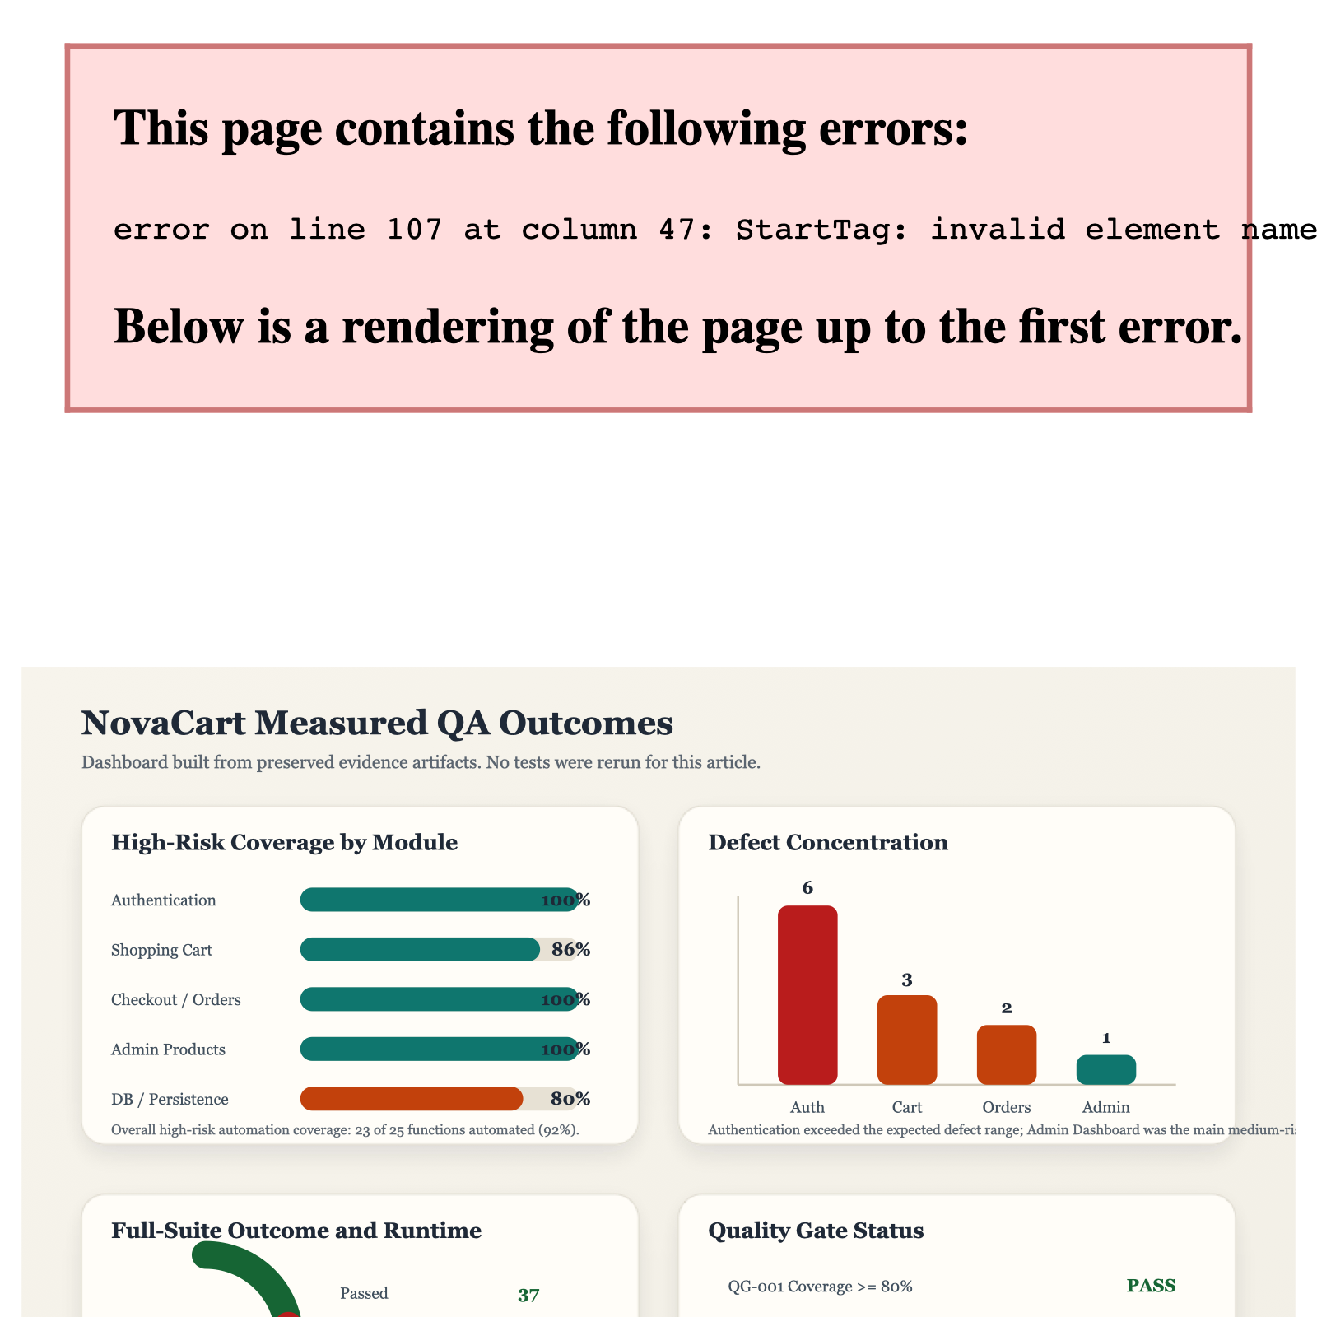
NovaCart results dashboard
Figure 2 aggregates the most important results from the preserved evidence set. The figure shows a positive picture in coverage and runtime, but a mixed picture in regression trustworthiness and release gating.

7. Analysis by Test Layer

7.1 API Integration Layer
The API layer carried most of the analytical weight in this project. It is where the highest-risk workflows were validated and where most failures were observed. That is not surprising. API-level automation typically reaches business rules more directly than browser smoke tests and can expose transaction, authorization, and persistence issues before the UI layer makes them visible. In NovaCart, this layer was especially important because the backend owns state transitions for authentication, cart mutation, pricing, order creation, and admin operations.
The measured evidence suggests that the API layer was already valuable as a defect discovery mechanism. However, its value as a release signal was reduced by upstream setup dependencies and fixture misuse. In practical terms, the suite was finding risk, but it was not yet fully separating product issues from framework or harness issues.

7.2 Browser Smoke Layer
The browser smoke layer served a different purpose. Instead of deep behavioral analysis, it checked whether major user-facing flows still worked when exercised through the running application. The saved evidence indicates a much cleaner outcome here, with the browser smoke suite reported as 10/10 passing in the project documentation.
That cleaner result should not be misread as stronger quality evidence overall. A smoke suite is intentionally narrower than a regression suite. Its success indicates that high-level journeys remain accessible, but it does not replace deeper verification of transactional and persistence-sensitive behavior. In NovaCart, the browser layer complements the API suite; it does not supersede it.

7.3 CI and Evidence Preservation Layer
The CI configuration also played a methodological role in the project. Even without a fresh rerun, the preserved logs, reports, and tables made later analysis possible. This is a meaningful engineering outcome. Many teams automate tests but preserve little evidence beyond pass or fail status. NovaCart’s project artifacts made it possible to reconstruct where the suite was strong, where it was weak, and which claims could still be defended at report time.

8. Discussion
The main result of this study is that the original testing priorities were directionally correct. The modules selected as most important early in the QA effort were the same modules that later showed the strongest concentration of failures, coverage gaps, or release risk. This is an encouraging outcome because it means the project focused effort where it mattered most.
At the same time, the study shows a common limitation of growing automation programs: coverage is not the same as confidence. NovaCart achieved broad coverage, yet the saved baseline still included critical-path failures and a failed regression gate. This distinction is consistent with broader software testing research, which emphasizes that the effectiveness of automation depends not only on having tests, but also on the strength of their checks, the reliability of their setup, and the interpretability of their results (Taromirad and Runeson, 2025).
Another important observation is that the browser smoke suite appears healthier than the API regression baseline. The project documentation records a 10/10 pass outcome for the preserved browser smoke layer, while the main API suite did not meet regression gate expectations. This suggests that the visible interface was not the only place quality mattered; deeper service-level verification was where the most significant issues surfaced. That pattern supports the use of layered testing rather than UI-only validation.
Finally, the project shows the practical value of evidence preservation. Because results, logs, and tables were retained, the team could perform meaningful analysis even without rerunning the suite. This kind of traceable evidence is especially useful in academic and industrial QA reporting because it enables reproducibility and honest separation between measured outcomes and later improvements.
There is also an important lesson about quality gates. NovaCart’s results show that teams can reach acceptable coverage and runtime thresholds before they reach trustworthy regression status. That difference matters because organizations sometimes overvalue percentage-based metrics. In this case, 92% high-risk coverage sounds strong, but the failed regression gate shows that coverage percentage alone cannot stand in for release confidence.

9. Recommendations
Based on the preserved findings, the next improvement steps should focus on trustworthiness rather than raw breadth.
First, the suite should isolate setup dependencies so that authentication failures do not cascade into downstream cart and order tests. This would improve fault localization and reduce false conclusions about unrelated modules.
Second, the remaining high-risk gaps should be closed and remeasured through a preserved rerun. Direct automation of coupon removal and explicit migration validation are both necessary if the project wants to claim comprehensive control over pricing state and deployment safety.
Third, the project should add a dedicated linting and static-analysis stage to CI. The current quality gate set already expects that evidence, but the repository does not preserve it. Adding that stage would strengthen structural quality claims and make the release criteria internally consistent.
Fourth, the updated suite should be rerun end-to-end with the same artifact preservation discipline used for the current baseline. That rerun is the key step that would convert structural improvements into measured progress.

10. Threats to Validity
Several threats to validity should be acknowledged.
First, this article is based on preserved evidence rather than a fresh rerun. That means the paper accurately reflects the saved baseline, but it may underrepresent the current state of the repository if later fixes were added without new execution artifacts.
Second, some recorded failures appear to come from test harness problems rather than confirmed product defects. As a result, defect counts should be read as indicators of discovered quality risk, not as a strict count of application-only faults.
Third, the coverage metric is function-oriented rather than code-instrumentation-based. It is therefore useful for business-risk interpretation, but it is not equivalent to line or branch coverage.
Fourth, the article cites external literature to frame the QA strategy, but the NovaCart analysis itself remains a single-project case study. The conclusions are therefore strongest as a project-specific evaluation rather than as a universal claim about all automation programs.

11. Conclusion
The NovaCart testing project demonstrates a strong and credible QA foundation for an existing application. The preserved evidence shows wide coverage of business-critical workflows, fast execution suitable for CI, and a risk model that successfully predicted where the most important defects would appear.
However, the study also shows that broad automation alone does not guarantee release readiness. The measured baseline still contains unresolved failures in critical areas, missing direct automation for two important high-risk behaviors, and a regression gate that cannot yet be considered trustworthy. The most defensible conclusion is therefore balanced: NovaCart’s QA implementation is mature enough to support serious quality analysis, but it still needs stabilization and a fresh rerun before it can be treated as a fully reliable release-control mechanism.

12. Evidence Sources Used in This Article
- docs/task5-midterm-report.md
- docs/task3-metrics-analysis.md
- docs/test-strategy.md
- evidence/AUTOMATION_COVERAGE_TABLE.md
- evidence/DEFECTS_RISK_COMPARISON_TABLE.md
- evidence/EXECUTION_TIME_TABLE.md
- evidence/QUALITY_GATE_TABLE.md
- preserved Playwright result artifacts and project logs under evidence/ and logs/

References
- Foidl, H., & Felderer, M. (2018). Integrating software quality models into risk-based testing. Software Quality Journal, 26, 809-847. https://doi.org/10.1007/s11219-016-9345-3
- Poth, A., Rrjolli, O., & Arcuri, A. (2025). Technology adoption performance evaluation applied to testing industrial REST APIs. Automated Software Engineering, 32, Article 5. https://doi.org/10.1007/s10515-024-00477-2
- Taromirad, M., & Runeson, P. (2025). Assertions in software testing: survey, landscape, and trends. International Journal on Software Tools for Technology Transfer, 27, 117-135. https://doi.org/10.1007/s10009-025-00794-1
- Gurbuz, H. G., & Tekinerdogan, B. (2018). Model-based testing for software safety: a systematic mapping study. Software Quality Journal, 26, 1327-1372. https://doi.org/10.1007/s11219-017-9386-2

