

Game of Thrones - Survival Analysis

# Description

* Author: Anthony Jourdan
* Date: 10 April 2020
* Notebook available at: <https://github.com/terman37/GoT-Survival_Analysis>

# Objectives

Target of this study is to analyze how much time was spent on screen by characters of GoT before they died (or the show ends).

We will try to find most influencing criterions among social indicators, and build a survival model.

This model will then be evaluated and checked on a test dataset.

# Dataset description

## Dataset Information

Dataset downloaded from [here](https://figshare.com/articles/Game_of_Thrones_mortality_and_survival_dataset/8259680/1)

Game of Thrones mortality and survival dataset

Dataset posted on 13.06.2019, 10:25 by Reidar Lystad Benjamin Brown

This dataset includes data from Game of Thrones Seasons 1–8. The dataset comprises two separate datasets and an accompanying data dictionary. The character dataset contains 359 observations (i.e. characters) and 35 variables, including information about sociodemographic, exposures, and mortality. The episode dataset contains 73 observations (i.e. episodes) and 8 variables, including information about episode running time.

In this study we will use only the character dataset.

## Character dataset

* Number of observations: 359.
* Outcome: **exp_time_hrs** - On screen time before death = Survival time of character

(calculated as the time between first apparition and death)

* Censoring indicator: **dth_flag**

= 0 if character is not dead by the end of the show, = 1 otherwise

* Explanatory variables:

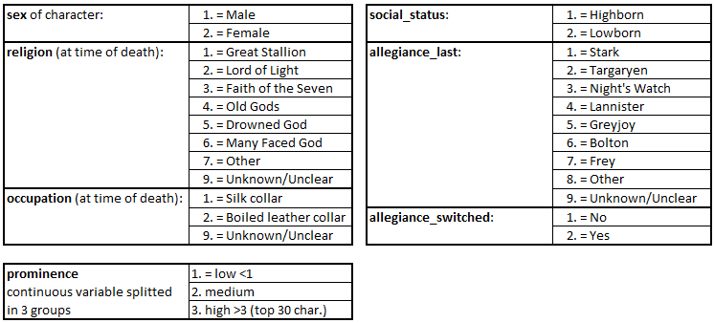

# Data Preparation

Load needed libraries

library(tidyverse)  
library(survival)  
library(ggfortify)  
library(ggplot2)  
library(broom)  
library(survminer)  
library(survivalROC)

Import data from csv file and format output:

raw_data = read.csv("./GoT_dataset/character_data_S01-S08.csv")  
dat_full = raw_data %>%   
 select(name,  
 exp_time_hrs,  
 dth_flag,  
 sex, religion,  
 occupation, social_status,  
 allegiance_last, allegiance_switched,  
 prominence) %>%   
 mutate(sex = c("Male", "Female")[match(sex, c(1,2))],  
 religion = c("Great Stallion",  
 "Lord of Light",  
 "Faith of the Seven",  
 "Old Gods",  
 "Drowned God",  
 "Many Faced God",  
 "Other",  
 "Unknown/Unclear")[match(religion,c(1,2,3,4,5,6,7,9))],  
 occupation = c("Silk collar",  
 "Boiled leather collar",  
 "Unknown/Unclear")[match(occupation,c(1,2,9))],  
 social_status = c("Highborn", "Lowborn")[match(social_status,c(1,2))],  
 allegiance_last = c("Stark",  
 "Targaryen",  
 "Night's Watch",  
 "Lannister",  
 "Greyjoy",  
 "Bolton",  
 "Frey",  
 "Other",  
 "Unknown/Unclear")[match(allegiance_last,c(1,2,3,4,5,6,7,8,9))],  
 allegiance_switched = c("No", "Yes")[match(allegiance_switched,c(1,2))],  
 prominence = ifelse(prominence>3, "High",  
 ifelse(prominence<1, "Low", "Medium")  
 ))

Keep 15% of data for evaluating the final model

train_size = 85 / 100 * nrow(dat_full)  
idx.dat = sample.int(nrow(dat_full), size = train_size, replace = FALSE)  
dat = dat_full[idx.dat,]  
dat_test = dat_full[-idx.dat,]

# Data Exploration

## Outcome: Survival duration

Let’s have a look at basic statistics about the survival duration.

summary(dat$exp_time_hrs)

## Min. 1st Qu. Median Mean 3rd Qu. Max.   
## 0.00 4.22 17.96 22.42 38.03 63.99

ggplot(dat,aes(exp_time_hrs)) + geom_histogram(bins = 10, color="black",fill="steelblue")

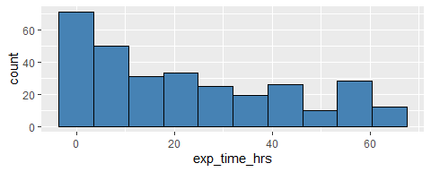

Median screen time for characters is 18 hours and 75% are not able to be on screen more than 38 hours, but it can be because they are dead or because the show has ended (careful with histograms and censored data)

## Censoring indicator

Proportion of people dead before the end of the show.

prop.table(table(dat$dth_flag))

## 0 1   
## 0.4098361 0.5901639

Roughly 40% of data are censored, 60% of the characters in the study are dead before the end of the TV show.

## Explanatory variables

Show explanatory variables composition:

d_plot = dat %>%  
 select(-name,-exp_time_hrs,-dth_flag) %>%  
 gather() %>%  
 group_by(key) %>%  
 count(value) %>%   
 mutate(frequency=round(`n`/sum(`n`)*100,0)) %>%  
 arrange(desc(key),desc(frequency))  
  
d_plot %>% ggplot(aes(x=value, y=frequency)) +  
 facet_wrap(~ key, scales = "free") +  
 geom_bar(stat="identity", fill="steelblue") +  
 theme(axis.text.x = element_text(angle = 90, hjust = 1))

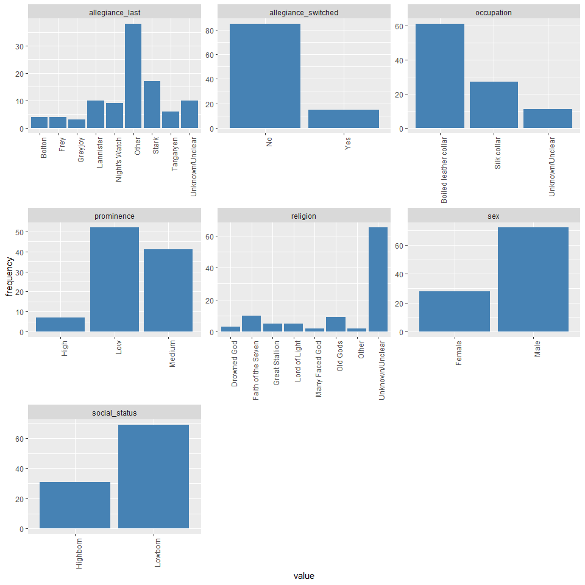

Main things to have in mind during analysis:

* 70% of characters are men, 30% are women.
* 70% are lowborn, 30% are high born, but we should see more survival in highborn (as they are less on the field during wars?)
* Most are boiled leather collar (60%)
* 65% of the population have not known or unclear religion –> Careful to check if meaningful
* Main allegiance is for Stark Family, after the “other” category, no sure to know what is the difference with “unknown/unclear”
* A vast majority of character have not switched allegiance during the show (does it help them to survive?)
* We have a smaller high prominence category, which make sense as it represents top characters of the show, low and medium are quite balanced.

# Global survival overview

**Kaplan-Meyer estimator**

fit.KM = survfit(Surv(exp_time_hrs, dth_flag) ~ 1, data = dat)  
autoplot(fit.KM,conf.int.fill = "#00FF00", censor=FALSE) +  
 geom_hline(yintercept=.5, linetype="dashed", color = "red") +   
 ggtitle("Kaplan-Meier estimate with CI")

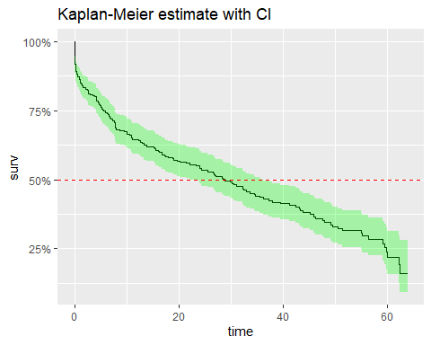

Median Survival Time: 28.8hrs - As a character, you would have 50% of change to appear on screen up to 28.8hrs

fit.KM

## Call: survfit(formula = Surv(exp_time_hrs, dth_flag) ~ 1, data = dat)  
##   
## n events median 0.95LCL 0.95UCL   
## 305.0 180.0 28.8 22.1 36.3

# Survival vs Explanatory variables

## Used functions

# draw the KM survival curve with stratification with a given exlanatory variable  
plot_KM <- function(df,col,CI=TRUE){  
 fit = survfit(Surv(df$exp_time_hrs, df$dth_flag) ~ df[,col])  
 autoplot(fit,conf.int=CI,censor=FALSE) +   
 geom_hline(yintercept=.5, linetype="dashed", color = "red")   
}  
  
# Print the medians for stratas (+formating)  
print_medians <- function(df,col){  
 fit = survfit(Surv(df$exp_time_hrs, df$dth_flag) ~ df[,col])  
 infos_fit = surv_median(fit) %>%  
 mutate(strata=substr(strata,11,100))  
 cat("Medians:\n")  
 cat(sprintf("%*s %*s %*s\n",25,"Group",15,"Median",20,"Conf.Interval"))  
 fit.conf=paste("( ",infos_fit$lower,";",infos_fit$upper," )",sep="")  
 cat(sprintf("%*s %*s %*s\n",25,infos_fit$strata,15,infos_fit$median,20,fit.conf))  
}  
  
# Print cox regression HR+CI and LRT for stratas (+formating)  
print_cox <- function(df,col){  
 fit_cox = coxph(Surv(df$exp_time_hrs, df$dth_flag) ~ df[,col])  
 x = tidy(fit_cox)  
 cox.ref = fit_cox$xlevels[[1]][1]  
 cox.term = substr(x$term,10,100)  
 cox.hr = round(exp(x$estimate),2)  
 cox.hr.conflow = round(exp(x$conf.low),2)  
 cox.hr.confhigh = round(exp(x$conf.high),2)  
 cat("Cox Regression:\n")  
 cat(sprintf("%*s %*s %*s\n",25,"Group",15,"Hazard Ratio",20,"Conf.Interval"))  
 cat(sprintf("%*s %*s %*s\n",25,cox.ref,15,"(Reference)",20,"-"))  
 cox.conf=paste("( ",cox.hr.conflow,";",cox.hr.confhigh," )",sep="")  
 cat(sprintf("%*s %*s %*s\n",25,cox.term,15,cox.hr,20,cox.conf))  
 y = glance(fit_cox)  
 cox.lrt = ifelse(y$p.value.log<0.01,  
 formatC(y$p.value.log, format = "e", digits = 2),  
 formatC(y$p.value.log, digits = 2))  
 cat(paste("\nLikelihood Ratio Test:",cox.lrt))  
}

## - How is gender influencing survival time?

plot_KM(dat,"sex")

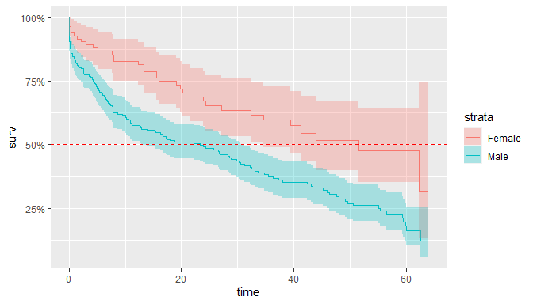

print_cox(dat,"sex")

## Cox Regression:  
## Group Hazard Ratio Conf.Interval  
## Female (Reference) -  
## Male 1.97 ( 1.36;2.86 )  
##   
## Likelihood Ratio Test: 1.45e-04

Likelihood ratio test (LRT) pvalue is very small, proving that there is a significant difference between men and women survival time.

Hazard ration is 1.97, meaning that men have almost twice more chances to be killed than women

Here is the median survival time for each category:

print_medians(dat,"sex")

## Medians:  
## Group Median Conf.Interval  
## Female 51.42 ( 34.57;NA )  
## Male 23.38 ( 12.92;30.6 )

## - How is religion survival time?

plot_KM(dat,"religion",FALSE)

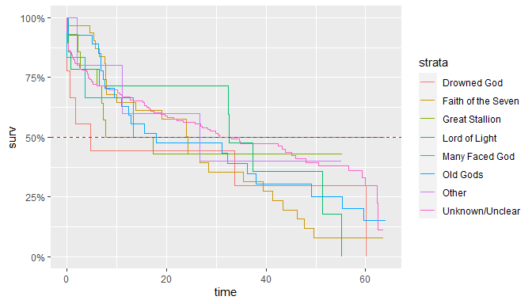

print_cox(dat,"religion")

## Cox Regression:  
## Group Hazard Ratio Conf.Interval  
## Drowned God (Reference) -  
## Faith of the Seven 0.89 ( 0.39;2.06 )  
## Great Stallion 0.71 ( 0.26;1.97 )  
## Lord of Light 0.7 ( 0.26;1.88 )  
## Many Faced God 0.46 ( 0.12;1.77 )  
## Old Gods 0.74 ( 0.32;1.75 )  
## Other 0.61 ( 0.16;2.38 )  
## Unknown/Unclear 0.61 ( 0.28;1.31 )  
##   
## Likelihood Ratio Test: 0.69

Cox regression LRT pvalue is very large and > 5% pointing that there is no significant difference between religions.

One thing that can be noted from the graph is that the “Drowned God” religion has a median survival time very low… If you were of this religion, you would have only 50% chance stay on screen more than 4.8hrs! (pretty scary)

print_medians(dat,"religion")

## Medians:  
## Group Median Conf.Interval  
## Drowned God 4.79 ( 0.56;NA )  
## Faith of the Seven 24.34 ( 10.05;41.33 )  
## Great Stallion 12.535 ( 6.9;NA )  
## Lord of Light 32.56 ( 32.36;NA )  
## Many Faced God 13.36 ( 3.59;NA )  
## Old Gods 17.96 ( 10.96;55.34 )  
## Other 26.63 ( 11.17;NA )  
## Unknown/Unclear 33.06 ( 23.38;47.99 )

## - How is occupation influencing?

plot_KM(dat,"occupation")

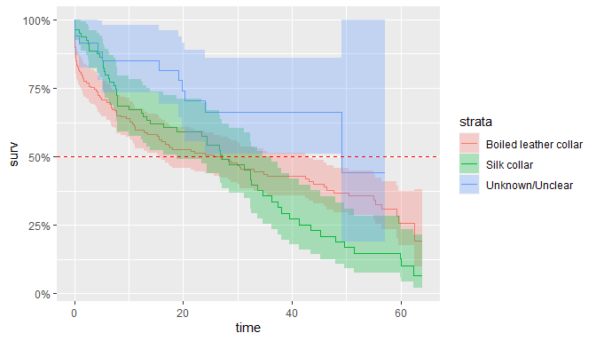

print_cox(dat,"occupation")

## Cox Regression:  
## Group Hazard Ratio Conf.Interval  
## Boiled leather collar (Reference) -  
## Silk collar 1.14 ( 0.83;1.57 )  
## Unknown/Unclear 0.49 ( 0.26;0.92 )  
##   
## Likelihood Ratio Test: 0.019

LRT pvalue is < 5%, we can say that at least one group is significantly different from other. It’s certainly due to the group ‘Unknown/Unclear’ (10% of characters) which has a hazard ratio close to 0.5, the 2 others are closer (HR ~ 1.1). This can be also seen on the medians were CI are overlapping.

print_medians(dat,"occupation")

## Medians:  
## Group Median Conf.Interval  
## Boiled leather collar 25.68 ( 15.57;43.17 )  
## Silk collar 27.12 ( 18.87;34.57 )  
## Unknown/Unclear 49.15 ( 49.15;NA )

## - Is social status influencing?

plot_KM(dat,"social_status")

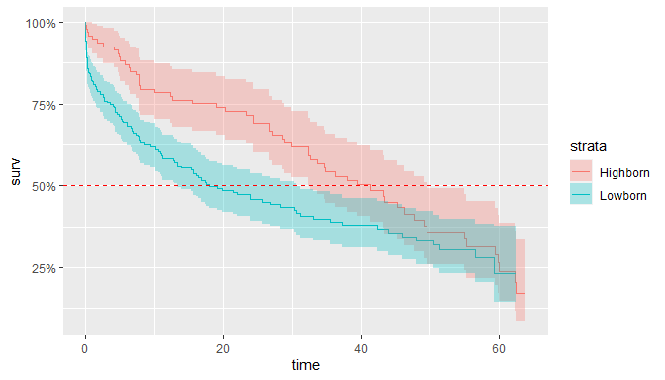

print_cox(dat,"social_status")

## Cox Regression:  
## Group Hazard Ratio Conf.Interval  
## Highborn (Reference) -  
## Lowborn 1.49 ( 1.08;2.05 )  
##   
## Likelihood Ratio Test: 0.012

Again, LRT pvalue is <5%, meaning that to be highborn or lowborn is significantly different in terms of survival time in GoT. Lowborn have a much smaller median survival time (with 18 hours vs 41 for highborn) but probability to survive over 50 hours tends to be the same whatever the social status.

print_medians(dat,"social_status")

## Medians:  
## Group Median Conf.Interval  
## Highborn 41.33 ( 32.36;49.59 )  
## Lowborn 17.96 ( 13.36;30.6 )

## – Is the last allegiance made influencing?

plot_KM(dat,"allegiance_last",FALSE)

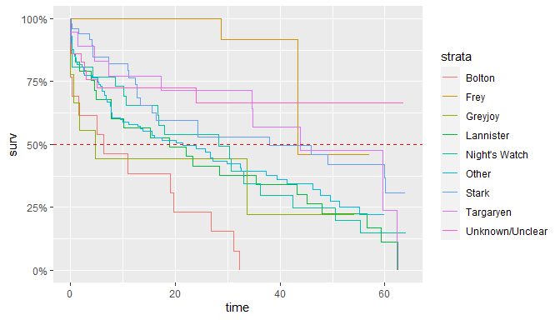

print_cox(dat,"allegiance_last")

## Cox Regression:  
## Group Hazard Ratio Conf.Interval  
## Bolton (Reference) -  
## Frey 0.06 ( 0.01;0.27 )  
## Greyjoy 0.58 ( 0.22;1.54 )  
## Lannister 0.47 ( 0.24;0.93 )  
## Night's Watch 0.41 ( 0.2;0.84 )  
## Other 0.41 ( 0.23;0.74 )  
## Stark 0.24 ( 0.12;0.48 )  
## Targaryen 0.25 ( 0.11;0.58 )  
## Unknown/Unclear 0.18 ( 0.08;0.42 )  
##   
## Likelihood Ratio Test: 1.02e-05

LRT pvalue is < 5%, we can say that at least one group is significantly different from other.

If your allegiance goes to ‘Bolton’, then you have 0% of chance to be present during all the show. But if you follow the ‘Greyjoy’, then your median survival time is not much better with 4.8hrs

print_medians(dat,"allegiance_last")

## Medians:  
## Group Median Conf.Interval  
## Bolton 6.26 ( 0.28;NA )  
## Frey 43.37 ( 43.37;NA )  
## Greyjoy 4.79 ( 0.56;NA )  
## Lannister 18.87 ( 7.75;45.18 )  
## Night's Watch 28.28 ( 10.61;50.52 )  
## Other 21.45 ( 11.17;37.37 )  
## Stark 38.03 ( 15.5;NA )  
## Targaryen 43.92 ( 34.57;NA )  
## Unknown/Unclear NA ( NA;NA )

## – Is the fact to have switched allegiance during the show influencing?

plot_KM(dat,"allegiance_switched")

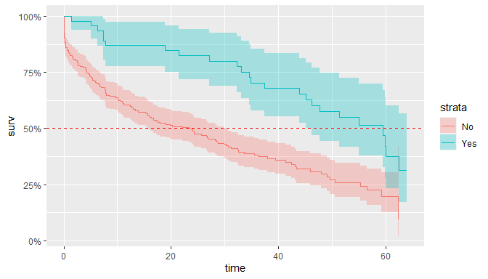

print_cox(dat,"allegiance_switched")

## Cox Regression:  
## Group Hazard Ratio Conf.Interval  
## No (Reference) -  
## Yes 0.41 ( 0.26;0.64 )  
##   
## Likelihood Ratio Test: 1.58e-05

pvalue < 5%, the change in allegiance has a real impact on the characters survival times.

It seems, that in GoT, if you want to maximize your chances to survive, you have to not be too strict with your allegiance. But remember, in the data exploration, we have seen that only a minority (15%) have switched allegiance. Characters are mainly loyal to their Families but it doesn’t make their life longer…

print_medians(dat,"allegiance_switched")

## Medians:  
## Group Median Conf.Interval  
## No 23.38 ( 15.57;30.32 )  
## Yes 59.54 ( 45.18;NA )

## – How is prominence influencing?

plot_KM(dat,"prominence")

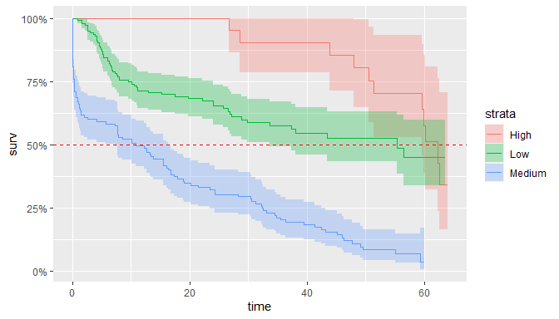

print_cox(dat,"prominence")

## Cox Regression:  
## Group Hazard Ratio Conf.Interval  
## High (Reference) -  
## Low 1.94 ( 0.98;3.83 )  
## Medium 6.28 ( 3.21;12.32 )  
##   
## Likelihood Ratio Test: 1.08e-16

Very significant difference, sounds logic for characters with high prominence (stars of the show), that producers decided not to kill them at the beginning of the show so their survival time is higher than others. It seems more surprising to me, that people with low prominence have a higher survival time than the ones in the middle.

print_medians(dat,"prominence")

## Medians:  
## Group Median Conf.Interval  
## High 62.35 ( 59.54;NA )  
## Low 55.34 ( 33.64;NA )  
## Medium 10.89 ( 7.34;16.32 )

# Build a model of Survival time in GoT

## - Model selection

Let’s start with a full model (using all explanatory variables) and run a step-wise model selection based on AIC.

dat_model = select(dat,-name)  
Model_Full = coxph(Surv(exp_time_hrs,dth_flag)~.,data=dat_model)  
MAIC = step(Model_Full)

## Start: AIC=1723.26  
## Surv(exp_time_hrs, dth_flag) ~ sex + religion + occupation +   
## social_status + allegiance_last + allegiance_switched + prominence  
##   
## Df AIC  
## - religion 7 1716.2  
## - allegiance_last 8 1721.9  
## - occupation 2 1722.0  
## <none> 1723.3  
## - social_status 1 1725.1  
## - sex 1 1727.1  
## - allegiance_switched 1 1736.0  
## - prominence 2 1780.3  
##   
## Step: AIC=1716.24  
## Surv(exp_time_hrs, dth_flag) ~ sex + occupation + social_status +   
## allegiance_last + allegiance_switched + prominence  
##   
## Df AIC  
## - occupation 2 1714.8  
## <none> 1716.2  
## - social_status 1 1717.2  
## - allegiance_last 8 1718.8  
## - sex 1 1720.5  
## - allegiance_switched 1 1727.7  
## - prominence 2 1771.3  
##   
## Step: AIC=1714.76  
## Surv(exp_time_hrs, dth_flag) ~ sex + social_status + allegiance_last +   
## allegiance_switched + prominence  
##   
## Df AIC  
## <none> 1714.8  
## - social_status 1 1715.4  
## - allegiance_last 8 1719.6  
## - sex 1 1721.2  
## - allegiance_switched 1 1727.6  
## - prominence 2 1769.1

After the step-wise selection, it appears that religion and occupation can be removed from model.

Remember that there was not significant difference between religion and we had a doubt about occupation as p value was below 5% but the 2 main categories were very close, main difference coming from unknown/unclear but representing only 10% of characters.

## - Model description & explanation

What’s the model looks like?

summary(MAIC)

## Call:  
## coxph(formula = Surv(exp_time_hrs, dth_flag) ~ sex + social_status +   
## allegiance_last + allegiance_switched + prominence, data = dat_model)  
##   
## n= 305, number of events= 180   
## coef exp(coef) se(coef) z Pr(>|z|)   
## sexMale 0.56158 1.75344 0.20130 2.790 0.005275 **   
## social_statusLowborn 0.29359 1.34124 0.18394 1.596 0.110453   
## allegiance_lastFrey -1.54787 0.21270 0.80873 -1.914 0.055625 .   
## allegiance_lastGreyjoy 0.11117 1.11758 0.51004 0.218 0.827461   
## allegiance_lastLannister -0.62418 0.53570 0.35607 -1.753 0.079603 .   
## allegiance_lastNight's Watch -0.98427 0.37371 0.36170 -2.721 0.006503 **   
## allegiance_lastOther -0.50191 0.60537 0.31087 -1.615 0.106414   
## allegiance_lastStark -1.06295 0.34544 0.36307 -2.928 0.003415 **   
## allegiance_lastTargaryen -0.70029 0.49644 0.43507 -1.610 0.107482   
## allegiance_lastUnknown/Unclear -1.27573 0.27923 0.44821 -2.846 0.004423 **   
## allegiance_switchedYes -0.89655 0.40797 0.24958 -3.592 0.000328 ***  
## prominenceLow -0.04301 0.95790 0.38290 -0.112 0.910557   
## prominenceMedium 1.20346 3.33163 0.36157 3.328 0.000873 ***  
## ---  
## Signif. codes: 0 '***' 0.001 '**' 0.01 '*' 0.05 '.' 0.1 ' ' 1  
##   
## exp(coef) exp(-coef) lower .95 upper .95  
## sexMale 1.7534 0.5703 1.18180 2.6016  
## social_statusLowborn 1.3412 0.7456 0.93527 1.9234  
## allegiance_lastFrey 0.2127 4.7014 0.04359 1.0379  
## allegiance_lastGreyjoy 1.1176 0.8948 0.41127 3.0369  
## allegiance_lastLannister 0.5357 1.8667 0.26659 1.0765  
## allegiance_lastNight's Watch 0.3737 2.6759 0.18393 0.7593  
## allegiance_lastOther 0.6054 1.6519 0.32916 1.1134  
## allegiance_lastStark 0.3454 2.8949 0.16956 0.7037  
## allegiance_lastTargaryen 0.4964 2.0143 0.21161 1.1647  
## allegiance_lastUnknown/Unclear 0.2792 3.5813 0.11600 0.6722  
## allegiance_switchedYes 0.4080 2.4511 0.25014 0.6654  
## prominenceLow 0.9579 1.0440 0.45227 2.0288  
## prominenceMedium 3.3316 0.3002 1.64017 6.7675  
##   
## Concordance= 0.75 (se = 0.019 )  
## Likelihood ratio test= 124.2 on 13 df, p=<2e-16  
## Wald test = 112.2 on 13 df, p=<2e-16  
## Score (logrank) test = 129.9 on 13 df, p=<2e-16

Most important things to note from model:

* men are 1.75 times more likely to be killed than women.
* social status as not a so big impact.
* all allegiance (except to GreyJoy) are better for your chances of survival than the Bolton’s one. Best one which be the allegiance to Stark family
* Switch allegiance gives 2.45 times more chances of survival
* Characters with medium prominence are 3 times more likely to not survive than high prominence.

# Evaluating and checking model

## ROC curve charts

Look at the ROC curves on test set for predicting survival at time t (hours):

lp = predict(MAIC, newdata = dat_test, type="lp")  
ROC_func <- function(t){  
 res = survivalROC(Stime = dat_test$exp_time_hrs,  
 status = dat_test$dth_flag,  
 marker = lp,  
 predict.time = t,  
 method = "KM")  
 with(res, plot(TP ~ FP, type = "l", main = sprintf("t = %.0f, AUC = %.2f", t, AUC)))  
 abline(a = 0, b = 1, lty = 2)  
 res  
}  
layout(matrix(1:6, byrow = TRUE, ncol = 3))  
res.survivalROC.age.sex <- lapply(1:6 * 10, function(t) {  
 ROC_func(t)  
})

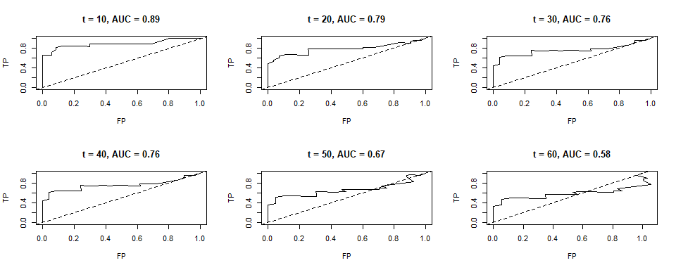

TEXT TO WRITE AUC PREDICTIVE POWER BLA BLA

## Case deletion residuals:

dfbetas = residuals(MAIC, type='dfbetas')  
db = sqrt(rowSums(dfbetas^2))  
plot(db,type = 'h')  
abline(h=0)

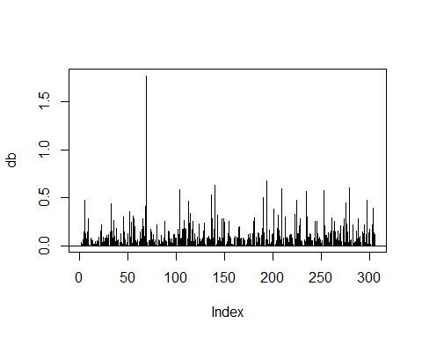

One case seems to have a larger impact on final estimates, let’s find who it is:

idx=names(db[db>1])  
dat[idx,]



dat_new = dat[idx,]  
z = list()  
for(i in 1:nrow(dat_new)) {  
 row <- dat_new[i,]  
 p_s = survfit(MAIC,newdata = row)  
 z = c(z,list(p_s))  
}  
names(z)=dat_new$name  
ggsurvplot_combine(z, censor = FALSE, ggtheme = theme_gray(), legend="right")

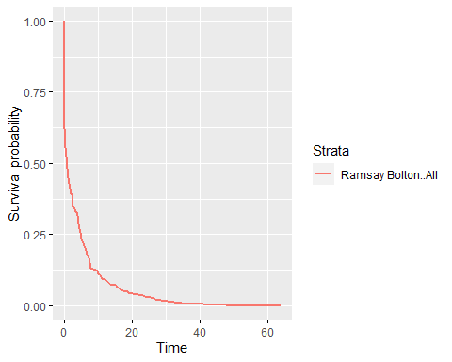

TEXT TO WRITE AUC PREDICTIVE POWER BLA BLA

# Conclusions

TEXT TO WRITE AUC PREDICTIVE POWER BLA BLA