CAN (CONTROLLER AREA NETWORK) ELEVATOR TEST DOCUMENT
engineering project (EECE73125)
  - Dinkar Sharma, Mike Akl, Anas Yassin
2017
Contents
Purpose 2
Audience 2
System Overview 2
Phase 1 3
1.0 Elevator Call Station Nodes 3
1.1 Elevator Call Station Buttons 3
1.2 Elevator Call Station Lights 3
1.3 Elevator Call Station Display 4
1.4 Elevator Car Door States 4
1.5 Elevator Car Door Lights 4
1.6 Elevator Car Floor Selection Buttons 4
1.7 Elevator Car Floor Selection Lights 5
1.8 Elevator Car Display 5
Phase 2 6
Phase 3 6

Purpose
The purpose of this document is to outline the test strategy and overall test approach for the CAN (Controller Area Network) Elevator project. This document includes test methodologies, estimated schedule, and resources requirement. The testing is separated into three separate phases with the final phase being integration of the components. The test cases are derived from the technical requirements of the system as well as the common CAN bus protocol used to communicate with the system.

Audience
The primary audience for this document are the project team members whom will be the primary testers. This document is also written for the faculty member of ESE who will evaluate this project.

System Overview
This section provides an overview of the system architecture in terms of the components that are tested during the unit test phase. Their dependencies are defined in this section.
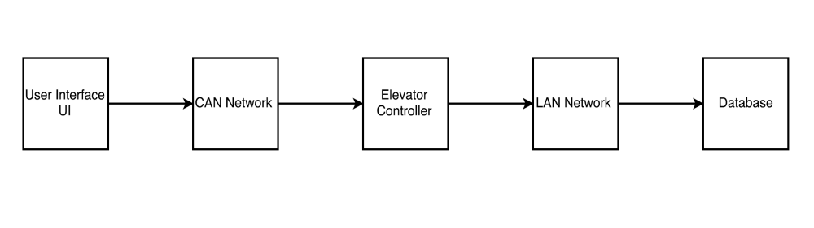
Figure 1 CAN Controller Elevator Architecture

Phase 1

Elevator Call Station Nodes
Floor | Node ID Expected | Node ID Tested | Comments
1 | 0x201 | 0x201 | Tested and work
2 | 0x202 | 0x202 | Tested and work
3 | 0x203 | 0x203 | Tested and work

1.1 Elevator Call Station Buttons
Floor | Expected CAN Data Frame for Button Press UP | Expected CAN Data Frame for Button Press DOWN | Actual CAN Data Frame for Button Press UP | Actual CAN Data Frame for Button Press DOWN
1 - ID: 201 | 0x01 | N/A | 0x01 | N/A
2 - ID: 202 | 0x12 | 0x02 |  | 0x02
 |  |  | ** for now both buttons do the same thing
3 - ID: 203 | N/A | 0x03 | N/A | 0x03
 | ** All Byte 0 | ** All Byte 0

1.2 Elevator Call Station Lights
For this test, a green LED will indicate a request for elevator DOWN at each call station. A yellow LED will indicate a request for elevator UP at each call station.
Floor | Expected Light to Be Lit for Button Press UP | Expected Light to Be Lit for Button Press DOWN | Actual Light Lit for Button Press UP | Actual Light Lit for Button Press DOWN
1 | Yellow | N/A | Yellow | N/A
2 | Yellow | Green | Yellow | Green
3 | N/A | Green | N/A | Green

1.3 Elevator Call Station Display
Implemented this with 3 LEDs, instead of LCD/7-Seg, in one column indicating which floor elevator is on
Floor  Selection | Expected LED To Light Up of Each Floor | Actual LED Lighting Up At Each Floor
1 | TOP | Top LED lights up
2 | Middle | Middle LED lights up
3 | Bottom | Bottom

1.4 Elevator Car Door States
Car  Control | Expected CAN Data Frame for Button OPEN | Expected CAN Data Frame for Button Press CLOSE | Actual CAN Data Frame for Button Press OPEN | Actual CAN Data Frame for Button Press CLOSE
OPEN | 0x04 | N/A | 0x04 | N/A
CLOSE | N/A | 0x00 | N/A | 0x00

1.5 Elevator Car Door Lights
For this test, the axman LEDs will be used to indicate door open and close status
Floor | Lit LEDs | Expected Light to Be Lit for Door CLOSE | Actual Light Lit for Door OPEN
1 | LED1 ON | N/A | Door is open
2 | LED2 ON | Door is closed | N/A

Elevator Car Floor Selection Buttons
Floor  Selection | Expected CAN Frame – IF Door OPEN | Expected CAN Frame – IF Door CLOSE | Actual CAN Frame – IF Door OPEN | Actual CAN Frame – If Door Close
1 | 0x01 | 0x05 | 0x01 | 0x05
2 | 0x02 | 0x06 | 0x02 | 0x06
3 | 0x03 | 0x07 | 0x03 | 0x07

1.7 Elevator Car Floor Selection Lights
For this test, three red LEDs will be used to assign to a single floor. The LEDs will be aligned vertically and the most bottom LED will indicate floor selection one, middle will indicate floor 2, and most top will indicate floor 3. During a floor selection the respective LED will be ON and the rest OFF.
Floor | Expected Light to Be Lit per Floor Selection | Actual Light Lit per Floor Selection
1 | Bottom LED ON | Bottom RED LED
2 | Middle LED ON | Middle RED LED
3 | Top LED ON | Top RED LED

1.8 Elevator Car Display
Floor | Expected Floor Number to Be Displayed | Actual Floor Number Displayed
1 | 1 | 1
2 | 2 | 2
3 | 3 | 3

Phase 2
TBD

Phase 3
TBD

