王潇

邮箱：18112911586

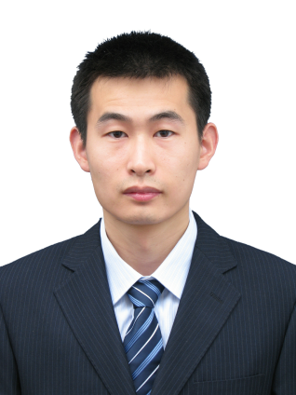

研究经历：

2014/09 – 现在，南京航空航天大学，自动化学院生物医学工程系，讲师

2010/09 – 2014/02，法国马赛中央理工，生物光子学，博士

2007/09 – 2010/03，浙江大学，光学工程，硕士

2003/09 – 2007/06，哈尔滨工业大学，电子科学与技术，学士

研究方向：

生物光子学、生物成像、荧光显微成像、 医疗增强显示。

发表文章：

1. Xiao Wang, Feng Yang, Jianhua, Yin “Quantifying the polarization properties of non-depolarizing optical elements with virtual distorting elements， Applied Optics，Vol. 56, No. 14 （2017）
2. 王潇， 何俊豪，吴曰超， 毛之华， 尹建华, 关节软骨的荧光显微检测方法研究,光散射学报,28(2),185-189,(2016)
3. Zhi-Hua Mao, Jian-Hua Yin, Xue-Xi Zhang, Xiao Wang, and Yang Xia "Discrimination of healthy and osteoarthritic articular cartilage by Fourier transform infraredimaging and Fisher’s discriminant analysis Biomedical," Optics Express, 7(2) , (2016)
4. Patrick Ferrand, Paulina Gasecka, Alla Kress, Xiao Wang, Fatma-Zohra Bioud, Julien Duboisset, and Sophie Brasselet，"Ultimate Use of Two-Photon Fluorescence Microscopy to Map Orientational Behavior of Fluorophores" Biophysical Journal, Vol. 106 (2014)
5. Xiao Wang, Alla Kress, Sophie Brasselet, and Patrick Ferrand,” High frame-rate fluorescence confocal angle-resolved linear dichroism microscopy” Rev. Sci. Instrum. 84, 053708 (2013).
6. Alla Kress, Xiao Wang, Hubert Ranchon, Julien Savatier, Patrick Ferrand, Sophie Brasselet,” Mapping the local organization of cell membranes using excitation-polarization-resolved confocal fluorescence microscopy” Biophys. J. Vol. 105, pp.127 (2013).
7. Duboisset J, Ferrand P, He W, Wang X, Rigneault H, Brasselet S.” Thioflavine-T and Congo Red reveal the polymorphism of insulin amyloid fibrils when probed by polarization-resolved fluorescence microscopy”, J. Phys. Chem. B Vol. 117, pp.784-788 (2013)
8. X. Wang, A. Kress, J. Savatier, H. Rigneault, J. Duboisset, P. Ferrand, S. Brasselet，“Imaging molecular organization of cell membranes and proteins assemblies using polarimetric fluorescence microscopy” Lasers and Electro-Optics Europe (CLEO EUROPE/IQEC), Conference on and International Quantum Electronics Conference. ( 2013)
9. S. Brasselet, P. Ferrand, A. Kress, X. Wang, H. Ranchon, A. Gasecka. “Imaging Molecular Order in Cell Membranes by Polarization-Resolved Fluorescence Microscopy” Fluorescent Methods to Study Biological Membranes, Proc. Springer-Verlag Berlin Vol. 13, pp.311 (2013)
10. Tingting Wang, Xiao Wang, CuifangKuang, Xiang Hao, and Xu Liu.” Experimental verification of the far-field subwavelength focusing with multiple concentric nanorings”. Appl. Phys. Lett. 97, 231105 (2010)
11. Xiao Wang, Jian Fu, Xu Liu, and Li-Min Tong, “Subwavelength focusing by a micro/nanoﬁber array”, Vol. 26, No.8 , J. Opt. Soc. Am. A (2009).

发明专利：

1. 一种矢量光束偏振分布检测装置和方法 2016
2. 一种控制显微物镜聚焦光场三维偏振方向的装置和方法 2016
3. 一种红光静脉增强显示装置和方法 2016

主持的科研项目

1. 国家自然科学基金青年科学基金项目（61505079）
2. 江苏省自然科学基金青年科学基金项目（BK20150752）
3. 南京航空航天大学引进人才科研启动基金 (1003-YAH15018)