The Contagion Sequences of the Epidemic S.I.s.a.R. Model:

a Source of Suggestions for Intervention Policies

Gianpiero Pescarmona1, Pietro Terna2, Alberto Acquadro1, Paolo Pescarmona3, Giuseppe Russo4, and Stefano Terna5

1University of Torino, Italy

* University of Torino, Italy, retired; Collegio Carlo Alberto, Torino, Italy∗ 3University of Groningen, The Netherlands

4Centro Einaudi, Torino, Italy

5TomorrowData†

September 15, 2020

Abstract

We propose an agent-based model to simulate the Covid-19 epidemic diﬀusion, with Susceptible, Infected, symptomatic, asymptomatic, and Recovered people: hence the name S.I.s.a.R. The scheme comes from S.I.R. models, with (i) infected agents catego-rized as symptomatic and asymptomatic and (ii) the places of contagion specified in a detailed way, thanks to agent-based modeling capabilities. The model includes Pied-mont’s structural data, an Italian region, but it can be readily calibrated it for other areas. The model reproduces a realistic calendar (e.g., national or local government decisions), via its script interpreter.

The model allows analyzing the sequences of contagions in simulated epidemics, while taking in account the places where they occur. We represent each infecting agent as a horizontal segment with a vertical connection to another agent receiving the infection. We represent the second agent via a further segment at an upper layer. With colors, line thickness, and styles, we display multiple data. This enables understanding at a glance how an epidemic episode is developing. In this way, it is easier to reason about countermeasures and, thus, to develop intervention policies.

* A quick introduction to epidemic modeling

The starting point from which we built our model is that of S.I.R compartmental models with Susceptible, Infected, and Recovered people. This approach allows looking at the

∗Corresponding author, <mailto:pietro.terna@unito.it>

* <https://tomorrowdata.io>

1

Work in progress & draft: Comments and Corrections Welcome!

epidemic dynamics, but on a macro scale. While the Covid-19 epidemic was spreading, there have been several attempts to introduce more realistic compartmental subdivisions. A relevant example in this direction is that of Scala et al. (2020). The research also been followed other work lines, as in Bellomo et al. (2020), where a multiscale framework accounts for the interaction of diﬀerent spatial levels, from the small scale of the virus itself and cells, to the large scale of individuals and further up to the collective behavior of populations.

Following Rahmandad and Sterman (2008), we know that the analysis based on the assumption of heterogeneity strongly diﬀers from S.I.R. compartmental structures modeled by diﬀerential equations. Their work ponders when it is better to use agent-based models and when it would be better to use diﬀerential equation models. Diﬀerential equation models assume homogeneity and perfect mixing within compartments, while agent-based models can capture heterogeneity in agent attributes and the structure of their interactions. We follow the second approach.

Finally, we subscribe the call of Squazzoni et al. (2020) to «cover the full behavioural and social complexity of societies under pandemic crisis» and we move in that directionin our work reported here.

1.1 Why model? Why agents? Why another model?

Why another model, and most of all, with Epstein (2008), why model? With the author, the reply is:

The choice (. . . ) is not whether to build models; it’s whether to build explicit ones. In explicit models, assumptions are laid out in detail, so we can study exactly what they entail. On these assumptions, this sort of thing happens. When you alter the assumptions that is what happens. By writing explicit models, you let others replicate your results.

And, strongly:

I am always amused when these same people challenge me with the ques-tion,“Can you validate your model” The appropriate retort, of course, is,“Can you validate yours?” At least I can write mine down so that it can, in principle, be calibrated to data, if that is what you mean by “validate” a term I assiduously avoid.

To reply to “why agents?”, with Axtell (2000) we define in short what an agent-based model is:

An agent-based model consists of individual agents, commonly implemented in software as objects. Agent objects have states and rules of behavior. Running such a model simply amounts to instantiating an agent population, letting the agents interact, and monitoring what happens. That is, executing the model— spinning it forward in time—is all that is necessary in order to “solve” it.

2

Work in progress & draft: Comments and Corrections Welcome!

More in detail:

There are, ostensibly, several advantages of agent-based computational model-ing over conventional mathematical theorizing. First, as described above, it is easy to limit agent rationality in agent-based computational models. Second, even if one wishes to use completely rational agents, it is a trivial matter to make agents heterogeneous in agent-based models. One simply instantiates a population having some distribution of initial states, e.g., preferences. That is, there is no need to appeal to representative agents. Third, since the model is “solved” merely by executing it, there results an entire dynamical history of the process under study. That is, one need not focus exclusively on the equilibria, should they exist, for the dynamics are an inescapable part of running the agent model. Finally, in most social processes either physical space or social networks matter. These are diﬃcult to account for mathematically except in highly styl-ized ways. However, in agent-based models it is usually quite easy to have the agent interactions mediated by space or networks or both.

And now, "why another?" As a commitment to our creativity, using our knowledge to understand what is happening. Indeed, with arbitrariness: it is up to others and time to judge. Modeling the Covid-19 pandemic requires a scenario and the actors. As in every play, the author defines the roles of the actors and the environment. The characters are not real, they are pre-built by the author, and they act according to their peculiar constraints. If the play is successful, they will play for a long time, even centuries. If not, we will rapidly forget them. Shakespeare Hamlet is still playing after centuries, even if he is entirely imaginary.

The same holds for our simulations: we are the authors, we arbitrarily define the char-acters, we force them to act again and again in diﬀerent scenarios. In both plays and simulations, we compress the time: whole life to 2 or 3 hours on the stage. In a few seconds, we run the Covid-19 pandemic spread in a given regional area.

1.2 Our model

With our model, we move from a macro compartmental vision to a meso and microanalysis capability. Its main characteristics are:

* + scalability: we take in account the interactions between virus and molecules inside the host, the interactions between individuals in more or less restricted contexts, the movement between diﬀerent environments (home, school, workplace, open spaces, shops, . . . );1

in detail, the scales are:

1In a second version, we will add transportations and long trips between regions/countries; discotheques; other social aggregation, as football events.

3

Work in progress & draft: Comments and Corrections Welcome!

– micro, with the internal biochemical mechanism involved in reacting to the virus, as in Silvagno et al. (2020), from where we derive the critical importance assigned to an individual attribute of intrinsic susceptibility related to the age and previ-ous morbidity episodes; the model indeed incorporates the medical insights and consistent perspectives of one of its co-authors, former full professor of clinical biochemistry, signing also the quoted article;

– meso, with the open and closed contexts where the agents behave, as reported above;

– macro, with the emergent eﬀects of the actions of the agents;

* granularity: at any level, the interactions are partially random and therefore the final results will always reflect the sum of the randomness at the diﬀerent levels; changing the constraints at diﬀerent levels and running multiple simulations should allow the identification of the most critical points, where to focus the intervention.

Summing up, S.I.s.a.R. (Terna et al., 2020) is an agent-based model designed to re-produce the diﬀusion of the COVID-19 using agent-based modeling in NetLogo (Wilensky,

1999). We have Susceptible, Infected, symptomatic, asymptomatic, and Recovered people: hence the name S.I.s.a.R.. The scheme comes from S.I.R. models, herewith (i) infected agents categorized as symptomatic and asymptomatic and (ii) the places of contagions specified in a detailed way, thanks to agent-based modeling capabilities. The model in-cludes Piedmont’s structural data, an Italian region, but we can quite easily calibrate it for other areas. It can reproduce the events following a realistic calendar (e.g., national or local government decisions, as in Appendix ??), via its script interpreter.2

We place two initial infected individuals in a population of 4350 individuals, on a scale of 1:1000 with Piedmont.3 The size of the initial infected group is out of scale: it is the smallest number, ensuring the epidemic’s activation in a substantial number of cases. Initial infected people bypass the incubation period. For implausibility reasons, we never choose initial infected people among persons in nursing homes or hospitals. The presence of agents in close space—such as classrooms, factories, homes, hospitals, nursing homes—is made with realistic numbers, not to be read in scale: e.g., a classroom contains 25 students, a home two persons, etc.

We can set:

* min and max duration of the individual infection;
* the length of the incubation interval;

2The model is online at <https://terna.to.it/simul/SIsaR.html>, from where it is also possible to run the code without installation. Corresponding author: Pietro Terna: <mailto:pietro.terna@unito.it>. Looking at the info sheet of the model, you have more than 20 pages of Supporting Information about both the structure and the calibration of the model.

3They appear as black segments in the sequences of Appendix A.

4

Work in progress & draft: Comments and Corrections Welcome!

* the critical distance, as the radius of a circle aﬀecting people which are in it, with a given probability;
* the correction of that probability, due to the personal characteristics of both active and the passive agents; passive agents, as receivers, can be robust, regular, fragile, and extra fragile.

We have two main types of contagion: (a) within a radius, for people moving around, also if only temporary present in a house/factory/nursing home/hospital (in schools we only have students and teachers); (b) in a given space (room or apartment) for people resident in their home or in a hospital or in a nursing home or being in school or in a working environment.

People in hospitals and nursing homes can be infected in two ways: (a) and (b). Instead, while people are at school, they can only receive the disease from people in the same class-room, where only teachers and students are present, so this is a third infection mechanism (c).

One should remark that workplaces are open to all persons, as clients, vendors, suppliers, external workers can go there. In contrast, schools are mainly reserved for students and school operators and are less aﬀected by contact with other types of agents.

All agents have their home, inside a city, or a town. The agents also have a regular place (RP) where they act and interact, moving around. These positions can be interpreted as free time elective places. When we activate the school, students and teachers have both RPs and the schools; healthcare operators have both RPs and hospitals or nursing homes; finally, workers have both RPs and working places. In each day (or tick of the model), we simulated realistic sequences of actions.

* The visualization of the sequences of contagions in simu-lated epidemics

2.1 Contagion sequences

How to understand what is happening in our simulated epidemics at a micro-scale? The key idea is to analyze the sequences of contagions by representing each infecting agent as a horizontal segment with a vertical link to another agent, receiving the infection. We render it via another segment at an upper layer. With colors, line thickness, and styles, we represent multiple data. We have time on the x axis and the progressive ordinal number of the infected agents in the y axis.

Read about the detail of visualization technique in Appendix C and in the example of Section A.0.1. The sequence analyzer is at [https://github.com/terna/contagion](https://github.com/terna/contagionSequence) [Sequence](https://github.com/terna/contagionSequence). From there, you can also run the program automatically, thanks to [https:](https://mybinder.org) [//mybinder.org](https://mybinder.org).

5

Work in progress & draft: Comments and Corrections Welcome!

Looking at the diﬀerent sequences, one feels as The Sorcerer’s Apprentice of the Goethe 1797 poem. How to proceed?

2.2 A few sequences suggesting a policy via counterfactual limitations

We report several sequences in Appendix A, considering them mainly as examples to com-ment, examining the eﬀects of nursing homes, workplaces, hospitals, homes, luckily close to never schools. Among those cases, we highlight the inspiring sequence of Section A.3.2 topics.

In Fig. 1 we can look both at the places where contagions occur and at the dynamics emerging with diﬀerent levels of intervention. Using the article’s pdf version as a file, the reader can enlarge the four pictures (and any figure in the appendices). The reference to specific days is related to the calendar of Appendix D. Here, in the fourth case (bottom right of Fig. 1, we introduce the stop to fragile agents of any type at Feb 15th; the decision would have been plausible, considering that the situation of danger probably was known before that date. To be more realistic, the analysis that deepens that situation in Appendix B and so in Table 1 uses the day Feb 20th as a turning point.

6

Work in progress & draft: Comments and Corrections Welcome!

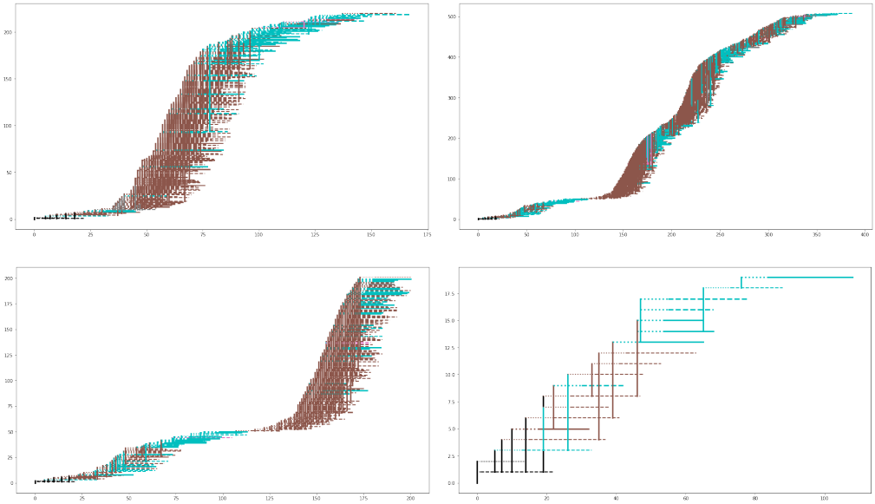

Figure 1: (top left) an epidemic with containment measures, showing a highly significant eﬀect of workplaces (brown); (top right) the eﬀects of stopping fragile workers at day 20, with a positive result, but home contagions (cyan) keep alive the pandemic, exploding again in workplaces (brown); (bottom left) the same analyzing the first 200 infections with evidence of the event around day 110 with the new phase due to a unique asymptomatic worker, and (bottom right) stopping fragile workers and any case of fragility at day 15, also isolating nursing homes

The four pictures, related to epidemics starting precisely in the same way, represent an evolving narrative, that:

1. starts from the observation of an epidemic in which workplaces have an evident role in sustaining the spreading of the virus, despite the adoption of the non-pharmaceutical containment measures adopted locally and at the national level;
2. adopts a counterfactual limitation holding back fragile workers from factories (any workplace), with some initial success, but with a bridge to a phase 2;
3. deepens the situation of the specific agent operating as a bridge, a regular (non-fragile) worker infected at work by another regular worker infected at home by a fragile agent;
4. introduces a more substantial control, anticipating at Feb 15th the limitation to fragile workers and stopping the mobility of all fragile people from Feb 20th with evident positive eﬀect, having the whole epidemic very few contagions and lasting a limited number of days.

7

Work in progress & draft: Comments and Corrections Welcome!

In our model, the fragile workers are those 55 years old or more; in this scheme, if they cannot work remotely from home, they are supposed to obtain regular sick pay (see Sections 4 and A.3.2 for considerations).

This kind of analysis is a source of suggestions for interventions, also if we cannot validate them only with micro studies, as in bullet point 3 above.

Summarizing:

* we confirm the interest of the knowledge that we can extract from contagion sequences;
* we suggest, as an integrative example, the simulation of Fig. 9 in Appendix A, showing many cases of fragile workers diﬀusing the infection;
* finally, we will use a more systematic data exploration, in Section B, as summarized in Section 3.
* Simulation repetition and emerging key results

Following the trace of Fig. 1, we now explore systematically the introduction of factual, counterfactual, and prospective interventions to control the spread of the contagions. Each simulation run—whose length coincides with the disappearance of symptomatic or asymp-tomatic contagion cases—is a datum in a wide scenario of variability in time and eﬀects. Consequently, we need to represent compactly the results emerging from batches of repeti-tions, to compare each batch’s basic assumption’s consequences.

We adopted blocs of one thousand repetitions (or more, for other analyses not reported here). Besides summarizing the results with the usual statistical indicators, we adopted the technique of the heat-maps (see Appendix B).

In this way, we endorse the Steinmann et al. (2020) incitement.

We urge those attempting to model COVID-19 for decision support to acknowl-edge the deep uncertainties surrounding the pandemic, and to employ Decision Making under Deep Uncertainty methods such as exploratory modelling, global sensitivity analysis, and robust decision-making in their analysis to account for these uncertainties.

Using the calculations of Appendix B, we build the Table 1, starting from a zero in-terventions case (no controls of any type) e moving toward actions more and more specific (always non-pharmaceutical). In the table, we report four indicators: the total number of symptomatic subjects in nursing homes; the total number of symptomatic subjects; the to-tal number of symptomatic-asymptomatic-deceased subjects; the duration of the epidemic. The scale to which refer the data is the Piedmont population, i.e., 4,350 million people. We report the mean and standard deviation of each measure in the batch of 1,000 repetitions of the simulated epidemic. In the last column, we write the section of the appendix, reporting the results of the specific batch calculation.

8

Work in progress & draft: Comments and Corrections Welcome!

|  |  |  |  |  |  |
| --- | --- | --- | --- | --- | --- |
| Scenarios | total sym. | total sym. | total sym. | days | Section |
|  | in nursing |  | asympt. |  |  |
|  | homes |  | deceased |  |  |
|  |  |  |  |  |  |
| 1. no control | 4.65 | 851.12 | 2253.48 | 340.10 | B.1 |
|  | (7.89) | (288.52) | (767.58) | (110.21) |  |
|  |  |  |  |  |  |
| 2. basic controls, no | 4.51 | 158.55 | 416.98 | 196.97 | B.2 |
| school in Sep 2020 | (7.39) | (174.10) | (462.94) | (131.18) |  |
|  |  |  |  |  |  |
| 3. basic controls, schools | 4.24 | 153.71 | 409.73 | 199.35 | B.3 |
| open in Sep 2020 | (7.29) | (168.55) | (454.12) | (129.00) |  |
|  |  |  |  |  |  |
| 4. basic controls, stop | 4.32 | 120.17 | 334.68 | 181.10 | B.4 |
| fragile workers, no | (7.48) | (149.10) | (413.90) | (125.46) |  |
| schools in Sep 2020 |  |  |  |  |  |
|  |  |  |  |  |  |
| 5. basic controls, nur- | 3.41 | 150.53 | 408.08 | 201.76 | B.5 |
| sing homes isol., no | (6.88) | (172.48) | (467.54) | (138.15) |  |
| schools in Sep 2020 |  |  |  |  |  |
|  |  |  |  |  |  |
| 6. basic controls, stop | 4.38 | 154.15 | 408.50 | 195.81 | B.6 |
| fragile people, no | (7.52) | (170.22) | (456.08) | (129.52) |  |
| schools in Sep 2020 |  |  |  |  |  |
|  |  |  |  |  |  |
| 7. basic controls, stop f. | 3.25 | 105.63 | 302.62 | 174.39 | B.7 |
| workers & f. people & | (6.60) | (134.80) | (382.14) | (121.82) |  |
| n. h. isol., no sch, Sep. |  |  |  |  |  |
|  |  |  |  |  |  |
| 8. b. controls, stop f. workers | 3.46 | 124.10 | 397.05 | 200.31 | B.8 |
| & f. people & nur. h. isol., | (6.65) | (132.42) | (399.64) | (121.46) |  |
| & factories op., no sch. Sep. |  |  |  |  |  |
|  |  |  |  |  |  |
| 9. b. controls, stop f. workers | 3.63 | 116.55 | 374.68 | 195.28 | B.9 |
| & f. people & nur. h. isol., | (6.96) | (130.91) | (394.66) | (119.33) |  |
| & factories op., sch. open Sep. |  |  |  |  |  |
|  |  |  |  |  |  |

Table 1: Report of the key results, with mean and (std)

The values of the standard deviations are impressive, as a signal of the diﬃculties in forecasting an epidemic. Those estimates are primarily due to very diﬀerent durations of the virus diﬀusion, being this occurrence also linked to thin events like that in bullet point 3 in Section 2.2. That event is not on scale to the population size (1:1000), but it is a single agent acting, as observed in reality, in many situations.

General notes: data refer to a population of 4,350 subjects (1:1,000 of Piedmont people). We over-represent nursing homes to have visibility of the phenomenon, both as the spatial distribution of these institutions and each unit dimension. As we clarify in the supporting information (see note 2), in scale, we would have less than one nursing home, with 30 hosts; we created five with a total value of around 60 hosts.

A comment to Table 1, following the diﬀerent blocks, row by row:

1. we start with a counterfactual analysis with 1,000 runs of the epidemic model without

9

Work in progress & draft: Comments and Corrections Welcome!

any non-pharmaceutical containment measures; The results are extraordinary heavy, both as symptomatic persons (19.6% of the population) and total infected people (51.8%); the mean duration of the epidemics is close to one year;

1. the second step, factual, is that of introducing the sequence of non-pharmaceutical containment measures of Appendix D, again in a batch of 1,000 runs; we have now 3,6% and 9,6% rates, with a diminution highly relevant, and a mean duration half of the preceding one; if you look at the heat-maps in Sections B.1 and B.2, where we classify the results in terms of durations and infections of each epidemic in the double histograms, you can see that the diﬀerence is astonishing; a note: the actual Piedmont, where the curve of the symptomatic cases flattened with the end of May, with around 30 thousand subjects, is included in the cell in the first row, immediately to the right of the mode in Fig. 21, considering that here we have to triplicate the number symptomatic subject to have the total measure of infected agents;
2. in this prospective analysis, we have the same sequence of containment measures of the previous case, with the diﬀerence that from September 14th (2020) schools are open; the rates on infection are a bit lower than those of case 2, the duration is very close; certainly standard deviation signal a relevant variability, but similar to the previous one; the rates of infection decrease, here and also in the similar step from case 8 to 9, with a possible interpretation: keeping in school the students for a part of the day decreases contagions in other regularly frequented spaces, where they could find more contagious people;
3. the fourth case is again a counterfactual one, always with the regular containment measures (and schools closed in September), but supposing that we had followed the strategy of Section 2.2, not admitting the fragile employees in the workplaces, from February 20th; the positive eﬀect is evident, with the infection rates now at 2.8% and 7.7%;
4. we decided to investigate separately two other counterfactual possibilities, always with the regular containment measures (and schools closed in September), starting with the isolation of the nursing homes, forbidding visits, separating the operators, and creating a buﬀer zone prohibiting to everyone to get close to nursing homes, again from February 20th; we have some positive eﬀect, but limited; sure, a bit more relevant for the nursing homes, where the residual infections are coming from contagions occurred before the blocking decision;
5. the second separate counterfactual verification, in the same conditions of the previous trial, is that of keeping all fragile people in isolation at home but, as in reality occurred, the workers can continue to move to go to their workplaces; the benefits are again quite limited;
6. with the 7th batch of simulated epidemics, we put in action all the measures of the counterfactual experiments number 4, 5, and 6; the results, in this case, are highly

10

Work in progress & draft: Comments and Corrections Welcome!

positive with the infection rates about symptomatic people and total ones reduced to 2.4% and 7.0%, with the minimal mean duration in the table; as a synthesis, we are preserving all fragile people;

1. continuing in the counterfactual perspective, we verify the consequence of not closing factories and workplaces of any kind; we measure some worsening if we compare these rates with the previous ones, but they are always a lot better than those of the factual case 2;
2. finally, as the last step, we add the decision of opening the schools in September, again—as for case 3—with some improvement if compared with the same situation with the schools closed.

To summarize, the actions carried out were of extraordinary eﬀect and usefulness. Still, it would have been possible to add other forms of action that could have had lower overall costs. Therefore, measures to preserve the situation at risk for all fragile people and at the same time to not stop the economy and society indiscriminately.

* Cost-benefit analysis of the of interventions

Considering the diﬀerent interventions of Table 1 we can evaluate . . .

First of all, the costs for the attribution of sick pay to workers who are compulsorily absent from work, if they are not able to carry out telework activities and the benefits of continuing economic activities . . .

Internal contents in Sections 2.2. 3 with Table 1, A.3.1, B.4, B.7.

An interesting reference is Miles et al. (2020), where . . . WORKS IN PROGRESS.

WORKS IN PROGRESS.

* Summarizing

WORKS IN PROGRESS.

For future works:

* to add: transportation; discotheques; movement regulation by hours; . . .

Acknowledgements

Many thanks to Simone Landini, Nizar Mansour, Fabio Pammolli, Enrico Scalas, and Fed-erico Tedeschi for precious discussions, insights, and critics. The usual disclaimer applies.

11

Work in progress & draft: Comments and Corrections Welcome!

* Appendix: Analyzing examples of contagion sequences

We introduce nine cases, mainly as examples. For technical details, look at Appendix C. Among those cases, we have the set of sequences commented in Section 2.2, which are a special source of suggestions for policies. Still, other suggestions can emerge by observing the other sequences reported here or that can be generated. Each run of the program produces a diﬀerent sequence that can be analyzed, as explained in the Appendix, using the program at <https://github.com/terna/contagionSequence>.

Notice that, with containment measures, sometimes the sequences get thinner, involving few agents. Then, they can start again or—with a bit of luck—stop. A typical situation is that of Fig. 14 where, on day 43, we have a unique spreading agent (that became infected in a nursing home, so orange). The agent continues the infection, with two further contagions (looking into the simulation run’s details, this agent is a nursing home operator). Without the containment measures, the flow of the contagions is ample, excluding the situation of Figs. 4 and 5 where, in the beginning, the epidemic seems not to start.

The agents starting the infection correspond to the two black segments in each picture’s bottom left corner. They are coming from nowhere, as external events. The evolution of each simulation is strongly influenced by randomness, as in reality: the New York Times of March 5th, 2020, oﬀered us since the beginning, a non-conventional analysis on «The Covid-19 Riddle: Why Does the Virus Wallop Some Places and Spare Others?»4. The title of the last paragraph is «Roll of the Dice» and starts with:

Finally, most experts agree that there may be no single reason for some countries to be hit and others missed. The answer is likely to be some combination of the above factors, as well as one other mentioned by researchers: sheer luck.

Countries with the same culture and climate could have vastly diﬀerent out-comes if one infected person attends a crowded social occasion, turning it into what researchers call a super-spreader event.

A.0.1 How to analyze the figures of this section

How the figures of this appendix work: refer as an example to Fig. 19, related to a simulation of a very short duration. We have a few infected people there, so the graphical representation is detailed without the need to enlarge the picture, which is always possible if you use the article’s pdf file.

We start with two externally infected people, represented by the two black segments in the picture’s bottom-left corner. The segments’ length means each subject’s infection period; these are asymptomatic (dashed lines, refer to Appendix C). The first one is a regular agent (as the thickness suggests). The second one is a robust agent; by convention, we introduce them in the simulation at the end of the incubation period. The first agent

* <https://www.nytimes.com/2020/05/03/world/asia/coronavirus-spread-where-why.html>.

12

Work in progress & draft: Comments and Corrections Welcome!

transmits (follow the vertical link) the contagion to another regular agent in a workplace (brown color); the second is not producing contagions. The third agent, asymptomatic after the incubation period (dotted line), infects five agents: four in the workplace (two of them fragile, as we see from the thickness of the line), and the last one (a fragile person) at home (cyan). The sequence continues until the 24th agent, infected in a hospital, infecting no one in turn.

We have to remember that we work here on a scale of 1:1000. Still, in interpreting these sequences, it is worth considering the agent to agent transmission as examples of events related to single persons.

A.1 Epidemics without containment measures

The cases of Sections A.1.1, A.1.2, and A.1.3 report simulation without any kind of non-pharmaceutical measures.

A.1.1 Case 1: workplaces, nursing homes, and homes

The epidemic in Fig. 2 lasted about 350 days and aﬀected about 2,500 people on a total of 4,350(in the 1:1,000 scale). In the beginning, the leading presence is that of contagions in nursing homes (orange) and in workplaces (brown), but successively a significant role is that of the contagions at home (cyan); some eﬀect is coming from hospitals. We can better understand the starting sequence in Fig. 3, where we report only the first 200 contagion cases.

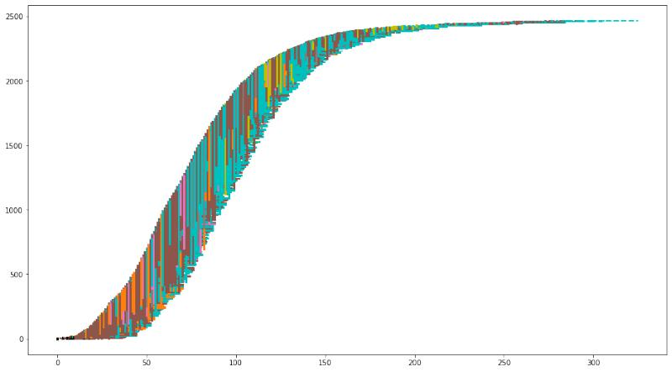

Figure 2: Case 1, without containment measures: contagions in nursing homes (orange), workplaces (brown), homes (cyan), hospitals (pink)

13

Work in progress & draft: Comments and Corrections Welcome!

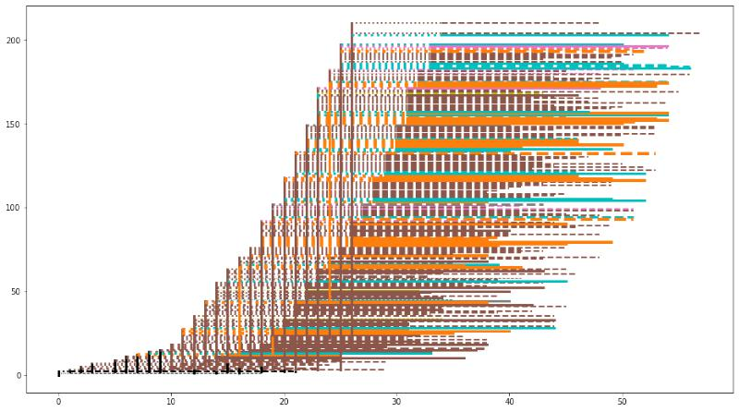

Figure 3: Case 1, without containment measures, first 200 infections with the main contri-bution of nursing homes (orange) and workplaces (brown)

A.1.2 Case 2: multiple sources of infection

In Fig. 4, we have another history of contagion without control—always with everything open, including schools—with the epidemic that alternates contagions at home (cyan), in hospitals (pink). in the workplaces (brown), with a decisive initial role of nursing homes (orange), as shown in Fig. 5, which enlarges the first 200 cases. There is also a bit of school contribution, but very limited. Around day 70, a unique contagion at home has the role of having the epidemic continuing.

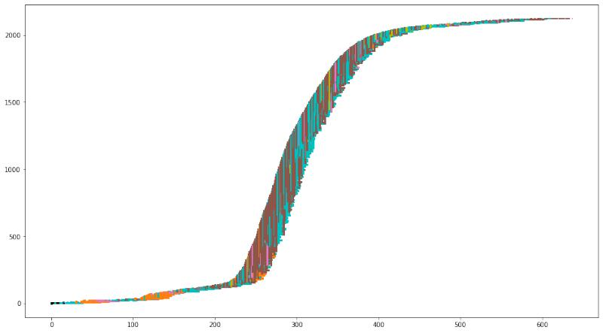

Figure 4: Case 2, without containment measures: nursing homes (orange) as starter

14

Work in progress & draft: Comments and Corrections Welcome!

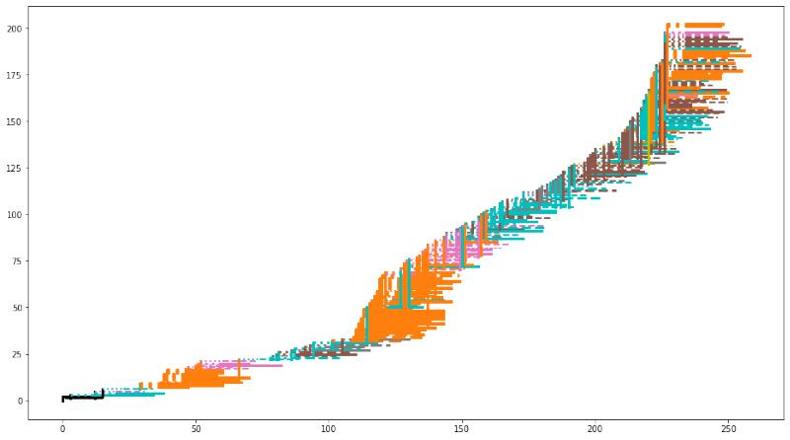

Figure 5: Case 2, without containment measures, first 200 infections: nursing homes (or-ange) as starter and around day 70 a unique contagion at home continuing the epidemic

A.1.3 Case 3: workplaces and homes

Without containment measures: an initial deep eﬀect of contagions is in workplaces and at home, both in Fig. 6 and very clearly in Fig.5b, where workplace and home eﬀects are interleaving. Analyzing the dimension and the style (solid or dashed, as in Section C.2) of the segments representing the agents infected in the early phase, we observe5 the role of fragile agents, also asymptomatic (dashed segments).

5To better observe, it is possible to enlarge the picture in the pdf version of the article.

15

Work in progress & draft: Comments and Corrections Welcome!

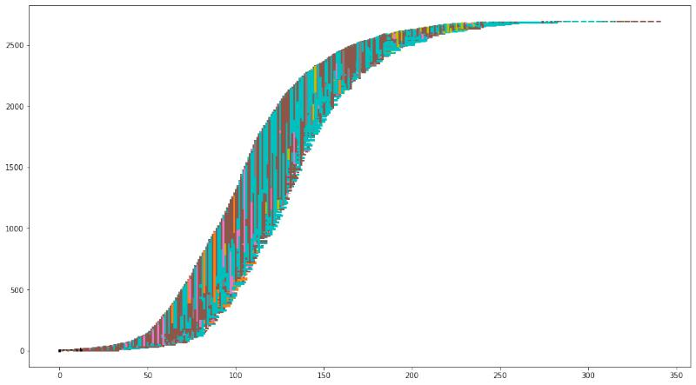

Figure 6: Case 3, without containment measures: an initial deep eﬀect of contagions in workplaces (brown) and homes (cyan)

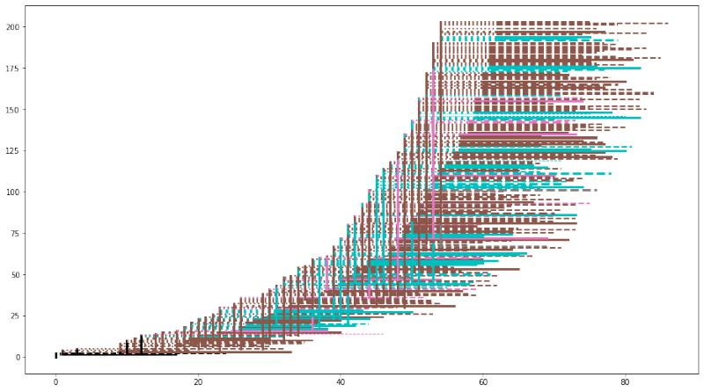

Figure 7: Case 3, without containment measures, first 200 infections: the initial deep eﬀect of contagions in workplaces (brown) and homes is due in the initial steps to fragile persons, also asymptomatic

A.2 Cases with containment measures

The cases of Sections A.2.1, A.2.2, and A.2.3 report simulation incorporating the non-pharmaceutical measures of the calendar in Appendix D.

16

Work in progress & draft: Comments and Corrections Welcome!

A.2.1 Case 4, again the importance of workplaces (brown) and homes (cyan)

We adopt here the non-pharmaceutical measures of the calendar in Appendix D. The school is always close also in September. In Figs. 8 and 9, we again can verify the importance of the workplaces and homes in diﬀusing the infection, with the critical signal, in Fig. 9, of many cases of fragile workers diﬀusing the disease.

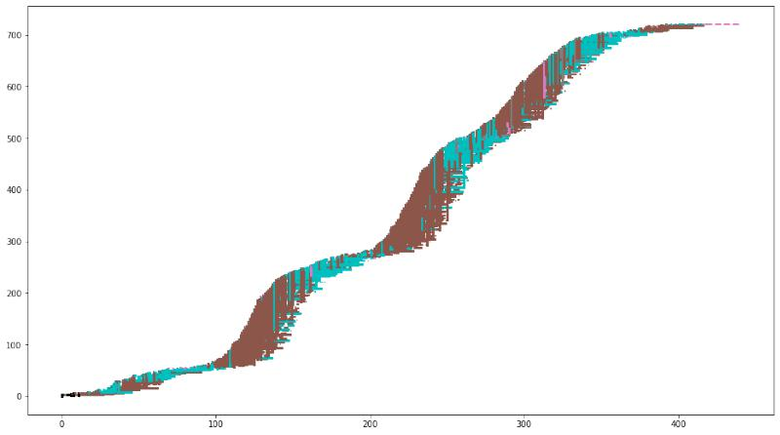

Figure 8: Case 4, with containment measures: another case of strong contribution of work-places (brown) and homes (cyan) to epidemic diﬀusion

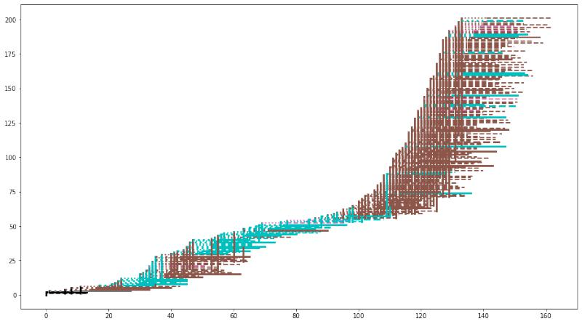

Figure 9: Case 4, with containment measures, first 200 infections: after day 100 we observe many significant cases of fragile workers diﬀusing the infection

17

Work in progress & draft: Comments and Corrections Welcome!

A.2.2 Case 5, with workplaces (brown), hospitals (pink), nursing homes (or-ange) and homes (cyan), then workplaces (brown)

In this case, we have a sequence of highly interlaced diﬀerent contagion places.

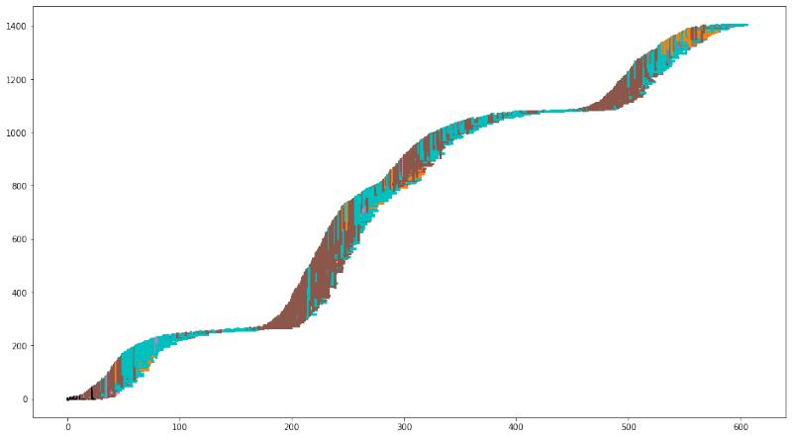

Figure 10: Case 5, with containment measures: workplaces (brown), hospitals (pink), nurs-ing homes (orange) and homes (cyan), then workplaces

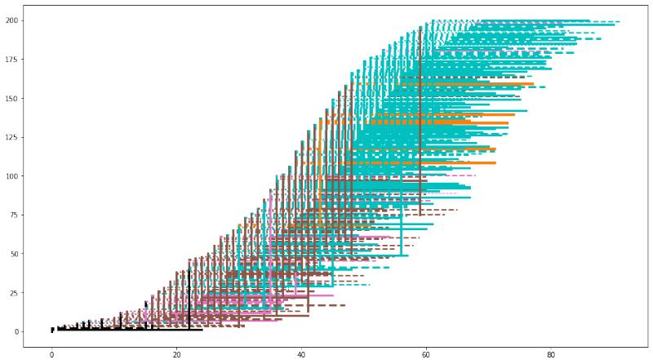

Figure 11: Case 5, with containment measures, first 200 infections: in the beginning work-places (brown), hospitals (pink), nursing homes (orange) and homes (cyan) interweaving

18

Work in progress & draft: Comments and Corrections Welcome!

A.2.3 Case 6, with workplaces (brown) and nursing homes (orange)

In this case, nursing homes’ initial role is evident, with a large number of extra-fragile people infected as symptomatic. Looking at the vertical links, we see in Fig. 13 them frequently coming from fragile or extra-fragile people (the last ones, infected in a nursing home, so orange).

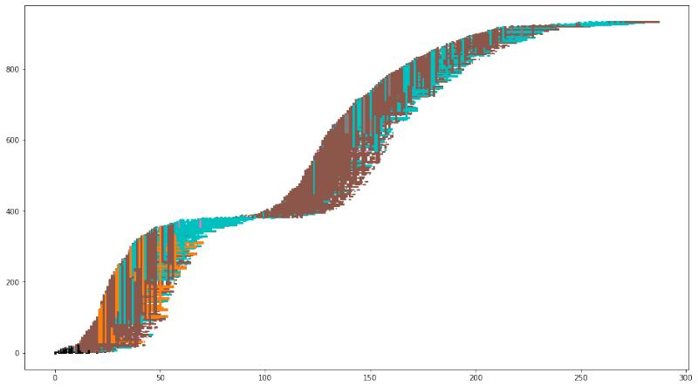

Figure 12: Case 6, with containment measures: workplaces (brown), nursing homes (or-ange), homes (cyan)

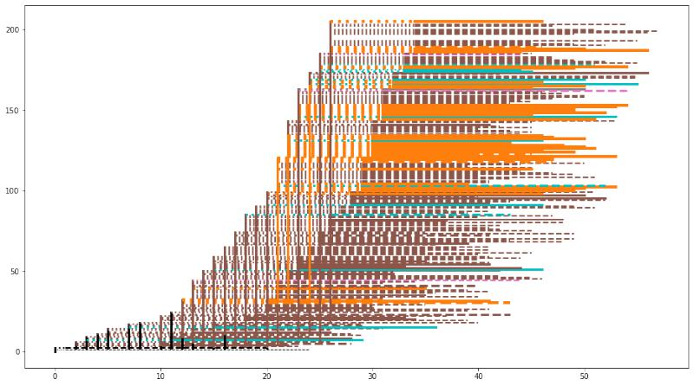

Figure 13: Case 6, with containment measures, first 200 infections: workplaces (brown) and nursing homes (orange) strictly interweaving

19

Work in progress & draft: Comments and Corrections Welcome!

A.3 Short running epidemic, with containment measures

The cases of Sections A.3.1, A.3.2, and A.3.3 report simulation with short duration, incor-porating the non-pharmaceutical measures of the calendar in Appendix D.

A.3.1 Case 7, only nursing homes (orange)

In Fig. 14 we have an extreme epidemic situation, involving uniquely the nursing homes.

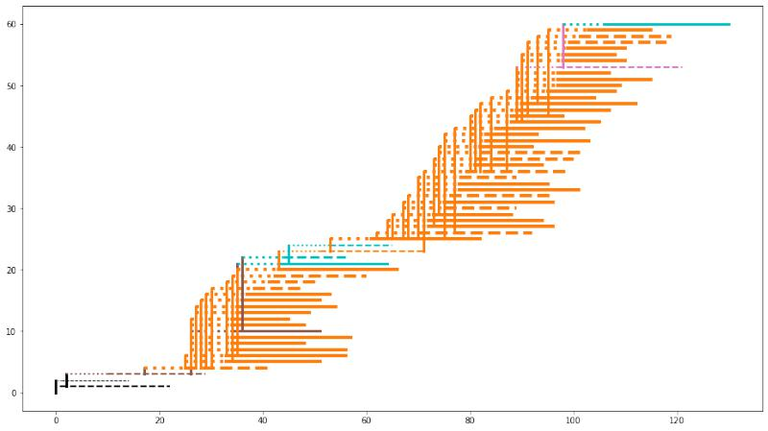

Figure 14: Case 7, with containment measures: the eﬀect of nursing homes (orange)

A.3.2 Case 8 with workers and control of fragility in two steps

The analysis of the sequences of contagion in this appendix makes evident the relevance of fragility, in workplaces and nursing homes, to sustain the diﬀusion of the Sars-Cov-2 virus. It suggests the importance of considering together two diﬀerent views: that of the defense of the health of every single person, especially if fragile, and that of the protection of collective health.

The document «Economic Aspects of the COVID-19 Crisis in the UK»6 of the DELVE initiative7 dedicates special attention to work conditions in virus spreading and the prob-lems related to workers’ preventive or immediate isolation, both fragile or with early mild symptoms.

* [https://rs-delve.github.io/reports/2020/08/14/economic-aspects-of-the-covid19-crisis-i](https://rs-delve.github.io/reports/2020/08/14/economic-aspects-of-the-covid19-crisis-in-the-uk.html) [n-the-uk.html](https://rs-delve.github.io/reports/2020/08/14/economic-aspects-of-the-covid19-crisis-in-the-uk.html).

7DELVE—Data Evaluation and Learning for Viral Epidemics—is a multi-disciplinary group, convened by the Royal Society, to support a data-driven approach to learning from the diﬀerent approaches countries are taking to managing the covid-19 pandemic. <https://rs-delve.github.io>.

20

Work in progress & draft: Comments and Corrections Welcome!

Current sick pay arrangements create a financial disincentive to self-isolate, with half of workers continuing to work through mild coronavirus symptoms, which in turn makes it more diﬃcult to control transmission. Reviewing statutory sick pay could help incentivise those with symptoms to self-isolate.

(...)

Low-earning workers are also in jobs that tend to be harder to perform remotely, increasing their risk of unemployment or infection in the workplace, if mitigating steps are not taken.

The proposal here is to devote maximum preventive attention to fragile workers, leaving them home with sick pays (in reality, a part of the would work remotely from home). This situation is diﬀerent from limiting fragile people’s movements because it is mainly related to ages more advanced than those of the workers. Besides, that kind of decision allows people to move to go to the workplace.

Intervention policies must properly design this non-pharmaceutical contention measure, defining the sick pay and the related rules with modalities and levels adequate to avoid the problems quoted above.

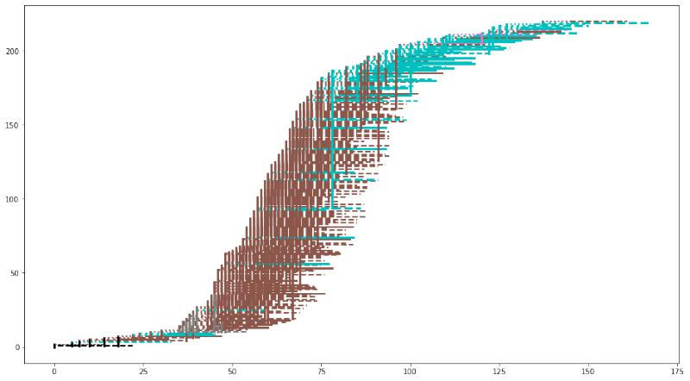

Figure 15: Case 8, with containment measures: a highly significant eﬀect of workplaces (brown)

In Fig. 15 we have the first of the four pictures already seen in Section 2.2. It is a case in which the workplace’s eﬀect as an elective area of contagion is powerful. The epidemic lasts around 170 days. We introduce a further containment measure to the regular ones (those of Appendix D). From the 20th day of the simulated period, fragile workers are no more participating in work activity (into our simulated Piedmont, they correspond to a quota of

21

Work in progress & draft: Comments and Corrections Welcome!

around the 5% of the whole population). The eﬀect, in Fig. 16 is very positive in stopping the initial workplace action, but a series of home contagions restarts the epidemic, again in workplaces. As we see in Fig. 18, here we have the eﬀect of an unlucky circumstance: that of a unique agent, infected at home, again spreading the infection in the workplaces. We show this event to confirm the high variability in epidemic developments. Considering batches of 1,000 simulations, as in Section B.4, the positive eﬀect of the proposed measure is well evident.

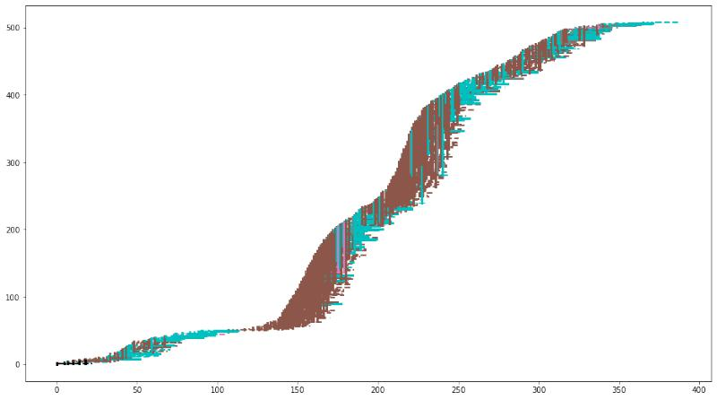

Figure 16: Case 8, with containment measures, stopping fragile workers at day 20, with a positive result, but home contagions (cyan) keep alive the pandemic, which explodes again in workplaces (brown)

22

Work in progress & draft: Comments and Corrections Welcome!

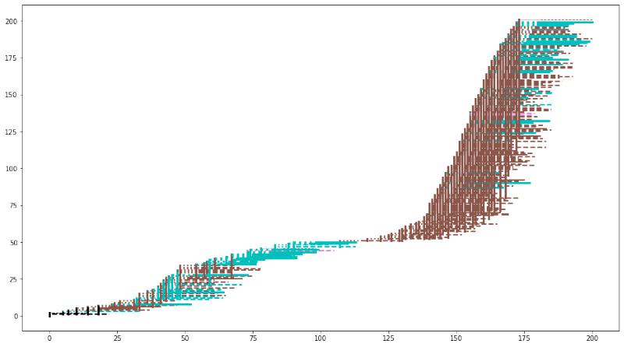

Figure 17: Case 8, with containment measures, stopping fragile workers at day 20, with a positive eﬀect, but home contagions (cyan) keep alive the pandemic, which explodes again in workplaces (brown), first 200 infections with evidence of the event around day 110 with the new phase due to a unique asymptomatic worker

As a most substantial measure, we try a general stop of any fragility since the 15th day of the simulated period. The positive eﬀect is evident in Fig. 18, with a short-lasting epidemics, aﬀecting few people. A note: in the batch analysis of Appendix B, we always use the 20th day as a turning point.

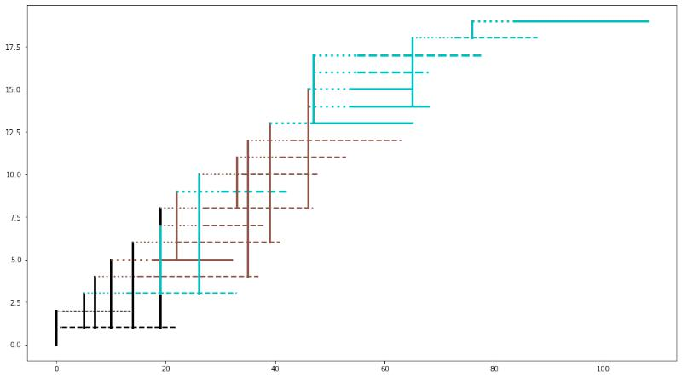

Figure 18: Case 8, with containment measures, stopping fragile workers and any case of fragility at day 15, also isolating nursing homes

23

Work in progress & draft: Comments and Corrections Welcome!

A.3.3 Case 9, a spontaneously stopping epidemic

To finish this series of examples, in Fig. 19 we show the case of an epidemic spontaneously stopping quickly, using the regular non-pharmaceutical containment measures.

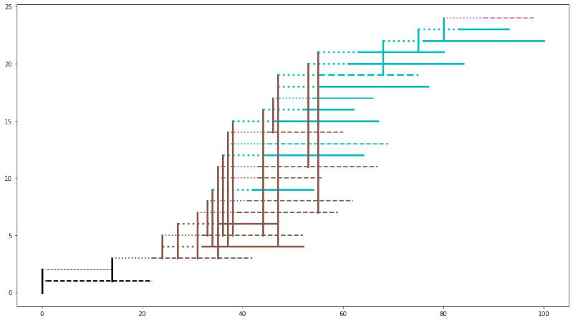

Figure 19: Case 9, with containment measures: a spontaneously stopping epidemic in short period

* Appendix: batches of 1,000 simulated experiments gener-ating data for policy proposals

To systematically explore the results of the diﬀerent simulations, taking into account the variability of the outcomes, we produce batches of 1,000 runs via the tool BehaviorSpace of NetLogo. BehaviorSpace creates csv files that we analyze with the programs at [https:](https://github.com/terna/readSIsaR_BatchResults)

[//github.com/terna/readSIsaR_ BatchResults](https://github.com/terna/readSIsaR_BatchResults). The diﬀerent titles correspond to those of this appendix; it is also possible to run the codes directly from there.

We report here the results of the calculations, both as descriptive statistics and as heat-maps. A heat-map is a double histogram; in our application, it displays each simulated epidemic’s duration in the x axis and the count of the symptomatic, asymptomatic, and deceased agents in the y axis. The cells contain the number of cases. The data are always on a scale 1:1000.

The descriptive statistics are about: the total number of symptomatic subjects in nurs-ing homes, the total number of symptomatic subjects, the total number of symptomatic-asymptomatic-deceased subjects, the duration of the epidemic.

24

Work in progress & draft: Comments and Corrections Welcome!

B.1 Epidemics without containment measures

Here we are without any control, and the school always open. The values of Table B.1 are scary, and the concentration of the cases in the heat-map of Fig. 20 shows that, except a few instances spontaneously concluding in a short period (left bottom corner), we have a heavy cloud8 of cases lasting one year or one year and a half, hitting (as symptomatic, asymptomatic and deceased) from 2.400 to 3,200 people on a total of 4,350.

The calculations of this Section are reported synthetically in Section 3 and in the related Table 1.

|  |  |  |  |  |
| --- | --- | --- | --- | --- |
|  | total sym. total sym. | | total sym. | days |
|  | in nursing |  | asympt. |  |
|  | homes |  | deceased |  |
|  |  |  |  |  |
| count | 962.00 | 1000.00 | 1000.00 | 1000.00 |
| mean | 4.65 | 851.12 | 2253.48 | 340.10 |
| std | 7.89 | 288.52 | 767.58 | 110.21 |
| min | 0.00 | 0.00 | 2.00 | 12.00 |
| 25% | 0.00 | 849.00 | 2246.75 | 317.00 |
| 50% | 0.00 | 924.00 | 2442.00 | 357.00 |
| 75% | 8.00 | 998.00 | 2639.25 | 399.25 |
| max | 54.00 | 1240.00 | 3592.00 | 638.00 |
|  |  |  |  |  |

Table 2: Epidemics without containment measures

* In the 2020 Summer, in the mountain, one of the authors saw the cloud configuration reporte at

<https://terna.to.it/simul/HeatmapInTheCloud.png>; a curious coincidence.

25

Work in progress & draft: Comments and Corrections Welcome!

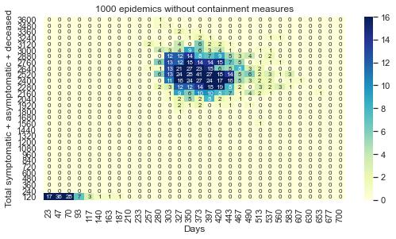

Figure 20: Epidemics without containment measures

B.2 Epidemics with basic non-pharmaceutical containment measures, no school in September 2020

We follow here the calendar of controls of Appendix D. Comparing the values of Table B.2 with those of Table B.1 we measure a strong diﬀerence. The content of Fig. B.2 shows the variability of results; most of all, a completely diﬀerent distribution of the events if compared with Fig. B.2. School is always closed in this simulation.

As in Section 3 we have here the possibility referring to actual Piedmont, where the curve of the symptomatic cases flattened with the end of May, with around 30 thousand subjects; with that datum, the region is included in the cell in the first row, immediately to the right of the mode in Fig. 21, considering that here we have to triplicate the number symptomatic subject to obtain the full measure of infected agents.

26

Work in progress & draft: Comments and Corrections Welcome!

|  |  |  |  |  |
| --- | --- | --- | --- | --- |
|  | total sym. total sym. | | total sym. | days |
|  | in nursing |  | asympt. |  |
|  | homes |  | deceased |  |
|  |  |  |  |  |
| count | 946.00 | 1000.00 | 1000.00 | 1000.00 |
| mean | 4.51 | 158.55 | 416.98 | 196.97 |
| std | 7.39 | 174.10 | 462.94 | 131.18 |
| min | 0.00 | 0.00 | 2.00 | 12.00 |
| 25% | 0.00 | 9.75 | 20.00 | 89.75 |
| 50% | 0.00 | 82.00 | 219.00 | 154.00 |
| 75% | 8.00 | 287.00 | 778.75 | 298.00 |
| max | 46.00 | 749.00 | 1916.00 | 611.00 |
|  |  |  |  |  |

Table 3: Epidemics with basic non-pharmaceutical containment measures, no school in September 2020

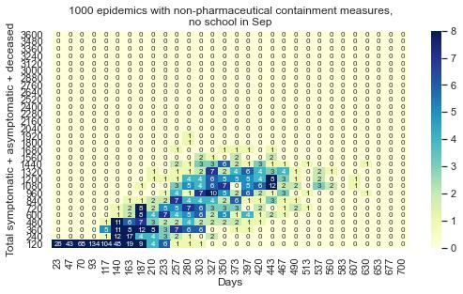

Figure 21: Epidemics with basic non-pharmaceutical containment measures, no school in September 2020

B.3 Epidemics with basic non-pharmaceutical containment measures, school open in September 2020

What if the school would be open in September? We note some reduction of the infections in Table B.3, maybe because concentrating the student in schools for a part of the day, we have fewer people around. The same observation holds for Section B.9.

27

Work in progress & draft: Comments and Corrections Welcome!

|  |  |  |  |  |
| --- | --- | --- | --- | --- |
|  | total sym. total sym. | | total sym. | days |
|  | in nursing |  | asympt. |  |
|  | homes |  | deceased |  |
|  |  |  |  |  |
| count | 946.00 | 1000.00 | 1000.00 | 1000.00 |
| mean | 4.24 | 153.71 | 409.73 | 199.35 |
| std | 7.29 | 168.55 | 454.12 | 129.00 |
| min | 0.00 | 0.00 | 2.00 | 13.00 |
| 25% | 0.00 | 9.00 | 18.75 | 95.00 |
| 50% | 0.00 | 81.50 | 231.50 | 154.00 |
| 75% | 6.00 | 269.50 | 770.00 | 309.25 |
| max | 42.00 | 738.00 | 1907.00 | 617.00 |
|  |  |  |  |  |

Table 4: Epidemics with basic non-pharmaceutical containment measures, schools open in September 2020

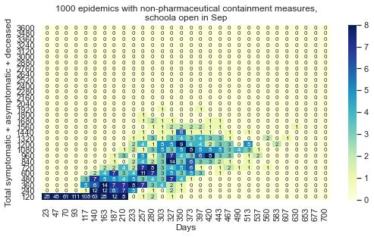

Figure 22: Epidemics with basic non-pharmaceutical containment measures, schools open in September 2020

B.4 Epidemics with immediate stop of fragile workers, non-pharmaceutical containment measures, no school in September 2020

In Table B.4 and in Fig. 23 we verify with a batch of 1,000 runs the analysis of Sections 2.2 and A.3.1. The verification of the strategy of stopping fragile workers with the epidemic early warnings, here at February 20th, gives a significant reduction of the infected people and the simulation duration. Anticipating the stop on February 15th, only some limited

28

Work in progress & draft: Comments and Corrections Welcome!

advantages are emerging.

|  |  |  |  |  |
| --- | --- | --- | --- | --- |
|  | total sym. total sym. | | total sym. | days |
|  | in nursing |  | asympt. |  |
|  | homes |  | deceased |  |
|  |  |  |  |  |
| count | 955.00 | 1000.00 | 1000.00 | 1000.00 |
| mean | 4.32 | 120.17 | 334.68 | 181.10 |
| std | 7.48 | 149.10 | 413.90 | 125.46 |
| min | 0.00 | 0.00 | 2.00 | 13.00 |
| 25% | 0.00 | 8.00 | 17.00 | 86.00 |
| 50% | 0.00 | 41.00 | 94.00 | 136.00 |
| 75% | 6.00 | 210.00 | 586.25 | 267.25 |
| max | 44.00 | 745.00 | 2043.00 | 746.00 |
|  |  |  |  |  |

Table 5: Epidemics with the immediate stop of fragile workers, non-pharmaceutical con-tainment measures, no school in September 2020

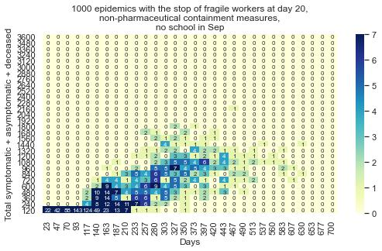

Figure 23: Epidemics with the immediate stop of fragile workers, non-pharmaceutical con-tainment measures, no school in September 2020

29

Work in progress & draft: Comments and Corrections Welcome!

B.5 Epidemics with absolute isolation of nursing homes, non-pharmaceutical containment measures, no school in September 2020

As explained in Section 3 commenting the Table 1, some strategies are separately explored.

If considered separately, each one gives positive but limited results.

First trial: we put in action the prohibition of the visits to the nursing homes and the isolation of the related operators, plus creating a buﬀer zone segregating nursing homes and hospitals. No school in September.

|  |  |  |  |  |
| --- | --- | --- | --- | --- |
|  | total sym. total sym. | | total sym. | days |
|  | in nursing |  | asympt. |  |
|  | homes |  | deceased |  |
|  |  |  |  |  |
| count | 955.00 | 1000.00 | 1000.00 | 1000.00 |
| mean | 3.41 | 150.53 | 408.08 | 201.76 |
| std | 6.88 | 172.48 | 467.54 | 138.15 |
| min | 0.00 | 0.00 | 2.00 | 12.00 |
| 25% | 0.00 | 8.00 | 18.00 | 89.00 |
| 50% | 0.00 | 70.00 | 196.00 | 147.50 |
| 75% | 0.00 | 268.25 | 756.50 | 312.25 |
| max | 47.00 | 737.00 | 1977.00 | 695.00 |
|  |  |  |  |  |

Table 6: Epidemics with the absolute isolation of nursing homes, non-pharmaceutical con-tainment measures, no school in September 2020

30

Work in progress & draft: Comments and Corrections Welcome!

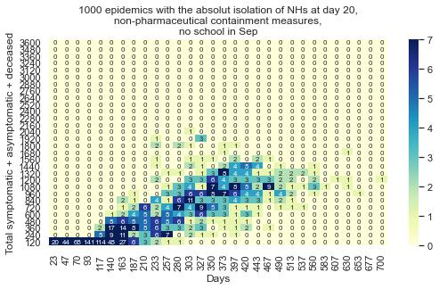

Figure 24: Epidemics with the absolute isolation of nursing homes, non-pharmaceutical containment measures, no school in September 2020

B.6 Epidemics stopping fragile people, non-pharmaceutical containment measures, no school in September 2020

Second trial: we lock fragile people at home, but the fragile workers continue their activ-ity?no school in September..

|  |  |  |  |  |
| --- | --- | --- | --- | --- |
|  | total sym. total sym. | | total sym. | days |
|  | in nursing |  | asympt. |  |
|  | homes |  | deceased |  |
|  |  |  |  |  |
| count | 952.00 | 1000.00 | 1000.00 | 1000.00 |
| mean | 4.38 | 154.15 | 408.50 | 195.81 |
| std | 7.52 | 170.22 | 456.08 | 129.52 |
| min | 0.00 | 0.00 | 2.00 | 14.00 |
| 25% | 0.00 | 9.00 | 19.00 | 90.00 |
| 50% | 0.00 | 93.50 | 251.00 | 154.50 |
| 75% | 7.25 | 264.25 | 747.50 | 294.00 |
| max | 57.00 | 820.00 | 2079.00 | 660.00 |
|  |  |  |  |  |

Table 7: Epidemics limiting fragile people mobility, non-pharmaceutical containment mea-sures, no school in September 2020

31

Work in progress & draft: Comments and Corrections Welcome!

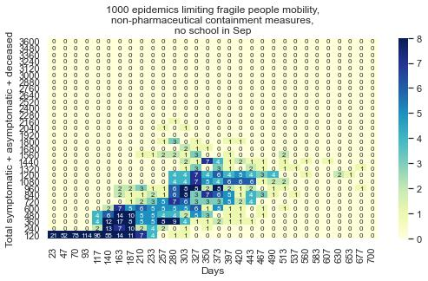

Figure 25: Epidemics limiting fragile people mobility, non-pharmaceutical containment measures, no school in September 2020

B.7 Epidemics excluding fragility of any type, non-pharmaceutical con-tainment measures, no school in September 2020

We put in action together all the limitations of Sections B.4, B.5, and B.6. The school is closed in September. The reduction of the infected people and of the duration, in Table B.7 and in Fig. 26, are relevant, representing the best result obtained.

32

Work in progress & draft: Comments and Corrections Welcome!

|  |  |  |  |  |
| --- | --- | --- | --- | --- |
|  | total sym. total sym. | | total sym. | days |
|  | in nursing |  | asympt. |  |
|  | homes |  | deceased |  |
|  |  |  |  |  |
| count | 947.00 | 1000.00 | 1000.00 | 1000.00 |
| mean | 3.25 | 105.63 | 302.62 | 174.39 |
| std | 6.60 | 134.80 | 382.14 | 121.82 |
| min | 0.00 | 0.00 | 2.00 | 12.00 |
| 25% | 0.00 | 8.00 | 17.00 | 84.75 |
| 50% | 0.00 | 37.50 | 84.00 | 131.00 |
| 75% | 0.00 | 173.00 | 515.50 | 252.25 |
| max | 40.00 | 728.00 | 1844.00 | 651.00 |
|  |  |  |  |  |

Table 8: Epidemics excluding fragility of any type, non-pharmaceutical containment mea-sures, no school in September 2020

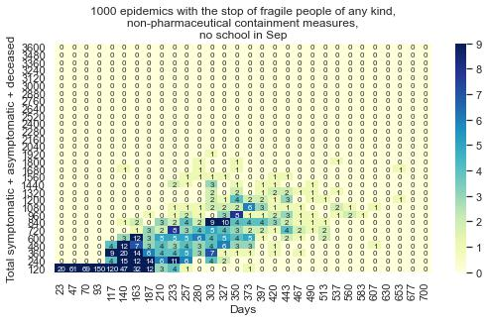

Figure 26: Epidemics excluding fragility of any type, non-pharmaceutical containment measures, no school in September 2020

B.8 Epidemics excluding fragility of any type, non-pharmaceutical con-tainment measures, factories open, no school in September 2020

We confirm the setting of Section B.7, but now with the factories (shops, oﬃces, etc.) always open. The results are acceptable.

33

Work in progress & draft: Comments and Corrections Welcome!

|  |  |  |  |  |
| --- | --- | --- | --- | --- |
|  | total sym. total sym. | | total sym. | days |
|  | in nursing |  | asympt. |  |
|  | homes |  | deceased |  |
|  |  |  |  |  |
| count | 960.00 | 1000.00 | 1000.00 | 1000.00 |
| mean | 3.46 | 124.10 | 397.05 | 200.31 |
| std | 6.65 | 132.42 | 399.64 | 121.46 |
| min | 0.00 | 0.00 | 2.00 | 14.00 |
| 25% | 0.00 | 9.00 | 19.00 | 95.75 |
| 50% | 0.00 | 85.00 | 279.00 | 188.00 |
| 75% | 5.00 | 202.25 | 707.00 | 284.00 |
| max | 41.00 | 868.00 | 2140.00 | 714.00 |
|  |  |  |  |  |

Table 9: Epidemics excluding fragility of any tyoe, non-pharmaceutical containment mea-sures, with factories open, no school in September 2020

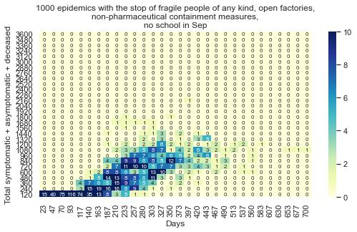

Figure 27: Epidemics excluding fragility of any type, non-pharmaceutical containment measures, with factories open, no school in September 2020

B.9 Epidemics excluding fragility of any type, non-pharmaceutical con-tainment measures, factories open, schools open in September 2020

Finally, to the setting of Section B.8, we add the decision of opening the schools in Septem-ber. The results are acceptable, with a slight improvement, already noticed in Section

34

Work in progress & draft: Comments and Corrections Welcome!

B.3.

|  |  |  |  |  |
| --- | --- | --- | --- | --- |
|  | total sym. total sym. | | total sym. | days |
|  | in nursing |  | asympt. |  |
|  | homes |  | deceased |  |
|  |  |  |  |  |
| count | 949.00 | 1000.00 | 1000.00 | 1000.00 |
| mean | 3.63 | 116.55 | 374.68 | 195.28 |
| std | 6.96 | 130.91 | 394.66 | 119.33 |
| min | 0.00 | 0.00 | 2.00 | 12.00 |
| 25% | 0.00 | 9.00 | 20.00 | 91.00 |
| 50% | 0.00 | 68.00 | 225.00 | 180.50 |
| 75% | 5.00 | 186.00 | 651.50 | 275.25 |
| max | 45.00 | 665.00 | 1844.00 | 666.00 |
|  |  |  |  |  |

Table 10: Epidemics excluding fragility of any type, non-pharmaceutical containment mea-sures, factories open, schools open in September 2020

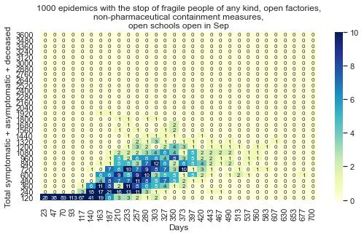

Figure 28: Epidemics excluding fragility of any type, non-pharmaceutical containment measures, factories open, schools open in September 2020

35

Work in progress & draft: Comments and Corrections Welcome!

* Appendix: How the visualization of contagion sequences works

C.1 The data

With each new infection, we add a record to a file. Each record contains:

1. the ID of the agent transmitting the contagion (for the initial cases, externally gen-erated, the ID has value -1);
2. its contagion progressive number, starting from 1 (for the initial cases, externally generated, this value is 0);
3. the conventional color of the place where it turned infected, following the NetLogo color swatches (for the externally generated initial cases, this value is 0);
4. the ID of the agent receiving the contagion;
5. its fragility rate (1 - robust; 2 - regular; 3 - fragile; 4 - extra fragile);
6. its contagion progressive number;
7. the conventional color of the place where it is turning infected, following the NetLogo color swatches;
8. the day (tick) of the contagion (for the initial cases, externally generated, this value is 0);
9. the starting infection day, i.e., the previous value plus the incubationPeriod (for the externally generated initial cases, the starting infection value is 0);
10. the day of the conclusion of the infection, i.e., the previous value plus a value between the minInfectionDuration and the maxInfectionDuration settings; this period stops if the agent deceases, but we do not consider that possibility here;
11. the symptomatic (1) or asymptomatic (2) status.

C.2 The plot

Into the plots, each agent is represented by a horizontal line, starting at x1 (date of the contagion, value 7 above) and finishing at x2 (time of recover, value 9 above).

The line is dotted in the incubation phase (until value 8 above), then solid for symp-tomatic cases or dashed for asymptomatic ones.

The line color is set by value 6 above. The line thickness is set by the value 4 above, with the scale: 1 robust, 2 regular, 3 fragile, 4 extra-fragile.

The position on y-axes is that of value 5 above.

Using data 1, 2, 5 and 7, we plot a vertical line with: the contagion date as x position (value 7 above); the y1 position identifying the agent transmitting the contagion (value 1

36

Work in progress & draft: Comments and Corrections Welcome!

above) and the y2 position identifying the agent receiving the contagion (value 5 above).

The color is that of the transmitting agent.

Using datum 4, we define the thickness of the horizontal lines : robust (lw = 1); regular (lw = 2); fragile (lw = 3); extra-fragile (lw = 4)

C.3 The colors

* black = contagion by an external unidentified agent;
* gray = contagion in an empty or open space;
* orange = contagion in a nursing home;
* brown = contagion in a factory/oﬃce/shop;
* yellow = contagion in a school;
* cyan = contagion at home;
* pink = contagion in a hospital.
* Appendix: The calendar
  + Day 1: conventionally, in the model the epidemic starts on Feb 3rd, 2020.
  + Day 17: due to carnival holidays, schools close.
  + Day 20: Piedmont Region first warning, with the prohibition of crowd gatherings.
  + Day 35: limitation of movement outside local areas.
  + Day 38: full lockdown on March 11th.
  + Day 49: almost total blockage of non-essential production activities.
  + Day 84: reduction of the limitations.
  + Day 106: elimination of a large part of the restrictions; schools always inactive.

References

Axtell, R. (2000). Why agents? On the varied motivations for agent computing in the social sciences. Tech. rep., Center on Social and Economic Dynamics Brookings Institution.

Bellomo, N., Bingham, R., Chaplain, M. A. J., Dosi, G., Forni, G., Knopoﬀ, D. A., Lowen-grub, J., Twarock, R. and Virgillito, M. E. (2020). A multiscale model of virus pandemic: Heterogeneous interactive entities in a globally connected world. In «Mathematical Mod-els and Methods in Applied Sciences», vol. 30(08), pp. 1591-1651.

URL <https://doi.org/10.1142/S0218202520500323>

37

Work in progress & draft: Comments and Corrections Welcome!

Epstein, J. (2008). Why model? . In «Journal of Artificial Societies and Social Simulation», vol. 11(4), p. 12.

URL <http://jasss.soc.surrey.ac.uk/11/4/12.html>

Miles, D., Stedman, M. and Heald, A. H. (2020). “Stay at Home, Protect the National Health

Service, Save Lives”: a cost benefit analysis of the lockdown in the United Kingdom. In «International Journal of Clinical Practice», vol. n/a(n/a), p. e13674. URL <https://onlinelibrary.wiley.com/doi/abs/10.1111/ijcp.13674>

Rahmandad, H. and Sterman, J. (2008). Heterogeneity and network structure in the dy-

namics of diﬀusion: Comparing agent-based and diﬀerential equation models. In «Man-agement Science», vol. 54(5), pp. 998–1014.

Scala, A., Flori, A., Spelta, A., Brugnoli, E., Cinelli, M., Quattrociocchi, W. and Pam-molli, F. (2020). Time, space and social interactions: exit mechanisms for the Covid-19 epidemics. In «Scientific Reports», vol. 10(1), p. 13764.

URL <https://doi.org/10.1038/s41598-020-70631-9>

Silvagno, F., Vernone, A. and Pescarmona, G. P. (2020). The Role of Glutathione in

Protecting against the Severe Inflammatory Response Triggered by COVID-19 . In «An-tioxidants», vol. 9(7), p. 624.

URL <http://dx.doi.org/10.3390/antiox9070624>

Squazzoni, F., Polhill, J. G., Edmonds, B., Ahrweiler, P., Antosz, P., Scholz, G., Chappin, E., Borit, M., Verhagen, H., Giardini, F. and Gilbert, N. (2020). Computational Models That Matter During a Global Pandemic Outbreak: A Call to Action. In «Journal of Artificial Societies and Social Simulation», vol. 23(2), p. 10.

URL <http://jasss.soc.surrey.ac.uk/23/2/10.html>

Steinmann, P., Wang, J. R., van Voorn, G. A. and Kwakkel, J. H. (2020). Don’t try to predict COVID-19. If you must, use deep uncertainty methods. In «Review of Artificial Societies and Social Simulation», vol. 17.

URL <https://rofasss.org/2020/04/17/deep-uncertainty/>

Terna, P., Pescarmona, G., Acquadro, A., Pescarmona, P., Russo, G. and Terna, S. (2020).

SIsaR, An Agent-Based Model of the Diﬀusion of Covid-19 Using NetLogo, with Suscep-tible, Infected, symptomatic, asymptomatic, and Recovered People. URL <https://terna.to.it/simul/SIsaR.html>

Wilensky, U. (1999). NetLogo.

URL <http://ccl.northwestern.edu/netlogo/>

38