**A TALE OF GHOSTS AND AGENTS: USING Repast4Py WITH A TWO-WAY INTERACTION**

By Eleonora Priori1, and [Pietro Terna](mailto:pietro.terna@unito.it)2,*

1Scuola Superiore Sant’Anna, Pisa, IT 2University of Torino, IT, retired & Collegio Carlo Alberto, Torino, IT *Corresponding author

Put here a short abstract

***Computational power and ABM***

Large Agent-Based Models (ABMs), with hundreds of thousands of agents, or millions, have to run on platforms, hardware and software, allowing scholars to obtain results in reasonable time. In Polhill *et al*. (2023) the authors clearly state that the problem is interaction specific affecting «agent-based modellers of social systems, while a crude characterisation of microsimulation work is that it does not simulate interactions among heterogeneous agents, which affects the parallelisation of simulating them».

SCHEMA

An idea for and example:

something close to the Chakraborti model in Is Inequality Inevitable? (Boghosian, 2019); more exactly, to the § 2.1 in Chakraborti (2002).

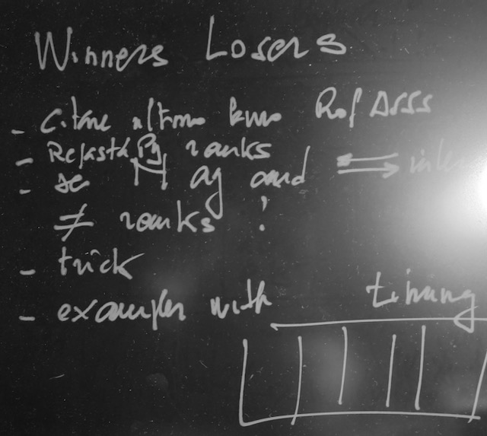

**Title**

c

**Title**

c

**References**

B. M. Boghosian. Is inequality inevitable. Scientific American, 321:70–77, 2019. URL https://www.scientificamerican.com/article/is-inequality-inevitable/.

A. Chakraborti. Distributions of money in model markets of econ- omy. International Journal of Modern Physics C, 13(10):1315–1321, 2002. URL https://arxiv.org/pdf/cond-mat/0205221.pdf.

G. Polhill, A. Ali- son Heppenstall, M. Batty, D. Salt, R. Colasanti, R. Milton, and M. Hare. Exascale Computing and ‘Next Generation’ Agent-Based Modelling. Review of Artificial Societies and Social Simulation - RofASSS, 9 2023. URL <https://rofasss.org/2023/09/29/exascale-computing-and-next-gen-abm/>.