Alt text

The picture above has alt text.
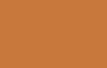
The picture above has none.

