Basic CRUD operations
The basic components of the synchronization resolver allow the user to view, create, and delete data in the system. Using these three operations it is possible to resolve all conflicts that the user may create. However, please note that the synchronization resolver is used to modify objects that exist in the database. As such the user is presented with a view of the database model which is different than the views presented to the user through the web interface.

Viewing existing data
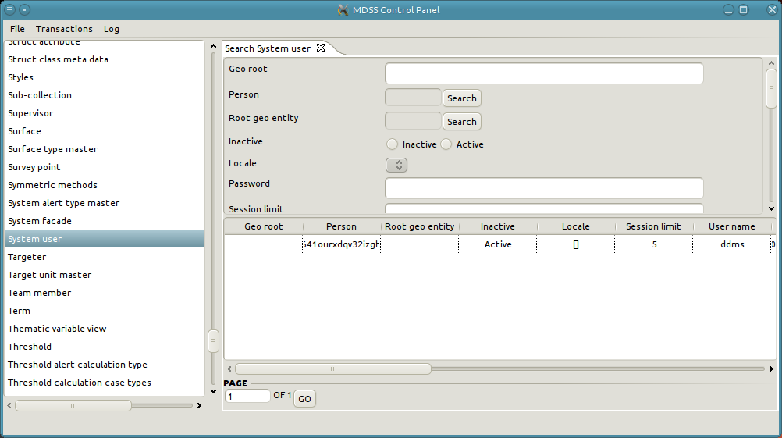
- On the left hand side of the resolver is a list of all data types in the system.
- Double click on the data type that you want to search
- A new tab with a search form of the selected type with open up.
- Fill out the search criteria as needed
- Click on "Search"
- The results of the search will appear in the paginated table below the search form
- To examine the next page of the results change the page number in the input field below the results table and hit enter or click on the “Go” button.
- To examine an object double click on a row of the result table

Create new data
- On the left hand side of the resolver is a list of all data types in the system.
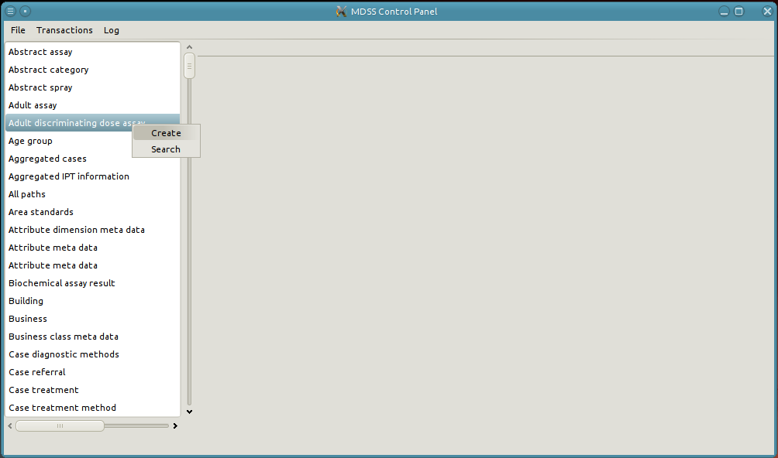
- Right-click on the type of the object you want to create and select "Create".

- This will open a new tab containing the form to create an object of the selected data type.
- Fill out the desired values on the form
- Apply the object

- Re-searching on that data type should now show your created object

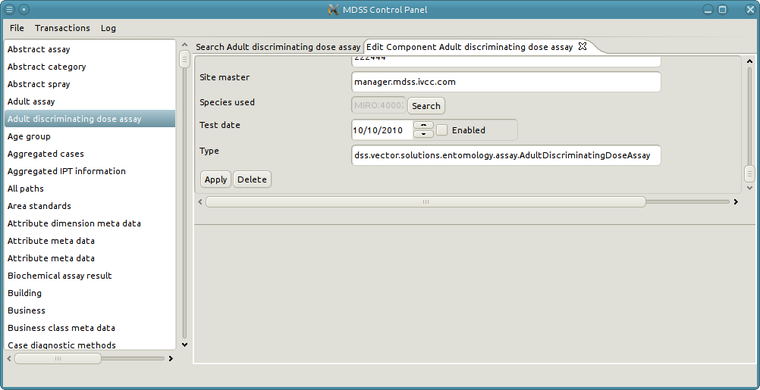
Edit existing data
- Find the object you wish to edit
- At the bottom of the form displaying an object's values there are two buttons, edit and delete

- To delete the object just click on the "delete" button
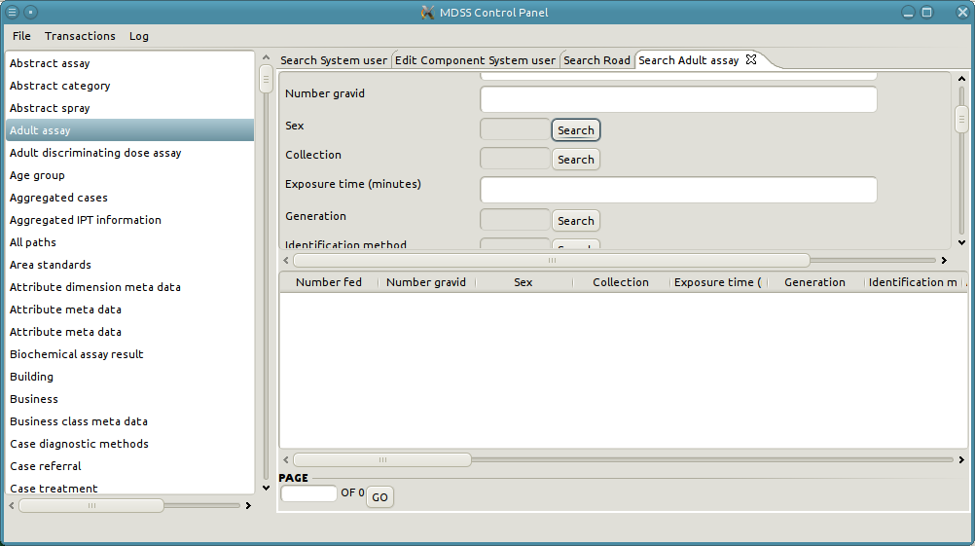
- To edit the object, make the modifications as needed, then click on the "apply" button
- Setting the value of a reference attribute is a multi-step process. This will bring up a pop-up where the user can search for a select the desired reference object.
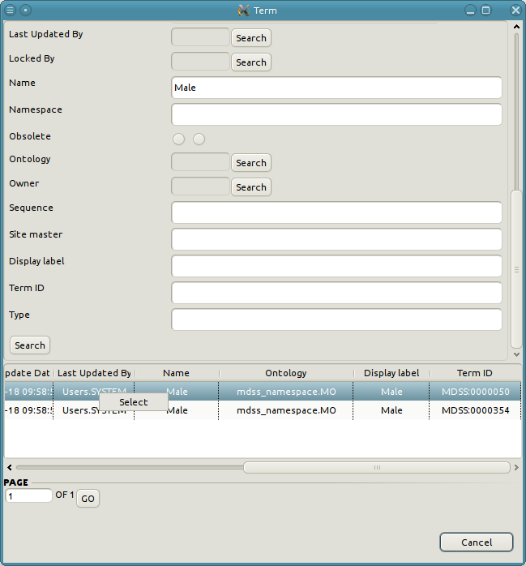
- First, the user must click on the search button corresponding to the reference attribute
- Next the user needs to add additional criteria in the search pop-up and search for the results.
- To set the reference value the user must right-click and select the desired row. It is also possible to double-click on the desired row.
- Once a row is selected the pop-up will close and the text field of the reference attribute will display the key of the selected object.

Examining relationship data
- Find the object you wish to edit
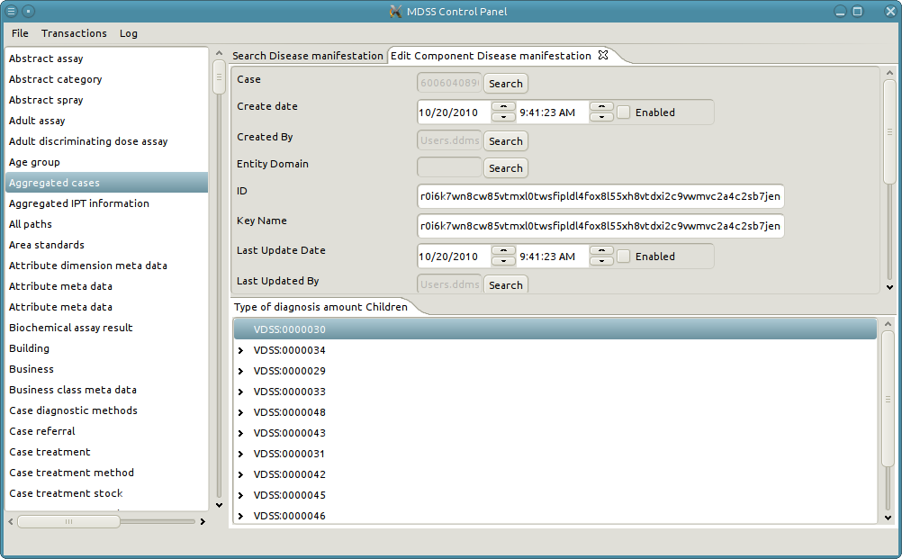
- To view the relationships of the object examine the bottom half of the tab. There is a series of tabbed folders. Each tab is a different type of relationships that the object participates in. Additionally, each tab will specify if the object is the parent or child of the relationship.
  - The content of each tab contains a tree of the objects on which the object is currently in a relationship with.
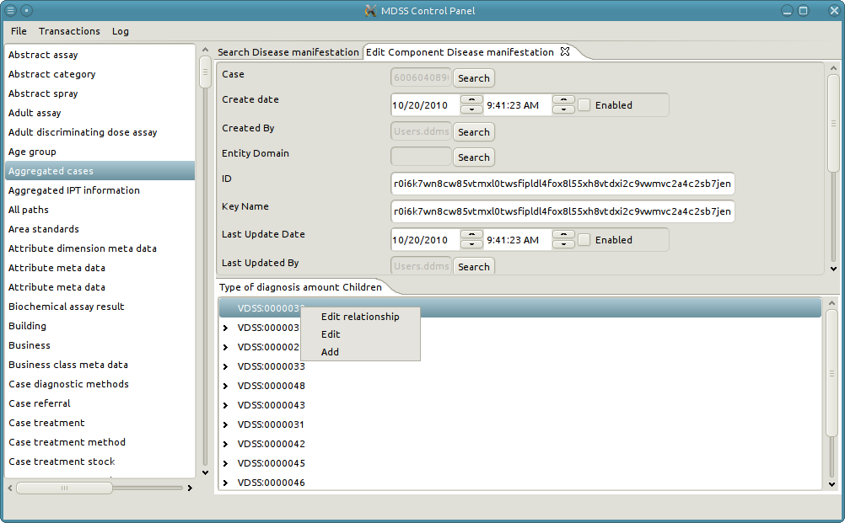
  - If a tree doesn't exist then the object is not currently participating in a relationship of the given type and direction.

Add a new relationship
- To add a new relationship right-click in the tab folder and select "Add".

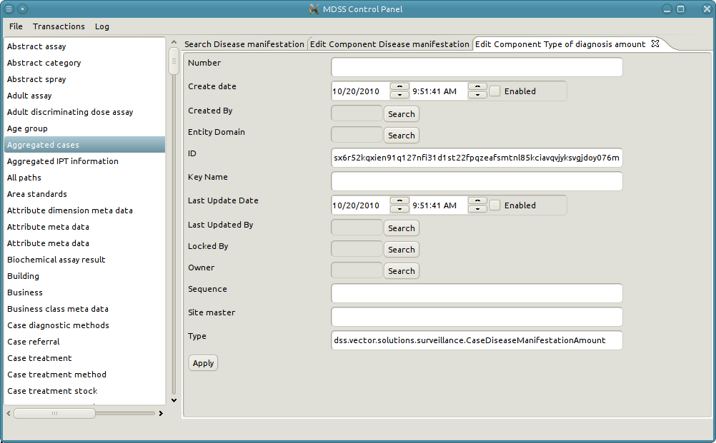
- This will bring up a pop-up (similar to selecting a reference object) where the user needs to select the other participating object in the relationship. Exactly like searching for an object, the user needs fill out the desired criteria to narrow down the potential choices and click search. To select the sink object double click on the desired row of the results table.

- Once the user has selected the sink object a new tab will appear with the information of the relationship. Modify the relationship values as needed and then apply the object.

View the participating object
- To examine the other participating object in the relationship right-click on a node of the tree and select "Edit". The user can also double-click on the node.

Edit an existing relationship
- To examine an existing relationship right-click on a node of the tree and select "Edit relationship"
- Note that it is impossible to change the parent and child of a relationship when editing a relationship. The only want to change a parent or child of a relationship is to delete the existing relationship and create a new one with the desired parent and child.

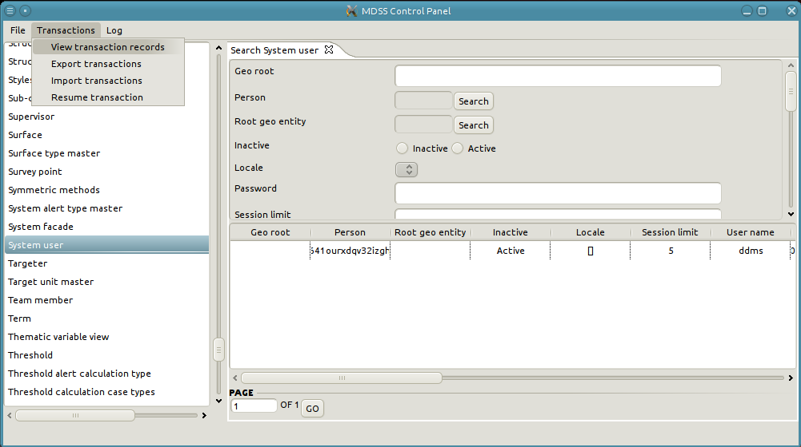
Transactions
The main goal of the synchronization manager is to facilitate transferring data from different nodes of a network. In order to accomplish that goal the manager allows the user to view, import, and export transaction records.

View Transaction Records
- Under the "Transaction" tab there is the option to "View Transaction Records". Click on this option.
- A list of all the transactions in the system will are displayed in a paginated table.
- Double click on a row to see the details of a single transaction record.
- The details of a transaction record contain information about the record itself and all of the transaction items which make up the transaction record.
- Double click on a single transaction item to see its details.

Export Transaction
- Ensure that the web server is shutdown.
- Under the "Transaction" tab there is the option to "Export Transaction". Click on this option.
- A pop-up box will appear with three options: All, Range, and Not Exported
  - All: This will export all transaction from the node regardless of the fact that they might have already been exported
  - Range: The user specifies the start and end sequence numbers of the transactions they wish to export.
  - Not Exported: This option exports all of the transaction which have not been previously exported.
- The user must also specify the location in which they wish the save the export zip file.
- Once the proper save location and the export options have been selected click "Export".
- A pop-up will appear with information about the status of the export. Once the pop-up closes then the export has finished.

Import Transaction
- Ensure that the server is stopped before importing any transactions.
- Under the "Transaction" tab there is the option to "Import Transaction". Click on this option.
- A pop-up box will appear asking for the location of the transaction zip.
- Select the zip location and click "Import".
- A pop-up will appear with information about the status of the import. Once the pop-up closes then the import has finished.
- Unfortunately it is possible for nodes to create conflicting data that the user will need to manually resolve.
- If a conflict occurs during the import process the import will pause, a message box will display the type of conflict, and a new tab will open with the object which caused the conflict.
- Using the basic CRUD operations of the manager, the user must determine and implement the desired resolution to the conflict.
- Once the conflict is resolved click on the "Resume transaction" button to continue the rest of the import.

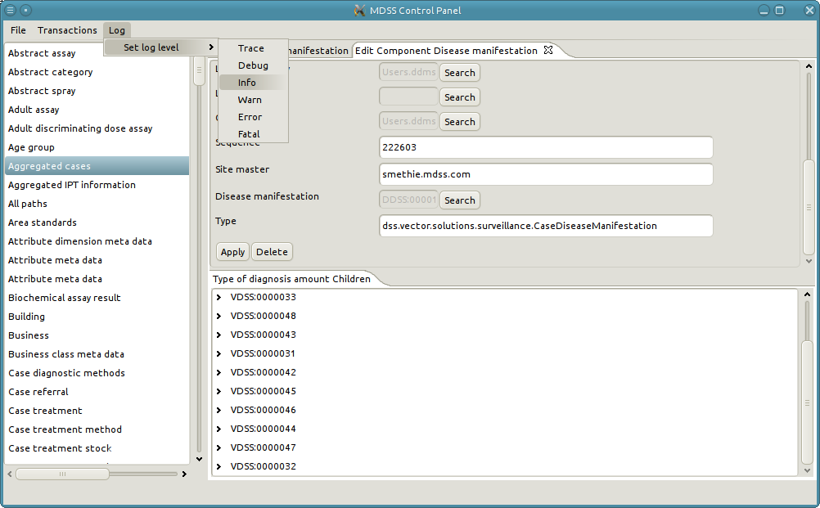
Modify Log Level
If a repeatable error is occuring in DDMS you can modify the log level of the system to get more information about the cause of the error. To modfiy the log level click on the “Log” menu item and hover over the “Set Log Level” item. The click on the desired log level. Once you have set the log level of the system you will need to restart the server before the change will take effect. The default log level of the system is “Trace”.

