# Fundamentals of data synchronization

Using a node's transaction records it is possible to transfer data between different nodes. As data is entered into the system transaction records are created. Transaction records contain all of the information required to duplicate the data on different nodes. That being said, transaction records are also created when importing transaction records of a different node. As such, it is not necessary to include the export of the first node when exporting the second node. It will automatically contain the records of the first node. For example, Node A exports it's data to Node B, Node B then export's its data to Node C. Node C will get the data of Node A from Node B's export.

# Basic CRUD operations

The synchronization resolver allows the user to view, create, and delete data in the system. These three operations enable the resolution of any conflicts raised during synchronization. However, since the synchronization resolver directly modifies objects in the database, it presents views of the database model, which differ from views seen through the web interface. As such, the resolver requires users with a high degree of technical proficiency and familiarity with DDMS.

## View existing dataA description...

* The left panel lists all data types in the system
* Double click the data type to search
* A new tab opens with a search form for the selected type
* Fill in search criteria as needed
* Click "Search" at the bottom of the form
* Search results appear in the paginated table below the form
* [Optional] Access additional pages of search results with the input field below the results table
* Double click a row of the result table to view the object

## Create new dataA description...

* The left panel lists all data types in the system
* Right-click the desired type from the list and select "Create"
* A new tab opens with the create form for the selected data type
* Fill in the form
* Click “Apply”

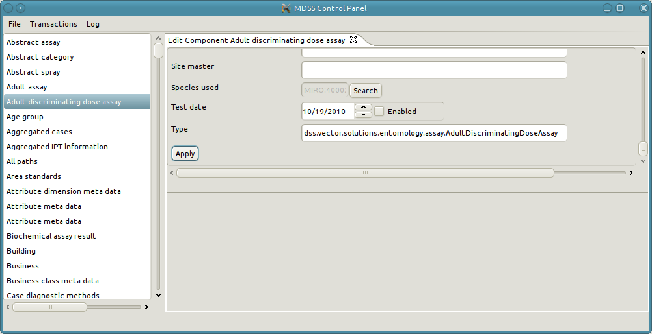

## Edit existing data

* Search for the object to edit [See “View existing data”]
* Click “Edit” at the bottom of the form
* Make modifications as needed
* Click "Apply"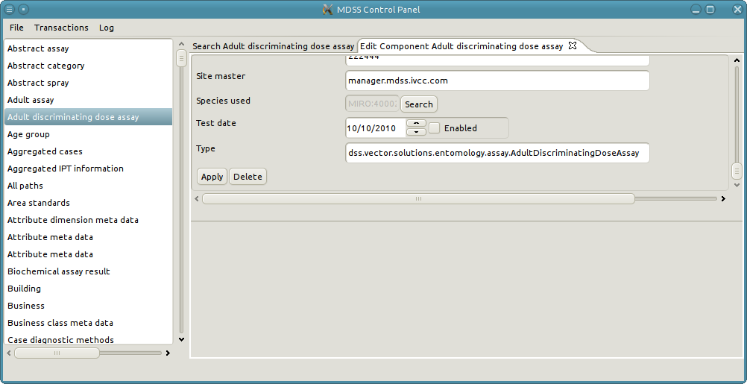

## Delete existing object

* Search for the object to edit [See “View existing data”]
* Click “Edit” at the bottom of the form
* Make modifications as needed
* Click "Delete"

**Edit a Reference Attribute**

* Click “Search” next to the reference attribute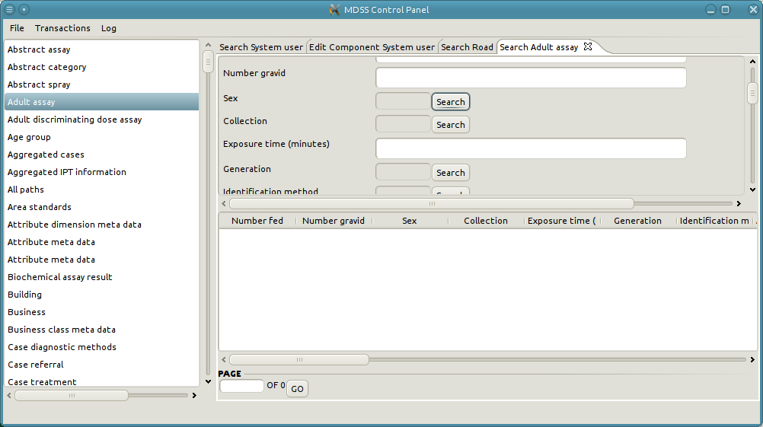
* A search dialog pops up
* Fill in criteria and click “Search.” Results appear in the bottom panel.
* Double-click the desired row or Right-click and click “Select”
* The pop-up closes, and the reference field contains the key of the selected object.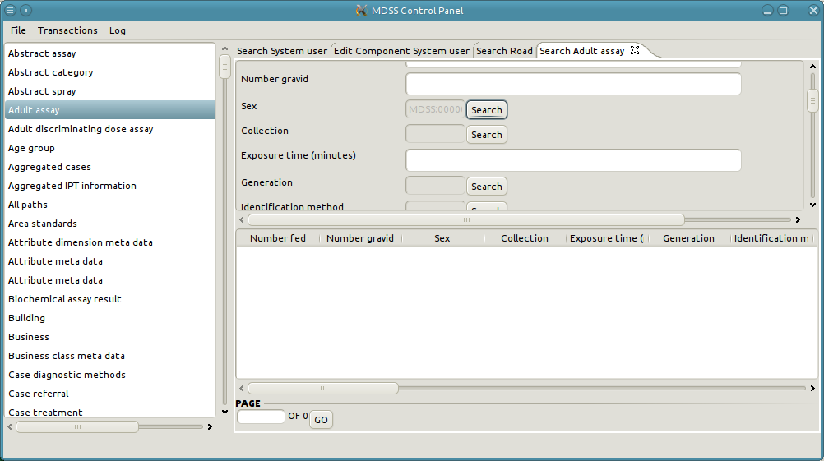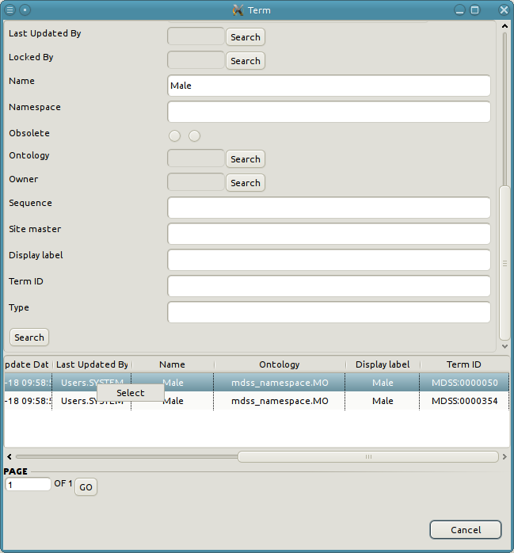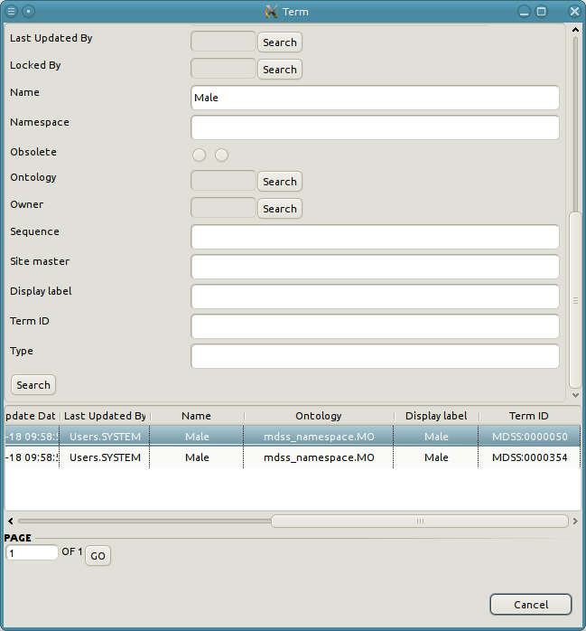

## View a relationship treeA description...

* Search for the object in the relationship [See “View existing data”]
* The bottom panel contains tabs for each type of relationship the object participates in. The tab also indicates the direction (parent or child) of the relationship.
* Select the tab with the correction relationship and direction
* The panel contains a tree structure representing the objects on the other end of the relationship
* Expand a node to see any objects the node is related to. Repeat as desired.

### Add a new relationshipA description...

* Select the participating data type and desired relationship tab [See “View a relationship tree”]
* Right-click the relationship tab and click “Add”
* A pop-up window opens to select the target object [See “Edit a reference attribute” for similar behavior]
* A new tab opens in the top panel containing the create form.
* Fill in the form and click “Apply”

### View the participating object

* Navigate to the desired object in the relationship tree [See “View a Relationship tree”]
* Double-click the desired row or Right-click and select "Edit"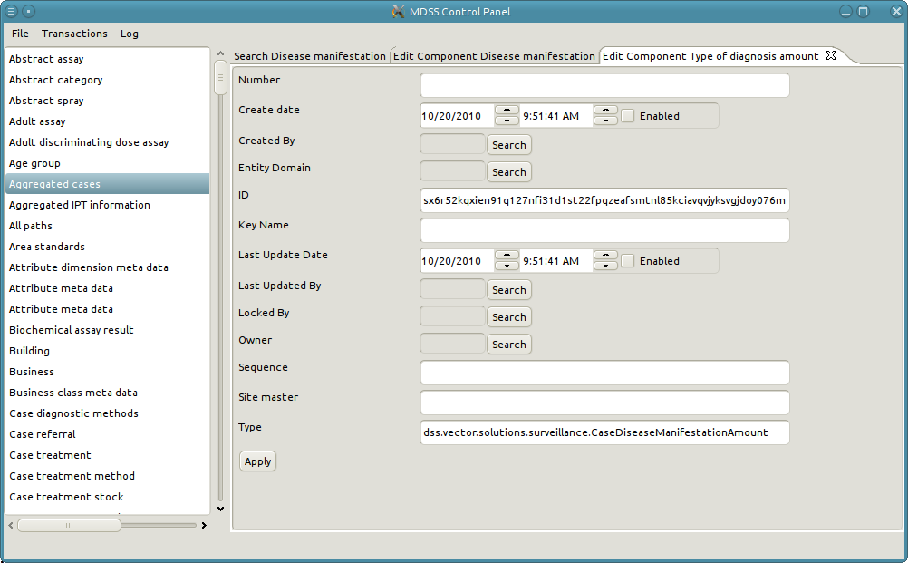

### Edit an existing relationship

* Select the participating data type and desired relationship tab [See “View a relationship tree”]
* Right-click the relationship tab and click “Edit Relationship”
* Make modifications as needed
* Click “Apply”

# Transactions

The synchronization manager primarily facilitates data transfer among multiple installations through use of the view, import, and export transaction functions.

## View Transaction RecordsA description...

* Open the "Transaction" menu and click "View Transaction Records"
* The main panel opens a paginated table listing all transactions in the system
* Double click a row to open the details of the transaction record in a new tab
* The bottom panel of the transaction record tab contains a list of transaction items in the record
* Double click a transaction item to open its view in a new tab

## Export Transaction

* Ensure that the web server is shut down
* Open the "Transaction" menu and click "Export Transaction"
* A pop-up opens with three options: All, Range, and Not Exported
  + All: Exports all transactions from the node regardless of the fact that they might have already been exported
  + Range: Exports transactions between the specified start and end sequence numbers
  + Not Exported: Exports all transactions which have not been previously exported
* Click “Choose File” and select a destination for the export file
* Click “OK” to being the export
* A pop-up appears with status information concerning the export. The pop-up closes when then the export completes.

## Import Transaction

* Ensure that the web server is shut down
* Open the "Transaction" menu and click "Import Transaction"
* A file selection dialog opens
* Select the import zip file and click "Import"
* A pop-up appears with status information concerning the import. The pop-up closes when the import completes.
* Conflicts can arise during the import process. These must be resolved manually.

**Resolving a Conflict**

* The import pauses on conflicts
* A message box displays the error causing the conflict
* A new tab opens viewing the conflicting object
* Resolve the conflict with the techniques described in the “Basic CRUD Operations” section. The specific steps necessary for resolution differ on a case by case basis, and may involve several objects or relationships.
* Once resolved, click "Resume transaction" to continue the import

## Modify Log LevelA description...

DDMS features a logging system with customizable levels of detail. The logs provide information useful for debugging and troubleshooting problems. Adjust the amount of information logged to accommodate different needs and circumstances.

* Open the “Log” menu item
* Mouse over “Set Log Level”
* Click on the desired log level
* Restart the server