TERRAN BLAKE // WEDNESDAY 7:30AM // ECE 241

BLUE = PART 1 RED = BOTH PARTS GREEN = PART 2

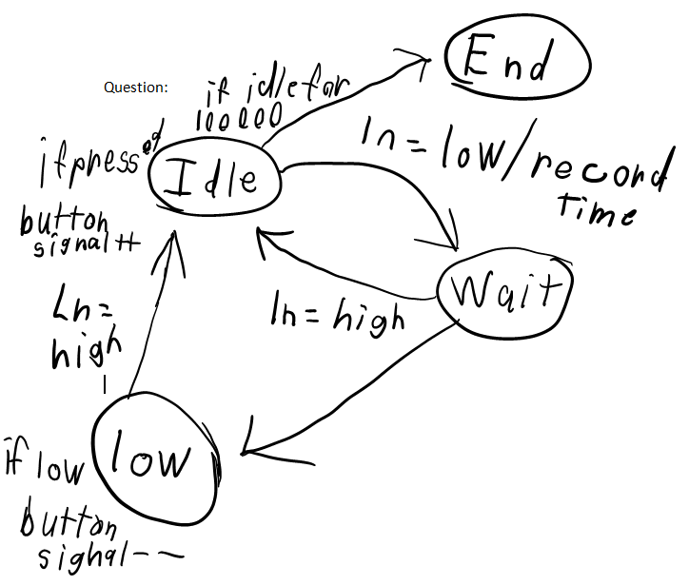

enum ProcStates { Idle, Wait2, Low2};

#include<LiquidCrystal.h> //These two lines setup the drivers for the display

LiquidCrystal LcdDriver(12, 11, 5, 6, 7, 8);

int interval = 5;

int ProcStates;

int buttonPin = 4;

int buttonPressCount = -1;

int tracker = 0;

int debounceInterval = 5; //Lets the button settle for 5ms

unsigned long currenttime = 0;

unsigned long timer = 0; //integer for button pin

unsigned long timeOfLastButtonEvent = 0; //store the last time the button state changed

boolean Input = LOW; //Stores the value of the current state

boolean Wait = LOW; //Stores the last state so that it loops properly

boolean Low = LOW;

void setup() {

pinMode(buttonPin, INPUT); //Sets pin 4 as an Input

Serial.begin(9600); //Begins Lcd on pin 16 and 2

LcdDriver.begin(16, 2);

LcdDriver.clear();

LcdDriver.setCursor(0,0);

ProcStates = Idle;

pinMode(10,OUTPUT);

}

int NextState(int ProcStates) {

switch(ProcStates) {

case Idle:

if (Input = LOW) {

timer = millis();

return Wait2;

}

break;

case Wait2:

if (Input = HIGH) {

return Idle;

}else if (timer - currenttime >= interval) {

// Serial.println("indicator light is on");

currenttime = timer;

return Low2;

}

break;

case Low2:

if (Input = HIGH) {

return Idle;

}

}

}

void loop(){

NextState(ProcStates);

Input = digitalRead(buttonPin);

unsigned long currentTime = millis();

if (Input != Wait){

timeOfLastButtonEvent = currentTime;

}

if (currentTime - timeOfLastButtonEvent > debounceInterval) { //Checks on the voltage based on timer

if (Input != Low) { //If the voltage has changed, switch states

Low = Input; //Updates the state

//trigger an event

if (Low == HIGH) { //Does a serial print when button is pressed

Serial.println("released");

buttonPressCount++;

//Question 2, ads to counter when pressed and depressed

} else {

Serial.println("pressed"); //Serial print and adds to button press count

buttonPressCount++; This is for part 1

}

}

}