Angular8 Authentication Application

 |

Angular8 Authentication application

**code circulation**

2020

Table of Contents

**Introduction2**

**Tools and Technology2**

**Application Structure3**

**Create Database/Tables Using Migration5**

User Registration9

Login16

My Profile17

Change Password19

Role Based Access21

Forgot Password26

**Introduction**

*This is the basic angular8 application, which will show you how to create basic authentication for any project using angular8 framework.*

**Tools and Technology**

1. *User Interface (Angular application)*
   1. *Angular CLI: 8.1.2*
   2. *Node: 10.16.0*
2. *API*
   1. *Asp.Net Core Web API (.Net Core 2.2)*
   2. *Asp.Net Core Identity*
   3. *JWT Authentication*

**Application Structure**

1. *Angular application structure.*

● src

+---● app

| +--● user

| | |--user.component.ts|.html

| | +--● registration

| | | |--registration.component.ts|.html

| | +--● login

| | | |--login.component.ts|.html

| | +--● account-activation

| | | |--account-activation.component.ts|.html

| | +--● forget-password

| | | |--forget-password.component.ts|.html

| | +--● password-reset

| | | |--login.component.ts|.html

| |

| +--● home

| | |--home.component.ts|.html

| | +--● change-password

| | | |--change-password.component.ts|.html

| | +--● my-profile

| | | |--my-profile.component.ts|.html

| | +--● program1 //For testing of role based access

| | | |--program1.component.ts|.html

| | +--● program2 //For testing of role based access

| | | |--program2.component.ts|.html

| +--● forbidden

| | |--forbidden.component.ts|.html

| |

| +--● shared

| | |--user.service.ts

| |

| +--● auth

| | |--auth.guard.ts

| | |--auth.interceptor.ts

| |

| |--app.module.ts

| |--app-routing.module.ts (route configs.)

|

|--index.html (cdn path for bootstrap)

* 1. Setup the angular application in your local machine.
     1. Open the angular project and run command - **ng serve - -o** to run the project**. If you are facing below mentioned error in the screenshot**, then run the command - **npm install @angular-devkit/build-angularng**. It will resolve the issue.

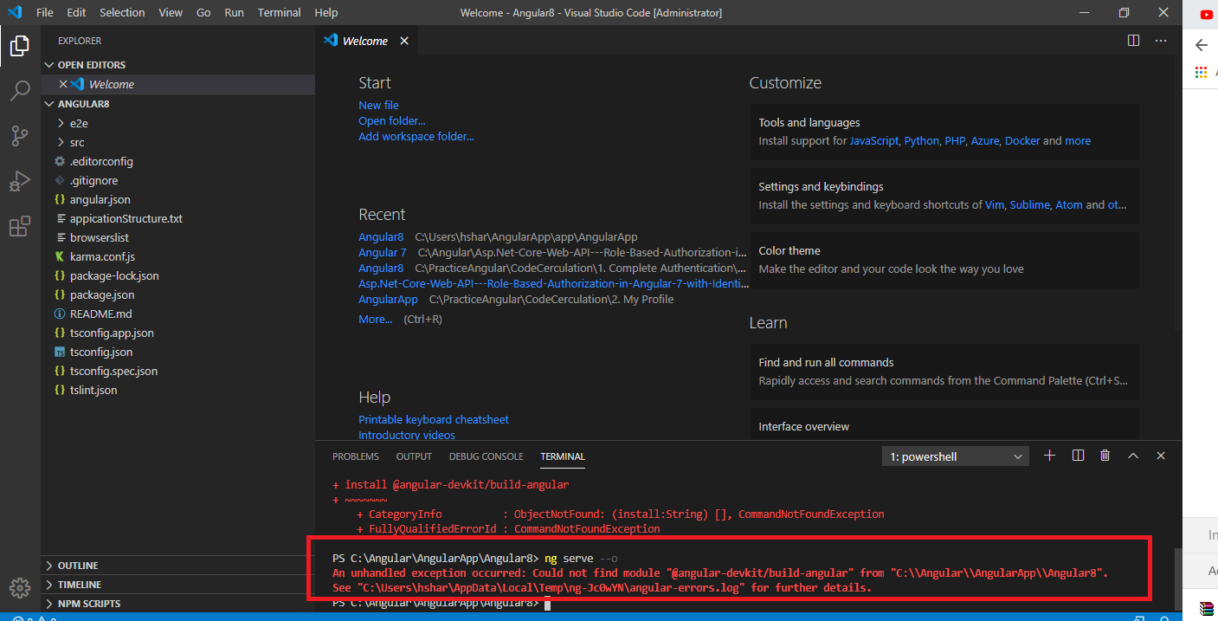

1. *Web API Structure* 
   1. *CommonCoreAPI [Web API]*
   2. *Libraries*
      1. *CommonCore.DataAccess*
         1. *Install following packages.*
            1. *Microsoft.EntityFrameworkCore (2.2)*
            2. *Microsoft.EntityFrameworkCore.SqlServer (2.2)*
            3. *Microsoft.EntityFrameworkCore.Tools (2.2)*
            4. *Microsoft.AspNetCore.All(2.2)*
      2. *CommonCore.Domain*
      3. *CommonCore.Services*
      4. *CommonCore.Helper [Helper library to access configurations]* 
         1. *Install following packages.*
            1. *Microsoft.Extensions.Configuration (2.2)*
            2. *Microsoft.Extensions.Configuration.Json (2.2)*

**Create Database/Table Using Migration**

1. *Observe the application structure.*

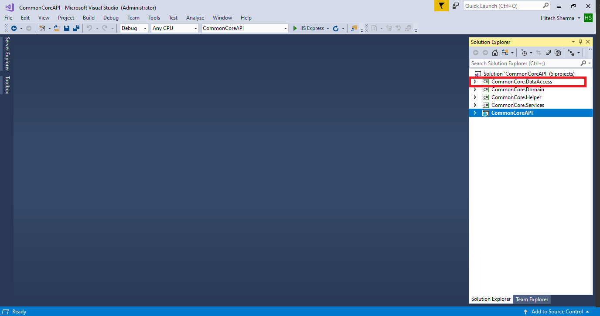

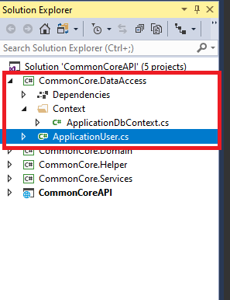

1. *Select library - CommonCore.DataAccess and run the migration*
   1. *Command: Add-Migration "InitialCreate"*

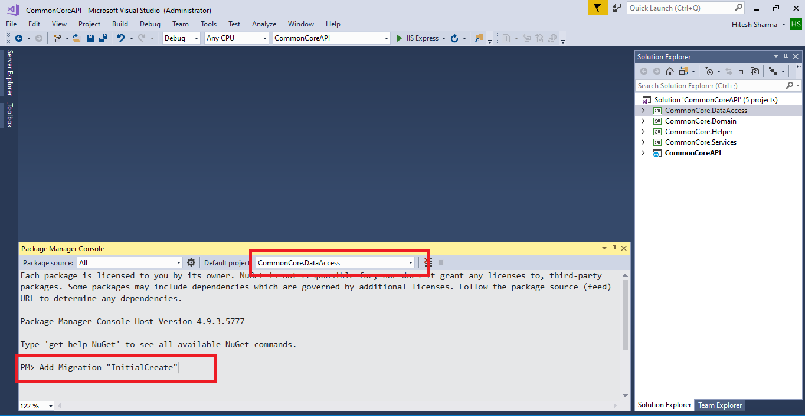

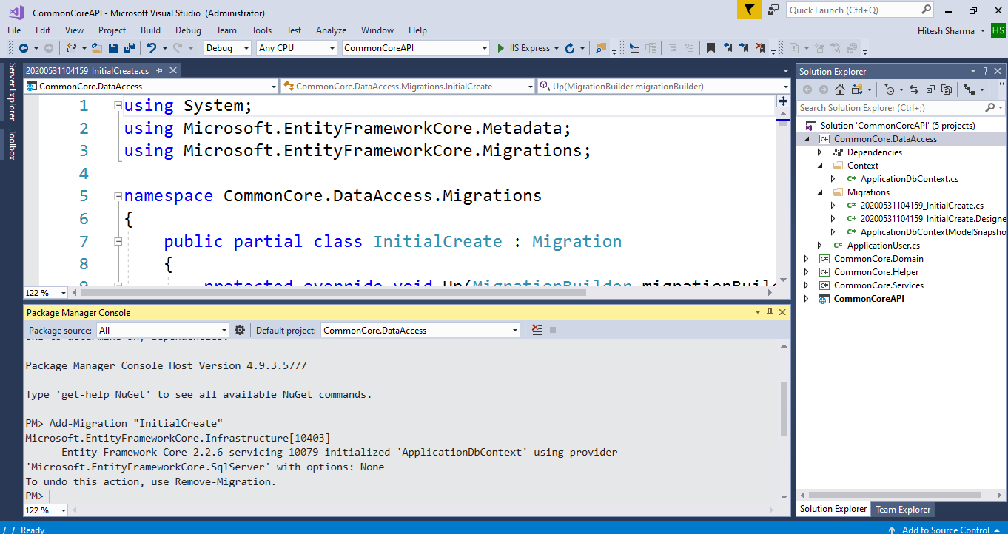

* 1. *Command: Update-Database*

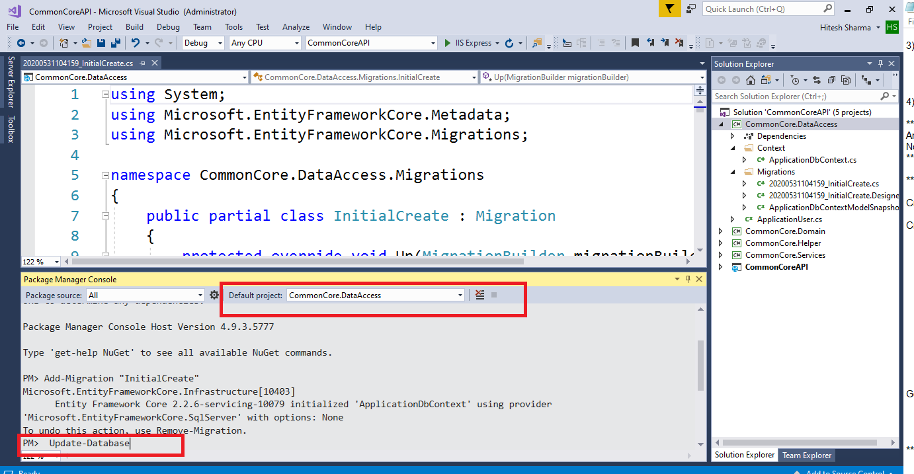

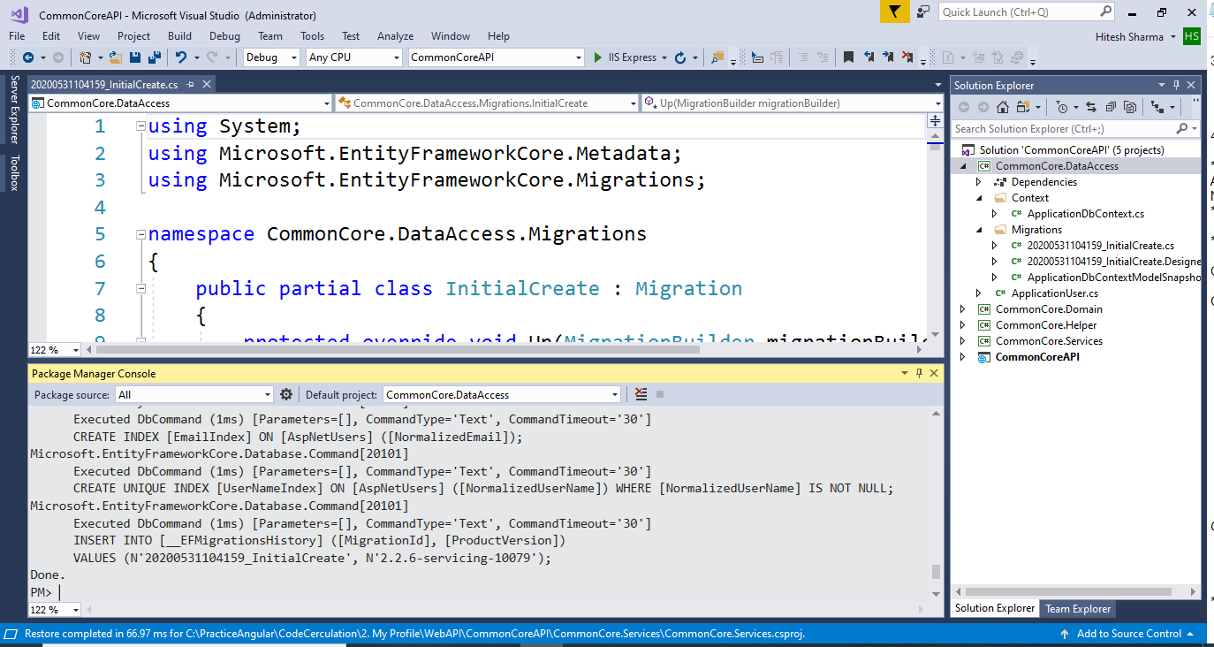

* 1. *Database and Tables are Created.*

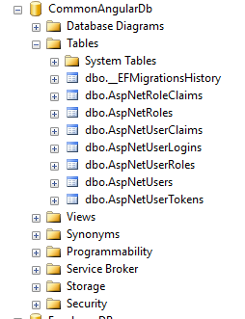

* 1. Update the proper credentials in email service, which will be using for sending email from the application (example : registration email, forgot password email ).

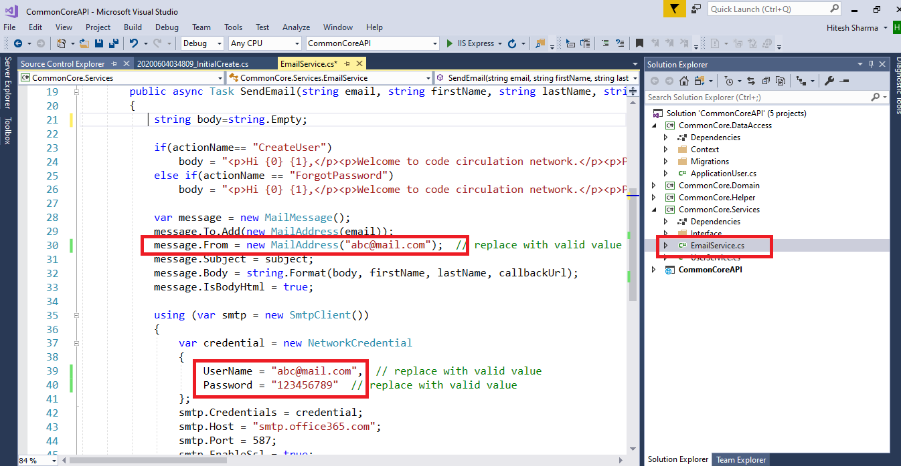

**User Registration**

1. *Default Role: Admin when user is created.*
   1. *Observe the form validation.*

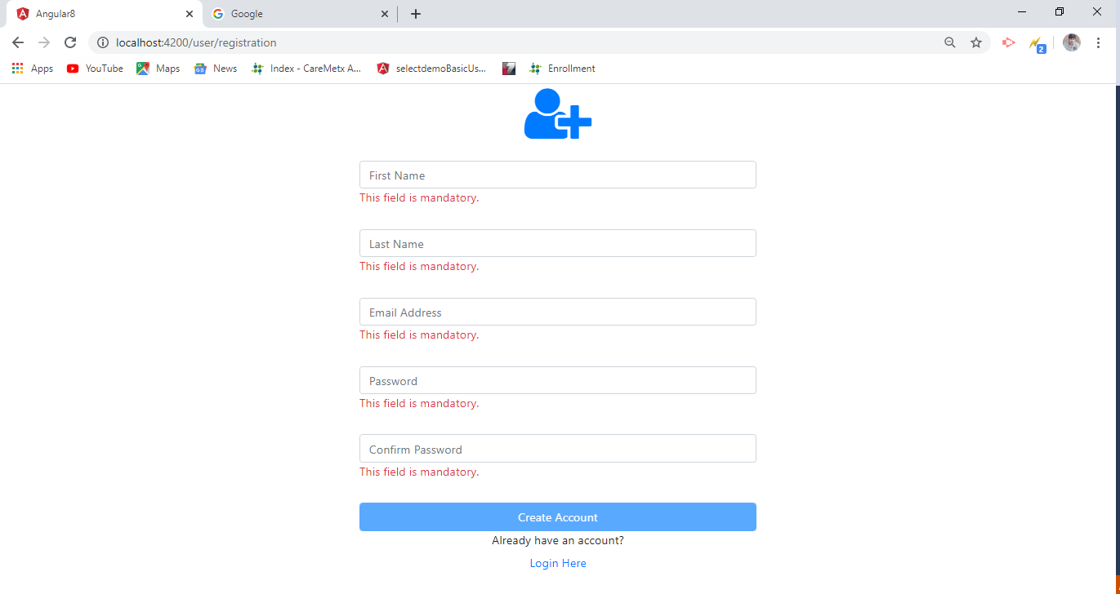

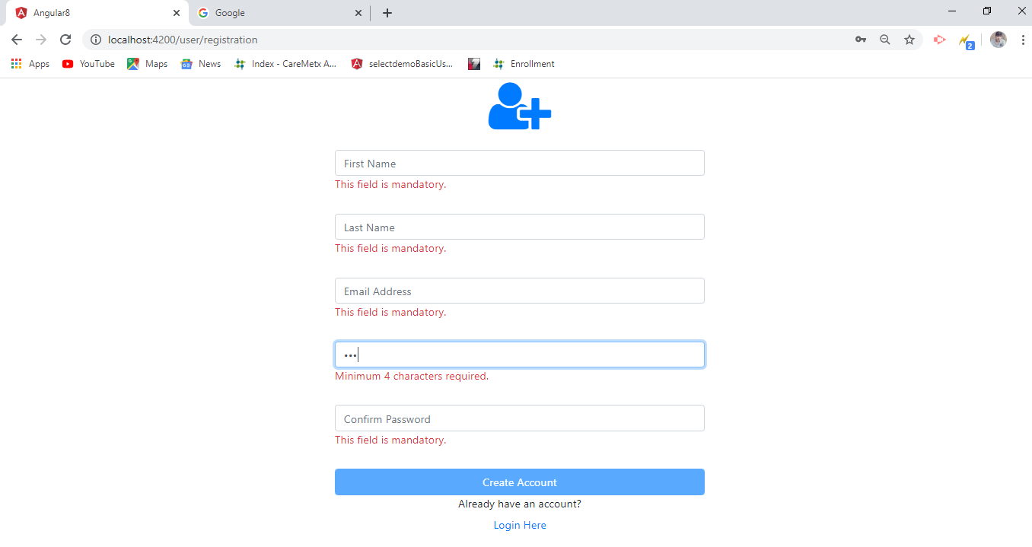

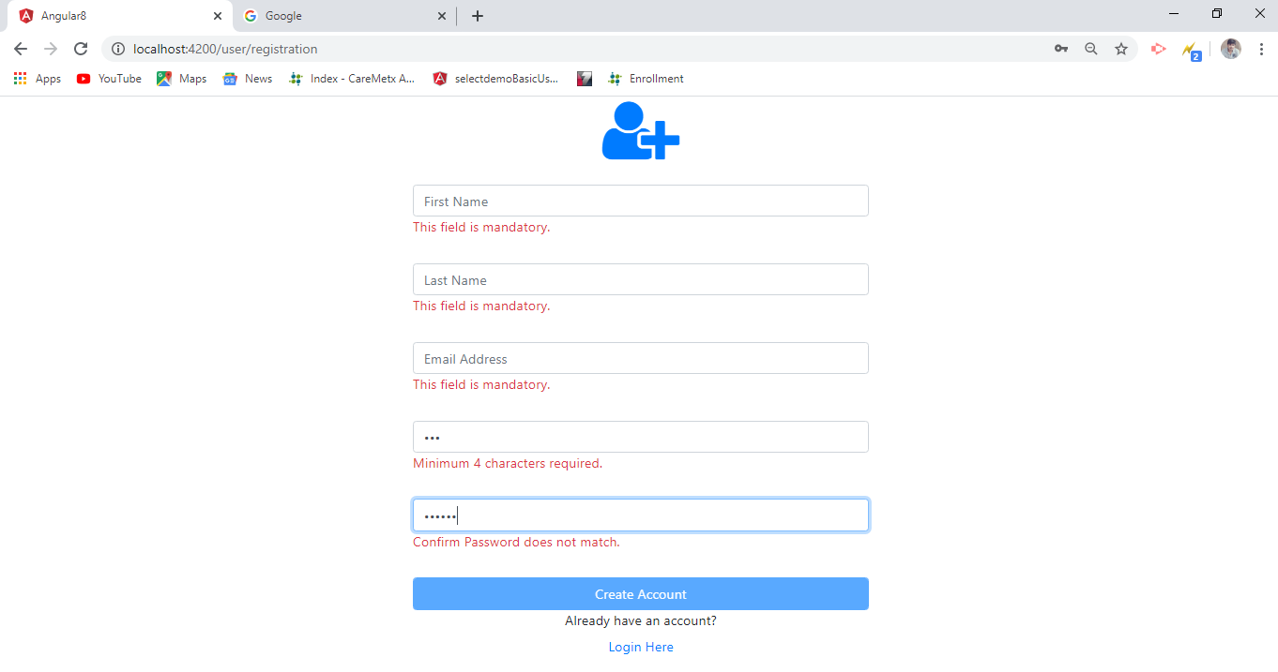

* 1. *Fill-up the registration form and hit submit button.*

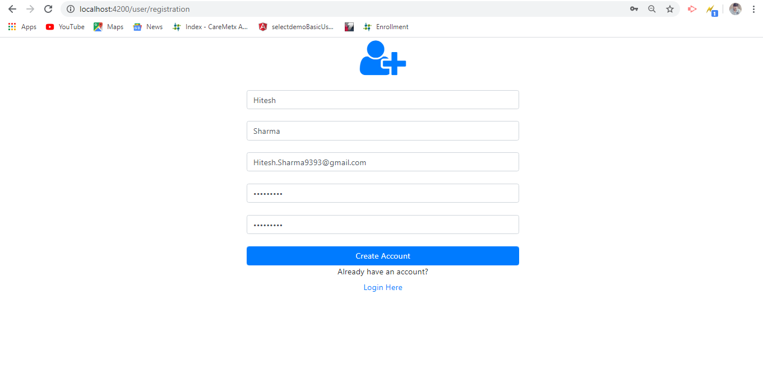

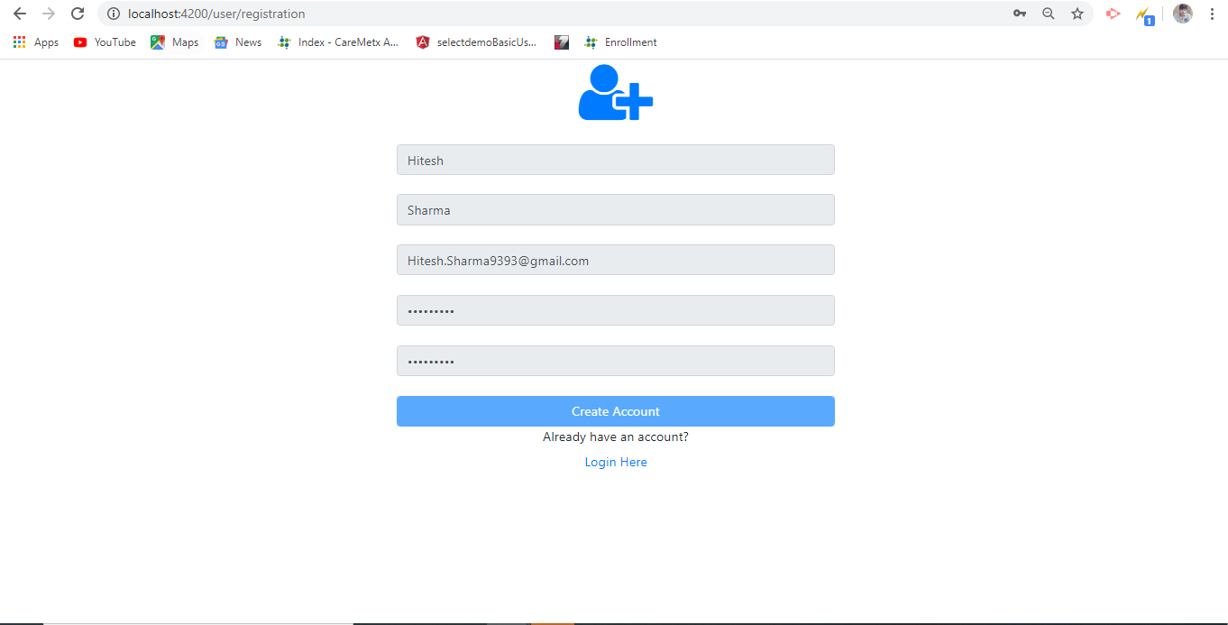

* 1. *User is created successfully. Account verification link has been sent to the user’s email address.*

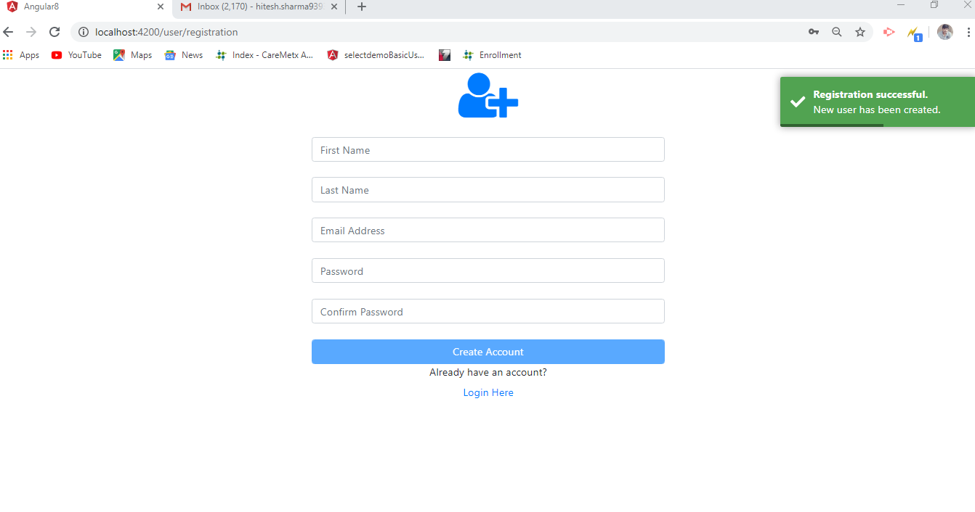

* 1. *Observe the created user in database.*
     1. *Manually enter two roles Admin and Customer in AspNetRoles table, then create the user from UI*

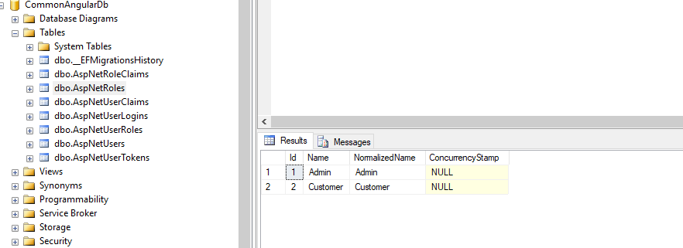

* + 1. *AspNetUsers Table*

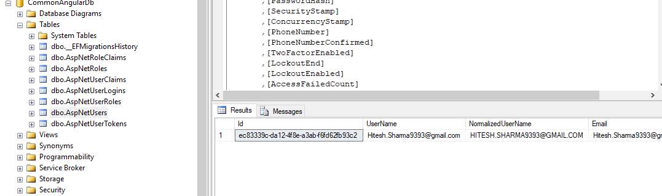

* + 1. *AspNetUserRoles Table*

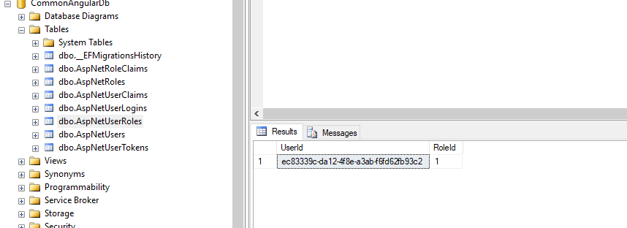

* 1. *Activate the created account for the login.*

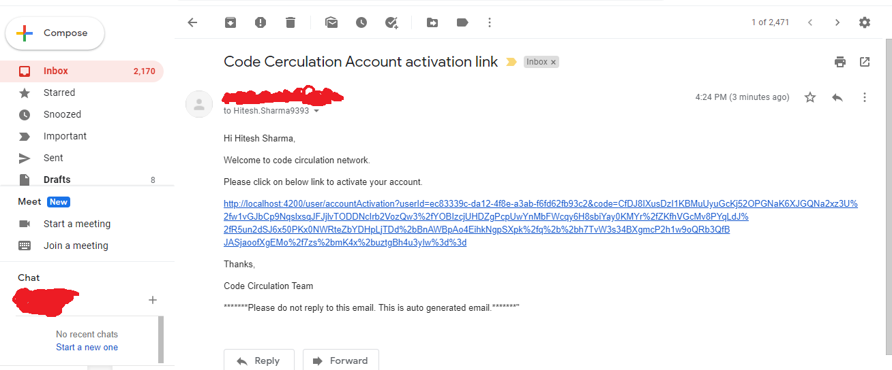

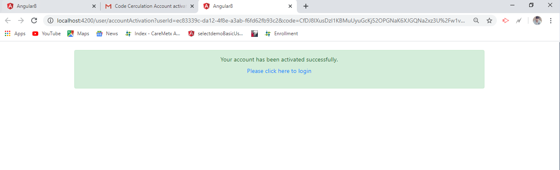

* 1. *Server-side validation (example: user already available)*

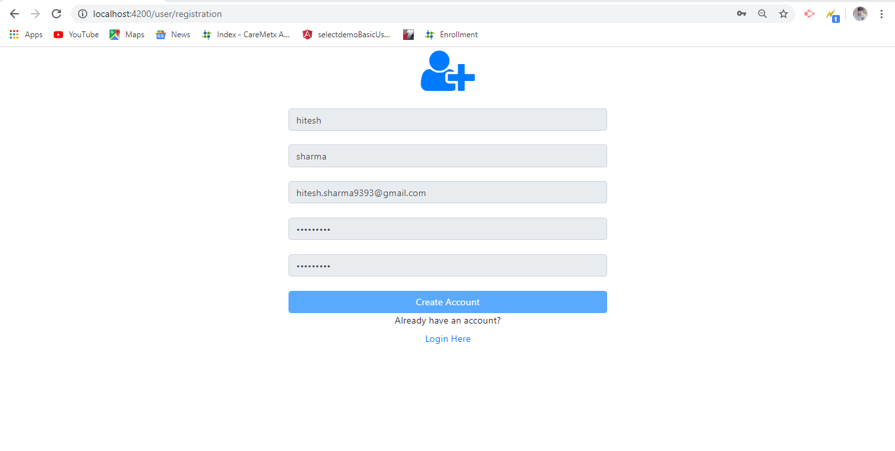

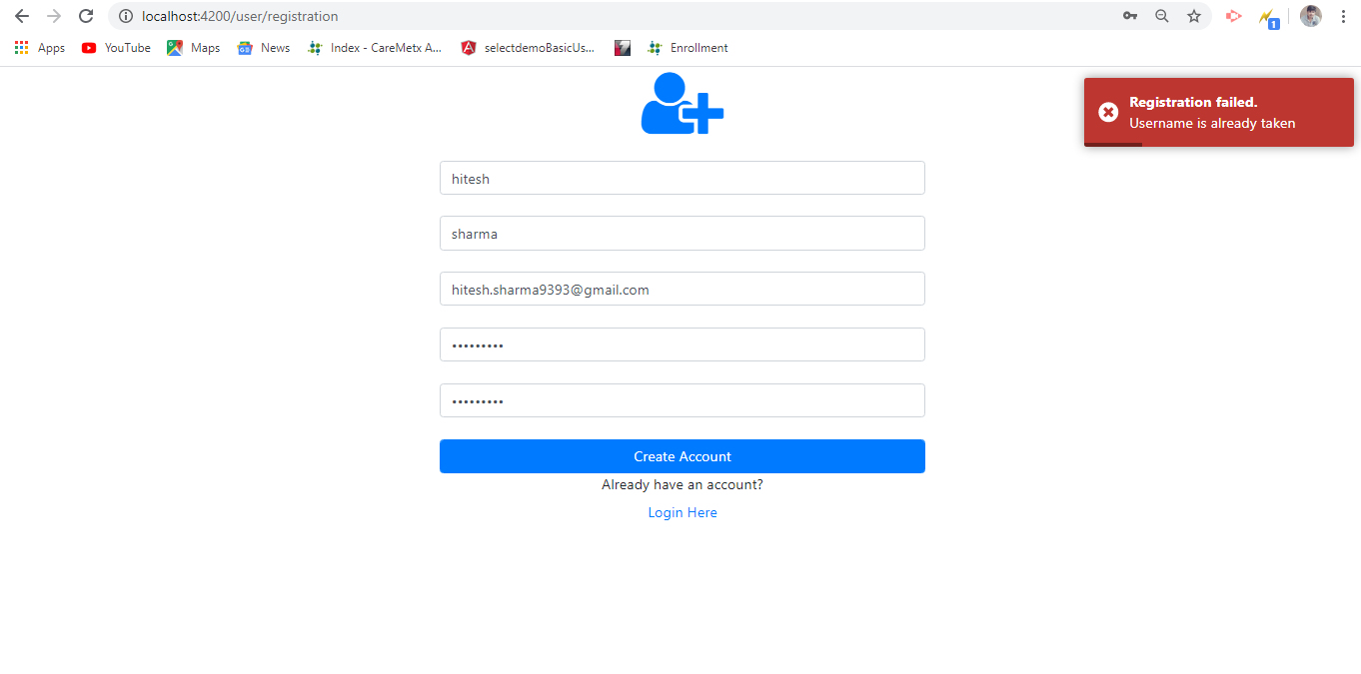

1. *Create User Role: Customer [Update the role from admin to customer in the database after successful registration, because now we don’t have dropdown for role selection, so default role type is admin when user is created from UI]*
   1. *Create user.*

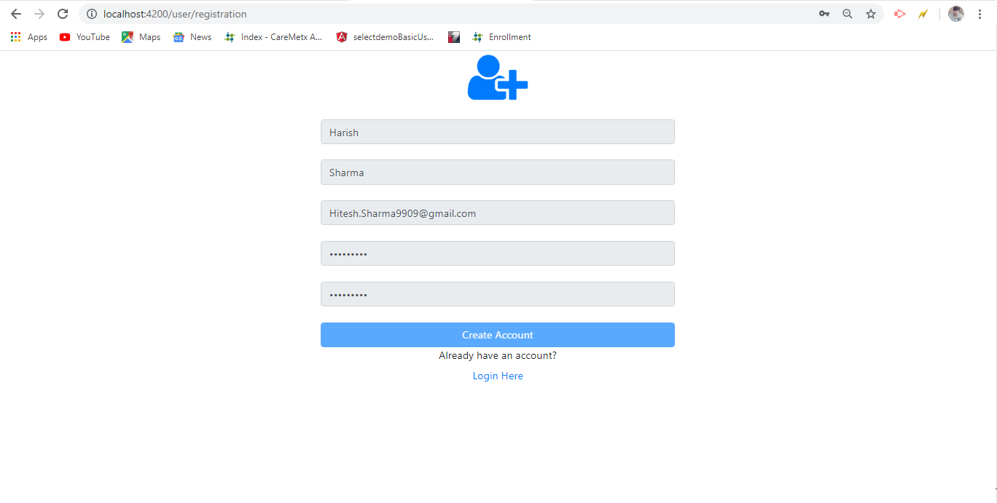

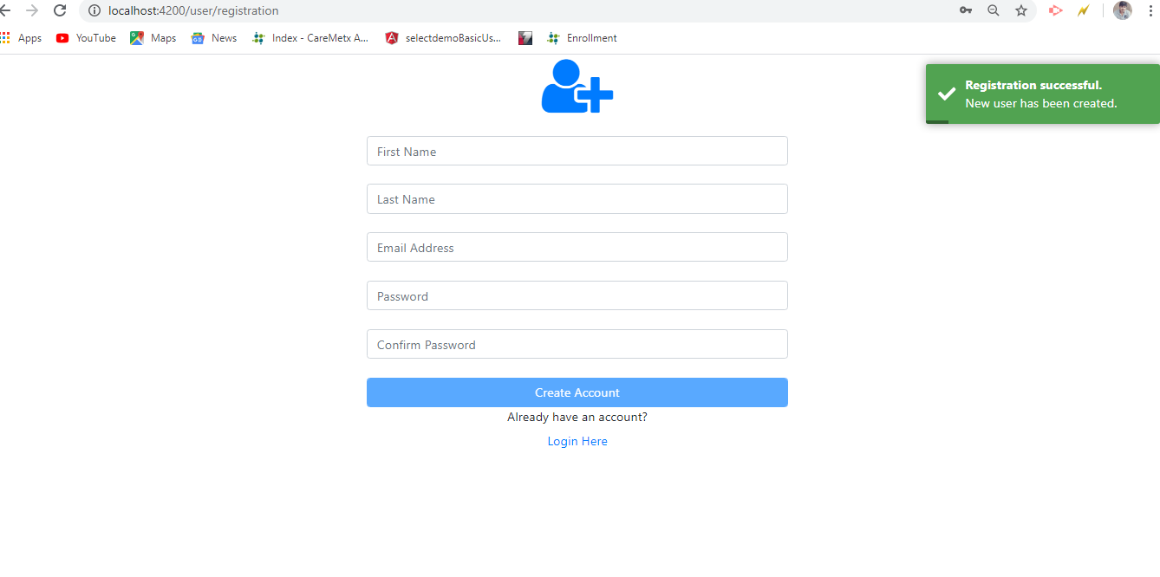

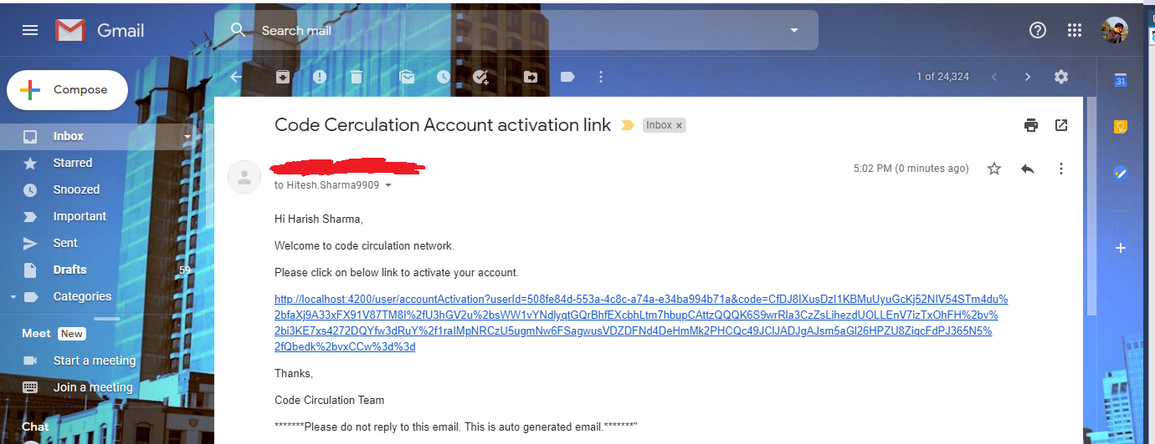

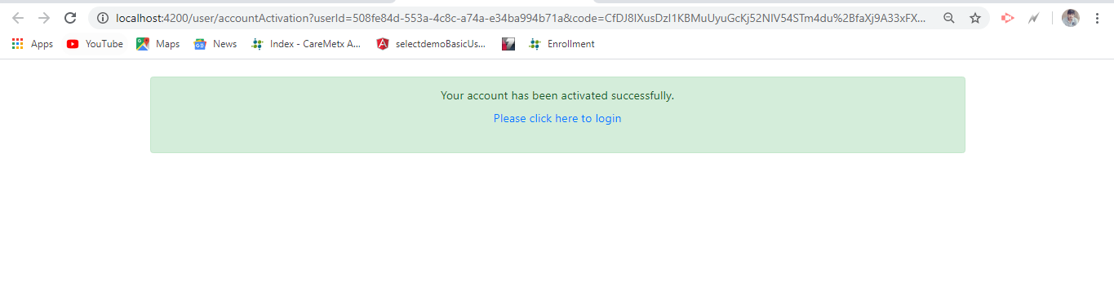

**Login**

1. *Role: Admin*
   1. *Observe the login validation.*

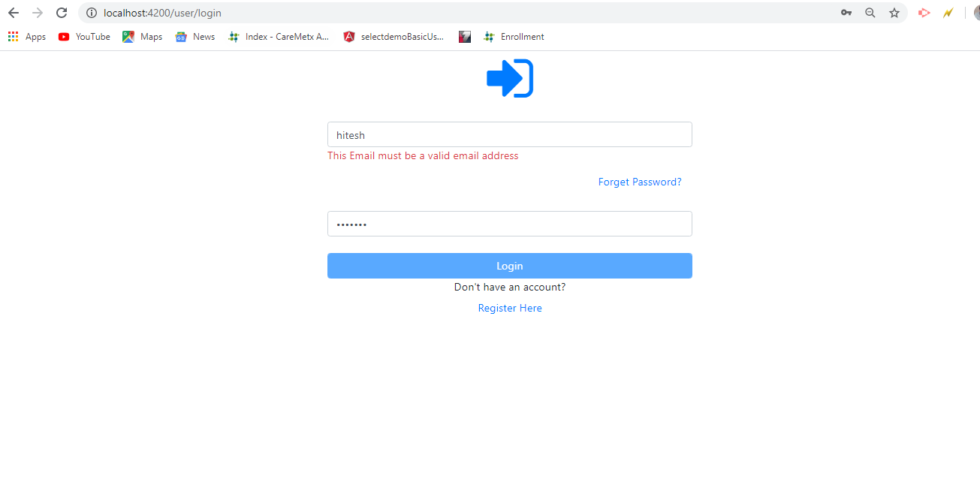

* 1. *Successful login.*

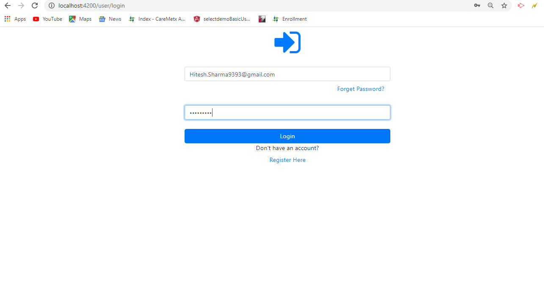

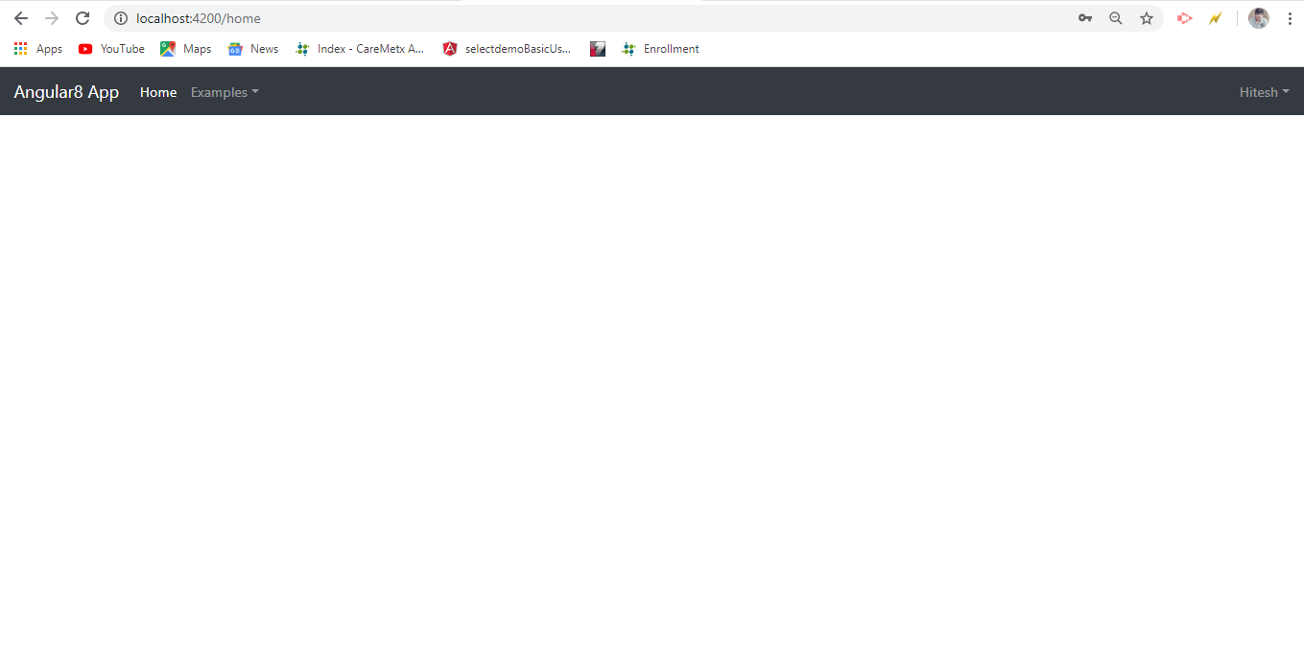

* 1. *My Profile Page.*
     1. *Update the profile information.*

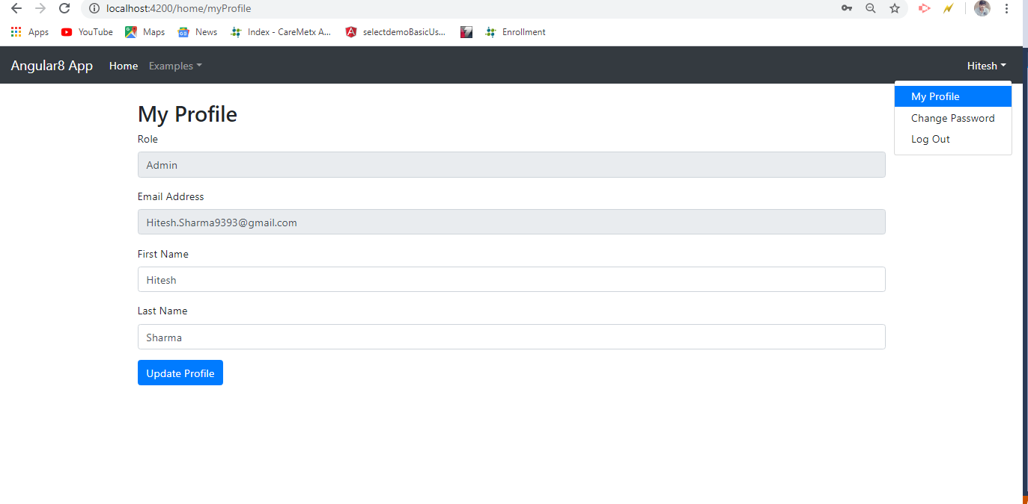

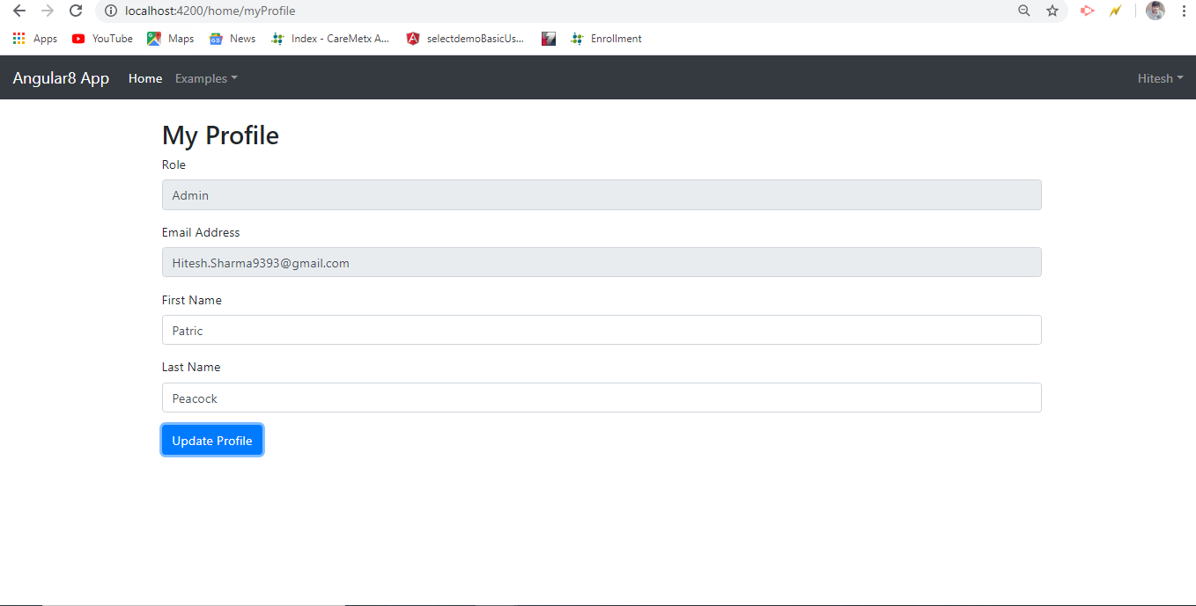

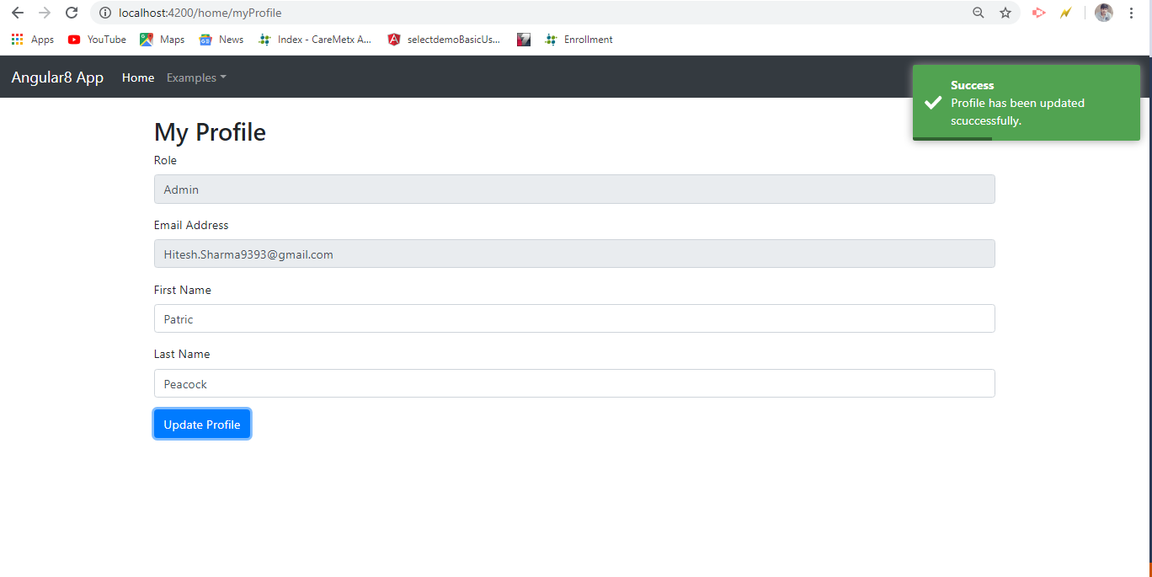

* 1. *Change Password*

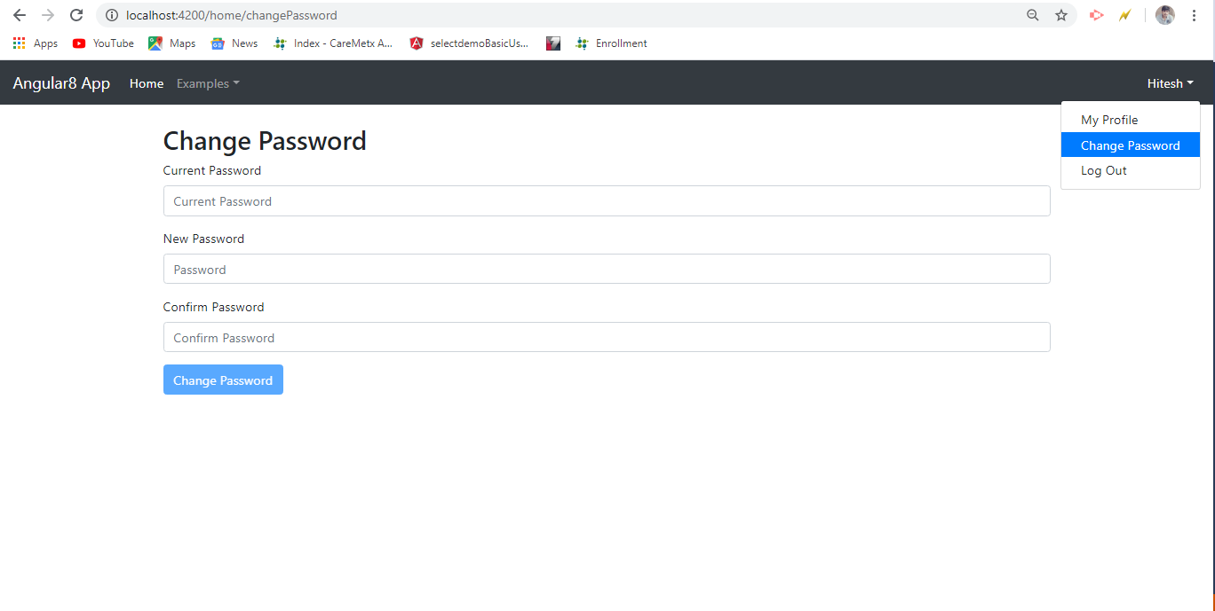

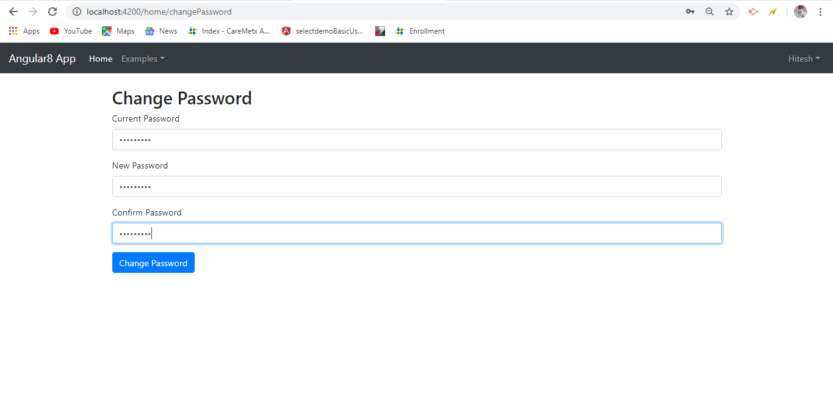

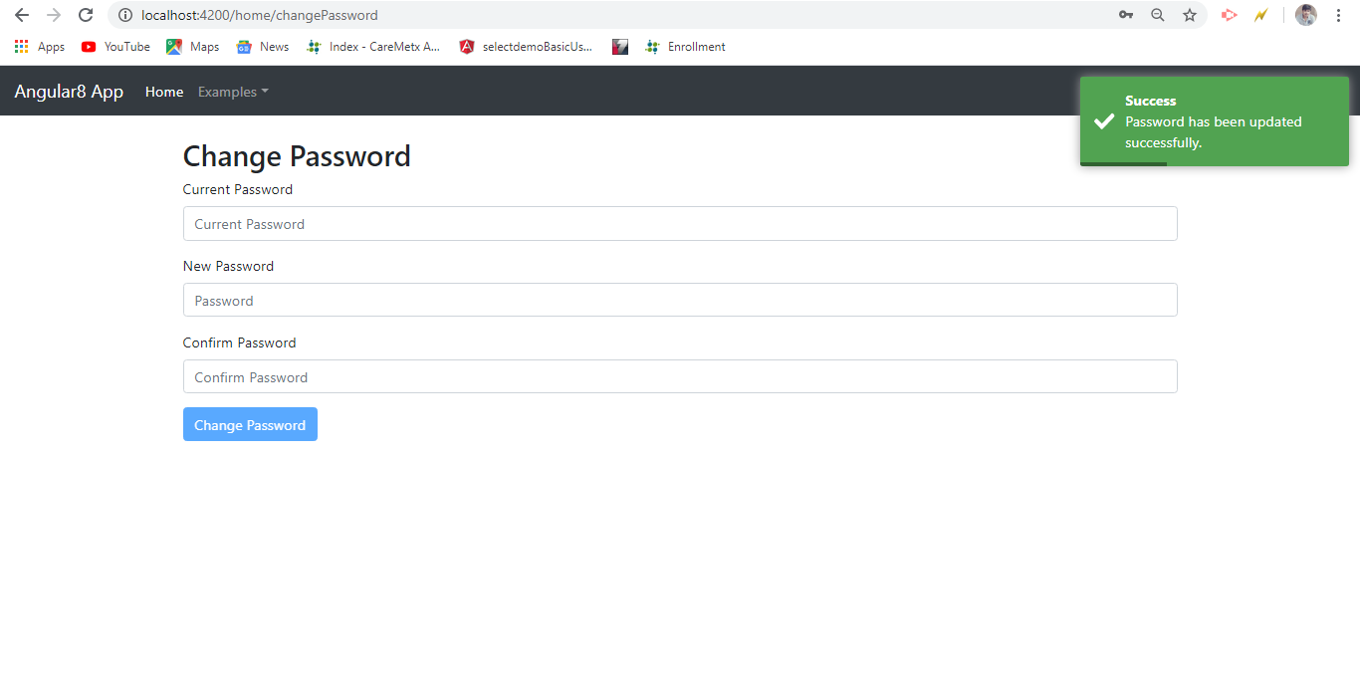

* 1. *Observe the validations.*

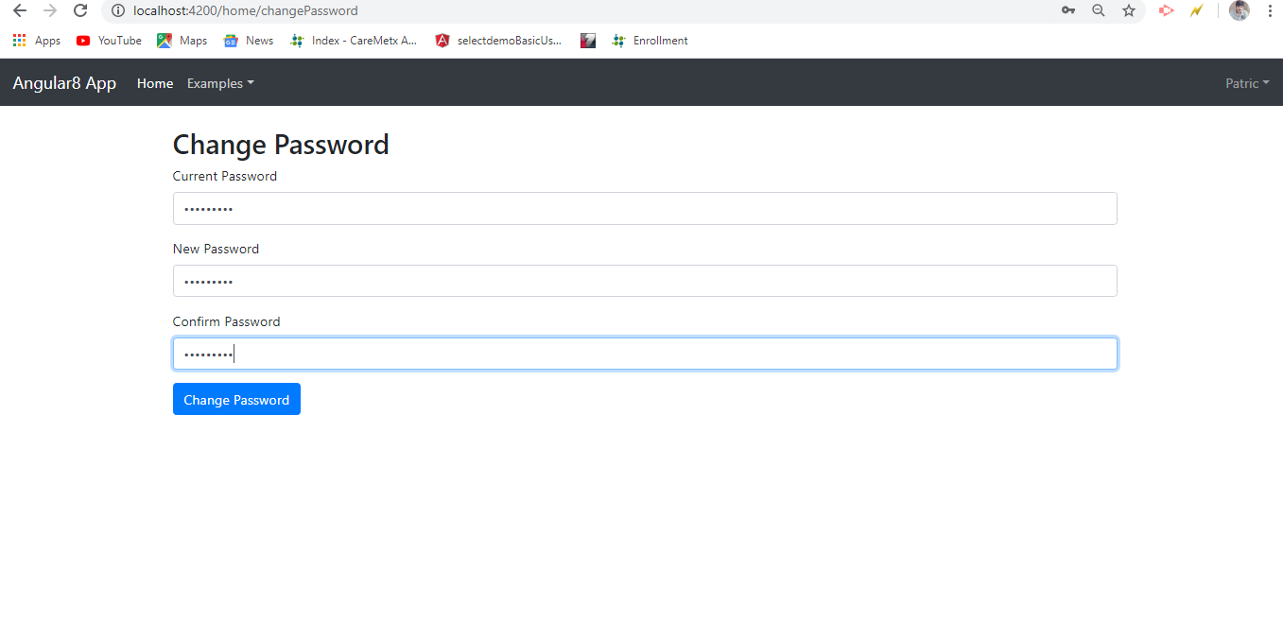

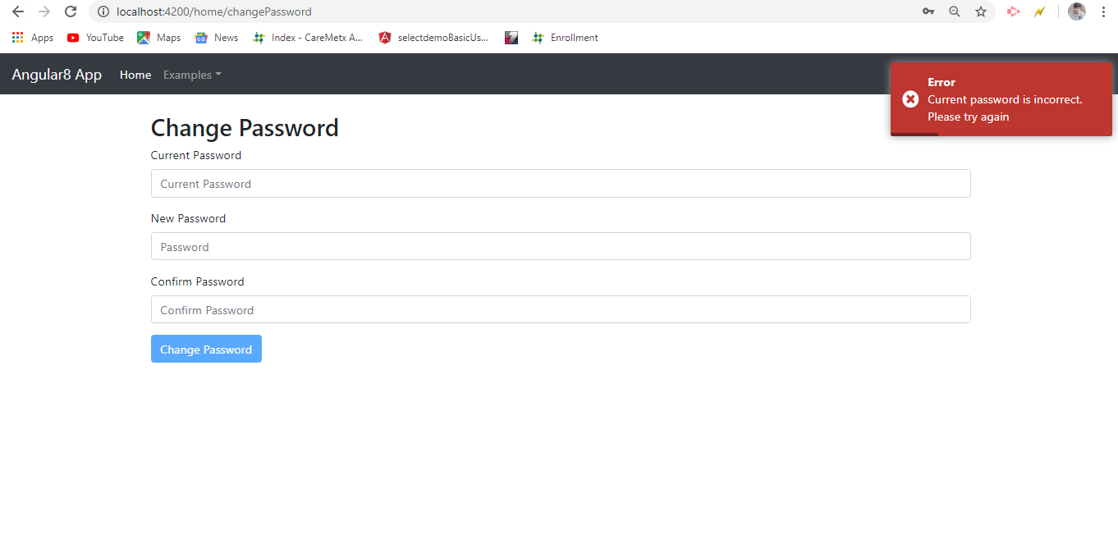

* 1. *Role based access*
     1. *Admin can access only Program1 Page. He cannot access the Program2 Page.*

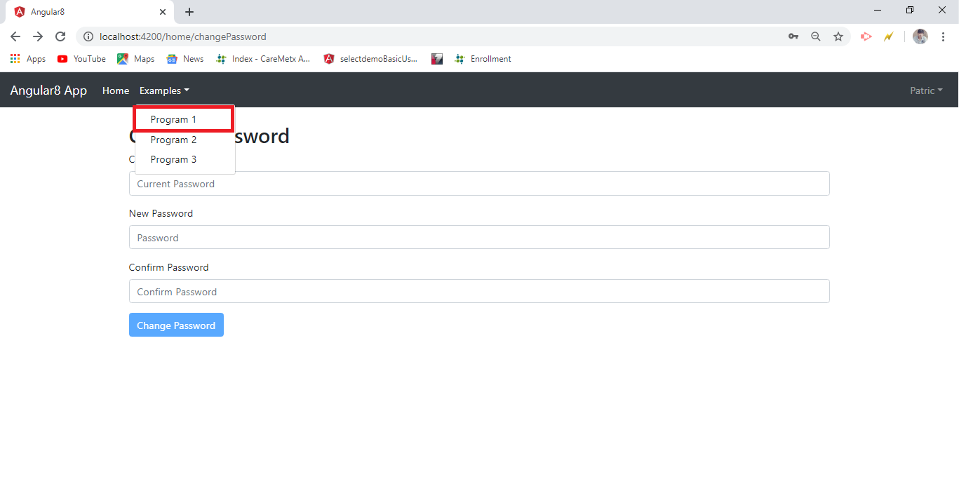

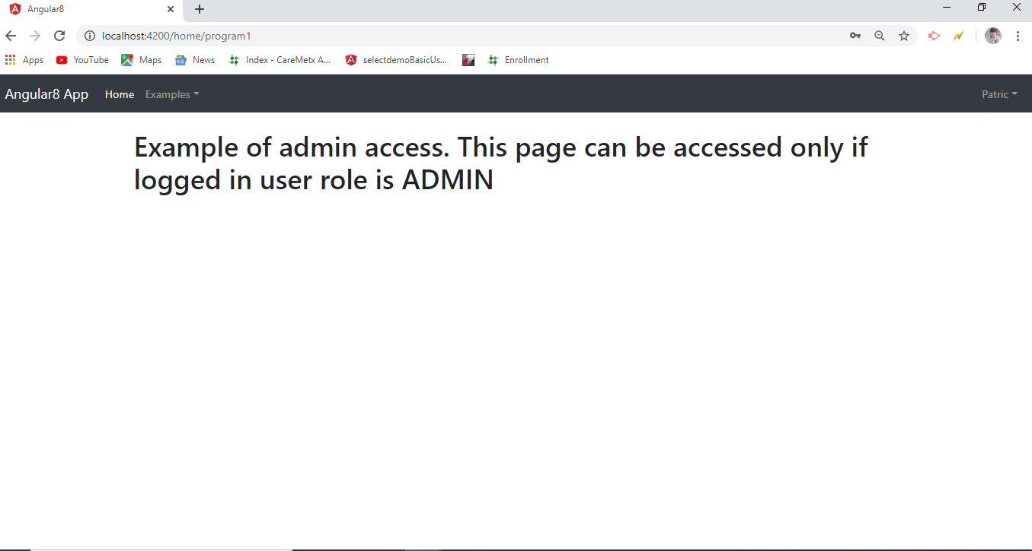

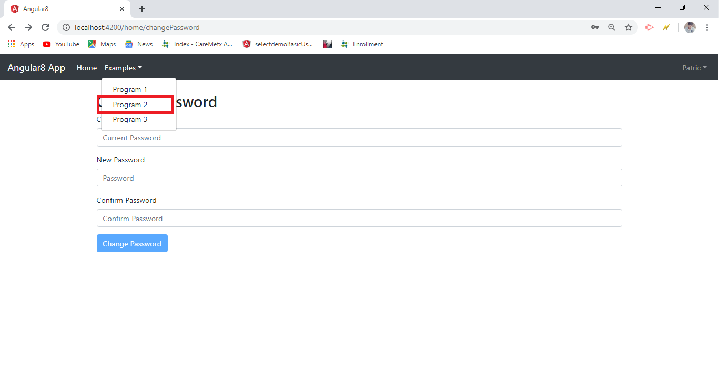

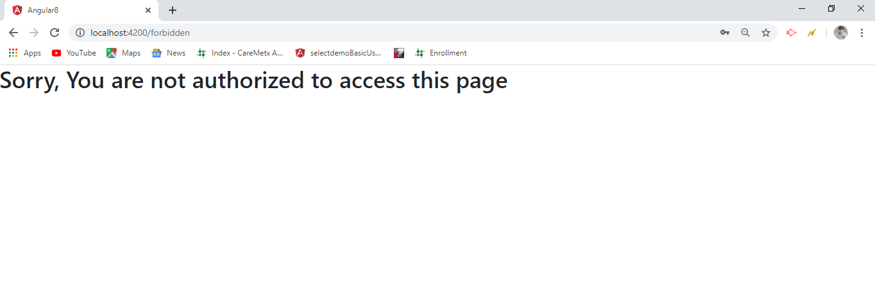

1. *Role: Customer*
   1. *Login as a customer.*

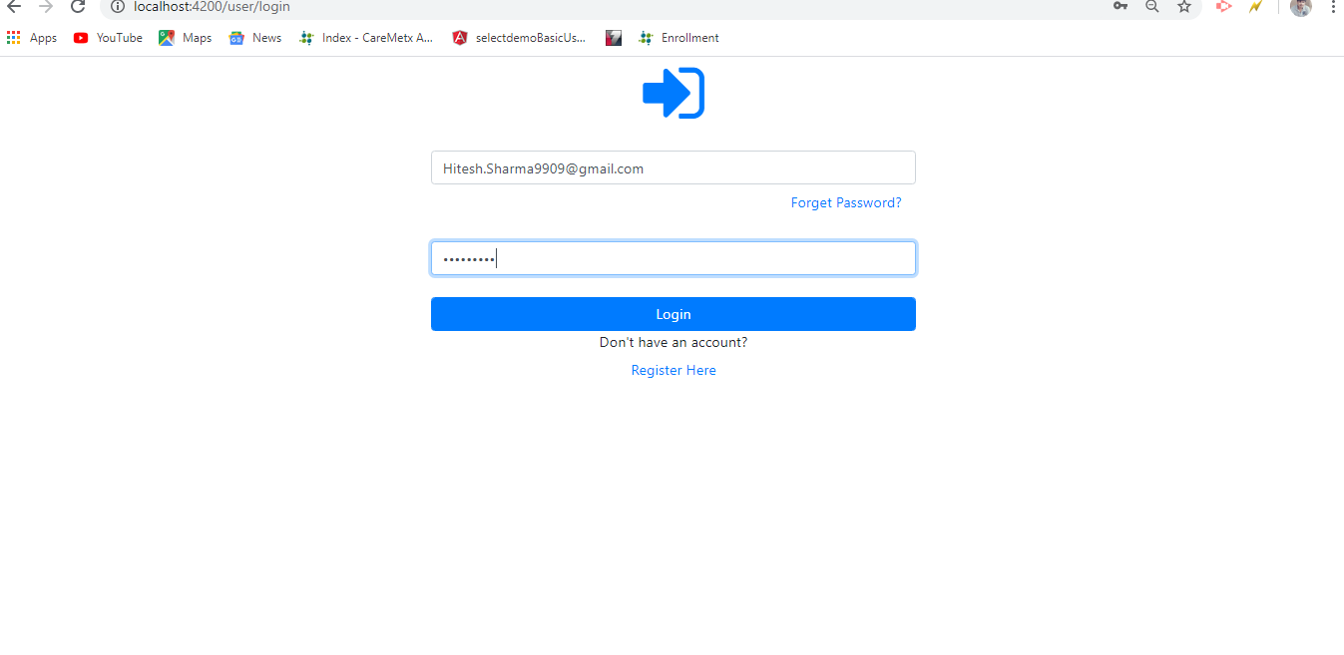

* 1. *My Profile*

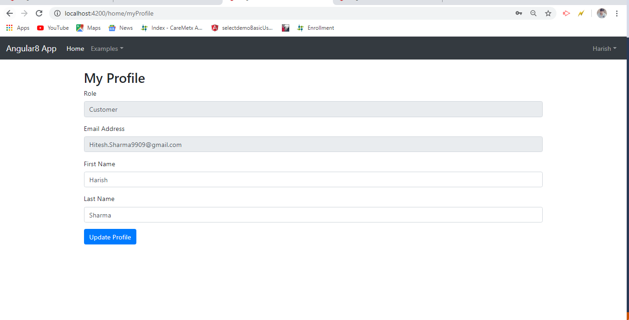

* 1. *Role based access*
     1. *Customer can access only Program2 Page. He cannot access the Program1 Page.*



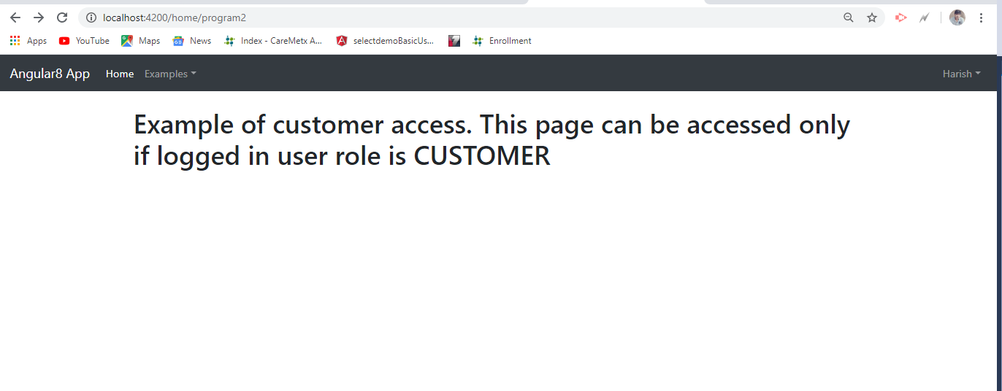



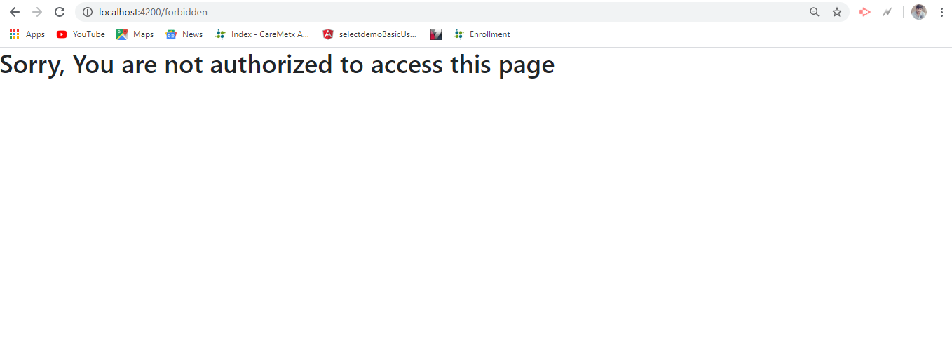

**Forgot Password**

1. *Open forgot password page. Enter the email address to get the password reset link.*

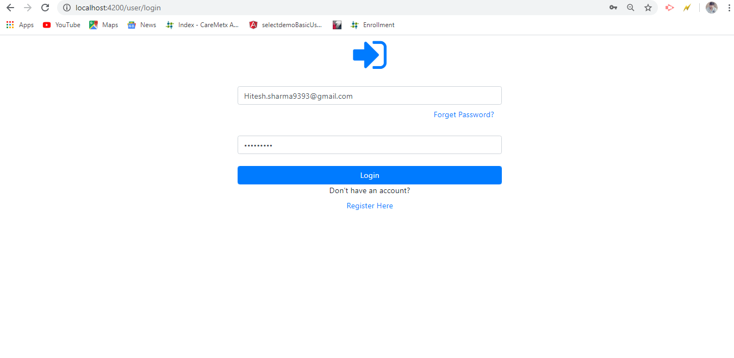

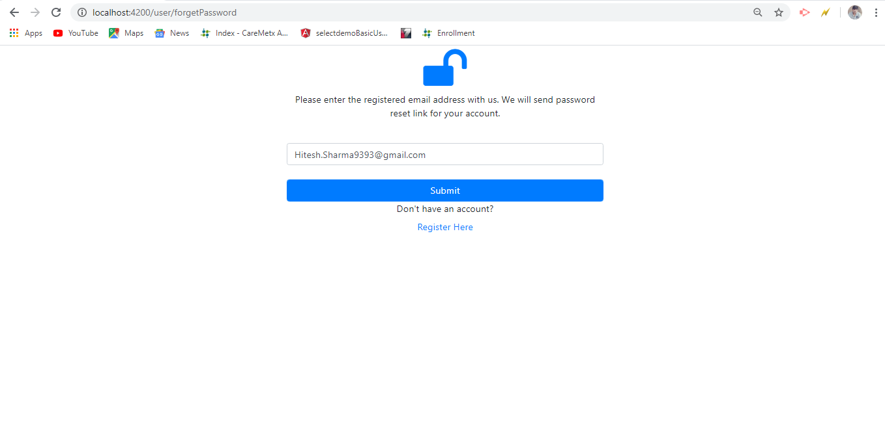

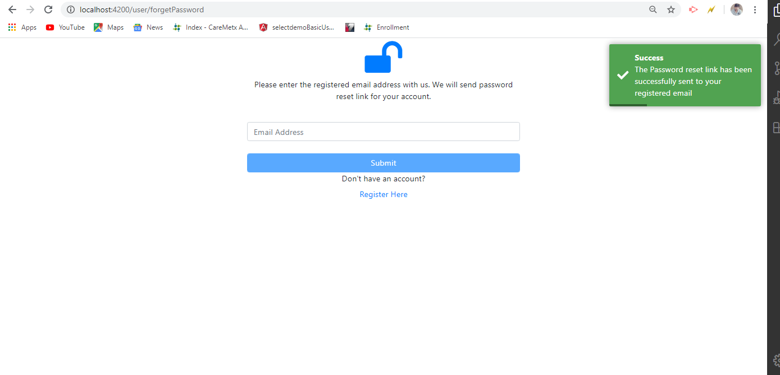

1. *Open the associated email to access the password reset email for account.*



