When Medical Bills Cost You Your Home
The connection between healthcare debt, housing insecurity, and homelessness
  - By Willis Butts
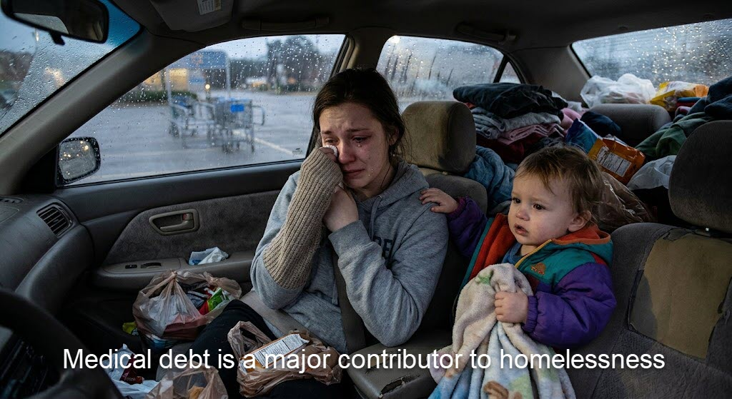
Illustrative photograph supplied for this article. The circumstances of the people pictured have not been verified.

A medical emergency should not become a housing emergency
Imagine a family living paycheck to paycheck. Their rent is current, their children are cared for, and the household is getting by. Then a parent develops a serious illness or is injured. Medical appointments begin. A hospital bill arrives. The parent misses work. Even with insurance, deductibles, copayments, uncovered services, and other costs can pile up. Suddenly, the money that paid for housing is going toward surviving a health crisis.
A missed rent payment becomes two. Late fees accumulate. A landlord may begin eviction proceedings. A homeowner may fall behind on the mortgage. The family did not stop needing a home; it ran out of financial room to keep one.

How medical bills can lead to the loss of a home
Medical bills can threaten housing through several overlapping pathways. The first is direct: money used for treatment or debt payments is money no longer available for rent, mortgage payments, utilities, or food. The second is lost earnings: illness, disability, recovery, or caregiving can reduce working hours or eliminate a paycheck. The third is the aftershock of debt: depleted savings, damaged credit, collections, and expensive borrowing can make it harder to catch up or qualify for another apartment.
These pressures can reinforce each other. A person who loses stable housing may find it harder to rest, store medication, attend appointments, keep a job, or recover from illness. Health problems can destabilize housing, and housing instability can make health problems worse.

Insurance does not always prevent the crisis
Having an insurance card is not the same as being protected from financial hardship. A household can be insured and still face high deductibles, coinsurance, out-of-network charges, or services that are not covered. Even when medical coverage is adequate, the loss of wages during treatment can be devastating. That distinction matters: healthcare reform can remove a major source of financial pressure, but housing stability also depends on income, affordable rents, disability support, and other protections.

What the evidence does—and does not—tell us
Research has documented substantial medical debt in the United States and links between health shocks, financial distress, and housing instability. Yet it would be misleading to claim that a single percentage of homelessness is caused by medical bills, or that medical debt is always the primary cause. Homelessness has multiple interacting causes, including housing costs, low incomes, unemployment, disability, family crises, and shortages of affordable housing.
The important point does not require exaggeration: for a household already near the financial edge, a medical crisis can be the event that pushes it over.

What Medicare for All could change
A well-designed Medicare for All system could remove premiums, deductibles, and copayments for covered medically necessary care, greatly reducing the risk that the price of treatment consumes a family’s housing budget. Broad coverage could also reduce delays in seeking care because of cost. The precise financial effects would depend on the legislation, benefits, financing, and implementation.
Medicare for All would not, by itself, replace lost wages, lower rent, or create affordable housing. To protect families fully, healthcare reform should work alongside paid medical leave, disability income protections, eviction prevention, and affordable housing policies. A systems approach recognizes that healthcare, employment, debt, and housing are connected.

A better measure of national success
We should ask more of a prosperous nation than whether a sick person can receive a bill. We should ask whether people can get the care they need without risking the roof over their heads. No parent should have to choose between a prescription and the rent. No family should have to trade a stable home for a hospital stay.
If we want to reduce homelessness, we must address the pressures that push people into it. Preventing medical bills from becoming a housing catastrophe is one practical place to start.

The bottom line
Medical debt is not the only cause of homelessness. But it can be one link in a devastating chain: illness, bills, lost income, missed housing payments, and displacement. Breaking that chain is both a healthcare goal and a housing-stability goal. We can build a system that treats people when they are sick without putting their homes at risk.

Further reading
KFF, “The Burden of Medical Debt in the United States” (2024): https://www.kff.org/health-costs/issue-brief/the-burden-of-medical-debt-in-the-united-states/
Consumer Financial Protection Bureau, reports and resources on medical debt: https://www.consumerfinance.gov/consumer-tools/credit-reports-and-scores/answers/key-terms/medical-debt/
U.S. Department of Housing and Urban Development, Annual Homeless Assessment Report: https://www.huduser.gov/portal/datasets/ahar.html

