Healthcare Is a Right, Not a Privilege
  - No One Should Be Financially Punished for Getting Sick
By Willis Butts | Terra Nova Development, Inc.
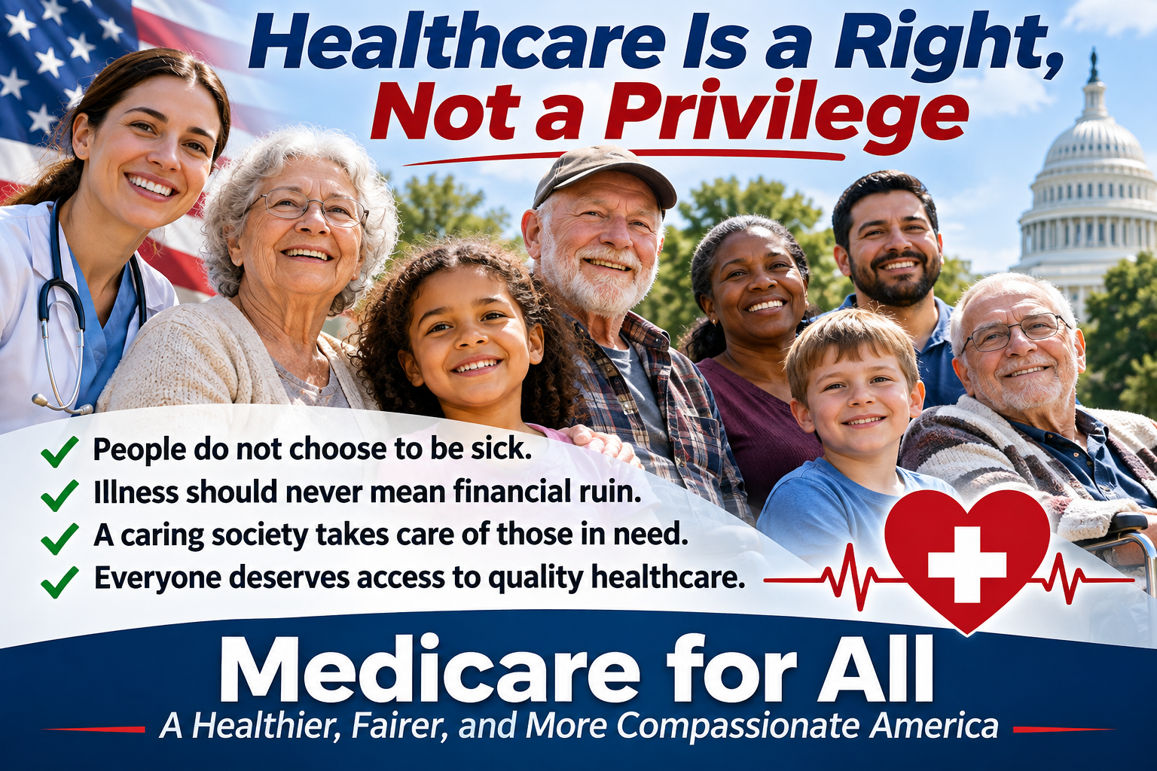
There is a fundamental question that every civilized society must answer:
When someone becomes sick, is it our responsibility to help them, or should we leave them to face the consequences alone?
I believe the answer says a great deal about who we are as a people.
Healthcare must be recognized as a fundamental human right, not a privilege reserved for those who can afford it.
People do not choose to become sick. They do not wake up one morning and decide to develop cancer, suffer a heart attack, contract pneumonia, or experience a debilitating illness. Disease and injury are part of the human condition. They can strike anyone, at any time, regardless of wealth, employment, education, or social standing.
And when illness strikes, the last thing a person needs is financial punishment.

Illness Is Not a Moral Failure
Somewhere along the way, America developed a healthcare financing system that often treats illness as though it were a personal financial responsibility rather than a shared human challenge.
A person can work hard, pay taxes, raise a family, contribute to the community, and do everything society asks of them. Then one serious illness can wipe out their savings, destroy their credit, force them into bankruptcy, or threaten the home they spent a lifetime paying for.
What did that person do wrong?
Nothing.
They got sick.
Getting sick should never be a financial crime for which the punishment is poverty.
We should not force people to choose between buying groceries and purchasing medication, between paying rent and visiting a doctor, or between receiving lifesaving treatment and protecting their family’s financial future.
These are choices that no one should have to make.

The True Meaning of Society
Human beings did not build civilization by abandoning one another.
We built communities because we discovered that cooperation makes us stronger. We created fire departments because no family should have to fight a house fire alone. We established public schools because educating children benefits everyone. We built roads, sanitation systems, and public infrastructure because certain necessities are better provided through collective effort.
Healthcare belongs in that same category.
When someone is sick, injured, disabled, elderly, or otherwise vulnerable, that is precisely when society should be there to help.
The measure of a society is not simply how much wealth it produces. It is also how it treats those who need help the most.
A wealthy nation that allows people to suffer unnecessarily because they cannot afford medical treatment has confused financial success with human progress.
Our greatest achievement should not be how many billionaires we create, but how few people we leave behind.

Healthcare Is Not an Ordinary Consumer Product
There is another fundamental problem with treating healthcare like an ordinary marketplace.
When you buy a car, you can compare prices, negotiate with dealers, or decide to wait another year.
When you suffer a heart attack, you cannot shop around for the best bargain.
When your child is seriously ill, you cannot simply decide that treatment is too expensive this month.
When a doctor tells you that you need surgery to survive, your decision is not an ordinary consumer choice.
Healthcare is different because the need for it is frequently involuntary, urgent, and essential to life itself.
That does not mean healthcare has no cost. Doctors, nurses, hospitals, medicines, equipment, and research all require resources.
But it does mean that the financial burden of illness should not fall disproportionately on the person unfortunate enough to become sick.
The cost of healthcare should be shared across society through a fair and sustainable financing system, just as we share the costs of other essential public services.

We Already Have the Resources
America is one of the wealthiest nations in human history.
We have extraordinary medical professionals, advanced hospitals, sophisticated technology, pharmaceutical research, and tremendous productive capacity.
Our problem is not that we lack the resources to care for everyone.
Our problem is how we organize, finance, and distribute those resources.
As a retired systems engineer, I see this as a systems-design problem.
We have constructed an enormously complicated healthcare financing structure involving private insurers, government programs, employer-sponsored plans, billing departments, claims processors, networks, deductibles, copayments, and countless administrative requirements.
We spend tremendous resources managing who pays for healthcare instead of concentrating those resources on delivering healthcare.
Medicare for All offers an opportunity to redesign that system.
Under a properly designed universal healthcare program, everyone would be covered. Medical decisions would be based on medical necessity rather than a patient’s ability to pay. Patients would no longer face premiums, deductibles, or copayments at the point of care.
The system would still need responsible budgeting, adequate provider compensation, effective management, and sustainable public financing. But those are engineering and policy challenges we can solve.
The objective should be straightforward: When someone needs medical care, they receive medical care. Period.

Financial Security Is Part of Healthcare
We often talk about healthcare as though it ends when the patient leaves the hospital.
But what happens afterward?
Imagine someone recovering from major surgery while worrying about a $100,000 medical bill.
Imagine a cancer patient struggling to recover while collection agencies call.
Imagine parents watching their child get better while knowing that the treatment has destroyed their family’s financial security.
Financial stress can undermine recovery, damage families, and create additional health problems.
A humane healthcare system should not save someone’s life and then financially devastate them for having needed that care.
That is why I believe Medicare for All should also be accompanied by a national medical debt relief program.
We should find responsible ways to remove existing medical debt burdens from patients while fairly addressing legitimate obligations owed to healthcare providers and creditors.
Healthcare reform should offer people not only physical recovery but also the opportunity for financial recovery.

Taking Care of One Another Is Not Charity
There is an important distinction between charity and a right.
Charity depends on whether someone chooses to help.
A right establishes that every person deserves certain fundamental protections simply because they are human.
When we recognize healthcare as a right, we are saying that a person’s life and well-being matter regardless of their bank account.
We are saying that the unemployed person deserves medical treatment just as much as the corporate executive.
We are saying that the elderly woman living on Social Security deserves the same dignity as the wealthy retiree.
We are saying that a child born into poverty deserves the same opportunity to grow up healthy as a child born into wealth.
We are saying that people who are sick deserve compassion, not financial penalties.
And we are recognizing something even more fundamental: Every one of us will need help at some point in our lives.
Today, you may be healthy and financially secure. Tomorrow, you may be the person lying in a hospital bed, hoping that someone will help you.
The healthcare system we build for others is the healthcare system we build for ourselves.

A Shared Responsibility, a Stronger Nation
Some people argue that healthcare is an individual responsibility and that government should have only a limited role in providing it.
Questions about taxation, personal freedom, government efficiency, and the sustainability of public programs deserve serious consideration.
But recognizing healthcare as a right does not eliminate personal responsibility. Nor does it mean that healthcare resources are unlimited.
It means that we accept a shared responsibility to ensure that nobody is denied necessary medical care simply because they cannot afford it.
We can still encourage healthy lifestyles, responsible use of medical resources, innovation, competition in medical technology, and efficient healthcare delivery.
We can still demand accountability, transparency, and sound financial management.
What we should not accept is a system in which illness becomes a pathway to financial ruin.
A healthier population benefits everyone. Healthy children learn better. Healthy workers are more productive. Families free from crushing medical debt have greater opportunities to participate in the economy.
Universal healthcare is not merely an expense. It is an investment in the well-being and productive capacity of our entire nation.

There Is No Them. There Is Only Us.
I believe we need to change the way we think about healthcare.
Instead of asking, “Why should I pay for someone else’s medical care?” we should ask, “What kind of society do we want to live in?”
Do we want a society where the fortunate are protected and the unfortunate are left to struggle?
Or do we want a society where everyone contributes according to their ability and everyone receives help when they need it?
We are not separate groups competing for the right to survive.
We are neighbors, families, friends, coworkers, and fellow human beings.
The healthy and the sick are not two different classes of people. They are often the same people at different moments in their lives.
There is no them. There is only us.
And when one of us becomes sick, the rest of us should be there to help.
That is not weakness. That is not dependency. That is civilization.

The America We Can Build
I envision an America where nobody hesitates to call an ambulance because of the cost.
An America where parents never have to wonder whether they can afford to take their child to the doctor.
An America where cancer patients concentrate on getting well instead of worrying about bankruptcy.
An America where businesses are free to focus on creating products, providing services, and employing people rather than administering complicated health insurance plans.
An America where doctors and nurses can devote more of their time to caring for patients instead of navigating insurance paperwork.
And an America where growing old does not mean growing afraid of medical bills.
This is not an impossible dream.
It is a goal worthy of a nation with our resources, our capabilities, and our professed commitment to human dignity.
We have the knowledge. We have the technology. We have the resources.
What we need is the collective determination to build a healthcare system that reflects our highest values.
Healthcare is a right, not a privilege.
Sickness is not a choice, and financial punishment should never be the consequence.
When people are under the weather, society should be their shelter, not another storm they must survive.
That is the America I believe we can build.
And that is why I support Medicare for All.
Willis Butts | Retired Systems Engineer | Terra Nova Development, Inc.
https://terranovadevelopment.github.io/MedicareForAll/

