U.S. vs. Canada: A Healthcare Reality Check
Article 12 · Medicare for All and international comparisons
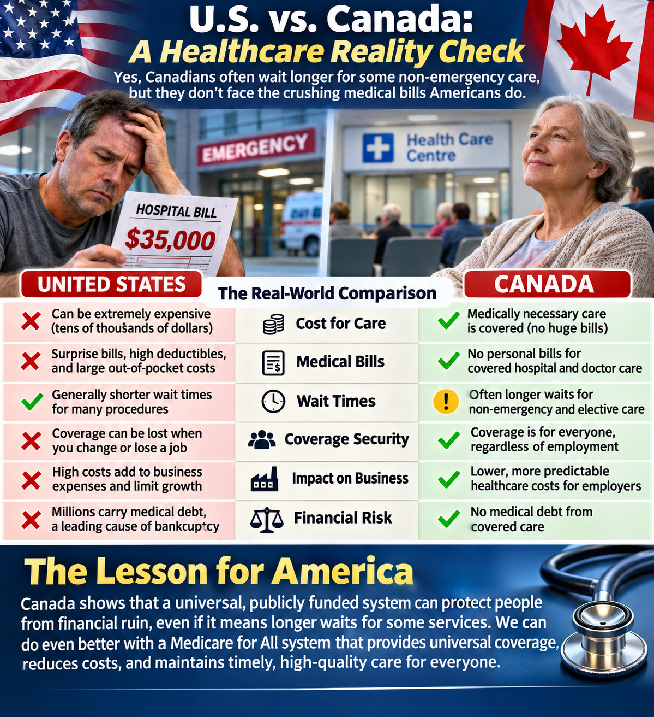
Illustration: contrasting financial risk and access concerns. Dollar figure is illustrative, not a representative bill.

The comparison needs two questions
How quickly can people obtain needed care? And what financial risk do they face when they receive it? Comparing only wait times, or only hospital bills, leaves out half the story.

What Canadians receive
Canada’s provincial and territorial public insurance systems generally cover medically necessary hospital and physician services for eligible residents without charges at the point of care. Coverage for prescription drugs outside hospitals, dental care, and other services varies; Canadians may still pay for care that is not covered.

Where Canada struggles
Long waits for some specialist appointments, diagnostic tests, and elective procedures are real concerns in Canada. Emergency departments can also experience prolonged waits. Wait times vary by province, facility, urgency, and type of service. Universal coverage does not automatically guarantee prompt access.

What Americans face
In the United States, people may obtain some specialist or elective services faster, depending on location, insurance, and ability to pay. But premiums, deductibles, network restrictions, and unexpected bills can delay care or cause financial hardship. An illustrative $35,000 hospital bill is not a typical charge for every emergency visit, nor what every insured patient ultimately pays.

What businesses should notice
U.S. employers often help finance private health insurance and administer employee benefits. Canada finances core hospital and physician services largely through public revenues, so coverage is not normally dependent on a particular employer. That can change how businesses budget and how freely workers move between jobs.

A lesson for Medicare for All
A U.S. universal coverage proposal should aim to protect patients from unaffordable bills without ignoring access, staffing, hospital capacity, and timely treatment. Whether it saves money depends on its payment rates, benefits, financing, and implementation. Canada offers useful lessons, not a flawless template.

Sources and further reading
Canadian Institute for Health Information (CIHI), Wait Times for Priority Procedures: https://www.cihi.ca/en/wait-times-for-priority-procedures ; Government of Canada, Canada Health Act: https://www.canada.ca/en/health-canada/services/health-care-system/canada-health-care-system.html ; Commonwealth Fund, International Health Care System Profiles: https://www.commonwealthfund.org/international-health-policy-center/system-profiles ; KFF, Health Costs: https://www.kff.org/health-costs/

