  - ARTICLE 30 | MEDICARE FOR ALL

Every Hospital Visit Should Mean Care—Not Debt
  - Why comprehensive hospital coverage belongs at the heart of universal healthcare
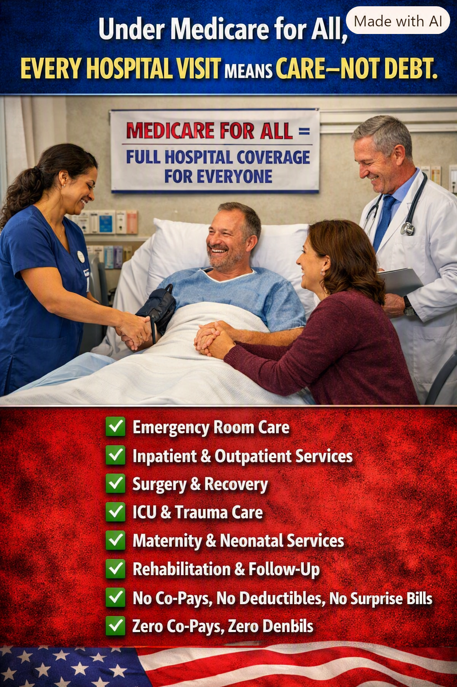
Illustration: the promise of hospital care without patient bills under a comprehensive Medicare for All proposal.

The moment care matters most
When a person arrives at a hospital with chest pain, a stroke, an injury, a difficult pregnancy, or a frightening diagnosis, the immediate question should be: What treatment does this patient need? It should not be: What will this cost the family? Yet in the United States, the financial consequences of hospitalization can continue long after a patient goes home.

Insurance is not the same as financial security
An insured patient may still face deductibles, copayments, coinsurance, network restrictions, and disputes over covered services. A hospital stay can involve multiple charges for physicians, imaging, laboratory work, medications, procedures, and rehabilitation. Even when coverage pays much of the bill, the remaining amount can disrupt a household budget. A policy that covers a hospitalization only after imposing unaffordable costs has not fully solved the problem.

What comprehensive Medicare for All would aim to cover
Under a comprehensive single-payer proposal, medically necessary emergency treatment, inpatient and outpatient hospital services, surgery, intensive care, trauma care, maternity and neonatal care, and appropriate rehabilitation and follow-up could be included as covered benefits. A central design goal is to eliminate separate premiums, deductibles, and copayments for covered care. The exact scope would depend on the law enacted, including definitions of medical necessity and payment arrangements for hospitals and clinicians.

The bill that follows you home
Recovery requires time, stability, medication, follow-up appointments, and sometimes physical or occupational therapy. Medical debt can undermine all of them. Families may postpone filling prescriptions, delay follow-up visits, use savings intended for rent or retirement, or borrow money just when income is interrupted by illness. The health system should support recovery rather than turn it into a second crisis.

A real-world concern, repeated nationwide
My own experience has made this issue personal. After a three-day hospitalization for a minor stroke, I expected thousands of dollars in copayments despite having a Medicare Advantage plan that I regarded as top-of-the-line. The final amount depends on actual claims and plan rules, but the uncertainty itself illustrates the problem. Millions of people face their own versions of this question: will the cost of treatment become a burden after the medical emergency has passed?

Better care requires more than paying the hospital bill
Universal coverage should also make it easier to obtain timely primary care, specialist visits, prescriptions, rehabilitation, and mental health treatment. Preventing avoidable complications can improve health and may reduce some expensive emergency visits and hospital admissions. But broader access can also increase appropriate use of services, so savings should not be assumed without careful analysis.

Hospitals still must be paid
No patient bill does not mean no cost. Doctors, nurses, technicians, facilities, supplies, and medicines all require funding. A Medicare for All system would replace much of today’s fragmented insurance payments and patient cost-sharing with public financing. Whether total national spending falls would depend on payment rates, administrative savings, drug prices, utilization, implementation, and the program’s financing structure.

A standard worthy of America
The test of healthcare reform is not whether an insurance card exists in a wallet. It is whether people can seek necessary treatment without risking financial ruin. When a patient is discharged, the next chapter should be healing—not a series of confusing invoices, collection notices, and impossible choices.

Conclusion: care, not debt
Every hospital visit should mean care—not debt. That is the promise we should demand from a thoughtfully designed universal healthcare system: medically necessary treatment for everyone, dependable financing for providers, and freedom from patient charges that punish people for getting sick. Healthcare should be organized around recovery, dignity, and the common good.
Willis Butts | Medicare for All

