Article 35 | Everyone Deserves to Hear Life Clearly
Hearing care is healthcare—and should be affordable for everyone.
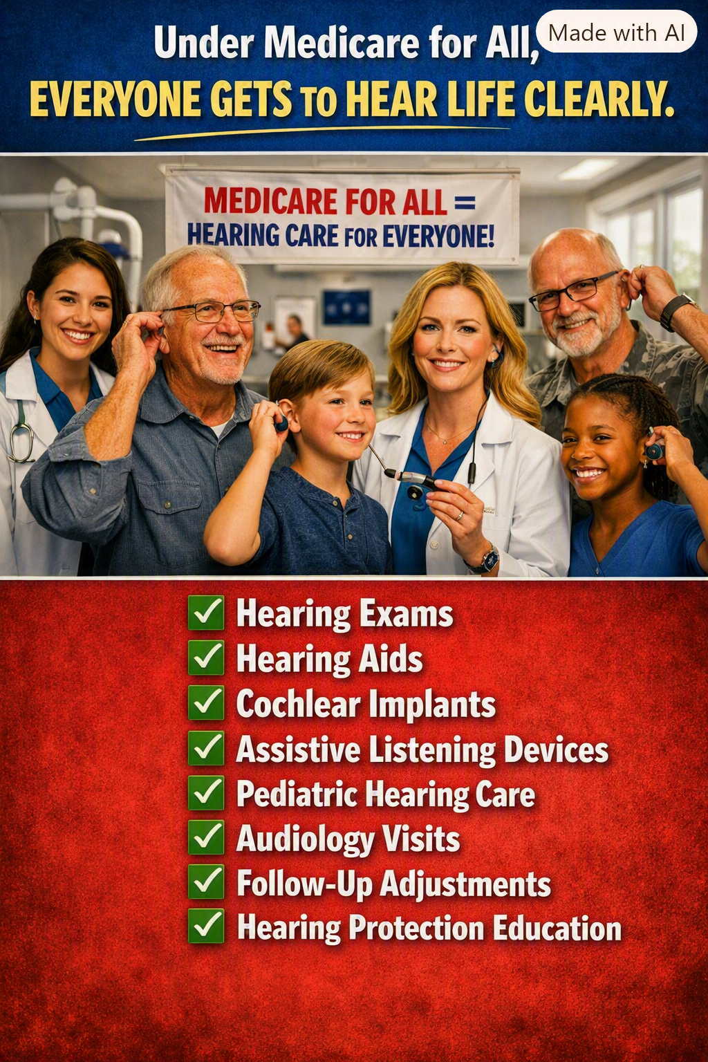
Illustration supplied for Article 35. It depicts the proposed vision of hearing benefits under Medicare for All, not benefits currently guaranteed by law.

Hearing connects us to one another
Imagine sitting at the dinner table and missing half the conversation. Imagine being unable to hear a grandchild’s question, a warning in traffic, or important instructions from a physician. Hearing loss can affect relationships, communication, safety, work, and independence. Yet for many Americans, getting help begins with a financial calculation.
The ability to hear should not depend on the size of a bank account. A comprehensive universal healthcare system should recognize hearing care as essential—not an optional extra left out of coverage.

The gap in the healthcare system we have now
Original Medicare generally does not cover routine hearing aids or the exams for fitting them, although it covers certain diagnostic hearing and balance examinations when medically indicated. Some Medicare Advantage plans offer hearing benefits, but their allowances, networks, and out-of-pocket costs vary. Eligible cochlear implants can be covered under Medicare when coverage criteria are met.
That patchwork leaves many people facing significant expenses for hearing devices, fitting, maintenance, or replacements. Some postpone testing or continue struggling with inadequate equipment. Others must choose between better hearing and other necessities.

What Medicare for All should cover
A well-designed Medicare for All program should include hearing examinations and diagnostic testing; audiology appointments; appropriately prescribed hearing aids; fittings, programming, and follow-up adjustments; repair and replacement when medically necessary; assistive listening technology; pediatric hearing services; and cochlear implants for patients who meet clinical criteria.
Hearing protection education and early screening also matter. The objective should be continuous, clinically appropriate care—from identifying a hearing problem to helping a person function well with the treatment or technology they need.

Prevention, early intervention, and long-term value
Hearing problems can emerge gradually. People may withdraw from conversations before they recognize the change. Early assessment can identify treatable conditions, help children access language and learning support, and connect adults with effective devices and rehabilitation.
Better access could reduce avoidable barriers to participation in school, work, and family life. The potential economic and social benefits are substantial, but savings should be evaluated carefully rather than assumed: devices, specialists, and follow-up services also require public funding.

No one should have to choose between hearing and groceries
The principle is simple: a person should not be asked to accept preventable isolation because hearing treatment is too expensive. If a doctor determines that an examination, hearing aid, implant, or follow-up adjustment is medically appropriate, financing should not be the obstacle that keeps the patient from receiving it.
Under a proposed Medicare for All system, covered hearing services could be provided without premiums, deductibles, or copayments at the point of care. The details—including clinical eligibility, device standards, and which providers participate—would have to be established in law and implemented responsibly.

The America we can choose
Universal healthcare is not only about surviving an emergency. It is about living fully: hearing a loved one’s voice, following a classroom lesson, taking part in a community meeting, and understanding what a doctor says.
Medicare for All should be comprehensive enough to include the ears as well as the rest of the body. Every American deserves a fair chance to hear life clearly.
Policy note: Medicare for All is a proposal, not current federal law. This article advocates a comprehensive benefit design; it does not claim that all hearing devices or services are currently covered or that every proposed bill uses identical rules.
Willis Butts | Medicare for All advocacy series

