MEDICARE FOR ALL | ARTICLE 41

Healthcare Can Unite Us
  - A common American purpose beyond party labels
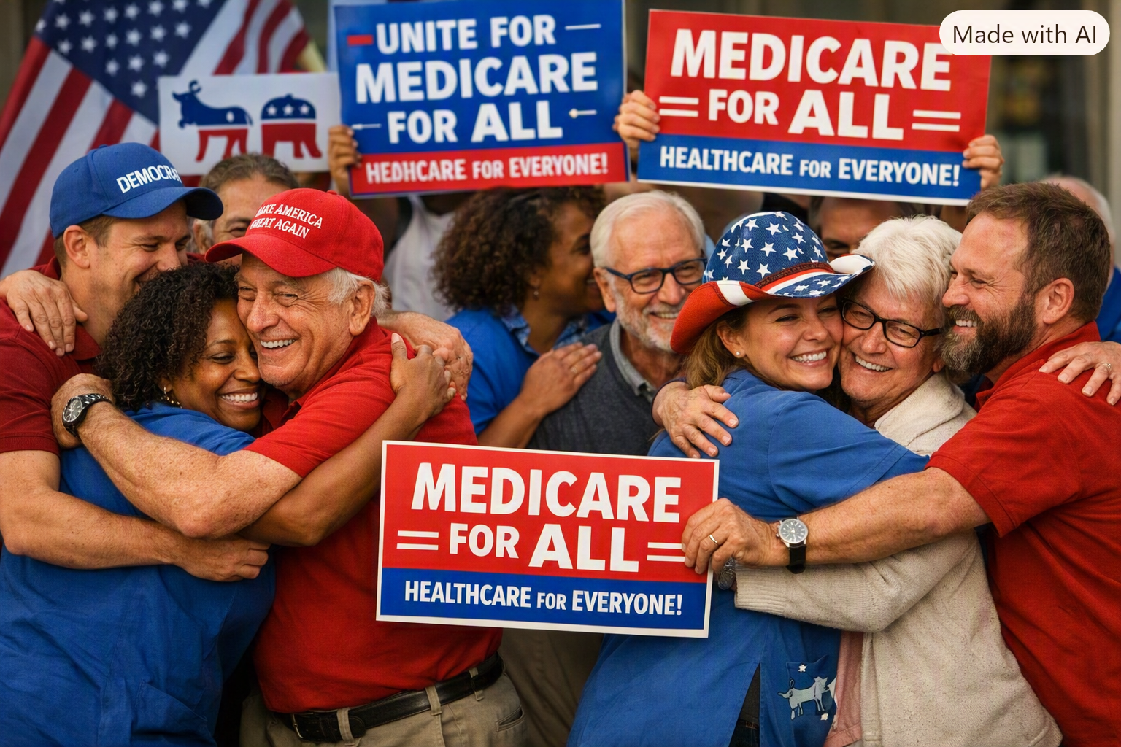
Illustration: Americans across political differences unite around the goal of healthcare for everyone.
We disagree about many things in America. We debate taxes, government, markets, and the proper responsibilities of individuals and institutions. Yet when someone suffers a heart attack, a child needs treatment, or a parent faces cancer, those political labels lose their importance. We are human beings who need care.
Medicare for All offers an opportunity to ask a simple question: Can we build a healthcare financing system that protects everyone, supports medical professionals, and uses our resources more wisely? That is not a question reserved for Democrats or Republicans. It belongs to all of us.

The values we already share
Conservatives value personal responsibility, economic freedom, family stability, and efficient use of public money. Progressives value universal access, fairness, and protection against financial hardship. Independents often want practical solutions that work. A well-designed universal healthcare system can be evaluated against all of these values, rather than dismissed because of a political label.
A person should be free to change jobs, start a business, retire, or care for a family member without losing access to necessary medical treatment. Employers should be able to compete without having to administer complex health benefit plans. Patients and clinicians should be able to focus on health rather than the next insurance dispute.

What Medicare for All would change
Medicare for All proposals generally envision one public financing program covering residents, with comprehensive medically necessary benefits and little or no cost sharing at the point of care. Instead of a patchwork of employer plans, individual policies, and separate eligibility rules, people would have coverage based on residence rather than employment or income.
That is different from the Medicare program we know today. It would also require major decisions about taxes, provider payment, hospital budgets, prescription prices, transition assistance, and how to maintain timely access to care. These questions deserve rigorous answers, not slogans.

Why working together matters
Today, Americans already pay for healthcare through premiums, taxes, deductibles, copayments, employer compensation budgets, and prices that incorporate business healthcare expenses. A public system would change where those payments occur. The proper comparison is not “new taxes versus no taxes,” but the full cost to households, businesses, and government under each system.
Supporters argue that simpler administration, stronger purchasing power, and earlier treatment could reduce waste and financial hardship. Critics raise legitimate concerns about transition costs, government budgeting, provider capacity, and possible disruptions. We should test those claims with evidence, publish transparent estimates, and design safeguards. A shared goal does not require pretending every detail is settled.

Healthcare is not a partisan identity test
No American should have to surrender their political beliefs to support affordable healthcare. A Republican can support universal coverage because it helps small businesses. A Democrat can support it because it protects vulnerable families. An independent can support it because the numbers and outcomes make sense. Others may favor a different path to universal coverage. All deserve a respectful hearing.
The picture accompanying this article expresses an aspiration: people who disagree on politics embracing a common purpose. It is not proof of a national consensus on one particular bill. It is a reminder that cooperation is possible.

The work ahead
Let us insist on a serious national comparison of reform options: total spending, taxes and premiums, access and waiting times, quality of care, financial protection, business competitiveness, and the effects on doctors, nurses, hospitals, and patients. Let us also insist on a realistic transition plan and accountability for results.
The objective is not to win an ideological argument. It is to build a healthcare system in which no one is excluded, no one is ruined by a medical emergency, and the people providing care have the resources to do their jobs well.
There is no them, only us.
Medicare for All should be judged on its merits—and on whether it can help us create a healthier, stronger, more secure America together.
Editorial note: This article advocates a policy direction. Specific coverage, costs, savings, and access outcomes depend on legislation, financing, implementation, and evidence.

