Article 42 | Medicare for All and the Power of Economic Growth
  - A stronger economy can help finance universal healthcare—but growth must be paired with a credible funding plan.
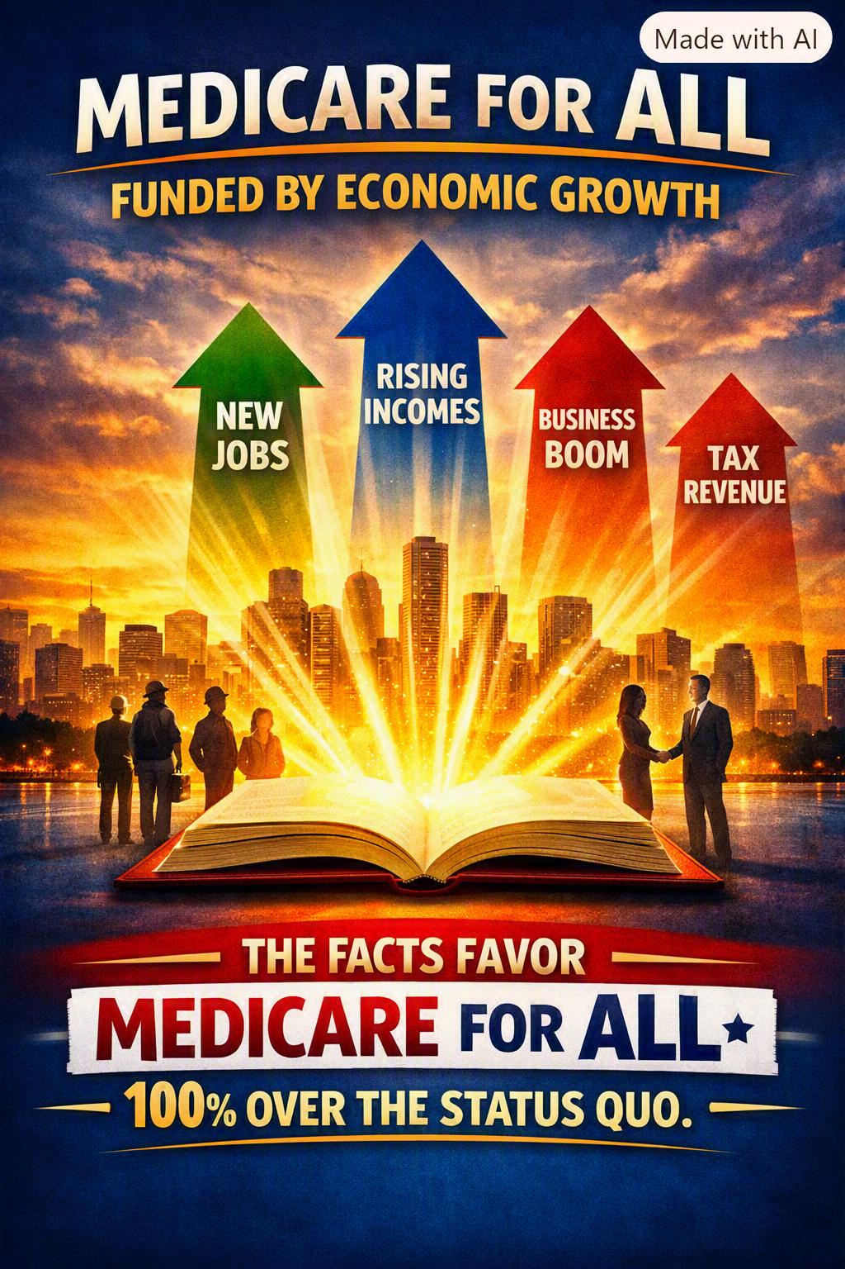
Illustration: The potential economic benefits of universal coverage. The graphic presents an advocacy argument, not a verified fiscal forecast.

A healthcare system should strengthen the nation
America’s healthcare debate is too often reduced to one question: “How will we pay for it?” That is a necessary question, but it is incomplete. We should also ask what the present system costs families and employers, how much it wastes, and what a healthier, more economically secure population could contribute to the nation. Medicare for All deserves to be evaluated as an economic reform as well as a healthcare reform.

The economic opportunity
When people can obtain timely care, they may avoid complications that disrupt work and family life. When coverage is no longer tied to a particular employer, workers can change jobs, start businesses, retire, or care for loved ones without the same fear of losing insurance. Employers may spend less time shopping for health plans and administering benefits. These changes could improve mobility, entrepreneurship, productivity, and competitiveness.

From better health to stronger revenues
The economic logic is straightforward: healthier workers and fewer financial barriers can support employment and productivity. Higher earnings and stronger business activity can, in turn, produce additional tax revenue. That revenue could help offset the public cost of a universal program. The effect is potentially meaningful, but it would unfold over time, vary across industries, and depend on the actual design of the reform.

Economic growth is not a complete financing plan
The claim that Medicare for All can be funded entirely by economic growth has not been established. A universal program would shift a large share of payments now made through premiums, employer contributions, and household out-of-pocket spending into public financing. Even if total national health spending fell, the federal budget would require substantial new revenue or redirected existing spending. Policymakers must specify taxes, contributions, payment rates, transition financing, and how savings would be achieved.

Savings must be demonstrated—not assumed
A single-payer approach could reduce some insurance-related administrative costs and strengthen bargaining over prices. Yet the size of any savings depends on provider payment levels, drug prices, covered benefits, utilization, and implementation. Some proposals project net national savings; others find higher spending under certain assumptions. No responsible analysis can promise that every family, employer, or government budget would immediately pay less.

What should be measured
A serious comparison should count the entire system: federal and state spending, employer and worker contributions, premiums, deductibles, copayments, medical debt, administration, and the consequences of people delaying necessary care. It should also test changes in wages, hiring, business formation, labor mobility, health outcomes, and tax receipts. The goal is to compare real alternatives against the actual status quo—not against a perfect imaginary system.

A practical path forward
Congress should commission transparent, independently reviewed estimates using multiple assumptions; publish a phased transition plan; protect continuity of care; and measure performance against clear benchmarks. Economic gains should be treated as a potential benefit and partial financing offset, not as money already in the bank. That is how a bold idea becomes a workable national program.

The facts deserve a fair hearing
The image accompanying this article declares that the facts favor Medicare for All “100% over the status quo.” That is a forceful statement of conviction, not a mathematical finding. The stronger argument is that the current system has serious, measurable shortcomings and that universal coverage may offer important improvements worth testing rigorously. We should demand evidence, accountability, and compassion from any proposal—especially one this consequential.

Conclusion: Invest in people, and measure the return
Healthcare should not be viewed only as an expense. It is also an investment in people’s capacity to live, work, learn, and contribute. Medicare for All could create a healthier population and a stronger economy. But we will build durable public support by being precise about what is possible, candid about the trade-offs, and determined to make the numbers work. There is no them, only us.

Further reading
- Congressional Budget Office, How CBO Analyzes Proposals for a Single-Payer Health Care System (2020).
- Congressional Budget Office, Key Design Components and Considerations for Establishing a Single-Payer Health Care System (2019).
- Centers for Medicare & Medicaid Services, National Health Expenditure Accounts (annual data).

