Obamacare vs. Medicare for All: The Difference Between Having Insurance and Affording Healthcare
  - Why the Affordable Care Act can still leave families exposed—and what a universal system would change
The Affordable Care Act (ACA), widely known as Obamacare, made a real difference: it expanded access to insurance, protected people with preexisting conditions, and created financial assistance for eligible households. But its name contains a promise that too many people still struggle to experience. Having an insurance card is not the same as being able to afford medical care.
Obamacare is often compared with Medicare for All as though they are two versions of the same policy. They are not. Obamacare mainly changes the rules and subsidies within a system of private insurance. Medicare for All, as commonly proposed in single-payer legislation, would fundamentally change how medically necessary care is financed.
Illustration: An example of how out-of-pocket expenses can differ. ACA costs vary by plan, income, household and year; Medicare for All features depend on enacted legislation.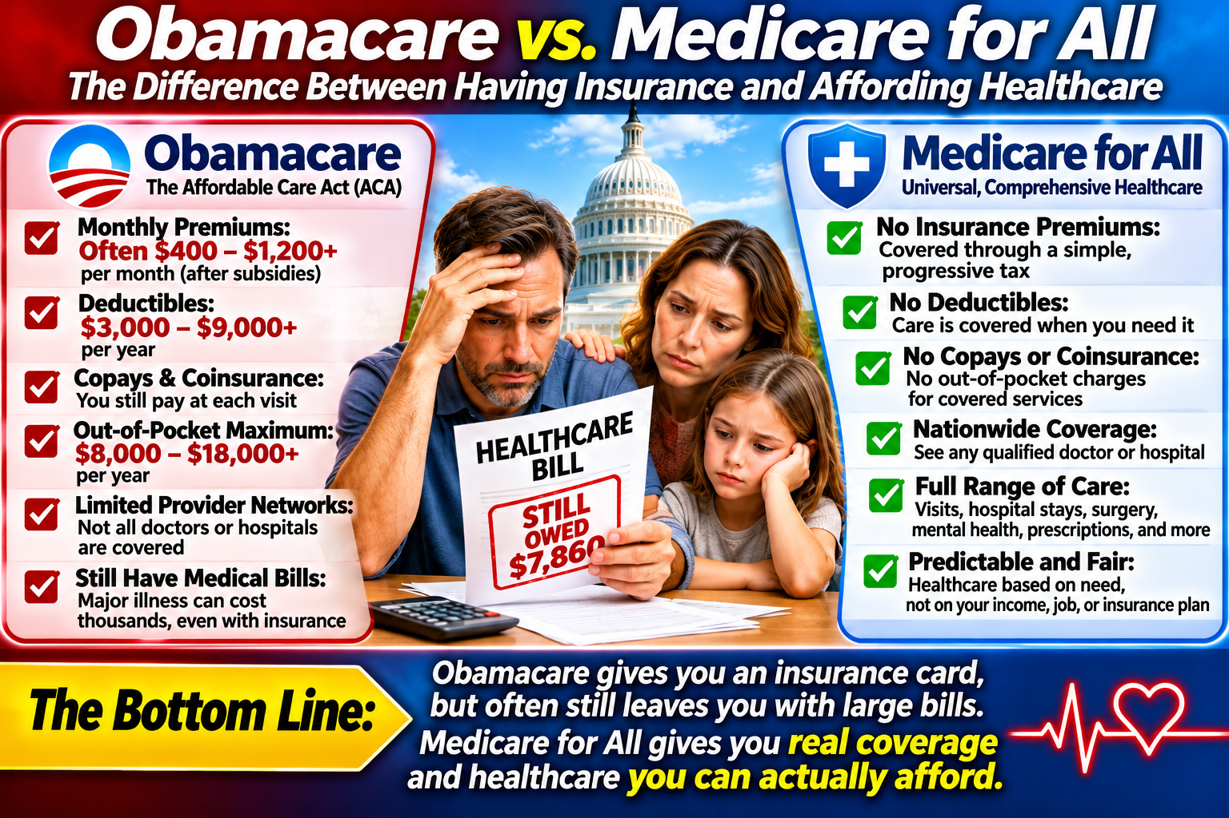

The problem with “affordable” insurance
An ACA marketplace plan can have a manageable monthly premium and still expose its owner to deductibles, copayments, coinsurance, prescription charges, and restricted provider networks. A person may postpone a specialist visit or diagnostic test because using the coverage is too expensive. For those who do not qualify for substantial subsidies, premiums themselves may also be difficult to afford.
Not every Obamacare enrollee has this experience. Some receive very low premiums and meaningful cost-sharing assistance; others have excellent coverage. It would be inaccurate to claim that the ACA is unaffordable for almost everybody who uses it. The stronger, defensible point is that millions remain underinsured or financially vulnerable despite being covered.

What would change for the patient?
Patient experience | ACA / Obamacare marketplace | Medicare for All proposal
Monthly premium | Varies; subsidies can reduce it | No separate private-plan premium under typical proposals
Deductible | Often applies, sometimes substantial | Typically none for covered medically necessary care
Copays and coinsurance | May apply to visits, tests, drugs | Typically eliminated or greatly reduced, depending on legislation
Doctor and hospital choice | Plan networks can restrict choice | Broad provider access if providers participate
Coverage after job loss | May require enrollment changes and new premium calculation | Coverage tied to residency/eligibility, not employment
Payment mechanism | Premiums, public subsidies, and out-of-pocket charges | Taxes/public financing replace most premiums and point-of-care charges
Important: Medicare for All is a proposed policy, not an enacted U.S. national program. Exact benefits, financing, provider participation, and any exceptions depend on the bill ultimately adopted. “No premium at the point of enrollment” does not mean the system has no cost: the public pays through taxes or other financing.

A family example: the difference in practical value
Imagine a family with an ACA marketplace plan costing $400 a month after subsidies. That is $4,800 a year in premiums. Suppose a medical episode also produces $3,000 in deductibles and coinsurance. Their direct annual spending becomes $7,800, before other uncovered expenses. This is a hypothetical example, not a national average.
Under a Medicare for All design with no premiums, deductibles, or copays for covered care, that family would not receive those bills. Its contribution would instead occur through the public financing system. Whether the family pays less overall depends on the actual tax design and its income—but the risk of a large bill when someone becomes ill would be dramatically reduced.

Why this is a more meaningful comparison
Critics often ask, “How much would Medicare for All cost the federal government?” That is an important question, but it is only half the comparison. Americans already finance healthcare through employer contributions that affect compensation, household premiums, taxes, and out-of-pocket charges. Moving costs onto a public budget can increase federal spending while reducing what households and employers pay elsewhere. The relevant measure is total cost and the distribution of that cost—not one government budget line alone.
A single-payer system could also reduce some insurance-related billing and administrative expenses and strengthen purchasing leverage. However, its overall fiscal effect depends on provider payment rates, utilization, drug prices, transition costs, and implementation. Claims of guaranteed trillions in savings are not justified without specifying those assumptions.

Obamacare was a step forward—not the finish line
The ACA should receive credit for protections that people rely on, including the prohibition on denying coverage because of preexisting conditions and financial help for qualifying marketplace customers. But it did not remove the underlying problem: access to care still depends in part on navigating a patchwork of premiums, networks, deductibles, and bills.
Medicare for All aims to replace that uncertainty with a simpler promise: when people need medically necessary care, the financing system should not make them hesitate to obtain it. That is the dramatic difference in value to the user—not just the price of an insurance policy, but the ability to use healthcare without fear of the bill.

The question America should ask
The question is not merely whether America can afford Medicare for All. It is whether we can afford to keep financing healthcare in ways that leave insured families afraid to use it. A fair national debate should compare complete household costs, taxes, coverage, provider access, and health outcomes under each system. Healthcare should be measured by care delivered and financial security provided—not by the number of insurance cards issued.

Sources and further reading
- HealthCare.gov — Premium Tax Credit, cost-sharing reductions, and Marketplace coverage: https://www.healthcare.gov/lower-costs/
- KFF — ACA Marketplace enrollment, premiums, deductibles, and affordability research: https://www.kff.org/affordable-care-act/
- Commonwealth Fund — Underinsurance and affordability surveys: https://www.commonwealthfund.org/
- Congressional Budget Office — Single-payer health care system analyses: https://www.cbo.gov/
- CMS — National Health Expenditure Accounts: https://www.cms.gov/data-research/statistics-trends-and-reports/national-health-expenditure-data

