We Can Afford Medicare for All. Can We Afford the System We Have?
  - A case for judging healthcare by its total cost, access, and value—not merely the size of the federal budget.
November 2026 | Universal Healthcare Social

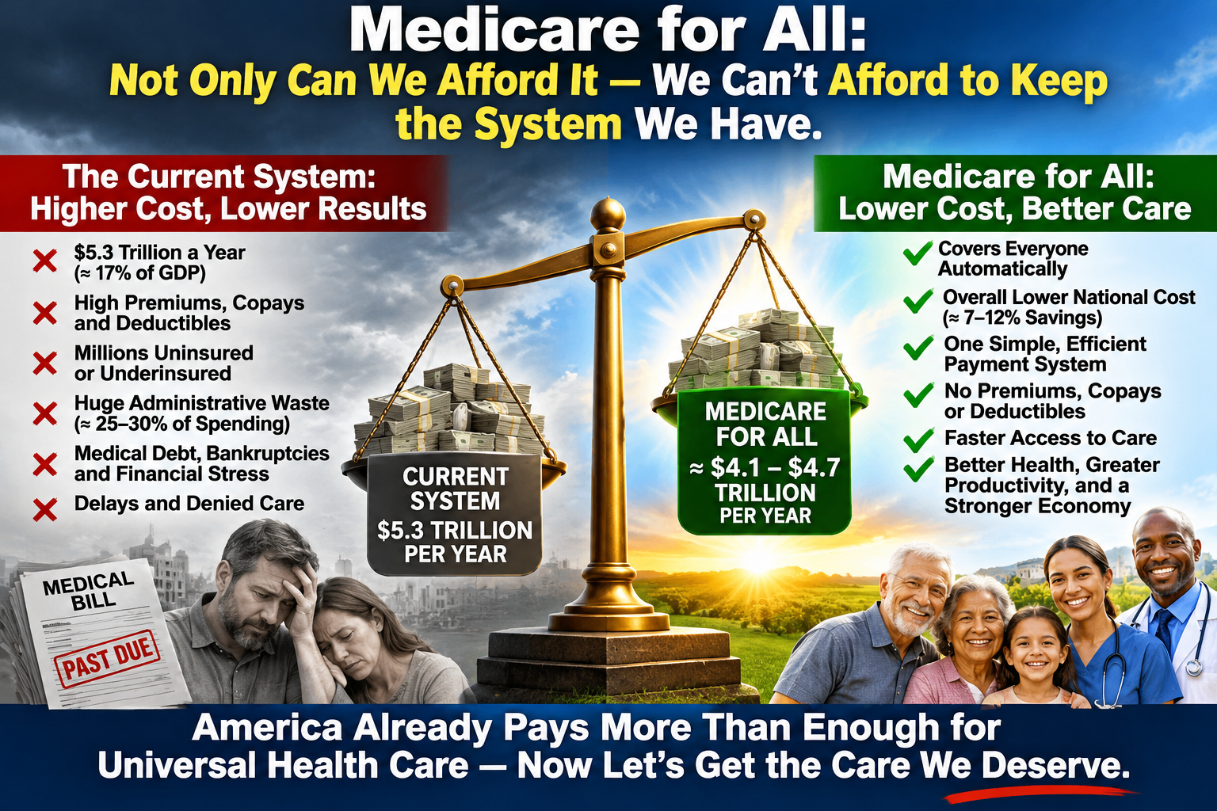The question is being asked backward
“How can we afford Medicare for All?” is a reasonable question. But it begins in the wrong place if it assumes the United States is not already paying for healthcare. Every year, families, businesses, and governments collectively spend trillions on insurance, hospitals, medicines, and medical services. The money is already being collected—through taxes, employer contributions, paychecks, premiums, deductibles, and direct bills.
The more revealing question is whether we can afford to keep financing healthcare through a fragmented system that is expensive to administer and still leaves people exposed to medical costs. Medicare for All would not make healthcare free to produce. It would change who collects the money, how providers are paid, and what patients owe at the point of care.

America is already paying an extraordinary price
The Centers for Medicare & Medicaid Services reports that U.S. health spending reached $5.3 trillion in 2024, or $15,474 per person—18.0% of gross domestic product. The same data show that 91.8% of the population was insured that year, meaning a substantial share still lacked coverage. Those numbers describe an expensive system, not a system waiting for someone to invent a way to pay for healthcare. [1, 2]
For workers and employers, the costs are equally concrete. KFF found that average annual employer-sponsored family premiums reached $26,993 in 2025: workers contributed $6,850 and employers contributed $20,143. Those employer payments are part of labor costs, even when employees do not see them as a deduction from their paycheck. [3]

The budget illusion: public spending versus total spending
Under a single-payer program, federal spending would rise sharply because payments now made by employers, private insurers, and households would be redirected through public financing. Opponents can accurately point to that larger federal budget. But a larger public budget does not necessarily mean a larger national healthcare bill.
Imagine that a household and its employer together spend $25,000 on coverage and medical costs. If a redesigned system replaced those payments with $22,000 in combined taxes, the federal share would rise while the combined cost would fall. That is an illustration, not a forecast or a proposed tax schedule. The real comparison must count every dollar paid by families, employers, and governments on both sides of the equation.

Where a unified system could save money
Our current system requires hospitals and clinics to navigate many insurance contracts, networks, billing codes, claim denials, prior-authorization rules, and payment schedules. A unified payer could simplify much of that machinery. Fewer duplicative billing operations could mean fewer resources devoted to moving money around rather than delivering care.
A national purchaser could also negotiate prices and establish clearer payment rules. These savings are possibilities, not guarantees: they depend on legislation, provider reimbursement, drug-price policy, fraud controls, and implementation. Administrative work would not disappear, and any reform must ensure that hospitals and clinicians remain financially viable.

What better coverage would mean
Medicare for All proposals commonly envision coverage that follows the person rather than the job, with fewer or no premiums, deductibles, and copayments for covered services. That could reduce the fear of losing insurance when changing jobs, starting a business, retiring early, or facing illness. It could also reduce the financial shock of receiving treatment.
Expanded coverage would increase use of some services, especially among people who have postponed care. That is a real expense and should be included in any credible cost estimate. Some earlier care may avert expensive complications; other valuable care improves health without reducing overall spending. The goal is not merely a lower bill. It is better health and more reliable access for the resources society spends.

The cost of keeping the present system
The status quo is not a zero-cost alternative. It means continued premium payments, cost sharing, administrative complexity, and uncertainty about future healthcare spending. These costs affect household budgets and business decisions even when they do not appear on a single federal balance sheet.
That is why the argument “we cannot afford to change” is incomplete. A full comparison must also estimate the future cost of not changing, including spending growth, financial exposure, and the consequences of people remaining uninsured or underinsured.

A serious reform must answer serious questions
No honest analysis can promise that every Medicare for All design will cost less. Outcomes depend on provider payment rates, taxes, covered benefits, demand for care, prescription prices, and the speed of transition. A poorly designed plan could raise national spending; a carefully designed plan could lower it while extending coverage. Federal fiscal effects and economy-wide effects must be reported separately.
The transition also requires protecting access to rural hospitals, planning for workers in insurance administration, ensuring timely care, and publishing clear household-by-household and employer-by-employer financing estimates. These are solvable design questions only if they are treated as real constraints rather than waved away.

The affordability test America should demand
We should ask every healthcare proposal—including the current system—to meet the same test: How much will the country spend in total? How much will families and employers pay? Who is covered? What care is actually available? What financial risks remain? And what will the system cost over time?
The United States already commits immense resources to healthcare. The central opportunity in Medicare for All is to redirect a greater share of those resources toward care and financial protection rather than complexity. The evidence does not establish that every version would save money. It does establish that we cannot judge affordability by federal expenditures alone.
We can afford to examine a fundamentally different system. The question is whether we can afford to stop examining alternatives while the present one continues to demand so much and leave so many exposed.

Sources
[1] Centers for Medicare & Medicaid Services, National Health Expenditure Fact Sheet (2024): https://www.cms.gov/data-research/statistics-trends-and-reports/national-health-expenditure-data/nhe-fact-sheet
[2] CMS, National Health Expenditures 2024 Highlights (insured share): https://www.cms.gov/files/document/nhe-infographic.pdf
[3] KFF, 2025 Employer Health Benefits Survey: https://www.kff.org/health-costs/2025-employer-health-benefits-survey/

