  - MEDICARE FOR ALL | ARTICLE 10

We Don’t Need to Rob the Rich to Help the Poor
  - Fix the system, not each other.
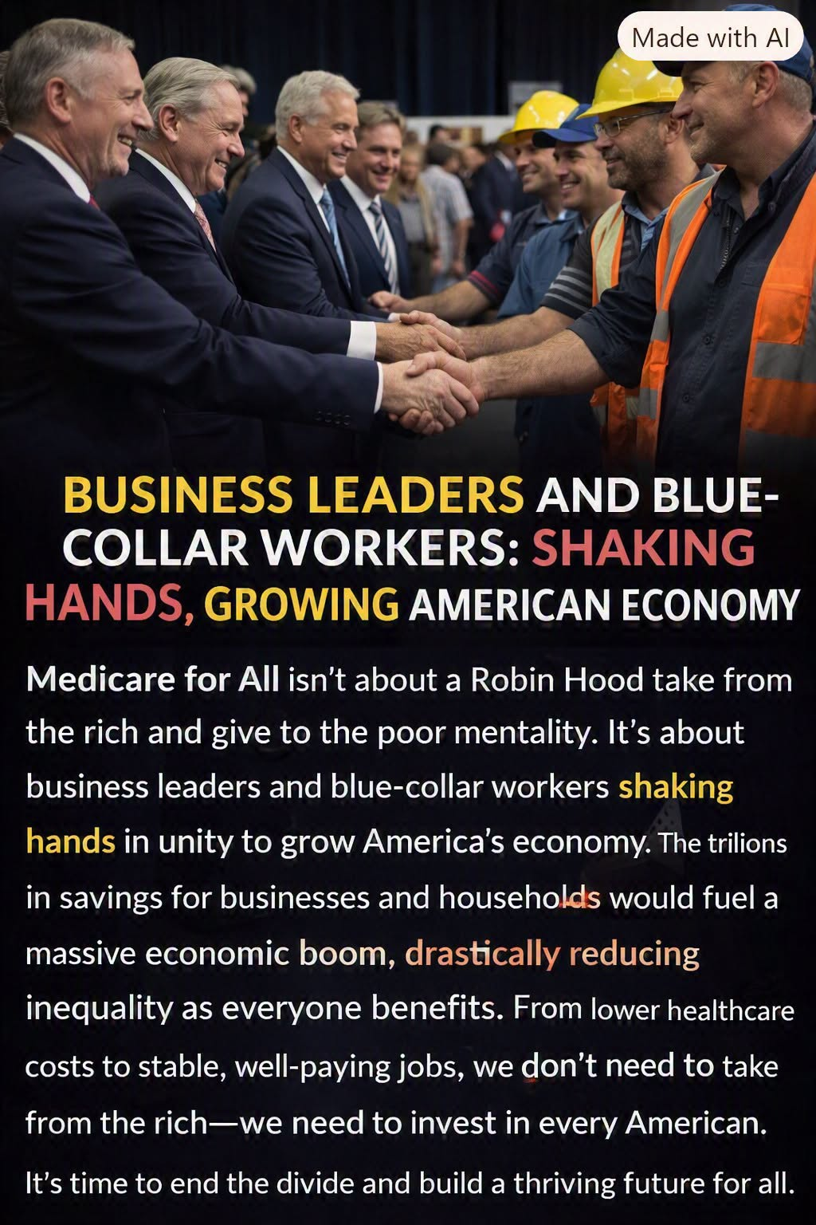
Business leaders and workers share an interest in an economy where healthcare is dependable and affordable.

A false choice
Too often, public debate treats economic progress as a contest: either protect successful people or help struggling families. That framing assumes that the only way to improve one person’s life is to take something away from someone else. But some of our largest problems are not primarily about who has the money. They are about how poorly our systems use the money we already spend.

Healthcare is a systems problem
American healthcare combines public programs, private insurance, employers, hospitals, clinicians, pharmacies, and patients in a complicated financing structure. Each layer may serve a purpose, but the whole system also produces overlapping administration, confusing bills, fragmented coverage, and difficult negotiations. Patients can face medical debt even when they are insured. Employers must devote money and staff time to selecting and managing benefits. Providers spend resources navigating multiple payment rules. These are system costs—not evidence that one economic class is the enemy of another.

What reform could change
A well-designed universal coverage system could simplify eligibility and billing, reduce certain administrative expenses, strengthen purchasing power for medicines and services, and make access to care less dependent on employment. The potential gains would not come from punishing business owners or rewarding one group at another’s expense. They would come from removing avoidable friction and redirecting resources toward care. Those gains are possibilities, not automatic results: payment rates, benefits, taxes, transition costs, and implementation would all matter.

Why business should care
Employers pay for healthcare through premiums, contributions, administration, and the uncertainty of future cost increases. Smaller firms may struggle to offer benefits that larger competitors can afford. Entrepreneurs may hesitate to leave a job because it provides family insurance. If reform replaces employer premiums with a more predictable financing arrangement, some businesses could gain room to hire, invest, or raise wages. Others could face higher taxes or different costs. A serious proposal must show those effects by business size and income, rather than promising every employer a windfall.

Why workers and families should care
Workers benefit when medical coverage does not disappear with a layoff, job change, or new business venture. Families benefit when an illness does not threaten their savings. People with lower incomes may gain the most from removing financial barriers to care, but middle-income households also face premiums, deductibles, and unexpected bills. Wealthier households have a stake too: a healthier workforce, more stable communities, and a more efficient economy can serve everyone.

Fair financing is not retaliation
Universal healthcare must be financed. Replacing private premiums and out-of-pocket bills with public financing can shift who writes the check, even if total national spending falls. Some households and firms may pay more; others may pay less. That deserves transparent analysis and fair debate. But asking how to fund a shared service is different from treating prosperity itself as wrongdoing. The objective should be broad access, sustainable costs, and economic opportunity—not revenge against people who have succeeded.

Measure the whole system
A systems engineer would not judge a machine by the performance of one component. The question is whether the complete system delivers its intended results at a reasonable total cost. Healthcare deserves the same discipline. Compare all spending—taxes, premiums, deductibles, copays, employer contributions, and administrative expenses—alongside outcomes such as access, health, provider capacity, and financial security. A reform that lowers one bill while increasing the total burden has not solved the problem.

A common interest
Business leaders and blue-collar workers do not have to stand on opposite sides of healthcare reform. Both need a healthy workforce, stable families, thriving communities, and an economy where productive effort is rewarded. We can debate the best way to achieve those goals without dividing the country into villains and victims. The opportunity is to repair costly structures so that more people can prosper together.
The goal is not to take from one American to punish another. It is to build systems that work better for all Americans.

Further reading
- Congressional Budget Office, “How CBO Analyzes Proposals for a Single-Payer Health Care System” (2020).
- Congressional Budget Office, “Key Design Components and Considerations for Establishing a Single-Payer Health Care System” (2019).
- Commonwealth Fund, research on U.S. healthcare administrative costs and international comparisons.

