  - ARTICLE 25

The True Cost of American Healthcare: What the Bills Don’t Show
Why premiums and hospital bills are only the beginning of the economic burden
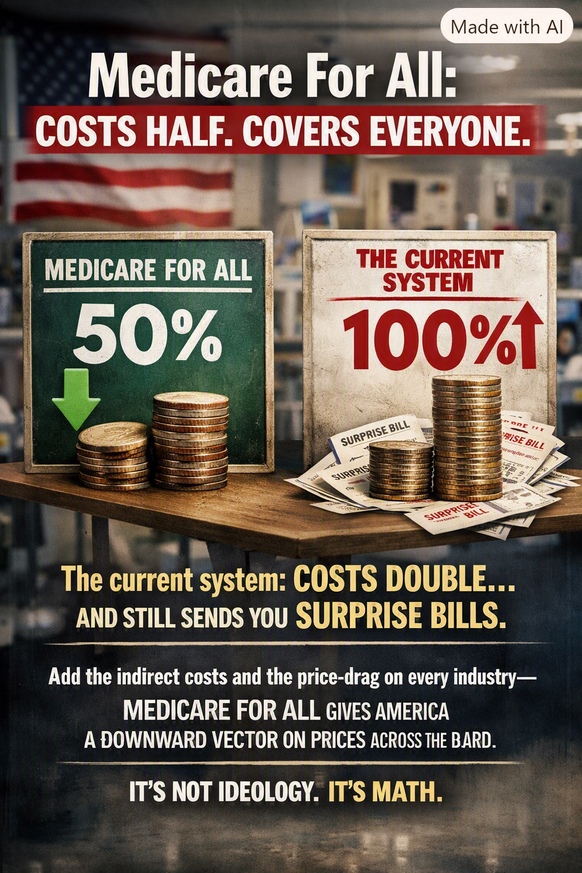
Author-supplied advocacy illustration. Its “costs half” and “costs double” figures are not verified estimates; this article examines the underlying economic argument.

We are counting the bills, but not all the damage
Americans see healthcare costs in premiums, deductibles, copayments, prescription charges, hospital bills, and taxes. These direct payments are enormous. Yet they do not capture every consequence of a fragmented insurance system. The true economic question is not only how much money changes hands in healthcare, but what families, employers, workers, and communities lose because of the way coverage is financed and administered.
My argument is that a well-designed Medicare for All system deserves to be evaluated against the full cost of today’s system—not merely against the federal budget line of a proposed program. When we count indirect costs, the case for fundamental reform may be much stronger than the usual debate suggests.

The direct costs: what we can already see
The visible costs include employer and employee insurance premiums; Medicare and Medicaid taxes and other public expenditures; deductibles and coinsurance; copays; prescription drugs; dental, vision, and other uncovered care; and the administrative work of billing, claims, authorizations, appeals, and collections. They also include the cost of carrying medical debt.
National health expenditure accounts capture most spending on medical goods, services, and administration. They do not, however, measure every downstream loss in employment, innovation, productivity, or household stability. A serious comparison must avoid double-counting amounts already included in national spending totals.

The hidden costs: where the burden spreads

1. The burden on employers
Companies finance insurance premiums, manage benefits, negotiate renewals, and absorb unpredictable cost increases. Smaller firms may have less bargaining power and face particularly difficult choices. These costs can affect compensation, hiring, investment, and competitiveness.

2. Job lock and lost mobility
People may stay in jobs they would otherwise leave because they fear losing affordable insurance or changing provider networks. Employer coverage can discourage job changes, early retirement, caregiving, or relocation—even when other work would be more productive or fulfilling.

3. Entrepreneurship that never happens
A person with a promising business idea may not start it because leaving a job means giving up a group health plan. Some people can purchase ACA marketplace coverage or qualify for subsidies, but affordability and continuity remain major considerations. Lost startups and delayed self-employment are difficult to price, yet they matter.

4. The cost of buying coverage alone
Individuals and families outside employer group plans may face high premiums or out-of-pocket expenses, especially without sufficient subsidies. Even when insurance is available, the combination of premiums, deductibles, and network limitations can make it hard to use.

5. Delayed, skipped, or rationed care
People sometimes postpone appointments, diagnostic tests, treatment, or prescriptions because of cost. Not every delay causes harm, but some allow manageable conditions to worsen. A later hospitalization or emergency visit can be more expensive and more painful than timely outpatient care.

6. Emergency care and preventable complications
When people lack affordable access to primary and specialty care, some conditions deteriorate until urgent treatment is necessary. Emergency departments are essential safety nets, but they are not substitutes for accessible ongoing care. Prevention does not always save money, but appropriate earlier treatment can avoid some costly complications.

7. Lost work and reduced productivity
Illness that goes untreated can increase absences, reduce effectiveness at work, and shorten careers. Family members may lose working hours while providing care. Some of these losses are economic costs beyond the medical bill itself.

8. Medical debt and household instability
Unpaid bills can consume savings, impair credit, and crowd out rent, food, transportation, or education. In extreme cases, health expenses combined with lost income can contribute to housing instability. These financial consequences reverberate through local economies.

9. Administrative time and frustration
Patients spend time checking networks, resolving claims, requesting authorizations, comparing plans, and disputing charges. Clinicians and employers also spend resources navigating multiple payment rules. Some administrative work would remain under Medicare for All, but the opportunity to simplify is substantial.

10. A drag on consumer spending and economic dynamism
Money reserved for unpredictable healthcare bills is money households cannot confidently spend or invest elsewhere. Employer health costs may be reflected in lower wages or reduced business investment. These effects are diffuse, but their cumulative influence may be large.

Could the full burden approach twice the cost?
It is possible to construct scenarios in which direct spending plus the value of lost output, financial insecurity, and other indirect harms substantially exceeds the cost of an alternative system. But there is no sound basis for declaring that today’s total burden is already twice the cost of Medicare for All. Doing so would require a transparent model, credible data, careful counterfactual assumptions, and safeguards against counting the same cost twice.
The claim that direct costs would initially be only slightly higher than Medicare for All is likewise not a settled fact. Published single-payer projections differ substantially because they assume different provider payment rates, drug savings, utilization, benefit packages, and taxes. Some project lower total national healthcare spending; others project higher spending. Federal expenditures would increase markedly even if overall national spending declined.

The comparison America deserves
Imagine two columns, each measured over the same years. One shows the current system’s medical spending plus separately measured economic losses from preventable illness, job lock, administration outside health accounts, and financial distress. The other shows a specific Medicare for All design: its medical spending, transition costs, tax financing, expected utilization, administrative savings, and any remaining indirect costs. That is the comparison policymakers should publish and debate.
The results should be broken down by income, age, employment status, business size, geography, and health needs. Americans deserve to know not just what a national total might be, but how families and employers would actually fare.

This is not ideology. It is systems engineering.
A systems engineer does not judge a complex system by one invoice. The engineer examines bottlenecks, failure modes, hidden dependencies, incentives, and the total cost of operation. Our healthcare system should be examined the same way.
A well-designed Medicare for All program could reduce coverage gaps, simplify financing, improve access, and reduce some of the costs that are invisible in ordinary healthcare accounting. Whether it delivers those benefits depends on careful legislation and implementation. But the current system should not get a free pass simply because its costs are scattered among millions of families and businesses.
The goal is not merely a smaller bill. It is a healthier, more productive, more secure America in which people can change jobs, start businesses, seek care early, and recover from illness without fearing financial catastrophe.

Research and methodological notes
Useful starting points for verification: Centers for Medicare & Medicaid Services, National Health Expenditure Accounts (cms.gov/data-research/statistics-trends-and-reports/national-health-expenditure-data); KFF, Employer Health Benefits Survey (kff.org/ehbs); Federal Reserve, Survey of Household Economics and Decisionmaking (federalreserve.gov/consumerscommunities/shed.htm); Congressional Budget Office, analyses of single-payer healthcare systems (cbo.gov). These sources measure different things and should not simply be added together.
Editorial note: The accompanying illustration uses 50% and 100% as rhetorical figures. They are not substantiated by a specific national cost comparison, and Medicare for All savings cannot be guaranteed without specifying the policy and assumptions.
Willis Butts | Medicare for All

