MEDICARE FOR ALL | ARTICLE 17

Medicare for All: What It Is—and What It Isn’t
A practical healthcare reform, not a political slogan.
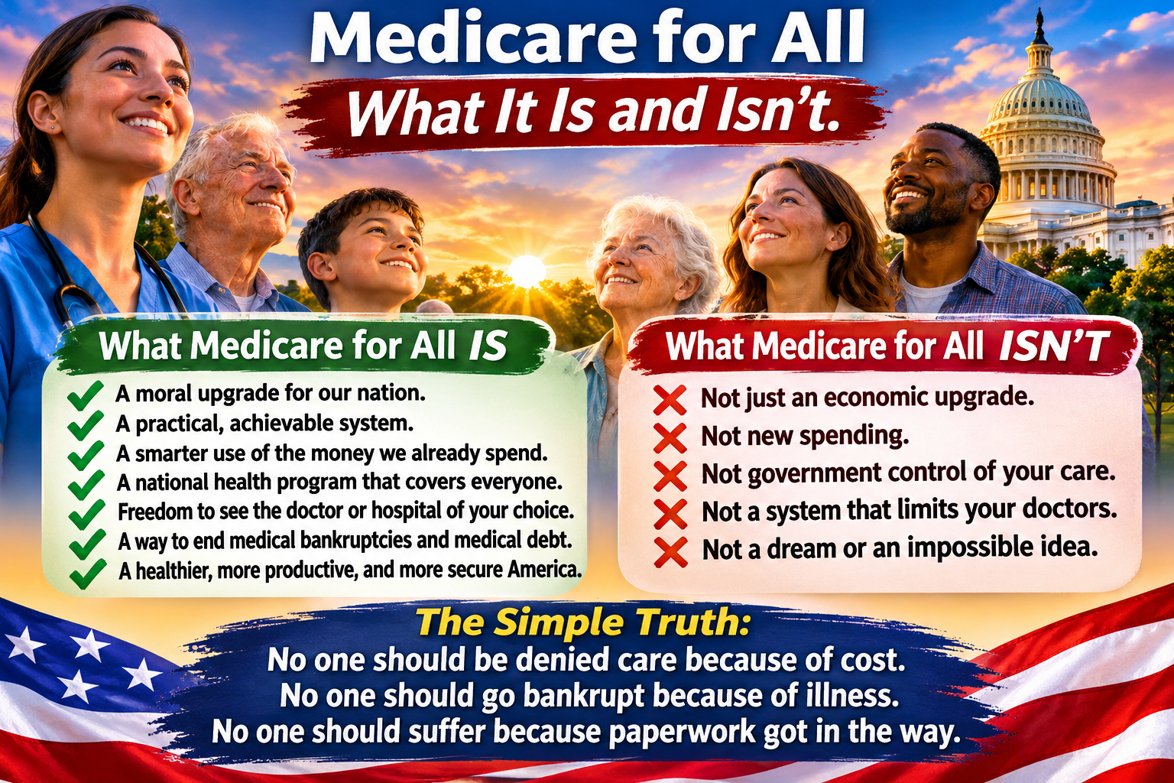
Illustration: Medicare for All — What It Is and Isn’t. Policy outcomes depend on the legislation enacted.
The accompanying graphic states a moral and practical case for universal healthcare. Its claims are advocacy positions; the details of a Medicare for All law would determine how it operates.

It is not just an economic upgrade. It is a moral upgrade.
Healthcare reform is about budgets, but it is also about people. A person with cancer should not have to postpone treatment because of a deductible. A parent should not have to weigh a prescription against groceries. A decent healthcare system should protect dignity as well as health.

It is not new spending. It is smarter spending.
Americans already finance healthcare through premiums, taxes, deductibles, copayments, employer contributions, and out-of-pocket bills. Medicare for All proposes to reorganize much of that financing into a publicly funded system. It would require substantial federal spending, while replacing many private payments. Whether total national costs fall depends on program design, payment rates, drug prices, and utilization.

It is not government control. It is government payment.
The central idea is public financing of medically necessary care, not necessarily government ownership of hospitals or employment of physicians. Patients would still see doctors and clinicians, and many providers could remain independent. Public rules would govern benefits and reimbursement, just as private insurers set coverage rules today. The precise balance would depend on legislation.

It is not a dream. It is a system we can design.
Other high-income countries provide universal or near-universal coverage through different models. The United States already administers Medicare, Medicaid, the Veterans Health Administration, and other public programs. Expanding coverage nationwide would be difficult, requiring financing, workforce planning, transition arrangements, and accountability. Difficulty is not impossibility.

No one should be denied care because of cost.
The strongest case for Medicare for All is simple: access to necessary healthcare should not depend on wealth, job status, or the ability to navigate an insurance maze. A well-designed program could remove many point-of-care financial barriers and reduce medical debt. It would not, by itself, solve every shortage, wait time, or inequity.

No one should go bankrupt because of illness.
Medical expenses can destabilize household finances, especially when illness also interrupts employment. Comprehensive coverage with little or no cost-sharing could greatly reduce medical bills as a cause of financial hardship. But families would still need income protection, disability support, and affordable housing when illness prevents them from working.

The question is how to make it work.
A serious proposal must specify covered benefits, provider payment, funding, the transition from employer-sponsored insurance, protections for workers in the insurance industry, and measures to maintain quality and access. Those details deserve open debate rather than slogans.

A promise worth making
Medicare for All should be judged by what it delivers: reliable care, fewer financial barriers, fair treatment of patients and providers, and responsible stewardship of public resources. We can disagree on the design while agreeing on the goal: nobody should suffer because paperwork or an unaffordable bill stands between them and care.
Willis Butts | Medicare for All

