Do We Really Want a Healthcare System That Profits from Sickness?
  - ARTICLE 13 | MEDICARE FOR ALL | OPINION & POLICY ANALYSIS
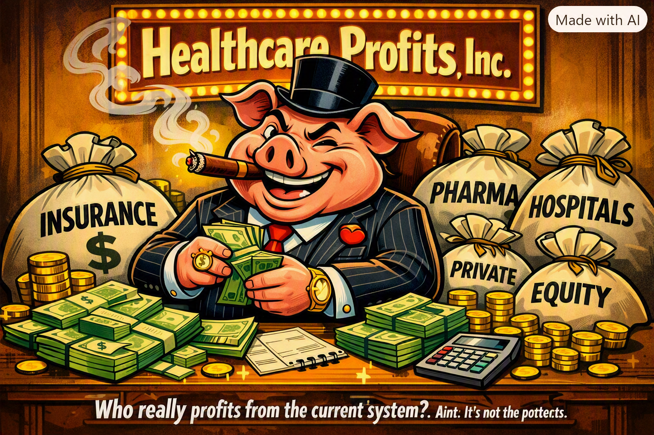
Illustration supplied by the author. The image is a political cartoon, not a depiction of any particular company or individual.

The question behind the cartoon
A healthcare system should be judged by what it delivers: timely treatment, financial security, professional care, and reasonable cost. The cartoon asks a pointed question: when sickness generates revenue, how do we make sure financial incentives never outrank patients? Profit itself is not proof of wrongdoing. Hospitals need operating margins, researchers need investment, and medical workers deserve good pay. The concern is whether payment rules reward complexity, high prices, or denying needed services rather than improving health.

The incentives are not all the same
Private insurers, pharmaceutical manufacturers, hospitals, physician practices, and investment firms have different business models and obligations. Some provide valuable innovations and services. Others may benefit financially from higher prices, greater market power, or administrative practices that are difficult for patients to navigate. It is misleading to treat every participant as identical. But it is reasonable to ask who benefits from each dollar spent, and whether patients receive commensurate value.

What patients and employers experience
Families may confront premiums, deductibles, copayments, confusing networks, prior authorization, and unexpected bills. Employers spend time and money choosing plans and managing benefits. Clinicians devote substantial effort to billing and insurance rules. These burdens are not just paperwork: they can influence whether people seek care, change jobs, or start businesses. Even people with insurance may worry about what an illness will cost.

What Medicare for All proposes to change
Medicare for All proposals generally aim to replace much of the current fragmented insurance financing with a universal public payment system. Advocates argue that common coverage rules, simpler billing, and stronger purchasing leverage could reduce administrative expense and financial barriers. Critics raise concerns about tax financing, government-set payment rates, transition disruption, provider capacity, and access to timely care. The outcome would depend on the legislation and its implementation—not merely on the program's name.

A better test than profit versus government
Instead of assuming every private dollar is harmful or every public dollar is efficient, policymakers should ask concrete questions: Are patients covered when they need care? Are prices transparent and justified? Are clinicians paid fairly? Can businesses predict their costs? Does the system reward prevention and effective treatment? Can people challenge a denial? And can the country afford the full cost over time? These are measurable standards that should apply to any reform.

Putting health first
A humane system can still support medical discovery, responsible enterprise, and well-compensated professionals. What it should not do is make illness a financial trap for families. The challenge is to align incentives so that preventing disease, treating people effectively, and controlling unnecessary costs are rewarded. Medicare for All is one proposed route toward that goal; its details deserve rigorous scrutiny. The underlying principle should be shared across political and economic lines: people are patients before they are revenue streams.

Questions worth debating
How much administrative cost could actually be eliminated? How would hospitals and rural clinics be financed? What payment rates would preserve access and quality? How would transition costs be handled? Which safeguards would protect patients from both private and public bureaucratic failures?
Editorial note: This article presents an argument about healthcare incentives, not a claim that all healthcare organizations or professionals act improperly.

