A Festering Wound: The History of Medicare for All and Congress’s Failure to Act
  - How a century of unfinished reform left American families exposed to medical bills, insurance gaps, and uncertainty.
Universal Healthcare Social | November 2026

The wound we have allowed to deepen
America’s healthcare crisis did not appear overnight. It developed through decades of decisions to expand coverage in pieces while leaving most working-age Americans dependent on a patchwork of private insurance, public programs, employment, and personal finances. Each reform helped someone. None established a universal guarantee that everyone could obtain comprehensive healthcare without financial hardship. The result resembles a wound repeatedly bandaged but never fully treated: coverage gaps, confusing bills, delayed treatment, and medical debt keep returning.
Editorial illustration: “Congress: Asleep at the Wheel”
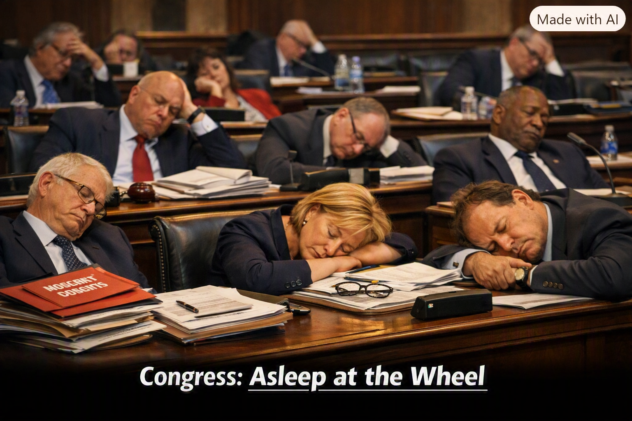

The idea is older than the phrase “Medicare for All”
National health insurance has been debated in the United States for more than a century. Progressive-era reformers proposed sickness insurance in the early 1900s. President Harry Truman urged Congress to establish national health insurance in 1945. His proposal faced fierce political and institutional opposition and was not enacted. These early campaigns established a recurring pattern: the public debate would reopen, but the comprehensive system would remain out of reach.

1965: A landmark achievement—and an unfinished promise
Congress enacted Medicare and Medicaid in 1965. Medicare created federal health insurance primarily for older Americans, while Medicaid provided coverage to qualifying people with low incomes and other eligible groups. These programs transformed access to care and demonstrated that public financing could protect large populations. Yet they did not cover everyone. For millions of people outside the programs, access still depended on employers, private policies, eligibility rules, and ability to pay.

From the 1970s through the 1990s: Plans, defeats, and compromises
National health insurance proposals continued under several administrations and in Congress. In the early 1970s, proposals from President Richard Nixon and Senator Edward Kennedy differed over employer coverage and public financing, but no comprehensive bill became law. President Bill Clinton’s 1993–94 health reform initiative also failed in Congress. Each defeat preserved much of the existing insurance structure, even as medical technology advanced and costs continued to rise.

The modern Medicare for All movement
Representative John Conyers introduced the Expanded and Improved Medicare for All Act in 2003, helping establish a recurring single-payer legislative vehicle in the House. Senator Bernie Sanders later introduced Medicare for All legislation in the Senate, and Representative Pramila Jayapal became a prominent House sponsor. Their bills have kept the idea visible and have spelled out a different financing model: broad public coverage, substantially reduced point-of-care charges for covered services, and financing through public revenue. Proposals differ in details and have not become federal law.

2010: Obamacare made real gains, but did not finish the job
The Affordable Care Act (ACA), often called Obamacare, became law in 2010. It expanded Medicaid where states adopted expansion, created insurance marketplaces and premium subsidies, barred insurers from denying coverage because of preexisting conditions, and set other consumer protections. These were consequential achievements, not congressional inactivity. Yet ACA marketplace coverage can still involve premiums, deductibles, copayments, networks, and annual out-of-pocket exposure. Some people remain uninsured or underinsured. Expanding access to insurance is not identical to ensuring affordable care when illness strikes.

Why Congress has not enacted Medicare for All
There is no single explanation. Lawmakers disagree about taxes, federal authority, the role of private insurance, provider reimbursement, transition costs, and whether a single-payer system would improve costs and access. Hospitals, insurers, employers, unions, clinicians, and patients have competing concerns. Congressional committee structures, partisan divisions, and the Senate’s legislative rules create additional hurdles. Supporters argue that administrative savings and pooled financing could improve value; critics warn of tax increases, implementation risks, and possible disruptions to care. These disagreements deserve examination—but they do not erase the costs of continuing the status quo.

What prolonged delay means in everyday life
For a family, the argument is not abstract. A parent may avoid a diagnostic test because the deductible is too high. A worker may remain in a job mainly to preserve insurance. A small business may struggle with annual premium increases. A hospital may employ substantial staff to navigate different insurers’ payment rules. These problems are not caused by congressional delay alone, and their scale varies across communities. But when Congress declines to establish a more comprehensive solution, the existing structure—and its recurring financial risks—continues.

What a serious solution must prove
Medicare for All is not costless, and no single estimate proves it would save a fixed amount. A workable law would need transparent financing, sufficient payments for hospitals and clinicians, a credible transition for workers and patients, protections against delays, and independent assessment of total national spending. The comparison must include taxes as well as today’s premiums, employer contributions, deductibles, copayments, and medical debt. The question is not simply how much government would spend; it is what the nation would pay overall and what care people would actually receive.

Congress can choose to heal the wound
Americans should credit Congress for the reforms it has enacted while also demanding accountability for the problems it has left unresolved. Medicare, Medicaid, and the ACA show that national action is possible. They also show the limitations of partial repairs. A nation that spends vast resources on healthcare should be able to debate, design, and enact a system in which illness does not routinely become a financial emergency. The wound will not heal through rhetoric alone. It requires legislation, transparent arithmetic, and the political will to put patients’ security at the center of the system.

Historical sources and further reading
Harry S. Truman Presidential Library, 1945 message to Congress on national health insurance; Social Security Administration, historical materials on Medicare and Medicaid (1965); Congress.gov legislative histories for the Expanded and Improved Medicare for All Act and Medicare for All Act; U.S. Department of Health and Human Services, Affordable Care Act overview; Congressional Budget Office, How CBO Analyzes Proposals for a Single-Payer Health Care System (2019).

