Medicare for All: A Bipartisan Opportunity
  - Why a well-designed universal healthcare system deserves serious consideration from Democrats, Republicans, and Americans at every income level.
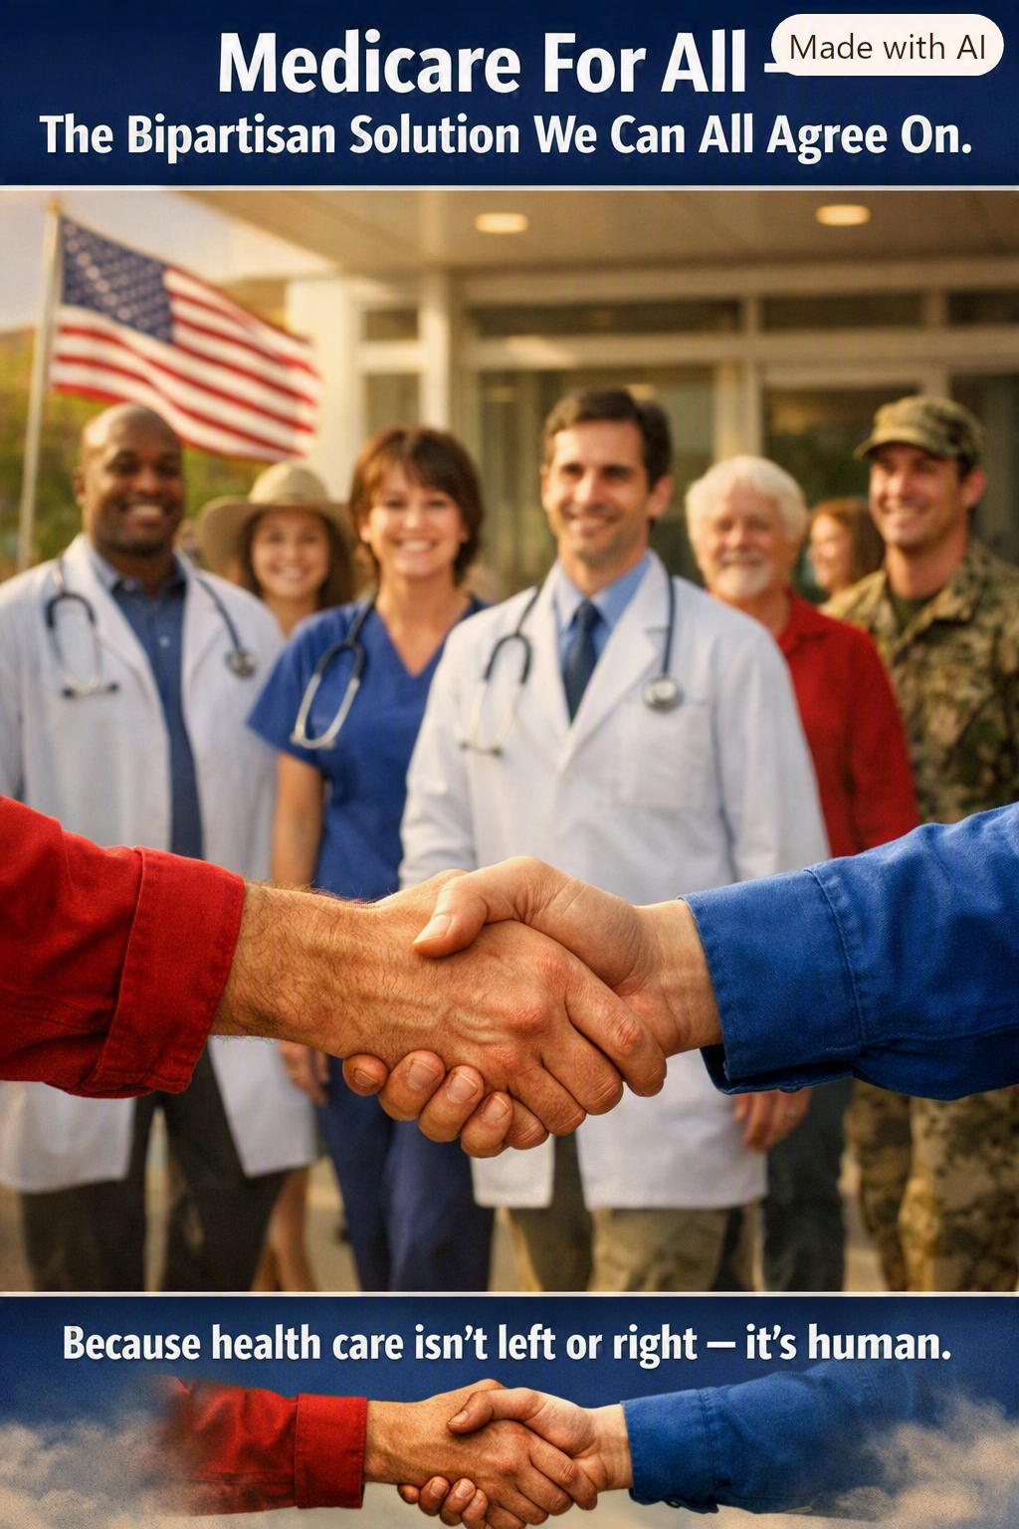
Healthcare is not left or right—it is human.

A common problem, regardless of party
A hospital bill does not ask how someone voted. Cancer, a serious injury, and a child’s illness do not distinguish between Republicans and Democrats. Yet Americans often approach healthcare as a partisan contest instead of a shared practical challenge: how can everyone receive needed care without financial ruin, while the country uses its resources responsibly?
Medicare for All is one proposed answer. Its central idea is to replace much of today’s fragmented insurance financing with a publicly financed system that guarantees a defined package of healthcare benefits. Supporters argue that broader coverage, simpler administration, and stronger purchasing power could make care more dependable and less expensive overall. Critics raise serious questions about taxes, government budgets, provider payments, choice, and the transition from employer-sponsored insurance. Those questions deserve answers—not slogans.

Why it matters to lower-income households
For people with modest incomes, the clearest potential gain is reliable access to treatment without the fear that a deductible, copayment, or uncovered service will overwhelm the family budget. A comprehensive Medicare for All plan could reduce medical debt, make preventive care easier to obtain, and reduce the pressure to postpone needed treatment. The actual benefits would depend on which services the law covers and how it is financed.

Why it matters to the middle class
Middle-income families may have insurance and still face premiums, deductibles, surprise expenses, and complicated networks. They may also feel tied to a job because leaving means losing coverage. A universal system could replace much of that uncertainty with portable coverage that follows the person rather than the employer. Some families would pay more in taxes and others less; the meaningful comparison is the full household balance sheet—new taxes versus premiums, out-of-pocket expenses, and the value of more secure coverage.

Why business owners and higher-income Americans should care
Healthcare is also an economic issue. Employers spend time and money selecting plans, administering benefits, negotiating renewals, and absorbing unpredictable premium increases. A universal financing arrangement could relieve businesses of much of that administrative burden, potentially helping smaller firms compete for workers and allowing entrepreneurs to start companies without having to recreate an insurance system for every employee.
Higher-income Americans and successful business owners may benefit from a healthier workforce, more predictable compensation costs, easier entrepreneurship, and fewer employees struggling with medical bills. However, some high earners and businesses could also face higher taxes under particular financing proposals. It would be misleading to promise that every wealthy household or company would save money. The business case must be evaluated alongside the proposed tax structure, effects on wages, and changes in provider reimbursement.

What Democrats and Republicans might find in common
People who emphasize social protection can see the appeal of guaranteed access to essential care. People who emphasize efficiency, business competitiveness, personal independence, and fiscal discipline can examine whether a simpler payment system would reduce waste and improve economic mobility. These values are not exclusive to either party. A serious bipartisan conversation could focus on measurable goals: affordable access, sustainable financing, patient choice, timely treatment, quality outcomes, and a manageable transition.

Can it really cost less?
Potential savings are not imaginary, but neither are they automatic. Studies of single-payer proposals have reached different conclusions because they assume different payment rates, administrative savings, drug prices, utilization, and benefit designs. A national system might spend less overall by simplifying billing and negotiating prices, even while federal spending rises substantially because costs now paid through employers and households shift onto public budgets.
The Congressional Budget Office has analyzed how national health expenditures and federal spending could change under different single-payer designs. Its work underscores why any proposal needs transparent assumptions. The relevant question is not merely “Will taxes rise?” but “What will Americans collectively pay, what care will they receive, and who will pay more or less?”

The practical questions we must answer
A credible proposal should spell out the covered benefits, the taxes or other revenues that replace premiums, payment rates for doctors and hospitals, the treatment of existing public programs, how long the transition takes, and safeguards for timely care. It should also explain how rural hospitals, small practices, workers in the insurance industry, and people with complex medical needs will be protected during the change.

A shared national opportunity
Medicare for All should not be accepted simply because it sounds compassionate, or rejected simply because it involves government. It should be judged by what it can demonstrably deliver. If a carefully designed plan can expand coverage, improve health security, reduce needless administrative work, and use the nation’s healthcare dollars more effectively, that is worth the attention of Americans across the political spectrum.
Our neighbors are not the opposition. The challenge is building a healthcare system that works for all of us.

Sources for further reading
Congressional Budget Office, “How CBO Analyzes Proposals for a Single-Payer Health Care System” (2020), and “Key Design Components and Considerations for Establishing a Single-Payer Health Care System” (2019).
Galvani, A. P., et al., “Improving the prognosis of health care in the USA,” The Lancet (2020). Estimates depend on modeling assumptions and are not guaranteed savings.
KFF, research and explainers on employer-sponsored insurance, healthcare affordability, and Medicare for All proposals (kff.org).

