  - ARTICLE 18 | MEDICARE FOR ALL

The Moral Imperative of Medicare for All
Love Thy Neighbor. Let the Healing Begin. Heal Our Political Divide.
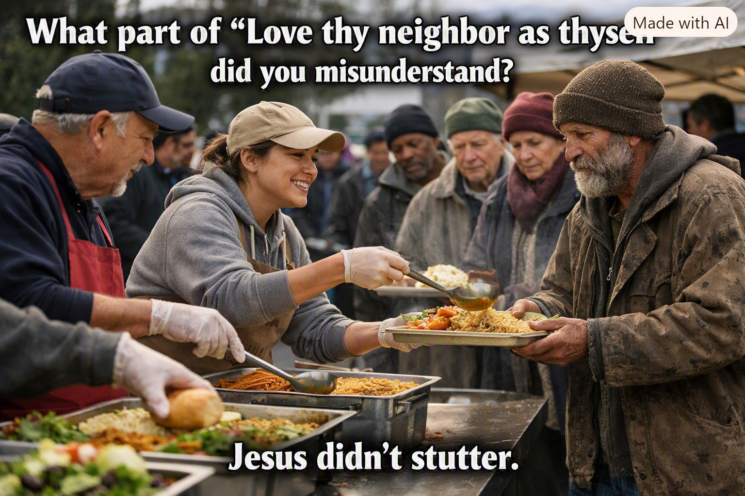
The call to love our neighbors must include those who are sick, poor, and vulnerable.
By Willis Butts | Medicare for All

A question of conscience
“Love thy neighbor as thyself” is more than a familiar religious phrase. It asks us to see another person’s suffering as worthy of our attention, compassion, and action. When someone cannot afford treatment, when a family fears bankruptcy after a diagnosis, or when a neighbor postpones care to keep the rent paid, that principle challenges us to do better.
Medicare for All is one proposed way to put that moral commitment into practice: a publicly financed healthcare system designed to cover everyone and reduce financial barriers to medically necessary care. It is not the only policy that can be debated in good faith. But the moral question remains: should access to essential treatment depend on the size of a person’s bank account?

Compassion should become a working system
Charity, churches, volunteers, and neighbors help people every day. Their generosity is invaluable. Yet a compassionate society should not require someone facing a medical emergency to depend on a fundraiser, a favorable insurance decision, or the luck of living near a charitable clinic.
A well-designed universal healthcare program could make help predictable rather than exceptional. It could establish coverage before illness strikes, simplify payment for care, and protect people from many medical bills that can push families into debt. This is how a moral value becomes a practical public system.

No one should be abandoned in sickness
Illness does not ask whether we are Republican or Democrat, Christian, Muslim, Jewish, of another faith, or of no faith at all. Cancer, diabetes, injuries, mental illness, and disability cross every boundary we draw between ourselves. Healthcare should reflect that shared vulnerability.
Religious believers may see the duty to care for the sick as a commandment. Others may reach the same conclusion through human dignity, fairness, mutual responsibility, or simple concern for their neighbors. We do not have to agree on theology to agree that preventable suffering matters.
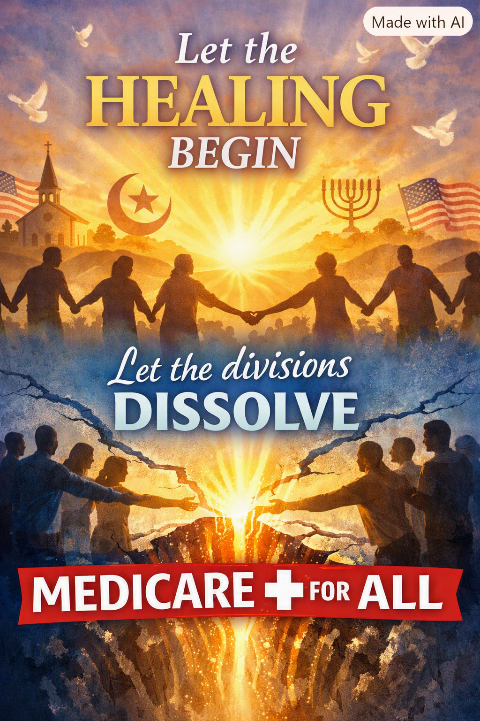
Healing our nation begins by recognizing our shared humanity across religious and cultural differences.

Healing our divisions through a common purpose
The debate over healthcare has become a symbol of political conflict. Yet Americans across political traditions care about protecting their families, supporting local hospitals, respecting medical professionals, and keeping healthcare affordable. Those shared priorities offer a place to begin.
Medicare for All should be evaluated with seriousness and openness: What benefits would be covered? How would taxes replace premiums and out-of-pocket payments? How would physicians and hospitals be paid? How would we maintain timely access and protect patients’ choice of providers? What would happen during the transition? These are difficult design questions, not reasons to stop talking.
The aim is not to defeat our fellow Americans. It is to create a healthcare system worthy of all of us. A policy that helps a political opponent’s child receive treatment helps our nation, too.
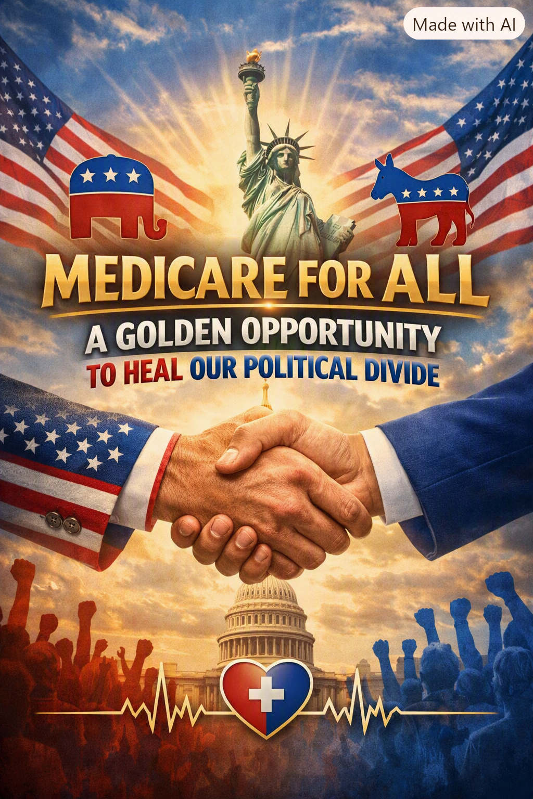
Healthcare can be a shared national goal rather than another reason to divide ourselves.

A moral imperative—and a practical responsibility
The moral case for Medicare for All is powerful, but compassion does not excuse careless planning. Universal coverage must be financed responsibly, preserve high-quality care, support the healthcare workforce, and be accountable for outcomes. Some proposals could reduce administrative waste and medical debt; their exact costs and savings depend on legislation and implementation.
We should debate those details vigorously. We should not confuse disagreement over a financing mechanism with indifference to human suffering. People of good faith can support different routes to universal access. The standard for every proposal should be whether it makes needed care more accessible, dependable, and affordable.

Let the healing begin
A nation demonstrates its greatness not only through wealth, technology, or military strength, but through how it treats people when they are most vulnerable. We have the resources, knowledge, and ingenuity to build a better healthcare system. What remains is the collective decision to make it a priority.
There is no “them,” only us. If we truly believe in loving our neighbors, then let us build institutions that express that love—not merely in words, but in the care people can count on when they need it most.
Let the healing begin. Let the divisions dissolve. Let us work together toward healthcare for everyone.

