ARTICLE 19

Judge Medicare for All on Its Merits, Not Its Political Label
A practical healthcare proposal deserves a practical debate
Willis Butts | Medicare for All
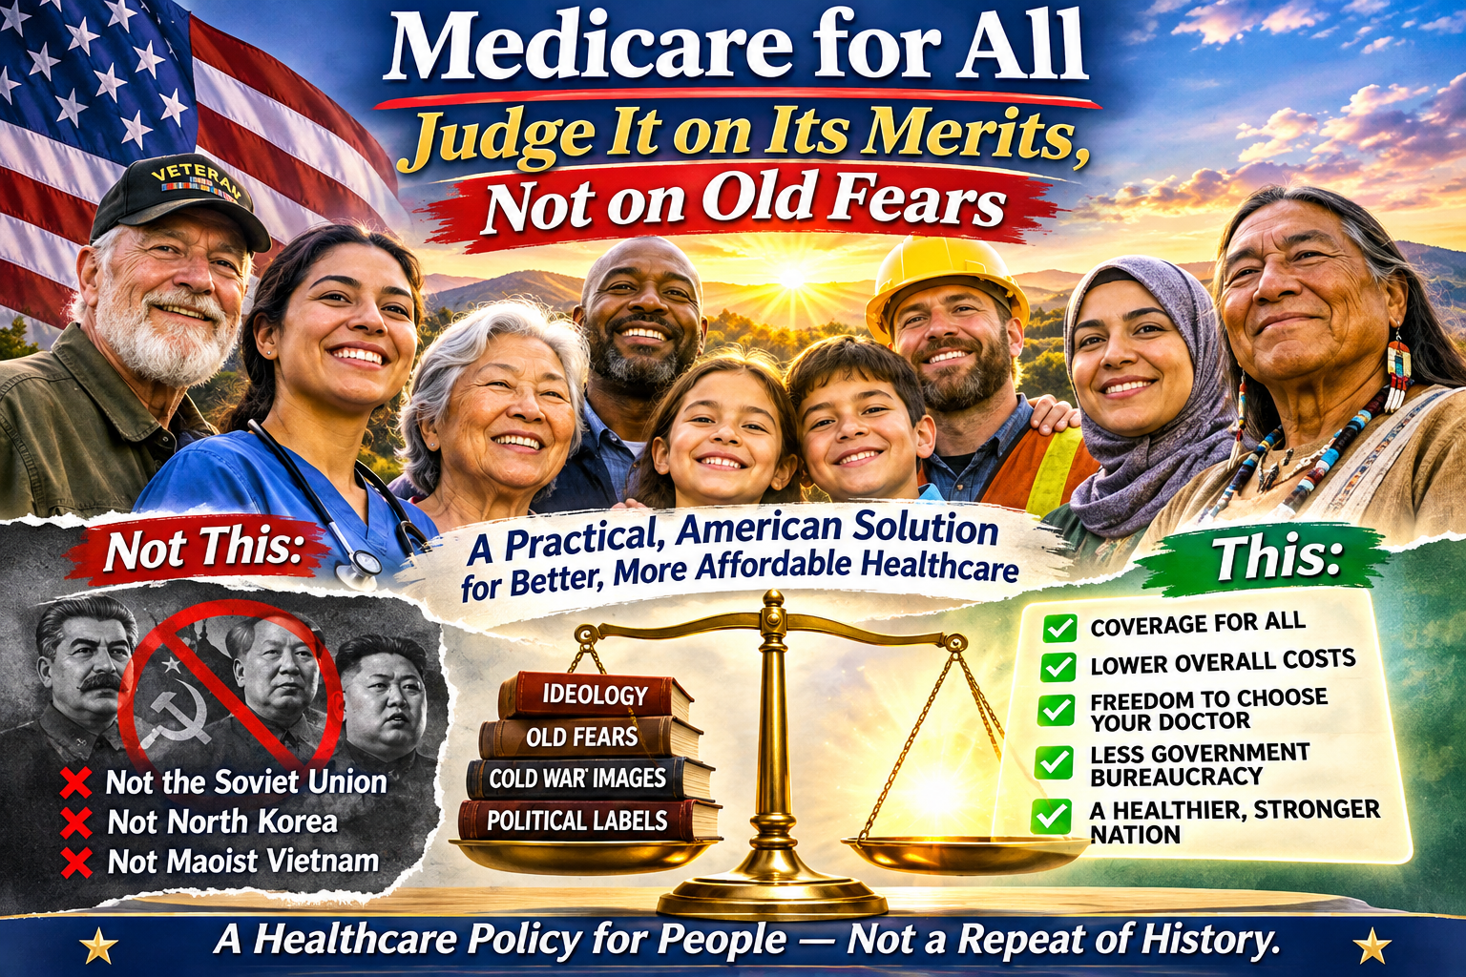
Editorial illustration supplied by the author. The graphic expresses a political perspective; it is not evidence that every position listed is held by every DSA member.

The debate we ought to be having
When Americans hear the phrase “Medicare for All,” some immediately think of socialism. The conversation can then turn to the Soviet Union, North Korea, or other authoritarian communist governments—before anyone has examined the actual healthcare proposal. That is a poor substitute for evaluating public policy.
An idea should stand or fall on its own merits: Who would be covered? Which services would be available? How would doctors and hospitals be paid? What would households and employers pay? Would care improve? Those are the questions that matter.

A healthcare financing system is not an authoritarian state
The Soviet Union and North Korea developed political and economic systems marked by extensive state control and profound restrictions on political freedom. Their histories raise serious concerns about concentrated power. But it does not follow that every publicly financed service reproduces those systems.
Medicare for All generally refers to proposals for universal health coverage financed through public funds. Under prominent U.S. single-payer proposals, many physicians and hospitals would remain privately operated even though a public program would pay for covered care. That is fundamentally different from abolishing private enterprise, political competition, or civil liberties.
Vietnam also should not be casually described as “Maoist Vietnam.” Its political history and economic reforms are distinct from Mao-era China. Sweeping analogies obscure rather than clarify the healthcare question.

We already accept public financing where it serves a purpose
Americans routinely combine private activity with public financing. Public schools, fire departments, roads, Social Security, and Medicare reflect different arrangements and purposes. Their existence does not make the United States the Soviet Union.
The relevant question is not whether a program can be labeled socialist. It is whether its benefits justify its costs and whether its design protects freedom, quality, accountability, and access.

The strongest objections deserve answers—not dismissal
Critics of Medicare for All raise concrete concerns: higher federal taxes, disruptions to existing insurance, possible provider-payment reductions, wait times, administrative transitions, and the risk of poorly managed public bureaucracy. Those are legitimate design and implementation questions, not automatically evidence of bad faith.
Supporters argue that a unified financing system could reduce insurance-related administrative complexity, improve negotiating power over prices, and prevent many families from facing premiums, deductibles, and medical debt. Those potential gains also require careful examination; savings are not guaranteed merely by changing the payer.
A credible proposal should publish its financing, define covered benefits, protect patient choice, assess effects on clinicians and hospitals, and establish measurable quality and access standards.

A shared moral goal need not require a shared ideology
People of different political and religious traditions may agree that illness should not destroy a family’s finances. A conservative may emphasize security and responsible spending. A liberal may emphasize equal access. A business owner may emphasize reduced employer burden. A person of faith may emphasize compassion. None must surrender their convictions to discuss the same healthcare design.
The words “socialist,” “progressive,” and “capitalist” can describe real differences in political philosophy. They should not be used as shortcuts that replace evidence.

Judge the proposal by results
Before rejecting or embracing Medicare for All, ask what it would do in practice. Would it expand access to necessary care? Reduce avoidable financial hardship? Maintain timely treatment? Treat providers fairly? Control costs transparently? Preserve democratic oversight and civil liberties?
If a proposed system cannot meet those tests, it should be revised. If it can, historical guilt by association is not a sufficient reason to reject it.
There is no “them,” only us. We deserve a healthcare debate that begins with people and evidence—not fear of a label.
Author’s note: This article is an argument for evaluating policy on its merits. It does not assert that ideology is the sole or predominant reason for opposition; public views and objections vary.

