MEDICARE FOR ALL • ARTICLE 21

The Status Quo Is Not a Healthcare Strategy
  - Why America needs a fundamental change of direction—not another round of minor repairs

Editorial illustration. The figures and claims shown in the graphic should be independently checked; they are not presented here as verified statistics.
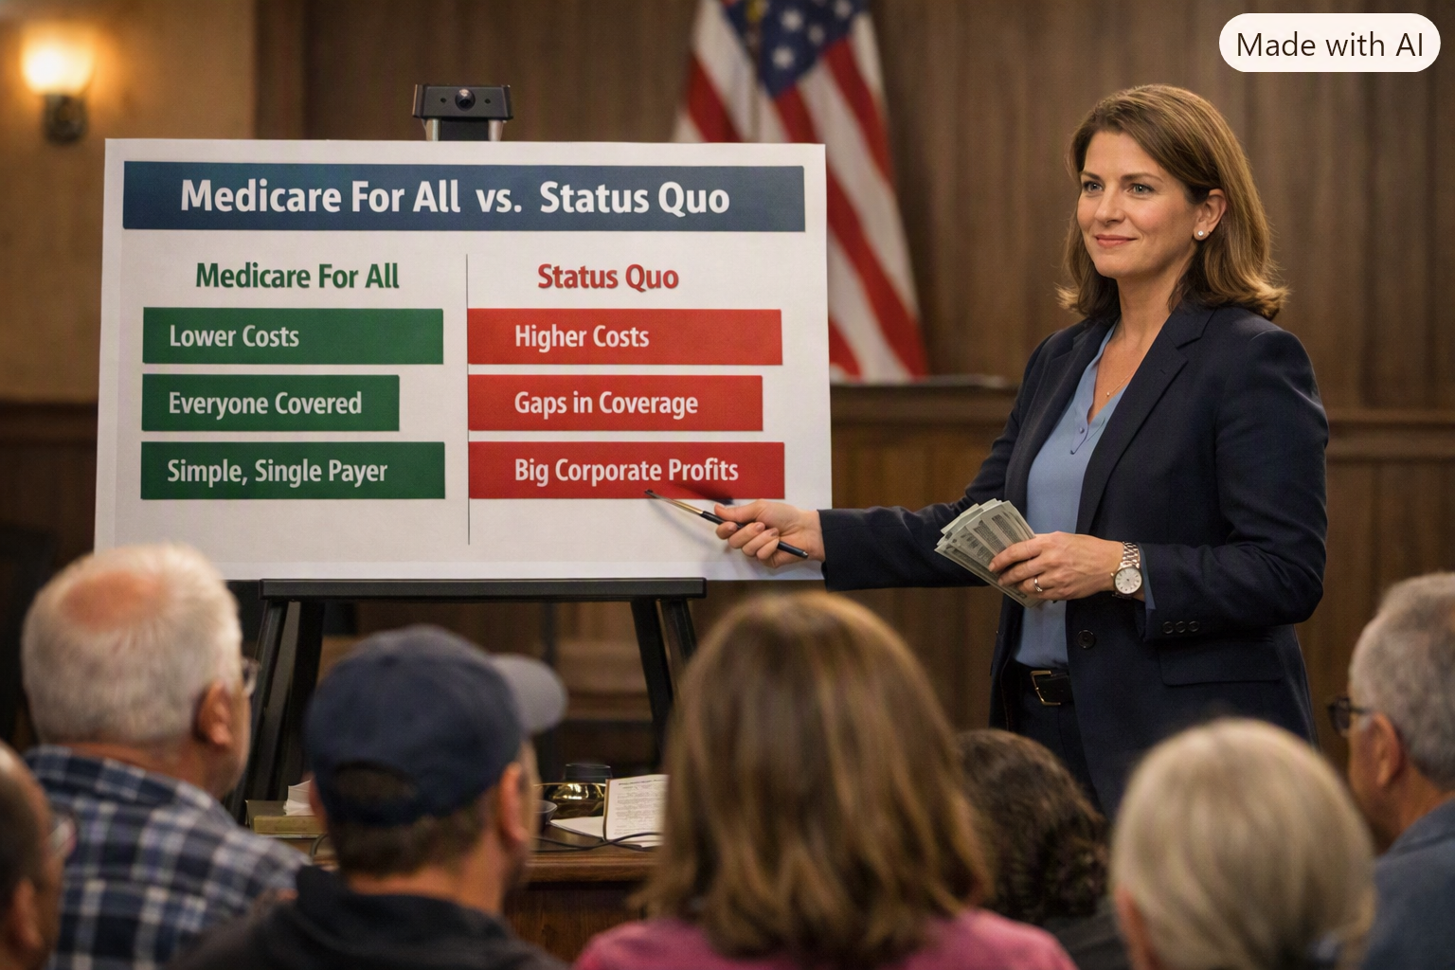
Illustrative town hall comparison of Medicare for All and the current system. Outcomes and costs depend on the details of any reform.

The question is no longer whether something is wrong
For decades, Americans have been told that the next adjustment to insurance markets, the next billing reform, or the next employer benefit redesign will finally make healthcare affordable. Yet many families still face premiums, deductibles, surprise expenses, disputed claims, and the fear that illness could disrupt their finances. A system can contain excellent clinicians and extraordinary medical technology while still failing to deliver dependable, affordable access to everyone.

The status quo is a policy choice
Keeping the present arrangement is not a neutral decision. It means continuing to rely on a fragmented mixture of employer coverage, individual insurance, Medicare, Medicaid, and other programs—with different rules, networks, and financial obligations. That complexity has costs. It consumes time for patients, employers, physicians, hospitals, and insurers. It also creates gaps when people change jobs, move, or experience financial hardship.

Why small fixes may not be enough
Incremental reforms can help: limits on surprise billing, stronger financial assistance, improved price transparency, and more effective oversight matter. But they do not necessarily remove the underlying dependence on multiple payers, varying benefits, and eligibility rules. When the design itself creates recurring barriers, treating each barrier separately may leave the central problem intact. That is the case for considering structural reform.

What the evidence tells us—and what it does not
The United States spends substantially more on healthcare per person than many other wealthy countries, without consistently achieving better population-level outcomes. Administrative complexity is one contributor, alongside prices, service intensity, and other factors. High spending alone does not prove that one particular reform will save money; it does demonstrate that current spending deserves rigorous scrutiny. Likewise, the graphic's specific claim about premium growth since 1999 should not be repeated as a verified fact without a defined measure, time period, and source.

A radical change in direction need not mean a reckless leap
Radical, in its original sense, means going to the root. A fundamental redesign can be careful, phased, transparent, and accountable. Medicare for All is one proposal: publicly financed coverage intended to replace much of today's insurance-related financial risk. Other universal-coverage models also merit comparison. The test should be whether a proposal improves access, health outcomes, financial protection, administrative simplicity, and long-term sustainability—not whether it sounds familiar.

What Medicare for All must answer
Supporters of Medicare for All should be prepared to explain how benefits will be defined, how care will be financed, how doctors and hospitals will be paid, how shortages and wait times will be managed, and how the transition will affect workers and existing programs. Critics are right to demand those answers. But criticism of a proposed replacement is not, by itself, a defense of keeping every defect of the current system.

The hidden price of doing nothing
The cost of the status quo is not measured only in dollars. It includes treatment postponed because of expense, hours lost to billing disputes, businesses managing benefits instead of their core work, and families anxious about the next diagnosis. Those harms are difficult to capture in a single budget line, but they are real considerations in public policy. The right comparison is not change versus a perfect present; it is the likely results of reform versus the likely results of continuing as we are.

A better standard for national ambition
America does not lack the expertise, wealth, or organizational capacity to pursue a better healthcare system. What it needs is a clear set of public goals and a willingness to evaluate alternatives honestly. Every proposal should be measured against the same questions: Does everyone have reliable access to necessary care? Can families seek treatment without financial devastation? Can providers spend more time caring and less time navigating paperwork? Is the system sustainable and fair?

A direction worth choosing
We do not have to agree that every feature of Medicare for All is settled. We do have to recognize that simply defending the familiar is not a plan. The future of American healthcare deserves more than slogans, patchwork, and resignation. It deserves a serious redesign grounded in evidence, compassion, and accountability. The status quo should have to earn its defense on the same terms as any proposed alternative.
Willis Butts | Medicare for All

