  - MEDICARE FOR ALL | ARTICLE 22

Why Do People Oppose Medicare for All?
  - Understanding the objections, the interests, and the evidence
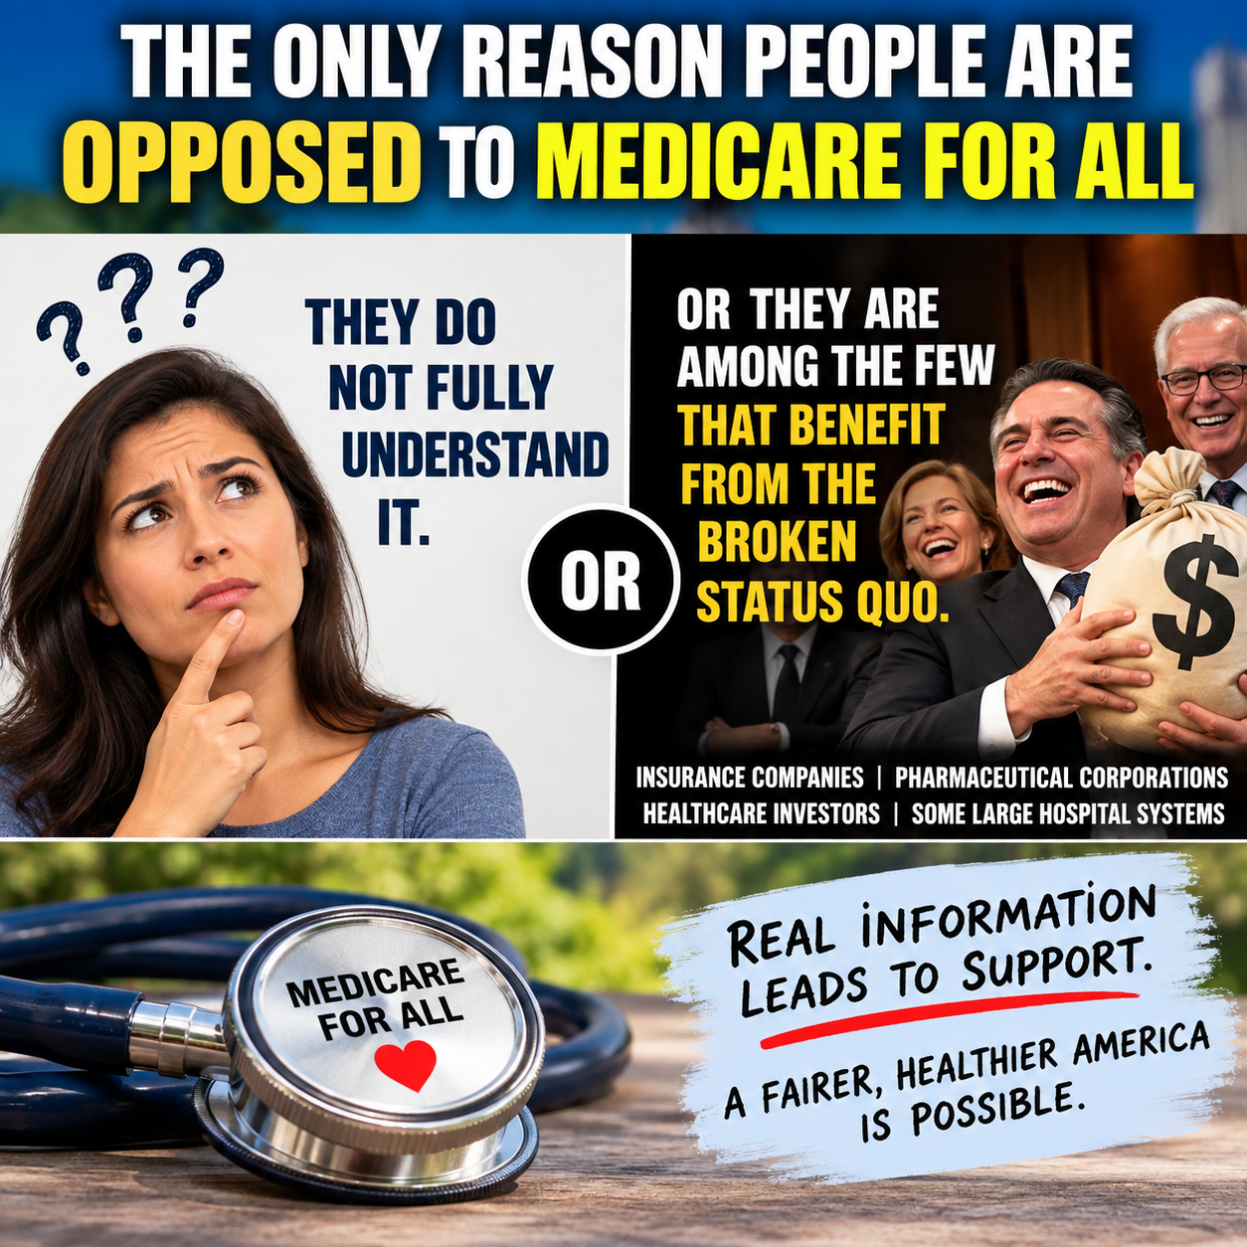
Editorial illustration supplied by the author. Its “only reason” claim is a provocative argument, not a demonstrated fact about every opponent.

A question worth asking
If a healthcare reform promises to make medically necessary care available to everyone, why does it face such determined opposition? The image accompanying this article offers a deliberately provocative answer: some people may misunderstand the proposal, while some institutions may benefit financially from the existing arrangements. Both possibilities deserve examination. But a serious national conversation also needs to acknowledge that people can oppose Medicare for All for reasons other than ignorance or self-interest.

What Medicare for All actually proposes
Medicare for All generally refers to a publicly financed national health insurance program intended to cover residents comprehensively. Hospitals and medical practices need not become government-owned. Under leading proposals, private and nonprofit providers could continue delivering care while a public program pays covered bills. The exact benefits, provider rates, taxes, and transition rules would depend on the law Congress enacts. A proposal should be evaluated by those details—not by a label.

Misunderstandings can shape opinions
Some objections arise from confusion between government financing and government ownership of medicine. Others assume that any increase in federal taxes is necessarily an increase in total household healthcare spending, overlooking the premiums, deductibles, copayments, and employer contributions that might be replaced. That does not mean every family would save money. Financing choices create winners and losers, and honest analysis must show who pays more, who pays less, and how care would change.

Financial interests are real—but not uniform
Private insurers, pharmaceutical manufacturers, hospital systems, investors, employers, and medical professionals all have stakes in how healthcare is financed. Some existing revenue streams, pricing leverage, and administrative functions could be reduced or reorganized under a single-payer system. Organizations therefore have incentives to advocate for policies that protect their interests. Yet those industries are not monolithic: hospitals worry about reimbursement levels, workers worry about jobs, and clinicians may support simplified billing while opposing inadequate payment rates. Financial incentives should be disclosed and debated, not used as proof of anyone’s personal motives.

Legitimate objections deserve answers
People may reasonably worry about the tax structure, federal budget exposure, wait times, capacity constraints, physician payment rates, disruption of existing coverage, or concentration of administrative power. These are not automatically bad-faith talking points. They are design problems requiring concrete answers, independent estimates, transparent implementation plans, and protections for patients and workers. A persuasive reform movement should welcome those questions.

What should determine the verdict?
The fairest test is comparative: How many people are covered? How much do households and employers pay in total? How timely is access? What happens to medical debt? How much administrative work is eliminated? Are clinicians and hospitals adequately supported? Can the system adapt and remain accountable? The present system must answer those same questions. It should not receive a free pass simply because it already exists.

A better way forward
Medicare for All deserves consideration on its own merits, with rigorous cost estimates and a transition plan that safeguards access and livelihoods. Opponents should explain what alternative will reliably deliver affordable, high-quality care to everyone. Supporters should explain precisely how their proposal will work. Neither side should substitute caricatures for evidence.

The bottom line
Our shared objective should be a healthcare system that helps people recover rather than fear the bill. We do not have to agree on every mechanism to insist that the system serve patients first. There is no “them,” only us—and every American deserves an informed, respectful debate about how to get there.
Willis Butts | Medicare for All

