The Healthcare System Isn’t Broken — It’s Doing What It Was Built to Do
  - Article 9 | Medicare for All
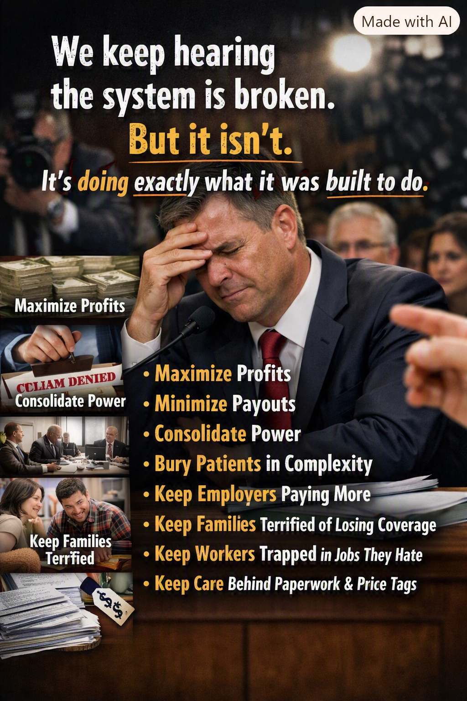
Illustration supplied for this article. Its claims are arguments for debate, not findings about every insurer, employer, or public official.

What do we mean by “broken”?
Americans often describe their healthcare system as broken. They point to medical bills, confusing insurance rules, denied claims, and the fear that losing a job could mean losing coverage. Yet the system is not failing at everything it was designed to accomplish. Private insurance is also a business: insurers collect premiums, manage risk, negotiate prices, and seek financial sustainability. In for-profit companies, returning value to investors is another legitimate corporate objective. The trouble begins when the incentives that reward a business do not consistently reward timely, affordable care for the person who needs it.

The incentive problem
A health insurer can improve its financial position by attracting healthier members, controlling the prices it pays, and avoiding unnecessary treatment. Some utilization review is intended to prevent waste or harmful care. But the same tools can impose paperwork, delay necessary treatment, or produce denials that patients and clinicians must appeal. The question is not whether every denial is wrong. It is whether the rules make the patient’s health the central measure of success—and whether people have a fair, accessible way to challenge decisions.

Complexity is a cost we all pay
A hospital or medical practice may have to navigate different contracts, billing codes, prior-authorization rules, networks, and appeals processes for many insurers. Employers maintain benefits programs. Families spend hours comparing plans, tracking deductibles, and disputing bills. These activities consume time and money even when no additional care is delivered. A simpler financing system could reduce some of that administrative burden. It would not eliminate the need for budgeting, fraud prevention, quality oversight, or decisions about which treatments are covered.

Why businesses should care
Employer-sponsored insurance makes healthcare a recurring business expense. Premium increases can compete with wage growth, hiring, and investment. Small businesses may struggle to offer benefits comparable to those of large employers. Workers may hesitate to change jobs or start companies because they fear losing affordable coverage. A universal system could reduce these connections between employment and access to care. But businesses would still need to evaluate how any replacement taxes or contributions compare with the premiums and costs they pay today.

Profit is not the same thing as care
Doctors, nurses, hospitals, and medical innovators must be paid, and well-designed incentives can encourage effective treatment and discovery. The concern is not that every participant earns money. It is that the financing system can reward administrative maneuvering and market leverage as well as better health outcomes. We should ask which activities deliver care, which merely transfer money between institutions, and which are truly necessary to protect patients.

What Medicare for All could change
A well-designed Medicare for All proposal would replace much of the current patchwork of private financing with a common public coverage framework. Depending on its precise design, it could make coverage continuous, simplify billing, and reduce the financial shock of illness. The proposal also raises serious questions: How would providers be paid? How would taxes replace premiums? What would happen to current insurance workers? How would the system preserve access, innovation, and timely care? Those are design questions to answer, not reasons to stop the conversation.

A standard worth demanding
The most useful test of any healthcare reform is not whether it fits a political label. It is whether people can get needed care without financial ruin, whether clinicians can spend more time treating patients, whether employers face predictable costs, and whether the nation receives good outcomes for the money it spends. If the present system reliably delivers revenue while leaving too many people anxious about coverage and bills, we should be willing to redesign its incentives. Healthcare should be organized around the people it exists to serve.

Questions readers can ask
How much time and money do we spend administering coverage rather than providing care? How often are medically necessary services delayed? What would each household and employer pay under a specific reform plan? What independent measures would tell us whether reform succeeds?
Editorial note: This article presents a policy argument. Claims about systemwide motives should not be read as evidence that every insurance decision is made in bad faith.

