ARTICLE 14
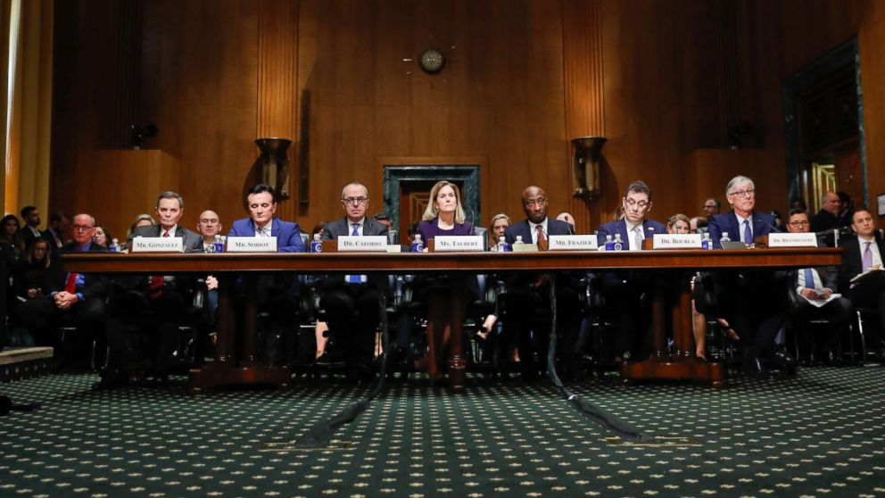
Congressional hearing photograph — archival image; date and participants not independently verified.

When Denying Care Becomes a Business Strategy
What Congress asked insurance executives—and what the answers reveal about healthcare incentives
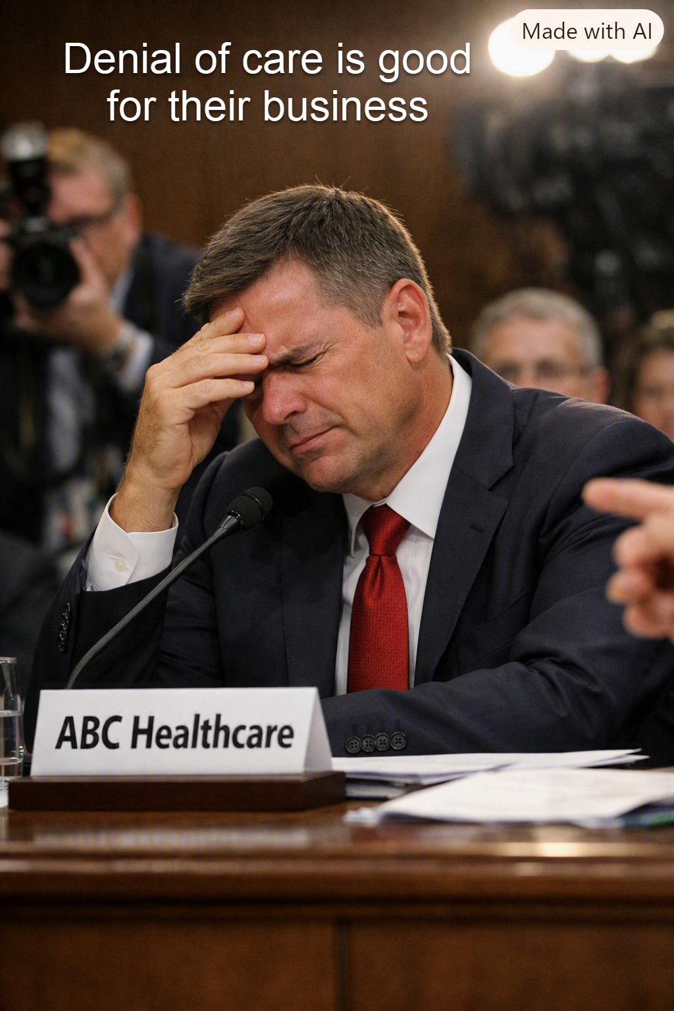
Illustration: a fictional insurance executive. The picture is commentary, not a depiction of a named witness.

A question Americans have every right to ask
If a patient needs treatment and an insurance company refuses to pay, the immediate consequences fall on the patient, the family, and the medical team. Yet the insurer may avoid an expense. That tension raises a serious systems-design question: can a business entrusted with financing care also benefit financially when care is not paid for?
Not every denial is improper. Plans need rules to prevent fraud, billing errors, and unnecessary treatment. But a legitimate review process should be accurate, timely, transparent, and easy to challenge. The financial incentive to spend less must never substitute for medical judgment.

What happened at the January 22, 2026 congressional hearings
On January 22, 2026, senior executives from UnitedHealth Group, CVS Health, Elevance Health, Cigna, and Ascendiun testified before congressional committees examining healthcare affordability. Lawmakers from both parties questioned rising premiums, denials, prior authorization, corporate concentration, and executive compensation.
Representative Kim Schrier, a Democrat from Washington, described a constituent who had been denied coverage for hospitalization following a stroke. In questioning UnitedHealth Group CEO Stephen Hemsley, she argued that the pattern of denials looked like a business model built on patients becoming exhausted by appeals. That was the lawmaker’s allegation—not an admission by the executive.
Representative Buddy Carter, a Republican from Georgia and a pharmacist, pressed the executives about having to tell patients their prescribed medication would not be covered. His questions illustrated that concerns about denied care crossed party lines.
The executives defended aspects of their operations and pointed to other contributors to high costs, including hospitals and drug companies. One witness, Paul Markovich of Ascendiun, acknowledged in prepared testimony that parts of the healthcare system, including health plans, had placed profits ahead of patients or tolerated complexity. That broader criticism should not be confused with a specific confession that denying necessary care was an intentional company policy.

The economic incentive behind a denial
In a conventional insurance arrangement, premium revenue pays for covered claims, administration, and other expenses. Paying fewer claims can reduce costs in the short term. However, insurers are also subject to contractual duties, medical-loss-ratio rules, regulations, oversight, appeals, and reputational pressures. It would be inaccurate to assume that every denial increases net profit or that every denied claim is medically justified.
The deeper concern is misalignment: the person who makes a coverage decision may work inside an organization whose financial objectives differ from the patient’s immediate medical needs. When appeal procedures are confusing, patients can abandon valid claims simply because they cannot navigate the process.
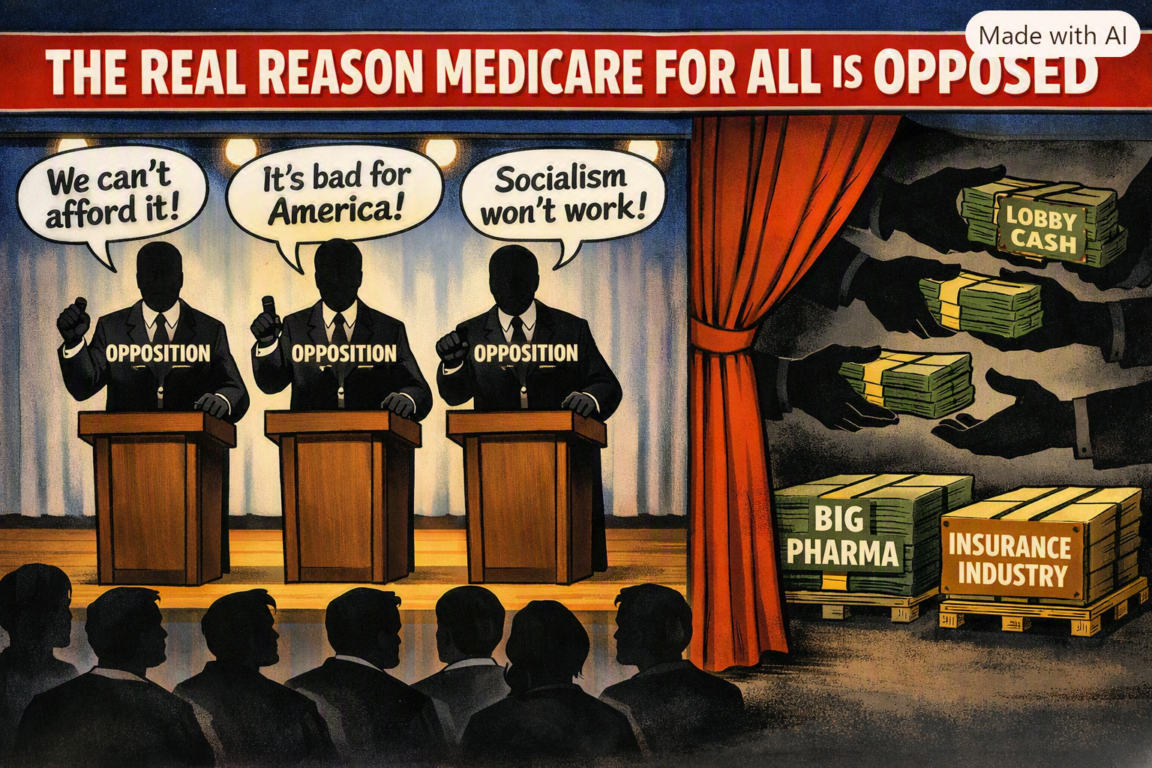
Illustration: a political cartoon about opposition arguments and lobbying. It expresses an opinion; it is not evidence of specific payments or motives.

Follow the money—but also follow the evidence
Insurers, pharmaceutical manufacturers, hospital systems, employers, and patients operate within a complicated set of incentives. Some financial controls protect patients and taxpayers from waste. Others can create barriers to necessary treatment. Any reform proposal should distinguish the two rather than treating all utilization review as abuse.
The congressional hearings provided vivid testimony and bipartisan scrutiny. They did not, by themselves, establish that every major insurer deliberately denies medically necessary care to increase profits. Establishing such a claim requires company records, representative denial data, independent audits, and evidence about appeals and patient outcomes.

What would Medicare for All change?
A comprehensive single-payer proposal would replace much of the fragmented private insurance payment structure with a publicly financed system. Depending on the design, it could simplify eligibility, reduce duplicated billing work, and replace insurer-specific coverage restrictions with uniform public rules.
Public financing would not eliminate hard decisions about which treatments to cover, how quickly care can be delivered, or how much providers are paid. It would move those decisions into a different accountability structure. The key tests should be whether patients receive medically appropriate care promptly, whether appeals are fair, and whether costs are sustainable.

A better standard for any healthcare system
Coverage decisions should be based on clinical evidence and clearly explained. Patients should receive prompt independent appeals, especially when delays could cause harm. Denial rates, reversal rates, processing times, and patient outcomes should be publicly reported in comparable formats.
The goal is not to prohibit healthcare organizations from operating efficiently. It is to ensure that financial success does not depend on obstructing necessary care. Whether policymakers favor Medicare for All or another approach, the same principle applies: patients should not have to fight a bureaucracy while fighting an illness.

Sources and further reading
U.S. House Committee on Ways and Means, “Full Committee Hearing with Health Insurance CEOs,” January 22, 2026. https://waysandmeans.house.gov/event/full-committee-hearing-with-health-insurance-ceos/
U.S. House Committee Repository, hearing materials and witness statements, January 22, 2026. https://docs.house.gov/Committee/Calendar/ByEvent.aspx?EventId=118887
Rebecca Pifer, Healthcare Dive, “Insurance CEOs’ no good, very bad day on the Hill,” January 23, 2026. https://www.healthcaredive.com/news/health-insurance-ceos-house-hearings-affordability/810269/
NBC News reporting republished by Rep. Kim Schrier, “Health insurance CEOs grilled on high costs of care in back-to-back House hearings,” January 22, 2026. https://schrier.house.gov/media/in-the-news/health-insurance-ceos-grilled-high-costs-care-back-back-house-hearings

