A New Foundation for Families
  - Free Child Care Through Public Schools
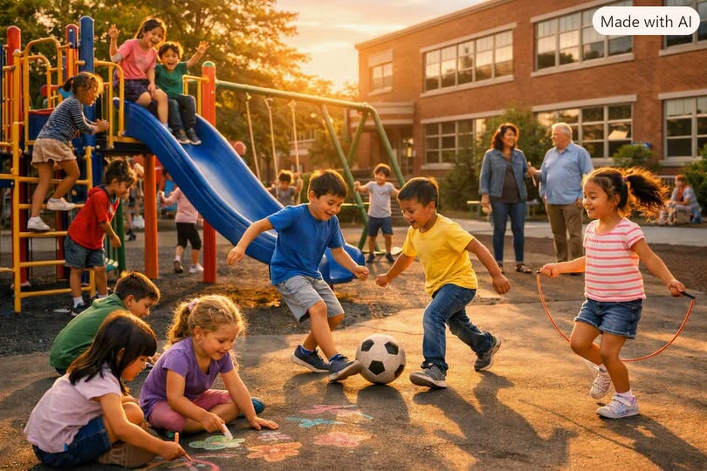
America’s public schools are the backbone of community life. They educate, feed, and protect millions of children every day. Yet for millions of working parents, the greatest challenge comes before and after the school day — and long before kindergarten begins. The lack of affordable child care forces families into impossible choices: work or care, income or stability. It’s time to rethink the role of public education and extend its reach to the earliest years of life.
The proposal is simple: allow school districts to independently opt in to provide free child care, from birth through age five, integrated into the public school system — operating 24 hours a day, seven days a week.

I. The Case for Universal Child Care
Child care is not a luxury; it is infrastructure.
It enables parents to work, study, and contribute to society. It shapes the cognitive and emotional development of children during their most formative years. Yet in the United States, child care costs more than college tuition in many states. Families spend thousands per month, and providers struggle to survive on low wages. The system fails both sides.
Public schools already have:
- Buildings, kitchens, and playgrounds
- Trained educators and administrators
- Transportation networks
- Health and safety standards
- Community trust
Expanding their mission to include early childhood care is not radical — it’s logical.

II. The Opt-In Model: Local Control, National Vision
Each school district could independently opt in to the program. This respects local autonomy while creating a national framework for universal access.
How it works:
- Districts apply for federal or state funding to convert unused classrooms or facilities into child care centers.
- Staffing combines certified early-childhood educators, paraprofessionals, and trained caregivers.
- Hours are flexible — up to 24/7 coverage for families working night shifts, weekends, or irregular hours.
- Enrollment is free for residents, with priority for low-income families.
- Oversight remains local, ensuring quality and accountability.
This model mirrors how public schools themselves evolved — locally governed, nationally supported.

III. Ages Zero to Five: The Missing Years
Brain development between birth and age five determines lifelong outcomes.
Children who receive consistent, nurturing care and early education:
- Enter kindergarten ready to learn
- Have higher graduation rates
- Experience fewer behavioral issues
- Require less remedial support later
By integrating child care into public schools, we create a seamless educational continuum — from infancy to high school graduation.

IV. 24/7 Access: Meeting Real-World Needs
Modern families don’t live on a 9-to-5 schedule. Nurses, factory workers, delivery drivers, and service employees often work nights and weekends. A 24/7 child care model recognizes this reality.
Benefits:
- Reduces absenteeism and job loss among parents
- Supports single parents and shift workers
- Provides safe, supervised environments for children at all hours
- Strengthens community resilience during emergencies
Schools already operate as community hubs — adding round-the-clock child care simply extends that role.

V. Economic and Social Impact
1. Workforce Participation — Free child care increases labor participation, especially among women. It boosts productivity and household income while reducing reliance on social assistance.
2. Education and Equity — Children from all backgrounds receive equal access to early learning, closing achievement gaps before they begin.
3. Public Health — Integrated care allows regular health screenings, nutrition programs, and mental-health support from infancy onward.
4. Economic Efficiency — Every dollar invested in early childhood yields up to $7 in long-term returns through higher earnings, lower crime, and reduced welfare costs.

VI. Implementation Pathway
Step 1: Pilot Programs — Launch in volunteer districts with high need and available space.
Step 2: Funding — Blend federal education grants, local taxes, and philanthropic partnerships.
Step 3: Workforce Development — Train early-childhood educators through community colleges and teacher-prep programs.
Step 4: Infrastructure Conversion — Repurpose unused classrooms, libraries, or administrative spaces for child care centers.
Step 5: Evaluation — Track outcomes in child development, family stability, and economic growth.

VII. The Broader Vision
Free child care through public schools is not just a social program — it’s a statement of values.
It says that every child deserves care, every parent deserves support, and every community deserves stability.
It redefines education as a lifelong continuum, beginning at birth and extending through adulthood.

VIII. Conclusion: Building the Future Together
There will always be a market for child care — because there will always be families.
By allowing school districts to opt in to free, 24/7 child care for ages zero to five, we can transform public education into a complete system of care.
This is not charity; it is investment.
It is the foundation of a stronger, more equitable society — one where every child is nurtured, every parent is empowered, and every community thrives.

