Growing Upward
  - Transforming Empty Towers and Obsolete Factories into Urban Vertical Farms
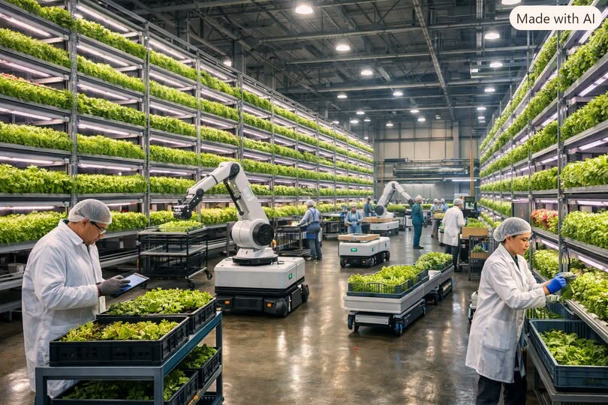
Across the United States, the economic landscape is shifting in ways that would have been unthinkable just a decade ago. Remote work has hollowed out downtown office districts. Automation and global supply chains have left once-thriving factories sitting idle. Cities everywhere are dotted with high-rise towers and industrial buildings that no longer serve their original purpose. Yet these structures — symbols of a past economic era — hold the potential to become the backbone of a new one.
The next great urban transformation is simple, practical, and inevitable: convert unused high-rise office buildings and obsolete factory buildings into vertical farming operations. Food will always have a market in urban areas. People may stop commuting, but they will never stop eating.
This is the opportunity of our time.

I. The Urban Food Problem We Can Solve
Cities consume enormous quantities of food every day, yet almost none of it is produced locally. Instead, it travels hundreds or thousands of miles from rural farms, passing through distribution centers, trucking networks, and cold-storage facilities. This system is fragile, expensive, and environmentally destructive.
Meanwhile, cities face:
- Rising food insecurity
- Supply chain disruptions
- Higher transportation costs
- Increasing demand for fresh, local produce
At the same time, millions of square feet of office and industrial space sit unused — heated, cooled, and maintained for tenants who may never return. These buildings are not liabilities. They are untapped agricultural infrastructure.

II. Why Vertical Farming Belongs in Cities
Vertical farming uses stacked hydroponic or aeroponic systems to grow crops indoors under controlled conditions. It is the most efficient form of agriculture ever developed.
Key advantages:
- Up to 10–20× more yield per square foot
- 90–95% less water usage
- No pesticides or herbicides
- Year-round production
- Near-zero transportation costs
- Freshness measured in hours, not days
Urban vertical farms can supply grocery stores, restaurants, hospitals, schools, senior living facilities, and food banks.
The demand is permanent and guaranteed.

III. High-Rise Office Buildings: Ready-Made Farms
Empty office towers already contain the core infrastructure vertical farms need:
- Climate control systems
- Water lines and drainage
- Electrical capacity for LED grow lights
- Freight elevators
- Loading docks
- Fire suppression systems
- Strong floors designed for heavy equipment
Each floor becomes a micro-farm: leafy greens on one level; herbs and spices on another; strawberries, mushrooms, or microgreens on the next; seedling propagation on the top floors; and packaging and distribution on the ground level.
The building becomes a living organism — producing food instead of paperwork.

IV. Obsolete Factories: The Perfect Agricultural Conversion
Old factories offer something office towers cannot: wide-open floor plans and massive square footage. These buildings are ideal for:
- Large-scale hydroponic systems
- Aquaponics (fish + plants)
- Mushroom cultivation
- Climate-controlled fruit production
- Automated harvesting systems
- Research and development labs
Factories were built for industrial output. Vertical farming simply replaces the old assembly lines with new ones — lines that grow food instead of manufacturing goods.

V. Economic Benefits: A New Urban Industry
1. Permanent Demand — Food demand never disappears. Vertical farming creates a stable, recession-proof industry inside the city itself.
2. Job Creation — Urban agriculture generates technicians, electricians, plumbers, biologists, data analysts, delivery drivers, packaging workers, and maintenance crews. This is a workforce transition strategy for cities losing office and manufacturing jobs.
3. Real Estate Revitalization — Property owners gain new revenue streams. Cities stabilize tax bases. Blighted districts become productive again.
4. Energy Efficiency — Vertical farms can integrate solar panels, battery storage, rainwater harvesting, waste-to-energy composting, smart sensors, and automation. Buildings become carbon-negative assets.

VI. Environmental and Social Impact
1. Reduced Emissions — Local food eliminates long-distance trucking, refrigeration, and packaging waste.
2. Food Security — Cities become self-reliant during supply chain disruptions, natural disasters, and economic shocks.
3. Healthier Communities — Fresh produce improves nutrition, especially in food deserts.
4. Urban Renewal — Green towers and revitalized factories transform the visual and cultural identity of cities.

VII. Policy Pathways to Make It Real
Cities can accelerate this transformation by:
- Offering tax credits for agricultural conversion
- Updating zoning laws to classify vertical farms as essential infrastructure
- Creating public-private partnerships
- Funding workforce training programs
- Supporting research through universities
- Incentivizing local food procurement for public institutions
This is not a futuristic fantasy — it is a practical redevelopment strategy.

VIII. Conclusion: The Future Grows Upward
Unused office towers and obsolete factories are not symbols of decline. They are the raw material for a new era of urban agriculture. Vertical farming is the logical next step in the evolution of cities — efficient, sustainable, profitable, and resilient.
There will always be a market for food in urban areas.
The question is not whether vertical farming belongs in cities.
The question is why we haven’t already filled every empty building with life.
The skyscrapers and factories that once powered the industrial age can now feed the digital age — growing upward, feeding millions, and proving that cities can be producers, not just consumers.
This is how we build the future.

