Medicare for All: The Most Powerful Competitiveness Strategy American Business Has Never Tried
  - American industry • Workforce productivity • Global competitiveness
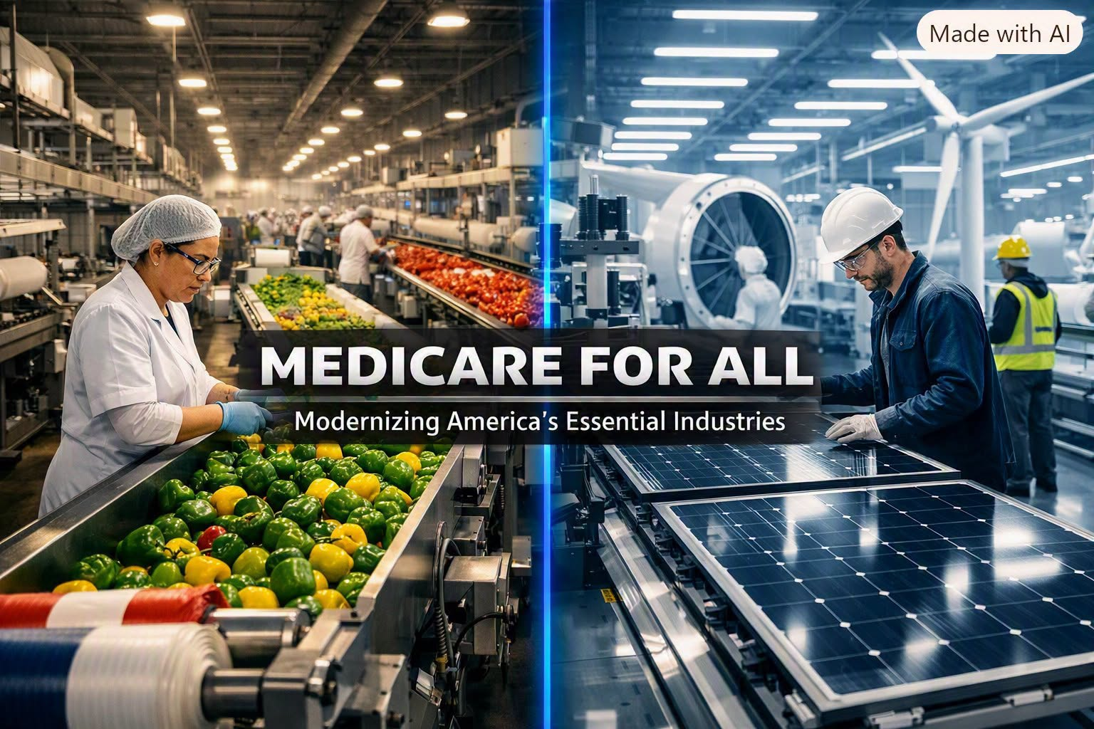
American business leaders spend enormous energy debating taxes, regulation, trade policy, and labor costs. Yet the single largest structural disadvantage facing U.S. companies in the global marketplace is hiding in plain sight: the American healthcare system. No other advanced economy forces its employers to shoulder such massive, unpredictable, and inflationary healthcare expenses. Medicare for All is not a political slogan — it is the most direct, measurable, and economically rational way to make American business competitive internationally.

I. The Employer Healthcare Burden: A Hidden Tax on Every Company
U.S. employers pay thousands of dollars per worker every year for health insurance premiums, administrative overhead, and cost-sharing arrangements. These expenses function as a private tax on employment — one that foreign competitors simply do not pay. Companies in Germany, Canada, Japan, and the United Kingdom operate within universal systems that provide healthcare as a public good, freeing businesses from the obligation to finance medical coverage.
This difference matters. When American firms must absorb $15,000–$20,000 per employee in health-related costs, they start every fiscal year at a disadvantage. That money could have gone toward wages, research, automation, expansion, or price reductions. Instead, it disappears into a fragmented insurance market that delivers inconsistent coverage at inflated prices.

II. The Indirect Costs: Productivity Losses That Never Show Up on a Balance Sheet
The direct cost of premiums is only the beginning. The American healthcare system imposes enormous indirect costs on employers through absenteeism, presenteeism, untreated chronic illness, and stress-related productivity losses. Workers delay care because of deductibles and copays. They show up sick because they fear medical bills. They skip preventive visits because coverage is confusing or unaffordable.
These behaviors reduce output, increase errors, and raise turnover. A universal system that eliminates financial barriers to care would produce a healthier, more reliable workforce. That is not ideology — it is basic economics. Healthy workers are productive workers, and productive workers make competitive companies.

III. Administrative Waste: The Billion-Dollar Drag on American Industry
The United States maintains the most administratively complex healthcare system in the world. Employers must navigate insurance networks, billing codes, claims disputes, enrollment cycles, and compliance requirements. Hospitals and clinics employ armies of billing specialists whose sole job is to negotiate with insurers.
This administrative bloat is a massive deadweight loss. It consumes time, money, and labor without producing a single medical benefit. Medicare for All would replace this labyrinth with a streamlined, unified system that dramatically reduces overhead. Lower administrative costs mean lower total costs — and lower total costs mean stronger international competitiveness.

IV. The Deflationary Power of a Single-Payer System
Healthcare inflation has outpaced wage growth and general inflation for decades. Premiums rise every year, often by double-digit percentages, and employers have no leverage to stop it. The current system is structurally inflationary because every private actor — insurers, hospitals, drug manufacturers, and middlemen — has an incentive to raise prices.
A single-payer system introduces the one force capable of reversing this trend: unified negotiating power. Medicare already pays significantly lower rates than private insurers for identical services. Extending that purchasing power across the entire system would create downward pressure on prices, stabilizing costs for employers and freeing capital for investment.
Deflation in healthcare is not just a policy win — it is a competitive advantage.

V. The Return of a Vibrant American Manufacturing and Industrial Base
One of the most overlooked benefits of Medicare for All is its potential to revive American manufacturing — not through subsidies, tariffs, or industrial policy, but by removing the single largest structural cost disadvantage U.S. factories face.
For decades, American manufacturers have struggled against foreign competitors whose governments provide universal healthcare. When a German automaker, a Japanese electronics firm, or a Canadian aerospace manufacturer hires a worker, healthcare is not a line item on the company’s ledger. In the United States, it is one of the largest.
This difference distorts global competition. It makes American-made goods more expensive, squeezes margins, and discourages domestic production. It pushes companies to offshore labor simply to escape healthcare costs — not wages, not regulations, but healthcare.
Medicare for All flips this equation.
By removing healthcare from the employer’s balance sheet, American factories would instantly become more cost-competitive. The savings could be redirected into:
- modernizing equipment
- expanding production lines
- reshoring previously offshored jobs
- raising wages to attract skilled labor
- investing in automation and advanced manufacturing
A universal system would also strengthen the industrial workforce itself. Manufacturing depends on physically demanding labor, and untreated injuries, chronic conditions, and delayed care reduce reliability and output. Universal coverage ensures workers receive timely treatment, rehabilitation, and preventive care — keeping them on the job and performing at full capacity.
The United States once led the world in steel, automobiles, electronics, shipbuilding, and heavy machinery. That dominance was built on a workforce that was healthy, stable, and affordable to employ. Medicare for All recreates the conditions necessary for that kind of industrial strength — not by turning back the clock, but by removing the structural barriers that have weakened American manufacturing for decades.
A revitalized industrial base is not a nostalgic dream. It is a direct economic consequence of eliminating the employer healthcare burden.

VI. Entrepreneurship and Labor Mobility: Ending Job Lock
Millions of Americans stay in jobs they dislike or avoid starting businesses because they fear losing health coverage. This “job lock” suppresses innovation, reduces labor mobility, and limits the formation of new enterprises. Medicare for All eliminates this barrier entirely.
Workers could change jobs, start companies, pursue creative ventures, or retire earlier without risking their health or finances. A dynamic labor market is a competitive labor market. Universal coverage unleashes the entrepreneurial energy that has always driven American economic leadership.

VII. Global Competition: Removing America’s Self-Inflicted Handicap
Foreign companies do not spend their time negotiating insurance premiums or absorbing unpredictable medical costs. They focus on production, innovation, and wages. American companies, by contrast, must operate inside a system that drains resources, reduces productivity, and inflates prices.
Medicare for All would instantly remove this structural handicap. It would align the United States with every other advanced economy that treats healthcare as infrastructure rather than a private commodity. It would allow American businesses to compete on quality, efficiency, and innovation — not on their ability to navigate a dysfunctional insurance market.

Conclusion: The Smartest Economic Reform Is Also the Simplest
Medicare for All is not about ideology. It is about competitiveness. It is about freeing American businesses from a burden no other advanced economy imposes. It is about unleashing productivity, stabilizing costs, strengthening the workforce, and rebuilding the industrial foundation that once made the United States an economic powerhouse.
If American business leaders truly want to compete internationally, the most powerful step they can take is to champion a universal healthcare system. Medicare for All is not just good policy — it is the smartest economic investment the United States can make.

