Medicare For All Americans
  - A Practical, Bipartisan, Pro-Business Solution
A deep dive into what Walmart spends on health care, what their employees spend, and the small amount of good it all does.
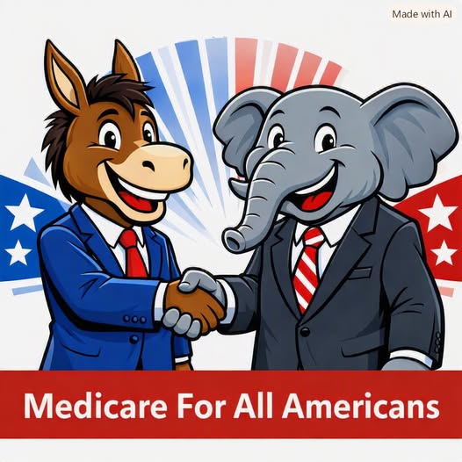
For decades, healthcare in the United States has been framed as a political battleground — a clash of ideologies, parties, and talking points. But when you strip away the noise, the truth becomes impossible to ignore: Medicare For All is not a left-wing dream or a right-wing threat. It is a practical, economically rational, and deeply bipartisan solution to a system that is failing Americans and American businesses alike.
The real divide is not between Democrats and Republicans. It is between ordinary people — workers, families, small business owners — and a healthcare system that drains resources, suppresses wages, and punishes innovation. When we look at the issue through the lens of economic reality rather than political branding, Medicare For All emerges as one of the most pro-growth, pro-business reforms available to the United States.

I. The Current System Is Economically Irrational — and Every Industry Pays the Price
American healthcare is the most expensive in the world, yet delivers worse outcomes than nations that spend far less. This is not because Americans use more healthcare — in fact, they often use less. It’s because the system is structurally inefficient, fragmented, and profit-driven in ways that punish both workers and employers alike.
- unpredictable annual premium hikes
- administrative complexity
- high employee turnover due to coverage issues
- suppressed wages caused by rising insurance costs
- reduced competitiveness against foreign firms
These pressures are not ideological. They are economic. And they hit every industry — manufacturing, retail, logistics, hospitality, construction, technology, agriculture, and especially small businesses. Medicare For All directly addresses these structural inefficiencies by replacing a chaotic, multi-payer system with a single, streamlined, predictable one.

II. Removing Employer Healthcare Costs Is an Economic Game-Changer
Employer-sponsored insurance costs American businesses over a trillion dollars per year. This is one of the largest non-productive expenses in the entire economy. It functions as a private tax on employers — a tax that grows every year, without delivering proportional value.
- Operating costs fall.
- Profit margins rise.
- Prices become more competitive.
- Wages can increase without raising total compensation costs.
- Hiring becomes easier and more predictable.
This is not ideological. It is basic cost-structure economics. A business that no longer has to budget for unpredictable insurance premiums is a business that can plan, invest, expand, and innovate.

III. Small Businesses Benefit the Most — and Become More Competitive Overnight
Large corporations negotiate better insurance rates because of their size. Small businesses do not. They pay more per employee, face worse volatility, and often offer weaker coverage. Medicare For All levels the playing field. When healthcare is removed from payroll obligations:
- small businesses can hire more workers
- entrepreneurs can launch companies without fear of losing coverage
- rural businesses gain stability
- local employers can compete with national chains
This is one of the most pro-small-business policies in American history. It empowers the backbone of the American economy — the millions of small employers who currently struggle under the weight of healthcare costs.

IV. Administrative Waste Disappears — and Productivity Rises
Under the current system, businesses maintain entire bureaucracies just to manage insurance:
- enrollment
- claims
- disputes
- compliance
- negotiations
- billing coordination
These tasks produce no economic value. They exist only because the system is inefficient. Medicare For All eliminates this waste. Companies can redirect labor toward production, customer service, innovation, logistics, and research and development. This is a direct productivity boost across the entire economy.

V. Workers Become Healthier, More Reliable, and More Productive
Universal healthcare increases preventive care, early treatment, chronic disease management, and mental health stability. This reduces sick days, medical leave, turnover, presenteeism (working while sick), and long-term disability claims.
Healthier workers produce more. That means lower unit costs, higher output, and stronger competitiveness. This is not ideological — it is operational efficiency.

VI. Job Mobility Strengthens the Labor Market
Employer-tied insurance traps workers in jobs they don’t want, suppressing entrepreneurship and reducing labor market flexibility. Medicare For All frees workers to:
- change jobs
- pursue better opportunities
- start businesses
- retire when ready
- relocate without losing coverage
This increases productivity and reduces friction across the entire economy.

VII. American Industries Become More Competitive Globally
Foreign companies do not carry the massive cost burden of employer-provided healthcare. Their governments provide coverage, allowing them to operate with lower overhead. Removing employer healthcare costs:
- lowers production costs
- increases export competitiveness
- attracts foreign investment
- strengthens manufacturing
- boosts technology and innovation sectors
This is a pro-industry, pro-growth, pro-competitiveness reform.

VIII. Medicare For All Is Not an Ideological Project — It Is a Practical One
Opponents often frame Medicare For All as a partisan or ideological battle. But when you examine its economic impact, the ideological framing collapses. Medicare For All:
- reduces costs
- increases efficiency
- strengthens businesses
- improves worker health
- boosts competitiveness
- simplifies government operations
- stabilizes household finances
These are not left-wing or right-wing goals. They are American goals. The real obstacle is not feasibility. It is political will — and the willingness to see healthcare not as a partisan weapon, but as a shared national interest.

Conclusion: A Unified Path Forward
Medicare For All Americans is not about choosing sides. It is about choosing solutions. It is about recognizing that the current system punishes businesses, workers, families, and industries across the board — and that a streamlined, universal system would unleash economic potential we have been suppressing for decades.
If a donkey and an elephant can shake hands, maybe the rest of the country can too.
Medicare For All Americans.

