Beyond the Ballot: Building a Digital Democracy
A Terra Nova Reflection on Continuous Civic Participation
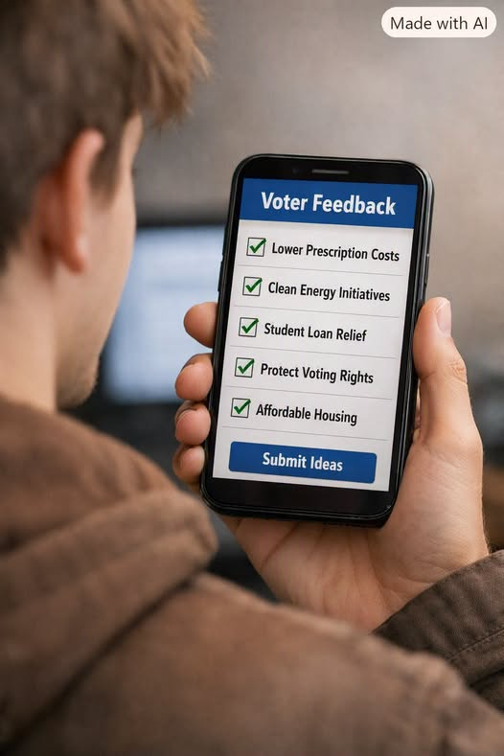
The American system calls itself democratic, but in practice it functions as a one-way street. Campaigns don’t ask citizens what they want; they tell them what’s on offer. Platforms are crafted by consultants, tested by pollsters, and handed down like finished products. The public’s role is reduced to reaction — a binary choice every few years.
Real democracy, however, is not a broadcast. It’s a conversation — a constant, dynamic exchange between representatives and the people they represent. It’s iterative, responsive, and alive. And in the twenty-first century, we have the technology to make that possible.
As a systems engineer, you know the infrastructure exists: secure authentication, distributed ledgers, encrypted communication, and scalable cloud systems. These tools could enable continuous civic participation — citizens proposing, debating, and voting on policy ideas in real time. Representatives could use these inputs to shape legislation collaboratively, not hierarchically.

Imagine a system where:
- Every bill has a public feedback portal before it’s introduced.
- Citizens can rank priorities, suggest amendments, and see transparent revisions.
- Local and national issues are discussed in verified digital forums, not filtered through corporate media.
- Data analytics summarize public sentiment without manipulation.
This isn’t utopian — it’s technically feasible and politically transformative. It would turn democracy from a ritual into a process, from a campaign into a collaboration.
The resistance isn’t technological; it’s institutional. Those who benefit from the current structure fear a system that redistributes influence. But history shows that every major democratic advance — from suffrage to civil rights — began with people demanding a voice that the system didn’t want to give.
Digital participation is the next frontier. It’s not about replacing representatives; it’s about reconnecting them to the people they serve. Elections should be checkpoints, not the only moments of contact. Democracy should be a living network, not a static hierarchy.

